The population impact and cost-effectiveness of the 10-valent pneumococcal conjugate vaccine in Iceland

Elías Eyþórsson

Thesis for the degree of Philosophiae Doctor

Supervisor:

Ásgeir Haraldsson

Advisor:  
Karl G. Kristinsson

Doctoral committee:

Helga Erlendsdóttir (chair)   
Ásgeir Haraldsson  
Birgir Hrafnkelsson  
Karl G. Kristinsson   
Tinna L. Ásgeirsdóttir

May 2019

Lýðgrunduð áhrif 10-gilds samtengds pneumókokka bóluefnis á notkun heilbrigðisþjónustu og kostnað

Elías Eyþórsson

Ritgerð til doktorsgráðu

Umsjónarkennari:

Ásgeir Haraldsson

Leiðbeinandi:

Karl G. Kristinsson

Doktorsnefnd:

Helga Erlendsdóttir (formaður)

Ásgeir Haraldsson  
Birgir Hrafnkelsson

Karl G. Kristinsson  
Tinna L. Ásgeirsdóttir

Maí 2019



Thesis for a doctoral degree at the University of Iceland. All right reserved. No part of this publication may be reproduced in any form without the prior permission of the copyright holder.

© Elías Eyþórsson 2019

ISBN (apply at <http://www.landsbokasafn.is/>)

Printing by Háskólaprent

Reykjavik, Iceland 2019

Ágrip

*Streptococcus pneumoniae* er Gram-jákvæð baktería sem getur valdið sýkingum í mönnum. Algengasta birtingarmynd pneumókokka er einkennalaust beraástand í nefkoki. Pneumókokkar eru einnig algengur sjúkdómsvaldur bæði staðbundina og ífarandi sýkinga. Alvarleiki þeirra spannar breitt bil: frá miðeyrnabólgum, sem ganga flestar yfir án inngrips, til blóðsýkinga og heilahimnubólga sem krefjast innlagnar á sjúkrahús. Þrátt fyrir að miðeyrnabólgur séu mildar sýkingar, þá eru þær algengasta orsök læknisheimsókna og sýklalyfjaávísanna barna. Rörísetningar í eyru eru algengustu aðgerðir hjá börnum sem krefjast svæfingar.

Bólusetningar gegn pneumókokkum eiga sér langa sögu. Fyrstu tilraunir í mönnum áttu sér stað 1914. Fjölsykrubóluefni var fyrst þróað árið 1945 en náði ekki útbreiðslu fyrr en 1983, þegar 23-gilt fjölsykrubóluefni kom á markaðinn. Það vakti hins vegar ekki gott ónæmissvar í börnum. Til þess þurfti próteintengingu. Sjö-gilt próteintengt pneumókokka bóluefni kom á markaðinn árið 2000. Fjöldi rannsókna hefur sýnt fram á að notkun þess verndi gegn miðeyrnabólgum, rörísetningum, lungnabólgum og ífarandi sýkingum hjá börnum. Einnig hefur verið sýnt fram á hjarðónæmi hjá fullorðnum. Samtengd bóluefni gegn 10 og 13 hjúpgerðum pneumókokka voru framleidd í kjölfarið. Í apríl 2011 var 10-gilda samtengda pneumókokka bóluefnið innleitt í ungbarnabólusetningar á Íslandi.

Markmið þessarar rannsóknar var að meta lýðgrunduð áhrif innleiðingar 10-gilda samtengda pneumókokka bóluefnisins á Íslandi. Sérstök áhersla var lögð á að meta notkun barna á heilbrigðisþjónstu: komur þeirra á heilsugæslu og bráðamóttöku Barnaspítala Hringsins vegna miðeyrnabólgu; sýklalyfjaávísanir og rörísetningar. Einnig voru skoðaðar innlagnir barna á sjúkrahús vegna miðeyrnabólgu, lungnabólgu, blóðsýkinga og heilahimnubólgu. Lýðgrunduð áhrif bólusetningarinnar voru einnig skoðuð og metið hvort hjarðónæmi hafði myndast hjá fullorðnum. Að lokum var markmið rannsóknarinnar að meta kostnaðarvirkni bóluefnisins á Íslandi.

Einstaklingsgögnum var safnað úr fimm lýðgrunduðum gagnagrunnum og sjúkraskrám Landspítala Háskólasjúkrahúss fyrir tímabilið 1. Janúar 2005 – 31. Desember 2017. Öllum pneumókokkabólusetningum og sýklalyfjaávísunum var safnað úr bólusetningargagnagrunni og lyfjagagnagrunni Embættis Landlæknis. Allar læknisheimsóknir vegna öndunarfærasýkinga voru dregnar úr samskiptaskrá heilsugæslustöðva og sjúkraskrá Landspítala Háskólasjúkrahúss, og upplýsingar um rörísetningar fengust úr endurgreiðslugrunni Sjúkratrygginga Íslands. Upplýsingar um búferlaflutninga barna til og frá Íslandi voru sótt til Hagstofu Íslands.

Fjórar ferilsrannsóknir voru framkvæmdar sem fylgdu eftir fæðingarárgöngum 2005-2015. Sú fyrsta fylgdi öllum börnum frá fæðingu til 36 mánaða aldurs með tilliti til koma á heilsugæslu vegna miðeyrnabólgu. Andersen-Gill líkan var notað sem leiðrétti fyrir aldri, kyni og fjölda fyrri koma vegna miðeyrnabólgu. Áhrif bólusetningarinnar voru metin sem (1 - áhættuhlutfallið milli síðasta bólusetta og óbólusetta árgangsins) * 100%, sem reyndist vera 22% með 95% öryggisbili 12%-31%. Tíðni ceftriaxone meðferðar við miðeyrnabólgu á Barnaspítala Hringsins var notaður til að áætla áhrif á bóluefnisins á alvarlegar miðeyrnabólgur, og reyndist vera 55% minni í kjölfar bólusetningarinnar með 95% öryggisbili 46%-63%.

Önnur ferilrannsóknin fylgdi börnum eftir til 36 mánaða aldurs með tilliti til allra sýklalyfjaávísanna. Sama líkan var notað og áhrifin metin á sama hátt, og sýklalyfjaávísunum fækkaði um 5.8% með 95% öryggisbili 1.6%-9.8%. Þriðja ferilrannsóknin mat tíðni rörísetninga. Hún fylgdi börnum eftir til 60 mánaða aldurs og sýndi fram á ómarktæka aukningu á rörísetningum, þrátt fyrir innleiðingu bóluefnisins. Fjórða rannsóknin skoðaði sjúkrahúsinnlagnir vegna öndunarfærasýkinga. Hún bar saman bólusetta árganga við óbólusetta og sýndi fram á 20% fækkun á innlögnum vegna lungnabólgu, 95% öryggisbil 5%-33%.

Lýðgrunduð rannsókn sem tók til allra aldurshópa mat hjarðónæmi og kostnaðarvirkni bóluefnisins. Rannsókninin beitti aðferðum Bayes á tímaraðgreiningu og notaði komur og innlagnir vegna annarra sjúkdóma til samanburðar. Rannsóknin sýndi fram á sterkt hjarðónæmi sem leiddi til fækkunar á miðeyrnabólgum, lungnabólgum og ífarandi sýkingum. Að teknu tilliti til sparnaðar vegna færri sýkinga, sparaði bóluefnið 7,463,176$ Bandaríkjadala á fyrstu fimm árum eftir innleiðingu þess.

Rannsóknirnar sem þessi ritgerð er byggð á sýndu fram á gríðarlegan samfélagslegan ábáta af innleiðingu pneumókokkabóluefnisins á Íslandi. Innleiðingin olli fækkun á læknisheimsóknum, sjúkrahúsinnlögnum og sýklalyfjaávísunum hjá börnum og hjarðónæmi myndaðist hjá fullorðnum. Að teknu tilliti til sparnaðar vegna færri sýkinga sparaði innleiðing bóluefnisins íslenskt samfélag 7,463,176$ Bandaríkjadala á föstu 2015 verðlagi.

**Lykilorð:** *Streptococcus pneumoniae*, samtengt pneumókokkabóluefni, kostnaðarvirknigreining, hjarðónæmi, miðeyrnabólga

Abstract

*Streptococcus pneumoniae* is a Gram-positive diplococcus that is both a commensal bacterium in the upper respiratory tract of humans, and a common pathogen. The infectious manifestations of pneumococcus span a range from benign to serious; from acute otitis media (AOM) that often resolves without intervention, to sepsis and meningitis which invariably require hospitalization. Despite its often benign course, AOM is the most common reason for physician visits and antimicrobial prescriptions for children, and tympanostomy tube placements are the most common surgical procedure in children requiring general anesthesia.

Pneumococcal vaccinations have a long history that began in 1914 with clinical trials in humans. A 23-valent polysaccharide vaccine was marketed in 1983 but was poorly immunogenic in children. The seven-valent pneumococcal conjugate vaccine was brought to market in 2000. Multiple studies have demonstrated protection against AOM, tympanostomy tube placements, pneumonia and invasive disease in children. Indirect protection in adults has also been demonstrated. Higher valent vaccines were later developed. In April of 2011, the 10-valent pneumococcal *Haemophilus influenzae* Protein D conjugate vaccine (PHiD-CV10) was introduced in Iceland.

The aim of the study was to evaluate the impact of PHiD-CV10 introduction in Iceland. Special attention was paid to the healthcare burden in children: visits to primary care and to the emergency department of Children‘s Hospital Iceland for AOM, antimicrobial prescriptions, tympanostomy tube placements, and hospitalizations for pneumonia and invasive disease. The population-based impact of PHiD-CV10 was examined including whether herd effect occurred in adults. Finally, the study aimed to estimate the cost-effectiveness of PhiD-CV10 in Iceland.

Individual level data were obtained from five population-based registries and Landspitali University Hospital‘s patient registry for the period from 1 January 2005 to 31 December 2017. Data on all administered doses of pneumococcal vaccines and all outpatient antimicrobial prescriptions were extracted from the National Vaccine and National Drug Prescription Registries of the Icelandic Directorate of Health. Visits for respiratory infections were extracted from the Primary Care Registry and Landspítali University Hospital‘s patient registry, and data on tympanostomy procedures were obtained from Icelandic Health Insurance‘s reimbursement database. Immigration and emigration data were provided by Statistics Iceland.

Four cohort studies followed 11 Icelandic birth-cohorts 2005-2015. The first such study followed children from birth to 36 months of age with regards to primary care visits for AOM. An Andersen-Gill model that corrected for age, gender and the number of previous AOM visits was used. The vaccine impact was calculated as (1 - hazard ratio between the last vaccine eligible and vaccine non-eligible cohort) * 100%, and revealed a 22% reduction in AOM with a 95% confidence interval (CI) 12% to 31%. The incidence of ceftriaxone treated AOM at Children‘s Hospital Iceland was examined before and after vaccine introduction to estimate the vaccine impact on AOM with treatment failure, and revealed a 55% (95% CI 46%-63%) reduction in ceftriaxone treatment episodes.

The second cohort study followed children from birth to 36 months of age with regards to outpatient antimicrobial prescriptions. The same methods were used, and the vaccine impact was calculated. A 5.8% (95% CI 1.6%-9.8%) decrease in the number of prescriptions was established. The third cohort study evaluated tympanostomy procedures. It followed children from birth to 60 months of age and revealed a non-significant increase in procedures, despite the introduction of PHiD-CV10. The fourth cohort study examined the hazard of hospitalization for respiratory and invasive infections. It compared vaccine eligible cohorts to vaccine non-eligible cohorts and found a 20% (95% CI 5%-33%) reduction in pneumonia hospitalizations.

A population-based study that included all age-groups estimated the cost-effectiveness of PHiD-CV10 and examined whether herd effect had occurred. A Bayesian time series methodology was used and included visits and hospitalization for diagnoses unrelated to the vaccine as controls. The study revealed strong evidence of herd effect for otitis media, pneumonia and invasive disease. After taking into account costs avoided because of prevented disease cases, the introduction of PHiD-CV10 was found to have saved 7,463,176 United States Dollars in the first five years of the program.

The studies that compromise this thesis showed a large societal impact of PHiD-CV10 introduction; visits, antimicrobial prescriptions and hospitalizations of children decreased, and indirect protection was observed in adults. The vaccination program was cost-saving from both the health sector and societal perspectives.

**Keywords:** *Streptococcus pneumoniae,* Pneumococcal conjugate vaccines, cost-effectiveness analysis, otitis media, herd immunity

Acknowledgements

My son was born in June of 2013. During the past five years, he has learned to walk, talk, laugh, sing, dance, tell jokes and make friends – a strong foundation upon which to build his future as a happy and productive member of society. He didn’t achieve this on his own. He was nurtured and taught by his family and by his wonderful pre-school teachers. In November of 2013, the University of Iceland Faculty of Medicine accepted my application for doctoral studies. I had no prior experience in scientific research, nor had I written any English text. During the same five-year period in which my son learned to be a human, I learned to be researcher; granted, a slightly less impressive accomplishment. I too did not achieve this by myself. I would like to acknowledge those who contributed to my training.

First, I thank my supervisor, Professor, Chief and Faculty Chairman of Pediatrics, Dr. Ásgeir Haraldsson. He, along with other members of my doctoral committee, created the environment and conditions required for me to become a researcher. He provided excellent mentorship, while pushing me to be independent. Our first interaction was in April of 2013, when in a phone call, he introduced himself and promptly offered me a PhD position. I had recently completed a small cost-effectiveness analysis for my Bachelor of Science in Medicine, supervised by Professor of Economics Dr. Tinna Laufey Ásgeirsdóttir – Ásgeir’s daughter. I can only surmise that she saw in me some inkling of potential and recommended me for doctoral studies. She would later represent a fifth of my doctoral committee and instruct me in the methodology of health economic analysis. I thank her for her help during the past five years.

I would also like to thank my co-advisors, Clinical Professor of Microbiology Helga Erlendsdóttir and Professor and Chief of Clinical Microbiology Dr. Karl G. Kristinsson, for their guidance and knowledge over the past five years. Every Tuesday, the study group met for an hour-long meeting in Karl’s office. Invariably present were Ásgeir, Helga and Karl. Each of the doctoral students were provided an opportunity to discuss their accomplishments over the past week, and seek assistance for issues that had come up. There; Ásgeir, Helga and Karl offered their collective wisdom regarding the hidden curriculum of scientific research, and advice and support regarding the problem at hand. The meetings were of immeasurable value, and as I later learned, above and beyond what is expected of a doctoral committee.

The last member of my doctoral committee, Professor of Statistics Dr. Birgir Hrafnkelsson, provided support and mentoring in the field of statistics. Birgir did not coddle me. He pushed me to do all my own statistical work and provided help if needed. As a result, I learned to program in the R statistical language and gained an appreciation and understanding of clinical epidemiology and applied statistics – both of which I intend to pursue in the future. For this, I am grateful.

I would like to thank the other members of our research group, who often attended the Tuesday meetings and contributed to my education and research. These included Dr. Gunnsteinn Haraldsson and Dr. Martha Hjálmarsdóttir, who provided helpful guidance and advice, and the two other PhD students in the group; Sigríður Júlía Quirk and Dr. Samúel Sigurðsson. I would especially like to thank Samúel for our collaboration during the final two years of my studies. When I was plagued with writer’s block, he was able to draft an article within days. He taught me that writing is iterative, and that the first draft is exactly that – the first draft. Without this lesson, I am unsure whether I could have written this thesis.

The data upon which my thesis is built were collected from several registries. I would like to thank Guðrún Kr. Guðfinnsdóttir at the Icelandic Directorate of Health; Elísabet Guðmundsdóttir and Ingibjörg Richter at Landspitali University Hospital; Margrét Rósa Kristjánsdóttir at Icelandic Health Insurance and Margrét Valdimarsdóttir at Statistics Iceland, for their work extracting data from their respective registries. Most of the data coordination was overseen by Guðrún, and I thank her especially for her patience and the assistance she provided. With the exception of my doctoral committee, she is my most frequent email recipient, having accumulated 93 emails from me during the past two years alone.

During the course of my studies, I developed an interest in statistics and methodology. I completed several courses in probability and statistics and was introduced to Professor of Statistics Dr. Thor Aspelund and Dr. Sigrún Helga Lund. As time passed, we became friends, and I learned to trust their advice. I would like to thank both for the contributions to my training, and for the support they have shown me during my studies.

It takes a village to raise a doctoral student. I would not have been able to do this without the support of my family and friends. I thank Kristín, my wife and mother of my child (soon children), for her patience and understanding. A PhD is completed during evenings and weekends, and she has had to endure the sight of my face illuminated by the harsh blue light of a computer screen for far too long. Breki, my son, I thank for reminding me of the balance I must maintain between work and family. He expresses the appropriate amount of contempt for my computer, which robs him of his father for long stretches of time. I thank my brother, Daníel, for reminding me of what an obnoxious over-achiever I have become. My parents Andrea and Eythor Haraldsson, I thank for their excellent parenting skills, which in my humble opinion have produced some the greatest minds in academia. Their sincere interest in my niche research proves that parents’ love for their child knows no bounds.

I would especially like to thank my mother. In addition to literally being the reason I am here today; she has directly contributed to my training as a researcher. A graduate of Smith College with a major in English, she has read every single sentence I have written since the beginning of my PhD, and advised on punctuation, grammar, and the structure of paragraphs and sentences. Each manuscript I have written has been passed to her for multiple language editing revisions, and this 300 page monograph is no exception. She taught me how to write well. Thank you.

Contents

Ágrip 3

Abstract 5

Acknowledgements 7

Contents 11

List of abbreviations 17

List of Figures 19

List of Tables 21

List of Original Papers 25

Declaration of contribution 27

1 Introduction 29

1.1 Clinical manifestations of *Streptococcus pneumoniae* 32

1.1.1 Acute otitis media 33

1.1.1.1 Pathogens implicated in acute otitis media 33

1.1.1.2 Health care burden of otitis media 34

1.1.1.3 Tympanostomy tube procedures 37

1.1.1.4 Acute otitis media in Iceland 39

1.1.2 Pneumonia 40

1.1.2.1 Pathogens causing pneumonia 40

1.1.2.2 Health care burden of pneumonia 42

1.1.3 Invasive pneumococcal disease and mortality 43

1.2 Pneumococcal vaccines 44

1.2.1 A brief history of pneumococcal vaccination 44

1.2.2 The impact of pneumococcal conjugate vaccines on otitis media 46

1.2.2.1 Randomized controlled trials evaluating the efficacy of pneumococcal conjugate vaccines for otitis media 46

1.2.2.2 Observational studies evaluating the impact of pneumococcal conjugate vaccines for otitis media. 51

1.2.3 The impact of pneumococcal conjugate vaccines on pneumonia 53

1.2.4 The impact of pneumococcal conjugate vaccines on invasive pneumococcal disease 55

1.3 Cost-effectiveness in the context of pneumococcal conjugate vaccination 57

1.3.1 Vaccine efficacy assumptions in economic analyses of pneumococcal conjugate vaccines 62

1.3.2 Assumptions regarding costs and utilities in economic analyses of pneumococcal vaccines 67

2 Aims 72

3 Materials and methods 73

3.1 Data collection and sources 73

3.1.1 Statistics Iceland 73

3.1.2 Landspitali University Hospital patient registry 74

3.1.3 The Primary Care Registry 78

3.1.4 The National Vaccine Registry 79

3.1.5 The National Drug Prescription Registry 79

3.1.6 Reimbursement database of Icelandic Health Insurance 80

3.2 Impact on otitis media with treatment failure (Paper I) 82

3.3 Impact on primary care visits for acute otitis media (Paper II) 84

3.4 Impact on outpatient antimicrobial prescriptions (Paper III) 85

3.5 Impact on tympanostomy tube procedures (Paper IV) 87

3.6 Impact on respiratory associated hospitalizations (Paper V) 89

3.7 Impact and cost-effectiveness analysis (Paper VI) 91

3.7.1 Data sources 92

3.7.2 Impact of PHiD-CV10 93

3.7.3 Cost-effectiveness analysis 94

4 Results 97

4.1 Data collection and sources 97

4.1.1 Statistics Iceland 98

4.1.2 Landspitali University Hospital patient registry 98

4.1.3 The Primary Care Registry 104

4.1.4 The National Vaccine Registry 104

4.1.5 Reimbursement database of Icelandic Health Insurance 108

4.2 Impact on otitis media with treatment failure (Paper I) 109

4.3 Impact on outpatient antimicrobial prescriptions (Paper III) 120

4.4 Impact on tympanostomy tube procedures (Paper IV) 127

4.5 Impact on respiratory associated hospitalizations (Paper V) 134

4.6 Impact and cost-effectiveness analysis (Paper VI) 140

4.6.1 Population impact on acute otitis media among children younger than 20 years of age 140

4.6.2 Population impact on pneumonia hospitalizations 148

4.6.3 Population impact on hospital admissions for invasive pneumococcal disease 155

5 Discussion 164

5.1 Main findings 164

5.2 Data collection and sources (Papers I-VI) 164

5.3 Epidemiology and management of otitis media in Iceland and the impact of PHiD-CV10 introduction (Papers I, II, III, V and VI) 168

5.3.1 Epidemiology of acute otitis media in Iceland (Papers II and V) 168

5.3.2 Impact on primary care visits for otitis media (Papers II and VI) 171

5.3.3 Impact on pediatric emergency department visits for acute otitis media (Paper I) 177

5.3.4 Impact on outpatient antimicrobial prescriptions for otitis media (Paper III) 177

5.3.5 Evidence of herd-effect of PHiD-CV10 on the incidence of otitis media in the unvaccinated population (Papers II and VI) 179

5.3.6 Impact on acute otitis media with treatment failure (Paper I) 181

5.3.7 Impact of PHiD-CV10 on tympanostomy tube placements (Paper IV) 182

5.4 Impact of PHiD-CV10 on hospital admissions for respiratory infections and invasive pneumococcal disease (Papers V and VI) 184

5.4.1 Impact on hospital admissions for otitis media and its complications (Paper V) 184

5.4.2 Impact on pediatric pneumonia hospitalizations (Papers V and VI) 185

5.4.3 Impact on hospital admissions for culture confirmed invasive pneumococcal disease 188

5.4.4 Evidence of herd-effect of PHiD-CV10 on hospital admissions for invasive pneumococcal disease in the unvaccinated population (Paper VI) 193

5.5 Cost-effectiveness of introducing PHiD-CV10 into the Icelandic pediatric vaccination program (Paper VI) 195

6 Conclusions 199

6.1 Direct and indirect impact on otitis media 199

6.2 Direct impact on antimicrobial consumption 199

6.3 Direct impact on tympanostomy tube placements 200

6.4 Direct and indirect impact on pneumonia hospitalizations 201

6.5 Direct and indirect impact on hospital admissions for invasive pneumococcal disease 201

6.6 Cost-effectiveness of PHiD-CV10 introduction 202

6.7 Future research questions 202

6.7.1 What is the relationship between the age of a child at the time of their first episode of acute otitis media and their future risk of recurrent or protracted disease? 202

6.7.2 To what degree, if any, did physicians change their prescribing habits for AOM following the introduction of a universal pneumococcal vaccination program? 203

6.7.3 What is the incidence of AOM with treatment failure and has it changed following vaccine introduction? 203

6.7.4 What is the incidence and cumulative incidence of tonsillectomies in young children in Iceland? 204

6.7.5 Do children experience fewer episodes of AOM after undergoing a tympanostomy tube placement than they would otherwise have experienced? 204

6.7.6 Would tympanostomy tube procedures have increased to a larger degree, had PHiD-CV10 not been introduced into the pediatric vaccination program? 205

6.7.7 What was the direct and indirect effect of PHiD-CV10 on individual and grouped serotypes of invasive pneumococcal disease, after adjustment for secular trends in both IPD and invasive disease caused by other pathogens? 206

6.8 Conclusion 206

References 209

Original publications 245

Paper I 247

Paper II 255

Paper III 265

Paper IV 279

Paper V 289

Paper VI 323

List of abbreviations

|  |  |
| --- | --- |
| Term | Abbreviation |
| Acute otitis media | AOM |
| Anatomical-Therapeutic-Chemical | ATC |
| Community-acquired pneumonia | CAP |
| Cost-benefit analysis | CBA |
| Cost-effectiveness analysis | CEA |
| Cost-effectiveness acceptability curve | CEAC |
| Case-fatality ratio | CFR |
| Confidence intervals | CI |
| Cost-utility analysis | CUA |
| Enzyme-linked immunosorbent assay | ELISA |
| Hospital-acquired pneumonia | HAP |
| Hazard ratio | HR |
| International Classification of Diseases, 10th revision | ICD-10 |
| Intensive care unit | ICU |
| Invasive pneumococcal disease | IPD |
| Incidence rate | IR |
| Incidence rate ratio | IRR |
| Icelandic krona | ISK |
| International Society for Pharmacoeconomics and Outcome Research | ISPOR |
| Leave-one-out cross-validation | LOOCV |
| Lower respiratory tract infection | LRTI |
| Meningococcal outer membrane protein complex | MOMPC |
| NOMESCO Classification of Surgical Procedures | NCSP |
| National Drug Prescription Registry | NDPR |
| non-typeable Haemophilus influenzae | NTHi |
| National Vaccine Registry | NVR |
| Organization for Economic Co-operation and Development | OECD |
| Principal component analysis | PCA |
| Pneumococcal conjugate vaccine | PCV |
| 10-valent pneumococcal conjugate vaccine | PCV10 |
| 11-valent pneumococcal conjugate vaccine | PCV11 |
| 13-valent pneumococcal conjugate vaccine | PCV13 |
| 7-valent pneumococcal conjugate vaccine | PCV7 |
| 10-valent pneumococcal *Haemophilus influnzae* protein-D conjugate vaccine | PHiD-CV10 |
| 23-valent pneumococcal polysaccharide vaccine | PPV-23 |
| Probabilistic sensitivity analysis | PSA |
| Quality-adjusted life-years | QALY |
| Respiratory syncytial virus | RSV |
| Seasonal and trend decomposition using LOESS | STL |
| Tympanostomy tube placement | TTP |
| Upper respiratory tract infection | URTI |
| Vaccine eligible cohorts | VEC |
| Vaccine non-eligible cohorts | VNEC |

List of Figures

Figure 1.The total number of contacts to Landspitali University Hospital and Primary Care Centers in Iceland associated with International Classification of Diseases, 10th revision (ICD-10) codes compatible with respiratory infections. 102

Figure 2. The distribution in the cost associated with contacts to Landspitali University Hospital 103

Figure 3. The monthly number of administered doses of pneumococcal vaccines in Iceland from 1 January 2005 to 31 December 2017. 104

Figure 4. The age at which children receive their first, second and third dose of a pneumococcal conjugate vaccine (PCV) as a function of birth-date. 106

Figure 5. The number of filled antimicrobial prescriptions as a function of age for selected chemical sub-levels of the Anatomical Therapeutic Chemical (ATC) classification system. 108

Figure 6. The monthly number of visits of children zero to 18 years of age to Children’s Hospital Iceland’s emergency department during the period from January 2002 to December 2016. 110

Figure 7. The quarterly incidence rate (IR) of ceftriaxone treatment episodes stratified by age and indication for the period from January 2008 to December 2015. 114

Figure 8. The monthly incidence rates (IR) of ceftriaxone treatment episodes per 1,000 person-years regardless of indication stratified by age-groups for the period from January 2005 to December 2016. 115

Figure 9. The incidence rate (IR) of acute otitis media (AOM) visits to primary care physicians stratified by birth-cohort and four-month age-groups. 117

Figure 10. The hazard ratio (HR) of acute otitis media (AOM) between each birth-cohort and the last vaccine non-eligible birth-cohort is shown. 118

Figure 11. The hazard ratio (HR) of acute otitis media (AOM) between the vaccine eligible (VEC) and vaccine non-eligible cohorts (VNEC) stratified by the number of previous AOM episodes. 119

Figure 12. The mean number of acute otitis media (AOM) episodes is shown as a function of age. 120

Figure 13. The proportion of visits resulting in antimicrobial prescription and the incidence of prescriptions for each diagnostic group for the period from 2005 to 2015. 122

Figure 14. The incidence rate (IR) of outpatient antimicrobial prescriptions is shown stratified by birth-cohort and six-month age-groups. 124

Figure 15. The hazard ratio (HR) of outpatient antimicrobial prescription between each birth-cohort and the last vaccine non-eligible birth-cohort. 125

Figure 16. The hazard ratio (HR) of outpatient antimicrobial prescriptions between the vaccine eligible (VEC) and vaccine non-eligible cohorts (VNEC) stratified by the number of previous prescriptions. 126

Figure 17. The mean number of outpatient antimicrobial prescriptions are shown as a function of age, and stratified by vaccine eligibility cohort and gender. 127

Figure 18. The incidence rate (IR) of tympanostomy tube placements (TTP) stratified by birth-cohort and six-month age-groups. 129

Figure 19. The cumulative incidence of tympanostomy tube placements (TTP) is shown for the vaccine eligible (VEC) and vaccine non-eligible cohorts (VNEC) as a continuous function of age. 130

Figure 20. The hazard ratio (HR) of tympanostomy tube placements (TTP) is depicted between each birth-cohort and the last vaccine non-eligible birth-cohort, as estimated by three Cox regression models. 133

Figure 21. Crude incidence rates (IR) of the six diagnostic groups (A-F) per 1,000 person-years for each of the birth-cohorts. 136

Figure 22. Kaplan-Meier cumulative event curves per 1,000 person-years for each of the diagnostic groups. 138

Figure 23. The number of primary care visits among children younger than 20 years of age per calendar-month from 1 January 2005 to 31 December 2015. 141

Figure 24. The observed and predicted number of visits for acute otitis media and its complications (AOM) from 1 January 2005 to 31 December 2015 for each age-group. 142

Figure 25. The observed and predicted number of AOM visits from 1 January 2005 to 31 December 2015 for each age-group. 144

Figure 26. The impact of the 10-valent Haemophilus influenzae protein D pneumococcal conjugate vaccine (PHiD-CV10) on acute otitis media and complications (AOM) among children younger than 20 years of age is summarized. 147

Figure 27. The monthly number of hospital admissions for pneumonia and hospitalizations regardless of diagnosis from 1 January 2005 to 31 December 2017. 149

Figure 28. The observed and predicted number of pneumonia hospitalizations from 1 January 2005 to 31 December 2017 for each age-group. 150

Figure 29. The observed and predicted number of pneumonia hospitalizations from 1 January 2005 to 31 December 2017 for each age-group. 151

Figure 30. The population impact of the 10-valent Haemophilus influenzae protein D pneumococcal conjugate vaccine (PHiD-CV10) on pneumonia hospitalizations is summarized. 154

Figure 31. The number of hospitalizations per year-quarter from 1 January 2005 to 31 December 2016. 156

Figure 32. The observed and predicted number of IPD hospitalizations from 1 January 2005 to 31 December 2016 for each age-group. 158

Figure 33. The observed and predicted number of IPD hospitalizations from 1 January 2005 to 31 December 2016 for each age-group. 160

Figure 34. The population impact of the 10-valent Haemophilus influenzae protein D pneumococcal conjugate vaccine (PHiD-CV10) on hospital admissions for invasive pneumococcal disease is summarized. 162

List of Tables

Table 1. A review of observed incidence rates of acute otitis media in high-income countries prior to the introduction of pediatric pneumococcal conjugate vaccination. 35

Table 2. A review of observed incidence rates of tympanostomy tube placements in high-income countries prior to the introduction of pediatric pneumococcal conjugate vaccination. 37

Table 3. Randomized controlled trials evaluating the efficacy of pneumococcal conjugate vaccines for acute otitis media (AOM) and tympanostomy procedures. 48

Table 4. Randomized controlled trials evaluating the efficacy of pneumococcal conjugate vaccines for pneumonia. 53

Table 5. Randomized controlled trials evaluating the efficacy of pneumococcal conjugate vaccines for invasive pneumococcal disease (IPD). 56

Table 6. A summary of the economic analyses of pneumococcal conjugate vaccines in high-income countries from 2009-2018. 61

Table 7. A summary of modeling assumptions used in economic analyses of pneumococcal conjugate vaccines in high-income countries from 2009-2018. 65

Table 8. The International Classification of Diseases, 10th revision (ICD-10) codes used for individual-level data collection from the Primary Care Registry and Landspitali University Hospital’s patient registry. 74

Table 9. NOMESCO Classification of Surgical Procedures (NCSP) codes used for individual-level data collection from Landspitali University Hospital’s patient registry. 76

Table 10. The International Classification of Diseases, 10th revision subchapters used to define the synthetic controls used in time series analyses. 77

Table 11. Anatomical Therapeutic Chemical (ATC) codes used for individual-level data collection from the National Drug Prescription Registry. 79

Table 12. Reimbursement codes used for individual-level data collection from the Reimbursement database of Icelandic Health Insurance. 81

Table 13. Definitions of the Paper V’s diagnostic groupings. 90

Table 14. Demographic information regarding birth-cohorts included in the study. 97

Table 15. The number of visits and hospitalizations with International Classification of Diseases, 10th revision (ICD-10) codes listed as the primary diagnosis. 98

Table 16. The number of NOMESCO Classification of Surgical Procedures (NCSP) performed at Landspitali University Hospital between 1 January 2005 and 31 December 2017. 101

Table 17. The number of children in each birth-cohort who received zero to three doses of a pneumococcal conjugate vaccine before four years of age. 105

Table 18. The number of filled outpatient prescriptions by Anatomical Therapeutic Chemical (ATC) is shown for the period from 1 January 2005 to 31 December 2017. 107

Table 19. The number of procedures reimbursed to independently practicing otolaryngologists from 1 January 2005 to 31 December 2016. 109

Table 20. The incidence of visits and ceftriaxone treatment episodes at Children’s Hospital Iceland by calendar-year. 110

Table 21. The incidence rate ratios (IRR) of acute otitis media (AOM) associated visits between the pre- and post-vaccine periods by age. 112

Table 22. The incidence rate ratios (IRR) of ceftriaxone treatment episodes of otitis media (AOM) between the pre- and post-vaccine periods by age. 112

Table 23. The incidence risk ratio (IRR) of receiving ceftriaxone treatment if presenting to Children’s Hospital Iceland with acute otitis media (AOM) between the pre- and post-vaccine periods by age. 112

Table 24. The incidence rate ratio (IRR) of ceftriaxone treatment episodes of pneumonia between the pre- and post-vaccine periods are presented along with 95% confidence intervals. 113

Table 25. The incidence rate ratios (IRR) of ceftriaxone treatment episodes for indications other than acute otitis media and pneumonia between the pre- and post-vaccine periods for each age. 114

Table 26. The incidence rate (IR) of acute otitis media visits to primary care physicians for each birth-cohort and gender. 116

Table 27. The proportion of each vaccine eligibility cohort that experienced zero, one to four and five to twelve cumulative episodes of AOM by 36 months of age. 117

Table 28. The incidence rate (IR) of outpatient antimicrobial prescriptions among children younger than three years of age is shown by calendar-year. 121

Table 29. The incidence rate (IR) of outpatient antimicrobial prescriptions is presented by birth-cohort and gender. 123

Table 30. The proportion of children in the vaccine non-eligible cohorts (VNEC, 2005–2010) and vaccine eligible cohorts (VEC, 2011–2013) who filled 0, 1–4, 5–9, 10–14 and ≥15 antimicrobial prescriptions by 36 months of age. 124

Table 31. An overview of the birth-cohorts included in paper IV. 128

Table 32. The cumulative incidence of having undergone at least one tympanostomy tube placement (TTP) at six-month age intervals is presented. 129

Table 33. The cumulative number of previous antimicrobial prescriptions for those children in the vaccine non-eligible (VNEC) and vaccine eligible cohorts (VEC) who underwent at least one tympanostomy tube placement. 131

Table 34. The cumulative number of previous otitis media visits for those children in the vaccine non-eligible (VNEC) and vaccine eligible cohorts (VEC) who underwent at least one tympanostomy tube placement. 131

Table 35. An overview of the birth-cohorts included in paper V. 134

Table 36. Hazard ratios (HR) between the vaccine eligible (VEC) and vaccine non-eligible birth-cohorts (VNEC) for each disease-group. 139

Table 37. The weights used to produce the final stacked model from the component models. 143

Table 38. The rate ratio between observed and predicted number of primary care visits due acute otitis media and complications (AOM) during the post-vaccine period (2013-2015) 145

Table 39. The posterior median of the rate ratio between observed and predicted number pneumonia hospitalizations during the post-vaccine period (2013-2017) 152

Table 40. The rate ratio between observed and predicted number of hospital admissions for invasive pneumococcal disease (IPD) during the post-vaccine period (2013-2016) 161

List of Original Papers

This thesis is based on the following original publications, which are referred to in the text by their Roman numerals (I-VI):

1. Eythorsson E, Hrafnkelsson B, Erlendsdóttir H, Atli Gudmundsson S, Kristinsson KG, Haraldsson Á. Decreased AOM with Treatment Failure Following Introduction of the Ten-Valent Pneumococcal Haemophilus influenzae Protein D Conjugate Vaccine. *Pediatr Infect Dis J*. December 2017:1. doi:10.1097/INF.0000000000001870.
2. Sigurdsson S, Eythorsson E, Hrafnkelsson B, Erlendsdóttir H, Kristinsson KG, Haraldsson Á. Reduction in All-Cause Acute Otitis Media in Children <3 Years of Age in Primary Care Following Vaccination With 10-Valent Pneumococcal Haemophilus influenzae Protein-D Conjugate Vaccine: A Whole-Population Study. *Clin Infect Dis*. 2018;67(8):12131219. doi:10.1093/cid/ciy233.
3. Eythorsson E, Sigurdsson S, Hrafnkelsson B, Erlendsdóttir H, Haraldsson Á, Kristinsson KG. Impact of the 10-valent pneumococcal conjugate vaccine on antimicrobial prescriptions in young children: a whole population study. *BMC Infect Dis*. 2018;18(1):505. doi:10.1186/s12879-018-3416-y.
4. Eythorsson E, Sigurdsson S, Erlendsdóttir H, Hrafnkelsson B, Kristinsson KG, Haraldsson Á. Increase in tympanostomy tube placements despite pneumococcal vaccination, a population-based study. *Acta Paediatr*. January 2019:1-8. doi:10.1111/apa.14724.
5. Sigurdsson S, Eythorsson E, Erlendsdóttir H, Hrafnkelsson B, Kristinsson KG, Haraldsson Á. Impact of the 10-valent pneumococcal conjugate vaccine on hospital admissions in children under three years of age in Iceland (Submitted for publication in *Vaccine*)
6. Eythorsson E, Hrafnkelsson B, Erlendsdóttir H, Kristinsson KG, Haraldsson Á. Impact and cost-effectiveness of the 10-valent pneumococcal conjugate vaccine in Iceland, a population-based study (Submitted for publication in *BMJ*)

All papers are reprinted by kind permission of the publishers.’

Declaration of contribution

* Paper I. The doctoral student, Elias Eyþórsson (EE), collected the data, refined the research question and conceptualized the study design under the guidance of Ásgeir Haraldsson (ÁH), Helga Erlendsdóttir (HE) and Karl G. Kristinsson (KGK). EE did the statistical analysis under the supervision of Birgir Hrafnkelsson (BH). EE drafted the paper and revised it alongside his co-authors.
* Paper II. EE collected and structured the data. EE refined the research question and conceptualized the study design along with Samúel Sigurðsson (SS), ÁH, HE, and KGK. EE analyzed the data and did the statistical analysis with oversight by BH. EE and SS drafted and revised the paper, and did critical revisions alongside their co-authors.
* Paper III. EE collected and structured the data. EE refined the research question and conceptualized the study design along with ÁH, HE, KGK, and SS. EE analyzed the data and did the statistical analysis, which was reviewed by BH. EE and SS drafted and revised the paper, and EE did critical revisions alongside his co-authors.
* Paper IV. EE collected and structured the data. EE refined the research question and conceptualized the study design along with ÁH, HE, KGK, and SS. EE analyzed the data and did the statistical analysis, which was reviewed by BH. EE and SS drafted the paper, and EE did critical revisions alongside his co-authors.
* Paper V. EE collected and structured the data. EE and SS refined the research question and conceptualized the study design along ÁH, HE, and KGK. EE analyzed the data and did the statistical analysis, which was reviewed by BH. EE and SS drafted and revised the paper, and did critical revisions alongside their co-authors
* Paper VI. EE collected and structured the data. EE refined the research question and conceptualized the study design along with Tinna Laufey Ásgeirsdóttir (TLÁ), ÁH, HE, and KGK. EE analyzed the data and did the statistical analysis, which was reviewed by BH. EE drafted and revised the paper, and did critical revisions alongside his co-authors.
* EE wrote the thesis under guidance from his doctoral committee.

# Introduction

*Streptococcus pneumoniae* is a commensal bacterium found in the nasopharynx of humans (Hussain et al. 2005). It is also a common pathogen, and one of the most common bacterial causes of lower respiratory disease in humans (K. L. O’Brien et al. 2009; Troeger et al. 2018). In classical medical texts, pneumococcus is described as a Gram-positive lancet-shaped coccus, usually found in pairs. In fact, pneumococcus is *the* Gram-positive coccus, being the first bacteria noted by the Danish scientist Christian Gram that retained the dark aniline-gentian violet stain that now bears his name (Gram 1884). Pneumococcus was first isolated in 1881 by two microbiologist, George M. Sternberg in the United States and Louis Pasteur in France (Pasteur 1881; Sternberg 1882; Watson et al. 1993). The causal association between this newly discovered bacterium and pneumonia was firmly established only five years later (Weichselbaum 1886), and in the following decade, all clinical presentations of pneumococcal infections had been described (Austrian 1981).

Pneumococcus has gone by many names since it was first isolated in 1881. It was originally named *Micrococcus pasteuri* by Sternberg (Sternberg 1882), but by 1920, a scientific consensus was reached that the official name should be *Diplococcus pneumoniae* (Winslow et al. 1920). It was not until 1974 that pneumococcus received its current name, *Streptococcus pneumoniae* (Deibel and Seeley 1974).

The infectious manifestations of pneumococcal disease are, broadly speaking, local infections of the respiratory tract and infections of previously sterile tissue. They range from common to uncommon, and from benign to serious. The most common infectious manifestation of pneumococcus is acute otitis media (AOM) – an infection of the middle ear (Coker et al. 2010; Ngo et al. 2016). The disease course is benign and rarely results in permanent disability (Vergison et al. 2010). On the other hand, AOM is the most common reason for physician visit and for antimicrobial prescription in the pediatric population (Grijalva, Nuorti, and Griffin 2009; Todberg et al. 2014). Antimicrobial consumption is causally related to antimicrobial resistance, a major threat to public health (Arason et al. 1996; Austin, Kristinsson, and Anderson 1999). Recurrent or persistent otitis media is sometimes treated with the surgical placement of tympanic tubes, rendering it the most common surgical procedure requiring general anesthesia in children (Cullen, Hall, and Golosinskiy 2009). Thus, while AOM is a benign disease, it is associated with a large health care burden (Arguedas et al. 2010; Monasta et al. 2012).

A potentially more serious manifestation of pneumococcal disease is pneumonia, the disease from which pneumococcus gets its name. Pneumonia often requires hospitalization and intravenous antimicrobial treatment, and can lead to permanent disability and death (Troeger et al. 2017). Pneumococcus can cause invasive infections if it gains access to normally sterile tissue. These includes bacteremia, an infection of the blood, and meningitis, an infection of the meninges. These infectious manifestations are grouped together as invasive pneumococcal disease (IPD). Whilst IPD is uncommon, the consequences can be disastrous (Feikin et al. 2000; Ricketson et al. 2013; Tsigrelis et al. 2008). The case-fatality ratio (CFR) from pneumococcal meningitis in Icelandic children and adults is estimated at 13% and 8% respectively (Snaebjarnardóttir et al. 2013; Þórðardóttir et al. 2014). Pneumococcal infections are responsible for a large health care burden that spans the range from outpatient to inpatient treatment (Backhaus et al. 2016; Pulido and Sorvillo 2010).

For over a century, scientists have attempted to prevent pneumococcal disease using vaccines with varying results. Pneumococcal vaccine development is complicated by the polysaccharide coating that protects pneumococcus from environmental factors. The polysaccharide capsule acts as an “invisibility cloak” to the human immune system, rendering it unable to detect pneumococcus except through defined patterns in the oligosaccharides contained within the capsule (Tuomanen, Austrian, and Masure 1995). Pneumococcus has been classified into over 97 different serotypes to date based on the polysaccharide capsule (Habib, Porter, and Satzke 2014). As the capsule contains only polysaccharides and not proteins, the immune response is T-cell independent and therefore poorly immunogenic, especially in children, even after being identified by the immune system (Geno et al. 2015).

The epidemiology of pneumococcus is dominated by person-to-person transmission of asymptomatic carriage (Beutels et al. 2006). Because young children do not have previous immunity to any serotype, they are colonized by pneumococcus more frequently, and each colonization lasts longer (Melegaro, Gay, and Medley 2004). This phenomenon is further augmented when multiple immune-naive children congregate, such as in daycare centers and pre-schools (Yagupsky et al. 1998). Thus, children act as a pneumococcal reservoir for the population, often without having any clinical disease (Hoshino et al. 2002; Le Polain de Waroux et al. 2014; Mosser et al. 2014; Quirk et al. 2018). Vaccinating children against certain serotypes may therefore lead to a decrease in pneumococcal disease caused by those serotypes in adults. In vaccine epidemiology, this is referred to as herd-effect and is an important consideration for pneumococcal vaccine development (Halloran, Longini, and Struchiner 2010; Tsaban and Ben-Shimol 2017). Serotype replacement can also occur, where previously rare serotypes appear and fill the ecological niche vacated by the vaccine serotypes (Weinberger, Malley, and Lipsitch 2011; Quirk et al. 2018).

Health systems operate under constraints on budgets and resources. Demonstrating vaccine benefit for individuals is essential, but not the only factor to consider when making health policy decisions. Cost and resource allocation are also of great importance. The diseases prevented by an intervention have associated expenses which must be accounted for when the expenditures for the intervention are evaluated. This is especially complicated in the case of vaccines, because benefits are not seen immediately but rather over time and occur in both vaccinated and unvaccinated members of the population (Isaacman et al. 2008; Kim and Goldie 2008). Cost-effectiveness analysis and cost-benefit analysis are methods developed to measure the ratio between expenditure and benefit, and are used as a tool in making health policy decisions (Gray et al. 2011). To adequately perform such analyses, detailed data on disease incidence and associated costs for the whole population must be available.

Iceland is an independent island nation, isolated in the mid-Atlantic, with a relatively homogeneous population of roughly 350,000 individuals. The first systematic program of vaccination against pneumococcus in Iceland began in April 2011, when the 10-valent pneumococcal *Haemophilus influnzae* protein-D conjugate vaccine (Synflorix, PHiD-CV10) was introduced into the national pediatric vaccination program. The vaccine program entailed two primary doses given at three and five months of age, and a booster dose at 12 months. No catch-up program was undertaken. Prior to the introduction, no systematic vaccination effort had been undertaken in Iceland.

As the other Nordic countries, Iceland has a rich legacy of national health-related registers. Detailed individual-level information on vaccine status, outpatient primary care visits, antimicrobial consumption, tympanic tube procedures and hospitalizations are accessible, and can be linked between the registries using national identification numbers. All health care costs are available on the individual-level from Icelandic Health Insurance, which is the insurer of all permanent Icelandic residents. This wealth of medical documentation enabled a unique whole-population ecological study examining the impact of systematic pneumococcal vaccination.

## Clinical manifestations of *Streptococcus pneumoniae*

In this chapter the clinical manifestations of pneumococcal disease will be reviewed. The mechanism by which individuals acquire pneumococcus into their normal upper respiratory flora will be discussed, and the association between pneumococcal carriage and disease will be described. Throughout this thesis, attention will be focused on three common clinical presentations of pneumococcal infections; otitis media, pneumonia and invasive pneumococcal disease, including the pathophysiology, natural disease course, and health care burden of each of the presentations.

Because pneumococcus is both a commensal bacterium and a pathogen, its relationship with humans is complex. Most children are colonized by pneumococci within the first months of life (Leino et al. 2001). Over the course of their lifetime, a child will be colonized by many different serotypes (Hussain et al. 2005; Le Polain de Waroux et al. 2014). Their immune system will learn to recognize newly acquired serotypes, and will either clear the colonization or maintain an equilibrium in which the serotype is kept within a certain limit of reproduction (Dowling, Sheehe, and Feldman 1971; Melegaro, Gay, and Medley 2004). In this manner, the contribution of pneumococcus to the human upper respiratory flora is in a state of constant flux (Devine et al. 2015). New serotypes enter and are carried for a variable period of time, and the relative density of serotypes changes (Rodrigues et al. 2016; Thors et al. 2018).

In some cases, the equilibrium between pneumococci and the host is destabilized resulting in clinical manifestations (Bergenfelz and Hakansson 2017). It is thought that this is most likely to occur directly following the acquisition of new serotype into the nasopharyngeal flora, though it may occur at any time (Casey, Adlowitz, and Pichichero 2009). Because pneumococcus is carried in the nasopharynx, this disequilibrium results in infections of adjacent tissue; the sinuses, middle ear and conjunctiva (Syrjänen et al. 2005). The pathogenesis of pneumococcal pneumonia is thought to occur through micro-aspiration of upper respiratory secretions, provoking a subsequent rapid proliferation of pneumococcus in the lower respiratory tract (Cilloniz et al. 2016).

Invasive disease occurs when pneumococcus penetrates the host’s immunological defenses and proliferates in normally sterile tissue (Song, Nahm, and Moseley 2013). This can occur as a primary event, or can be secondary to infections of the upper or lower respiratory tract. Generally, IPD is considered to encompass bacteremic pneumonia, empyema, septicemia and meningitis (Song, Nahm, and Moseley 2013). While some may argue that the middle ear is normally sterile, AOM is not considered invasive disease.

### Acute otitis media

Otitis media is an inflammatory state of the middle ear that is most often caused by a viral or bacterial infection (Bergenfelz and Hakansson 2017; Heikkinen and Chonmaitree 2003). The clinical presentation of otitis media is variable. Its onset ranges from abrupt to gradual, and its duration from short to protracted (Thornton et al. 2011). Several categories have been defined to facilitate communication concerning this variability. They are not mutually exclusive, but rather represent a continuum of the disease process. Otitis media can manifest as an acute inflammatory event. This is the classical acute otitis media with which most parents are familiar. AOM can be recurrent, which is defined as AOM occurring three times over a six month period, or four or more times over a 12 month period (Pichichero et al. 2008; Venekamp et al. 2018). Conversely, it can take the form of a chronic low-grade process. The later phenotype includes otitis media with effusion and chronic suppurative otitis media (Chen et al. 2013; Rosenfeld et al. 2016)

#### Pathogens implicated in acute otitis media

Any pathogen that is able to gain access to the middle ear, disrupt the normal function of the Eustachian tube and replicate within the resulting fluid, has the potential to cause otitis media. Though most studies focus on bacterial pathogens, the most common cause of AOM is Eustachian tube dysfunction caused by viral infection (Heikkinen and Chonmaitree 2003). Even when bacteria are cultured from middle ear fluid of children experiencing AOM, the causative agent may still be a virus, and the bacteria an innocent bystander that was trapped in the middle ear following acute closure of the Eustachian tube (Chonmaitree et al. 2016). In upwards of 90% of otitis media cases with a positive bacterial culture, the bacteria aspirated from the middle ear fluid will also be found in the nasopharynx (Casey, Adlowitz, and Pichichero 2009). The most common bacterial causes of otitis media are *Streptococcus pneumoniae*, non-typeable *Haemophilus influenzae* (NTHi), and *Moraxella catarrhalis* (Bluestone, Stephenson, and Martin 1992; Casey and Pichichero 2004; Casey, Adlowitz, and Pichichero 2009; Ngo et al. 2016; Pumarola et al. 2013). The relative contribution of these three pathogens is remarkably stable between countries and over time (Ngo et al. 2016). This is likely a consequence of how common they are in the nasopharyngeal flora of children.

A systematic review of studies from 1970-2014 which reported the etiology of otitis media, found that *Streptococcus pneumoniae* caused 30% of acute otitis media in Europe (Ngo et al. 2016). In countries that have introduced systematic pneumococcal vaccination, there is evidence to suggest that the microbiology of otitis media has shifted from being predominantly due to pneumococcus to predominantly due to NTHi (Block et al. 2004; Van Dyke et al. 2017). Of the pneumococcal AOM, the prevalence of vaccine serotypes has decreased, and non-vaccine serotypes now predominate. Children with otitis media who experience spontaneous rupture of the tympanic membrane have a slightly different distribution of pathogens, with a higher proportion of *Streptococcus pyogenes* and *Staphylococcus aureus* (Chen et al. 2013; Quirk et al. 2018; Sonsuwan, Watcharinyanon, and Sawanyawisuth 2016). This could be explained by these pathogens causing a more aggressive infection, or possibly by contamination by bacteria located in the external ear canal. Similarly, coagulase negative staphylococci and *Staphylococcus aureus* are more common in otitis media with effusion (Kim et al. 2013).

#### Health care burden of otitis media

The health care burden caused by otitis media is disproportionate to the severity of the disease (Ahmed, Shapiro, and Bhattacharyya 2014). Acute otitis media is the most common reason for physician visit among children, a fact which has been frequently documented in multiple countries (Arguedas et al. 2010; Marchisio et al. 2012; Monasta et al. 2012). Only focusing on physician visits underestimates the impact of AOM, as some episodes are not reported to physicians but still result in distressing symptoms in children and parental missed days of work (Blank et al. 2014). A Dutch study which surveyed parents of children younger than one year of age repeatedly for 12 consecutive months found that the incidence of parentally reported acute otitis media episodes was 624 per 1,000 person-years, and that only half resulted in physician visits (Fortanier et al. 2015). By a child’s third birthday, 60% to 80% will have experienced at least one episode of AOM (Kaur, Morris, and Pichichero 2017; Teele, Klein, and Rosner 1989). The incidence of outpatient AOM in children is reviewed in Table 1.

Table . A review of observed incidence rates of acute otitis media in high-income countries prior to the introduction of pediatric pneumococcal conjugate vaccination.

Countries are displayed in alphabetical order. The studies report incidence for different age-groups. The incidence is provided per 100 person-years. When applicable, the cumulative incidence of children who had experienced at least one episode of otitis media by a certain age are displayed. Only two studies were designed to capture this measure of incidence. Only Sigurdsson et al. (2018) provided information on both incidence and cumulative incidence. Missing information is indicated with a hyphen (-).

|  |  |  |  |  |  |
| --- | --- | --- | --- | --- | --- |
| Study | Country | Observation year | Age (years) | Incidence (per 100 person-years) | Cumulative incidence |
| De Wals et al. (2009) | Canada | 2000 | 0-5 | 59 | - |
| Todberg et al. (2014) | Denmark | 2010 | 0-7 | - | 60% by seven |
| Usonis et al. (2016) | Estonia | 2013 | 0-5 | 14 | - |
| Adam and Fehnle (2008) | Germany | 2007 | 0-2 | 29 | - |
| Liese et al. (2014) | Germany | 2010 | 0-5 | 26 | - |
| Gudnason et al. (2012) | Iceland | 2000 | 2-6 | 68 | - |
| Sigurdsson et al. (2018) | Iceland | 2005-2010 | 0-3 | 44 | 60% by three |
| Esposito et al. (2007) | Italy | 2002 | 0-2.5 | 47 | - |
| Marchisio et al. (2012) | Italy | 2004 | 0-6 | 16 | - |
| Liese et al. (2014) | Italy | 2010 | 0-5 | 20 | - |
| Usonis et al. (2016) | Lithuania | 2013 | 0-5 | 18 | - |
| Gribben et al. (2012) | New Zealand | 2009 | 0-4 | 27 | - |
| Usonis et al. (2016) | Poland | 2013 | 0-5 | 12 | - |
| Usonis et al. (2016) | Romania | 2013 | 0-5 | 14 | - |
| Usonis et al. (2016) | Slovenia | 2013 | 0-5 | 34 | - |
| Liese et al. (2014) | Spain | 2010 | 0-5 | 33 | - |
| Gisselsson-Solen (2017) | Sweden | 2009 | 0-4 | 47 | - |
| Liese et al. (2014) | Sweden | 2010 | 0-5 | 26 | - |
| Lau et al. (2015) | United Kingdom | 2005 | 0-10 | 13 | - |
| Liese et al. (2014) | United Kingdom | 2010 | 0-5 | 23 | - |
| Grijalva, Nuorti, and Griffin (2009) | United States | 1996 | 0-5 | 95 | - |
| Grijalva et al. (2006) | United States | 1999 | 0-2 | 142 | - |
| Zhou et al. (2008) | United States | 1999 | 0-2 | 207 | - |
| Poehling (2004) | United States | 2000 | 0-2 | 178-225 | - |

Likewise, otitis media is also responsible for the majority of antimicrobial prescriptions, and thus contributes significantly to antimicrobial resistance (Austin, Kristinsson, and Anderson 1999; Grijalva, Nuorti, and Griffin 2009). Though often benign and self-limiting, AOM can progress to recurrent or chronic infection and require more invasive treatment (Cullen, Hall, and Golosinskiy 2009; Vlastarakos et al. 2007). Mastoiditis is a rare but serious complication of AOM that invariably requires hospital admission and administration of intravenous antimicrobials (Finnbogadóttir et al. 2009; Groth et al. 2011).

#### Tympanostomy tube procedures

For various reasons, parents and clinicians may opt to treat recurrent or chronic otitis media with the placement of a tympanic tube. Tympanic tube procedures are consequently the most common surgical procedure requiring general anesthesia in the pediatric population (Black 1984; Cullen, Hall, and Golosinskiy 2009). Despite their popularity, there is little evidence for the use of tympanostomy tubes for their two most common indications; recurrent otitis media and hearing loss associated with otitis media with effusion (Browning et al. 2010; Paradise et al. 2001, 2007; Venekamp et al. 2018). Inconsistent evidence regarding the efficacy of tympanostomy tube procedures is mirrored in the large variation in incidence that is seen both within and between different countries (Table 2).

Table . A review of observed incidence rates of tympanostomy tube placements in high-income countries prior to the introduction of pediatric pneumococcal conjugate vaccination.

Countries are displayed in alphabetical order. The studies report incidence for different age-groups. The incidence is provided per 100 person-years. When applicable, the cumulative incidence of children who had undergone at least one procedure by a certain age are displayed. Missing information is indicated with a hyphen (-)

|  |  |  |  |  |  |
| --- | --- | --- | --- | --- | --- |
| Study | Country | Observation year | Age (years) | Incidence (per 100 person-years) | Cumulative incidence |
| Spilsbury et al. (2006) | Australia | 2005 | 0-14 | 6 | 8% by 15 |
| Falster et al. (2013) | Australia | 2007 | 0-8 | 6 | 4% by eight |
| Coyte et al. (2001) | Canada | 1999 | 0-14 | 8 | - |
| Desai, Kellner, and Drummond (2002) | Canada | 2000 | 0-15 | 11 | 7% by three |
| Howitz et al. (2017) | Denmark | 2007 | 0-15 | 38 | - |
| Djurhuus et al. (2014) | Denmark | 2007 | 0-15 | 32 | 29% by five |
| Groth, Thomsen, and Ovesen (2015) | Denmark | 2007 | 0-2 | 76 | 1% by 10 |
| Pedersen et al. (2016) | Denmark | 2007 | 0-3 | 101 | 24% by three |
| Haapkylä et al. (2008) | Finland | 2005 | 0-7 | 15 | - |
| Sarasoja et al. (2013) | Finland | 2008 | 2-13 | - | 15% by 13 |
| Palmu et al. (2017) | Finland | 2009 | 0-5 | 5 | - |
| A. Palmu et al. (2015) | Finland | 2010 | 0-2 | 8 | 13% by two |
| Arason et al. (2002) | Iceland | 1998 | 0-5 | - | 30% by six |
| Arason et al. (2005) | Iceland | 2003 | 0-5 | - | 34% by six |
| Kvaerner, Nafstad, and Jaakkola (2002) | Norway | 1996 | 0-4 | - | 9% by five |
| Haapkylä et al. (2008) | Norway | 2005 | 0-7 | 12 | - |
| Florentzson and Finizia (2012) | Sweden | 2006 | 0-10 | - | - |
| Gisselsson-Solen (2017) | Sweden | 2007 | 0-4 | 8 | - |
| Black (1984) | United Kingdom | 1982 | 0-9 | 9 | - |
| Bright et al. (1993) | United States | 1988 | 0-17 | - | 13% by 18 |
| Kogan et al. (2000) | United States | 1991 | 0-3 | - | 7% by three |
| Cullen, Hall, and Golosinskiy (2009) | United States | 2006 | 0-14 | 11 | - |

The variation can possibly be explained by different thresholds for performing the procedure. By carefully examining the medical records of all children who underwent tympanic tube procedures in five hospitals in New York, Keyhani et al. were able to show that 92% of the procedures would not have been recommended according to the guidelines in force at the time of surgery (Keyhani et al. 2008).

#### Acute otitis media in Iceland

The incidence AOM, its microbiology, treatment and complications have been evaluated in Iceland. In 1990, a retrospective analysis of two birth-cohorts in a small village in Iceland showed a 66% cumulative incidence of AOM by 24 months of age (Bjarnason, Friðriksson, and Benediktsson 1991). A larger study conducted in 1998 used parental questionnaires to estimate the incidence of upper respiratory infections that resulted in antimicrobial treatment and tympanic tube placements among children ages one to six years old (Arason et al. 2002). A total of 1030 children were randomly sampled from four geographically separated areas of Iceland and the study achieved a 78% response rate. The study demonstrated high incidence rates of antimicrobial treated AOM for all age-groups, ranging from 1.79 treatment episodes among children one year of age to 0.25 treatment episodes in children six years of age. In this random sample, 58% of all antimicrobial prescriptions were due to AOM. The cumulative incidence of tympanic tube placements was alarmingly high. By one year of age, 23% (95%CI 16%-31%) had already received at least one tympanostomy tube. This proportion exceeded 30% by age two and remained fairly stable thereafter. The study was repeated by the same investigators in 2003 using the exact same cross-sectional random sampling (Arason et al. 2005). The proportion of all antimicrobial prescriptions that were due to AOM was almost exactly the same, 57%. Surprisingly, the cumulative incidence of tympanostomy tube placement had slightly increased and was now estimated to be 34%, A study evaluating a hygiene intervention in daycare centers in the capital region in Iceland using parental questionnaires reported the rate of AOM to be 67 per 100 person-years among children two to six years of age from 2000 to 2001 (Gudnason et al. 2012).

### Pneumonia

Pneumonia is defined as the infectious infiltration of the lung parenchyma. It is classified as community acquired pneumonia if it is detected in people with limited contact with the health care system in the weeks prior to diagnosis. Remaining pneumonia cases are classified as health care associated pneumonia, or hospital-acquired pneumonia if diagnosed during a hospital admission. This simple classification system is remarkably good at predicting antimicrobial resistance in the causative pathogen, and informs the choice of antimicrobial agents (Mackenzie 2016).

#### Pathogens causing pneumonia

Any pathogen that can gain access to the lung and replicate there, has the potential to cause pneumonia. As is the case of otitis media, the most common bacterial pathogens causing community acquired pneumonia in children are *Streptococcus pneumoniae* and *Haemophilus influnzae* (Rodrigues and Groves 2017). Here again, this is most likely to be a function of how common these pathogens are in the upper respiratory flora. In the case of pneumonia, it is exceedingly difficult to determine the causative pathogen (Cilloniz et al. 2016; Feikin et al. 2017). Ideally, a sample would be taken from the lung itself, but the dangers of such procedures render this option unfeasible. Most studies, therefore, use proxy measures such as sputum, blood cultures and nasopharyngeal swabs. In addition, the inability of children to produce a quality sputum sample exacerbates the difficulties of determine the causative pathogen in this age group (Rodrigues and Groves 2017).

The relative contribution of pathogens varies greatly with the age and risk factor profile. Only a few studies in developed countries have evaluated the distribution of pathogens which cause pneumonia in children, but they have consistently demonstrated the importance of viruses in pediatric pneumonia (Berg et al. 2016; Jain et al. 2015; Rudan et al. 2013). Results have either indicated that viruses are the primary etiological factor, or that viruses weaken the respiratory defenses and allow bacterial disease to develop (Feikin et al. 2017). The considerable heterogeneity in the proportion of pneumonias found to be caused by various pathogens, underscores the importance of study population, time-period and, most importantly, the methods used in determining the causative pathogen (Feikin et al. 2017). A large multicenter study, The Pneumonia Etiology Research for Child Health (PERCH), is underway to clarify the etiology of pediatric pneumonia (Levine et al. 2012). Its results have not yet been published.

One of the first prospective studies of pediatric pneumonia was undertaken in Chapel Hill, North Carolina, from 1963 to 1971. The study investigated all lower respiratory infections in children, and found most to be caused by respiratory syncytial virus (RSV), parainfluenza virus and *Mycoplasma pneumoniae* (Glezen and Denny 1973). The predominance of causative viruses is likely due to the methods, current at the time, used to detect etiology. Following the advent of pneumococcal antibody testing, the recognition of pneumococcus as an important pathogen increased. Using pneumococcal antigens, Paisley et al. (1984) found pneumococcus to be a contributor in 19% of pediatric pneumonias from 1978-1979. In a study conducted in Göteborg, Sweden from 1982-1983, a primitive enzyme-linked immunosorbent assay was used to determine etiology, and found that 13% of pediatric pneumonias were due to *Streptococcus pneumoniae* (Claesson et al. 1989). In that study, however, antibody testing for pneumococcus was only performed on those who were found to be pneumococcal carriers by nasopharyngeal swap. A few years later, in 1989, a prospective study of pediatric pneumonia in Turku, Finland demonstrated pneumococcus to be a causative pathogen in 38% of cases (Ruuskanen et al. 1992). Another etiological study in Paris in 1992-1994, enrolled 104 consecutive children who presented with pneumonia to a single hospital. Of those, 14% were found to have pneumococcal pneumonia (Gendrel et al. 1997).

In populations where pneumococcal vaccination is universal, two studies on the etiology of pediatric pneumonia have been published. One of these, conducted in the United Kingdom in 2009-2011, found pneumococcus to be causative in 17.4% of cases (Elemraid et al. 2013). The other is a large prospective study of 2,358 children conducted in 2011-2012 in the United States, which utilized a variety of sampling methods, and detected pneumococcus in only 4% of cases, a result considerably different than all other etiological studies of pediatric pneumonia (Jain et al. 2015). The authors’ discussion of possible reasons for this included speculation that low proportion of pneumococcal pneumonia might be due to universal pneumococcal vaccination.

All of the above studies identified respiratory syncytial virus to be the most common causative pathogen. Of the bacterial pneumonias, all but one found pneumococcus to be the most common. Their interpretation is complicated by the lack of direct sampling from the lungs. In studies that used strict radiological inclusion criteria and lung aspiration to determine the etiology, pneumococcus was found to cause from 20% to 40% of pneumonias (Gilani et al. 2012; World Health Organization Pneumonia Vaccine Trial Investigators’ Group 2001).

While the etiology of adult pneumonia has been more extensively studied, the same challenges are encountered as in studies of children. The estimated proportion of pneumonia cases caused by different pathogens varies between studies. This may represent a true difference in the underlying study populations or may be a result of different study design and methodology. A recent meta-analysis evaluated all published studies of pneumonia etiology in Europe from 1990-2011 (Rozenbaum et al. 2013). Seventy-seven studies were included, and inclusion criteria were strict, considering only radiologically confirmed pneumonia. The crude estimate of the proportion of pneumonia caused by *Streptococcus pneumoniae* was 19.3%. After adjusting for several variables using a fixed-effects meta-regression model, the estimated proportion of pneumococcal pneumonia in the average Northern European country was 15%. Another meta-analysis estimated pneumococcus to be the etiology of 24.8% of community acquired pneumonia (Said et al. 2013). In a prospective population-based study in Iceland, 373 consecutive patients admitted to Landspitali University Hospital for pneumonia were recruited and systematically tested for etiology (Bjarnason et al. 2015). Pneumococcus was found to be the causative agent in 28% of community acquired pneumonias, and 41% of health care-associated pneumonias. In a subsequent report of the same prospective cohort, the incidence of community acquired pneumonia was 21 per 10,000 person-years, and 20% were caused by pneumococci (Bjarnason et al. 2018).

#### Health care burden of pneumonia

Lower respiratory infections were, in 2016, estimated to cause 2,38 million deaths worldwide and were the sixth leading cause of death (Troeger et al. 2018). Of those deaths, 652,572 (95%CI 586,475 to 720,612) were estimated to occur among children under five years of age, making lower respiratory infections the leading cause of death in this age-group (Troeger et al. 2018). Large variations exist in the incidence, morbidity and mortality of pneumonia between countries (Troeger et al. 2018). Pneumonia disproportionately affects developing countries, which experience over half of the pneumonia associated mortality (Troeger et al. 2018). Yet pneumonia is still a large health care burden in developed countries, and accounts for 3%-18% of all childhood hospital admissions (Madhi et al. 2012). In developed countries, the incidence of pneumonia in children under five years of age is 34-40 cases per 1,000 person-years (Madhi et al. 2012).

The burden of pneumonia is not isolated to mortality. Studies have shown a large impact on health-related quality of life that lasts for months after hospitalization for pneumonia (Andrade et al. 2018; Mangen et al. 2017), and in detailed cost analyses, hospitalized cases of pneumonia are associated with large direct and indirect monetary expenditure (Birnbaum et al. 2002; Keitel et al. 2014).

### Invasive pneumococcal disease and mortality

Invasive pneumococcal disease represents the most serious infectious presentation of *Streptococcus pneumoniae*. It occurs when pneumococcus gains access to normally sterile tissue. IPD is an umbrella term that compromises empyema, septic arthritis, bacteremia and meningitis.

The case-fatality ratio (CFR) of hospitalized pneumococcal bacteremia was reported to be 24.8% between 1952 and 1962 (Austrian 1964). Most patients died within five days of hospital admission despite antimicrobial treatment. Though the CFR has improved in the modern era, most patients who die, still do so within five days of hospitalization (Drijkoningen and Rohde 2014; Harboe et al. 2010; Mufson and Stanek 1999; Ladhani et al. 2013; Ricketson et al. 2013; Tsigrelis et al. 2008). The improvement in case-fatality is best demonstrated by a Swedish study which reported the incidence, case-fatality and mortality of hospitalized IPD from 1964 to 2008 (Backhaus et al. 2016). The overall CFR was 20% from 1964-1980, 15% from 1981-1995 and 9% from 1996-2008 (Backhaus et al. 2016). A report from an enhanced surveillance database of IPD in 26 European countries, documented CFR of 2.4% in children under five years of age, 9.1% in individuals 5-64 years of age, and 18.6% in adults 65 years of age and older (Torné et al. 2014). Pneumococcal serotypes have a variable propensity to cause death (Harboe et al. 2009; Hoek, Andrews, et al. 2012; Weinberger et al. 2010), and interactions between IPD CFR and seasonal influenza epidemics have been reported (Weinberger et al. 2013). However, a review of this is beyond the scope of this thesis.

Of the different manifestations of invasive disease, meningitis is associated with the highest CFR. The CFR of pediatric pneumococcal meningitis in Europe and the United States is estimated to be 38% and 8.4% respectively (K. L. O’Brien et al. 2009; Hsu et al. 2009) From 1995-2005, the CFR of adult pneumococcal meningitis in Iceland was 8% (Þórðardóttir et al. 2014), and a CFR of 13% was documented for pediatric meningitis between 1975-2010 (Snaebjarnardóttir et al. 2013). Of those who survive, morbidity is common. In a single-center case series of pneumococcal meningitis, only 48% of patients were discharged from hospital with good neurological outcome (Kastenbauer and Pfister 2003). Another such study demonstrated long-term neurological sequelae in 30% of survivors (Weisfelt et al. 2006). The proportion of surviving children experiencing morbidity is even higher, with 49% having one or more long-term sequelae (Chandran et al. 2011). The effect of these conditions on health-related quality of life is devastating (Oostenbrink, A Moll, and Essink-Bot 2002).

## Pneumococcal vaccines

In this chapter the history of pneumococcal vaccination is reviewed to better understand the current vaccine climate. Special attention is paid to the scientific discourse that led to conjugating pneumococcal polysaccharides to a protein carrier. The scientific literature on the impact of pneumococcal conjugate vaccines on acute otitis media, pneumonia and invasive pneumococcal disease is reviewed and discussed.

### A brief history of pneumococcal vaccination

The history of pneumococcal vaccination can roughly be divided into three phases; the inactivated (killed) whole-cell vaccines; the polysaccharide vaccines and the conjugated vaccines. In George Sternberg’s original description of pneumococcus in 1881, he observed that rabbits who were injected with saliva mixed with alcohol and quinine died less frequently than those injected with saliva alone, and were later resistant to re-injection with saliva (Austrian 1999; Sternberg 1882). Sternberg had inadvertently immunized the laboratory animals against subsequent infection by injecting killed pneumococci, thereby foreshadowing the concept of pneumococcal vaccination 30 years before it was first attempted in 1911 (Austrian 1999). In 1911, Wright and colleagues tested an inoculation of heat-killed pneumococcus to vaccinate South African miners against pneumococcal pneumonia (Wright et al. 1914). The trial failed to demonstrate efficacy because the significance of serotypes and serotype specific immunogenicity was not known at the time (Austrian 1999). In the following two decades, several trials using inactivated whole-cell pneumococcal vaccines were published (Cecil 1918; Lister 1916; Lister and Ordman 1936; Maynard 1913) Due to inconsistencies in study design, the efficacy of whole bacteria pneumococcal vaccines remained fiercely debated at the time, despite some evidence of benefit (Austrian 1999).

Following discoveries of the immunogenicity of the polysaccharide capsule in the 1920s and 1930s (Dochez and Avery 1917; Finland 1931; Francis and Tillett 1930; Heidelberger and Avery 1923; Schiemann and Casper 1927), inactivated whole-cell pneumococcal vaccines were soon replaced with polysaccharide vaccines. The first clinical trial of a pneumococcal polysaccharide vaccine was conducted in the 1930s on 29,000 adult males in the American Civilian Conservation Corps using a bivalent vaccine (Ekwurzel et al. 1938). With similar methodological problems of previous trials of the inactivated vaccines, the results were debated. A second large trial was conducted in the late 1930s, using a tetravalent polysaccharide vaccine (Macleod et al. 1945). This trial built upon the experience of previous trials, and was able to show convincing efficacy against pneumococcal pneumonia, leading to the licensure of two hexavalent polysaccharide pneumococcal vaccines in the 1940s (Austrian 1999). One was formulated for adults and the other for children, each optimized to the serotype distribution within the respective age-group (Austrian 1999). Unfortunately, these early vaccines fell victim to unfavorable timing; in 1944, Tillet and colleagues showed that bacteremic pneumococcal pneumonia could be cured by parenteral administration of benzylpenicillin (Tillett, Cambier, and McCormack 1944). With this discovery, the medical community became complacent. The mortality rate of pneumococcal disease decreased sufficiently that there was no longer a perceived need for preventative vaccination. The licenses for the polysaccharide vaccines were withdrawn by the manufacturer due to lack of use (Austrian 1999). Interest in pneumococcal vaccination re-emerged in the 1950s when it was noted that the mortality benefit of penicillin was not ubiquitous. The elderly and those who had underlying disease did not experience a decrease in their case fatality ratio (Austrian 1964). This led to a redoubled effort to create a new polysaccharide vaccine. Several large randomized controlled trials were conducted in South Africa in the 1970s (Austrian et al. 1976; Smit 1977) and, based on these, a 14-valent pneumococcal vaccine was licensed in the United States in 1977. Its valency was increased to 23 polysaccharides in 1983 (Austrian 1999).

Early in the development of pneumococcal vaccines, there was an interest in vaccinating children. Two trials were conducted in the early 1980s which tested the use of polysaccharide vaccines on young children. Neither showed benefit (Mäkelä et al. 1981; Sloyer, Ploussard, and Howie 1981). This result was not entirely unexpected. In 1937, The first polysaccharide trial conducted in children failed to detect any immunological response (Davies 1937). Laboratory studies in the 1930s and 1940s revealed that a response could be induced by adding a protein adjuvant (Austrian 1999). Several different pneumococcal conjugate vaccines entered phase II and phase III clinical trials in the late 1990s (Austrian 1999). The first of these to receive licensure was the seven valent pneumococcal conjugate vaccine, licensed in 2000 in the United States (Austrian 1999). It included the purified polysaccharides of seven serotypes of pneumococcus (4, 9V, 14, 19F, 23F, 18C and 6B) conjugated to CRM197 (PCV7CRM197), a nontoxic variant of the diphtheria toxin. It was shown to be efficacious for IPD, pneumococcal pneumonia and AOM in several randomized trials (Black et al. 2000; S. B. Black et al. 2002; Eskola et al. 2001; Fireman et al. 2003; O’Brien et al. 2003, 2008). In the 2000s, higher valency conjugated vaccines were developed and received licensure, based on the randomized trials conducted for the heptavalent conjugated vaccine. They have been shown to be effective in several cluster randomized trials and observational studies.

### The impact of pneumococcal conjugate vaccines on otitis media

Bacterial acute otitis media is still most often caused by *Streptococcus pneumoniae* and *Haemophilus influenzae* despite changes in otopathogens (Ngo et al. 2016). It was used as an outcome measure in the earliest trials of pneumococcal polysaccharide vaccines (Mäkelä et al. 1981; Sloyer, Ploussard, and Howie 1981). In the following sub-chapters, evidence regarding the efficacy and impact of PCV on otitis media will be reviewed. Randomized controlled trials will be reviewed in greater depth, as they represent the highest quality of evidence of true efficacy. Observational studies will be reviewed more generally.

#### Randomized controlled trials evaluating the efficacy of pneumococcal conjugate vaccines for otitis media

Eight randomized controlled trials have examined the efficacy of pneumococcal conjugate vaccines on acute otitis media (Black et al. 2000; Dagan et al. 2001; Eskola et al. 2001; Fireman et al. 2003; Kilpi et al. 2003; O’Brien et al. 2008; A. Palmu et al. 2015; Prymula et al. 2006; Tregnaghi et al. 2014; Vesikari et al. 2016). Six trials reported the efficacy for vaccine-type pneumococcal AOM and pneumococcal AOM regardless of serotype revealing large and statistically significant effects. Six trials demonstrated a moderate efficacy against all-cause AOM, but only three reached statistical significance. The studies are summarized in Table 3.

The first published randomized controlled trial of a pneumococcal conjugate vaccine reported, among other outcomes, the efficacy against AOM (Black et al. 2000). The study recruited 37,868 children and randomized them to the either PCV7CRM197 or the meningococcus C CRM197 conjugate vaccine. A separate publication from the same trial examined the effect of PCV7CRM197 on AOM in more detail using the full data (Fireman et al. 2003). The estimated vaccine efficacy against otitis media visits was 7.8% (95%CI 5.4% to 10.2%). Slightly higher point estimates were found for otitis media episodes, frequent otitis media and ventilatory tube placements (Black et al. 2000; Fireman et al. 2003)

The following year the results of two more randomized controlled trials were published (Dagan et al. 2001; Eskola et al. 2001). Dagan et al. (2001) enrolled 264 children ages 12-35 months of age attending eight daycare centers in Beer-Sheva, Isreal. The study’s primary endpoint was vaccine-type nasopharyngeal carriage and the secondary endpoint was parent-reported respiratory infections. The study reported an efficacy of 17% (95%CI -2% to 33%) for otitis media episodes and 20% (95%CI 14% to 26%) for antimicrobial treated otitis media, as measured by days spent on antimicrobials.

The later study published in 2001 compared two heptavalent pneumococcal conjugate vaccine to a hepatitis B vaccine control (Eskola et al. 2001; Kilpi et al. 2003). The two heptavalent pneumococcal vaccines differed in their use of carrier protein. One was the same vaccine as in the Black et al. (2000) study (PCV7CRM197), and the other was conjugated to meningococcal outer membrane protein complex (PCV7MOMPC). The Eskola et al. (2001) paper reported comparison of the PCV7CRM197 to the hepatitis B vaccine. The analogous comparison of the PCV7MOMPC was reported in a separate publication (Kilpi et al. 2003). No head-to-head comparison of the two heptavalent vaccines was ever reported.

A total of 2,497 children were enrolled, of which 835 received the PCV7MOMPC vaccine and were therefore not reported in the Eskola et al. (2001) paper. If AOM was diagnosed as defined by the study criteria, myringotomy and aspiration of middle-ear fluid were performed and samples sent for culture. The results were most consistent with a 6% efficacy against all-cause AOM with 95% confidence limits of -4% and 16%. The study was also one of the first to demonstrate clinically relevant serotype replacement, showing a 33% (95%CI -1%-80%) increase in pneumococcal AOM caused by serotypes not included in the vaccine.

The effect estimates for the PCV7MOMPC against culture-confirmed pneumococcal AOM was 25% (95%CI 11%-37%) and was 56% (95%CI 44%-66%) for the seven serotypes included in the vaccine (Kilpi et al. 2003). However, unlike PCVCRM197, it did not seem to confer protection against cross-reactive serotypes. Interestingly, virtually no effect was seen on all-cause AOM with this vaccine preparation. The effect estimate was -1% (95%CI -12% to 10%).

Table . Randomized controlled trials evaluating the efficacy of pneumococcal conjugate vaccines for acute otitis media (AOM) and tympanostomy procedures.

Vaccine efficacy is presented along with 95% confidence intervals for vaccine-type AOM, pneumococcal AOM, all-cause AOM, recurrent AOM (rAOM) and tympanostomy tube placements (TTP). Information that was not reported in a particular trial is indicated with a hyphen (-). Some studies did not present intention to treat estimates. In those cases, per-protocol efficacy estimates are presented and indicated with an asterix (*)

|  |  |  |  |  |  |
| --- | --- | --- | --- | --- | --- |
| Study | Vaccine-type AOM | Pneumococcal AOM | All-cause AOM | rAOM | TTP |
| Black et al. (2000); Fireman et al. (2003) | 65% (not specified) | - | 7.8% (5.4% to 10.2%) | 9% (3% to 15% | 20% (2% to 35% |
| Dagan et al. (2001) | - | - | 17%  (-2% to 33%) | - | - |
| Eskola et al. (2001) | 54% (41% to 64%) | 34% (21% to 45%) | 6% (-4% to 16%) | 16%  (-6% to 35%) | 4%  (-19% to 23%) |
| Kilpi et al. (2003) | 56% (44% to 66%)* | 25% (11% to 37%) | -1%  (-12% to 10%) | - | - |
| Prymula et al. (2006) | 53% (35% to 66%) | 52% (37% to 63%) | 33.6% (20.8% to 44.3%)* | 56%  (-2% to 81%) | 60%  (-27% to %88) |
| O’Brien et al. (2008) | 64%  (-34% to 90%)* | - | -0.4%  (-19.4% to 15.6%) | 5%  (-52% to 41%) | 28%  (-225% to 84%) |
| Tregnaghi et al. (2014) | 69.9% (29.8% to 87.1% | 55.7% (21.5% to 75%) | 19% (4.4% to 31.4%) | - | - |
| A. Palmu et al. (2015); Vesikari et al. (2016) | - | - | 6.4%  (-5.5% to 17.2%) | - | 13%  (-2% to 26%) |

In 2006, Prymula et al. (2006) reported a randomized study of an 11-valent pneumococcal conjugate vaccine in 4,968 children recruited from pediatric centers in the Czech Republic and Slovakia (Prymula et al. 2006). The 11-valent vaccine was conjugated to *Haemophilus influenzae* protein D, and one of the study aims was to estimate the efficacy against AOM caused by non-typeable *Haemophilus influenzae*. In the intention to treat analysis, the vaccine efficacy for the first occurrence of AOM caused by pneumococcus was 52.6% (95%CI 36.1% to 65.5%) and was 32.7% (95%CI 0.77% to 54.3%) for the first occurrence of AOM caused by NTHi. Only per-protocol efficacy was presented for all-cause AOM, which was estimated to be 33.6% (20.8% to 44.3%).

In 2003, the first paper from a cluster randomized controlled trial of PCV7CRM197 among the Navajo and White Mountain Apache infants was published (O’Brien et al. 2003), and in 2008, a retrospective chart review of AOM visits among the participating children was published (O’Brien et al. 2008). The study population was defined as children who had adhered to the study protocol, i.e. a per-protocol analysis. From this population, 944 of the 4,476 eligible children were randomly sampled for chart review. No difference was found between the PCV7CRM197 arm and the control, with an estimated vaccine efficacy of -0.4% (95%CI -19.4%-15.6%).

Tregnaghi et al. (2014) reported a randomized controlled trial of PHiD-CV10 conducted in Argentina, Panama and Colombia with an enrollment period from 2007-2011. The primary outcome was bacterial community acquired pneumonia in the per-protocol cohort, and the first secondary outcome was clinically diagnosed AOM. All clinically suspected cases of AOM were subsequently referred to otolaryngologists associated with the study, who confirmed the diagnosis and performed tympanocentesis if middle ear fluid was present. The study reported a 19% (95%CI 4.4% to 31.4%) vaccine efficacy for clinically diagnosed AOM in the intention to treat analysis. The estimated efficacy for pneumococcal AOM was 55.7% (95%CI 21.5% to 75%) and the estimated efficacy for vaccine-type AOM was 69.9% (95%CI 29.8% to 87.1%). Unlike Prymula et al. (2006), the study did not find a statistically significant efficacy against AOM caused by NTHi, though the point estimate was similar 21.5% (95%CI -43.4% to 57.0%) (Tregnaghi et al. 2014).

Finally, the results of a cluster-randomized controlled trial on AOM and tympanostomy tube placements conducted in Finland in 2009 were reported in two publications (A. Palmu et al. 2015; Vesikari et al. 2016). The details of the trial are outlined in Chapter 1.2.4. Tympanic tube placements were evaluated in the main trial, while the efficacy against AOM was evaluated in a smaller trial, nested within the main trial. Vaccine efficacy for tympanic tube placements was 13% (955CI -2% to 26%) (A. Palmu et al. 2015). The efficacy of parent-reported, physician diagnosed AOM was assessed with active surveillance through means of text messaging, and was estimated as 6.4% (95%CI -5.5% to 17.2%) (Vesikari et al. 2016).

Taken together, six randomized controlled trials of pneumococcal conjugate vaccines demonstrated a large and consistent decrease in pneumococcal AOM, with estimates ranging from 53% to 70% for vaccine-type disease and 25% to 56% for pneumococcal disease regardless of serotype (Black et al. 2000; Eskola et al. 2001; Fireman et al. 2003; Kilpi et al. 2003; O’Brien et al. 2008; Prymula et al. 2006; Tregnaghi et al. 2014). The effects on all-cause AOM were less consistent. All eight randomized trials reported the effect on all-cause AOM, with estimates ranging from -1% to 34% (Black et al. 2000; Dagan et al. 2001; Eskola et al. 2001; Fireman et al. 2003; Kilpi et al. 2003; O’Brien et al. 2008; A. Palmu et al. 2015; Prymula et al. 2006; Tregnaghi et al. 2014; Vesikari et al. 2016). Five trials tested a seven-valent pneumococcal conjugate vaccine, with effect estimates ranging from -1% to 17% (Black et al. 2000; Dagan et al. 2001; Eskola et al. 2001; Fireman et al. 2003; Kilpi et al. 2003; O’Brien et al. 2008). Of those, only Fireman et al. (2003) reached statistical significance. Three trials tested PHiD-CV10 or its 11-valent predecessor (A. Palmu et al. 2015; Prymula et al. 2006; Tregnaghi et al. 2014; Vesikari et al. 2016). The effect estimates were larger, ranging from 6% to 34%, and two of the three studies reached statistical significance (Prymula et al. 2006; Tregnaghi et al. 2014). The results of the randomized controlled trials provide a plausible range within which the vaccine impact as estimated by observational studies are likely to fall.

#### Observational studies evaluating the impact of pneumococcal conjugate vaccines for otitis media.

The observational studies discussed in this chapter were obtained from two systematic reviews of the impact of pneumococcal conjugate vaccines on otitis media (Taylor et al. 2012; Vojtek, Nordgren, and Hoet 2017). Nine studies were included and reported impact ranging from -7% to 29%, with large variations in case definition and methodology (Ben-Shimol et al. 2014; Grijalva et al. 2006; Grijalva, Nuorti, and Griffin 2009; Poehling 2004; Poehling et al. 2007; Lau et al. 2015; Magnus et al. 2012; Marom et al. 2014; Singleton et al. 2009). The discussion will focus on if and how the studies accounted for secular trends in the incidence of AOM prior to the introduction of PCV, and whether population-based data were used.

Eight of the nine studies included acknowledged an observed decreasing trend of AOM prior to vaccine introduction (Grijalva et al. 2006; Grijalva, Nuorti, and Griffin 2009; Poehling 2004; Poehling et al. 2007; Lau et al. 2015; Magnus et al. 2012; Marom et al. 2014; Singleton et al. 2009). However, only three attempted to correct for the observed secular trend. Grijalva et al. (2006) employed a crude difference-in-differences approach, in which the relative risk ratio between young vaccine eligible children and older vaccine non-eligible children in the pre- and post-vaccine periods were compared. This approach assumes that secular trends in AOM are identical in children under the age of three, and between three and six years of age and that no other changes than vaccination occurred that could upset this balance. This resulted in an estimated impact of 0.80 (95%CI 0.66 to 0.96).

Lau et al. (2015) and Marom et al. (2014) used a variation of linear interrupted time series analysis. Interrupted time series analysis is a segmented regression, which fits a linear trend in a defined pre-intervention period, and compares this to a linear trend in a defined post-intervention period (Penfold and Zhang 2013; Wagner et al. 2002). The major threats to the validity of such analyses are few pre- and post-intervention observations, the existence of other possible changes that correlate with the intervention and inappropriate use of linear trends (Jandoc et al. 2015). Lau et al. (2015) demonstrated a roughly 20% sequential decrease in the incidence of otitis media among children younger than 10 years of age following the introduction of PCV7 and PCV13. There do not seem to be obvious threats to the validity of this study. In Marom et al. (2014), a version of segmented linear regression was performed on 11 annual incidence estimates of otitis media to estimate the added benefit of PCV13 over PCV7. A linear trend was constructed from eight of these estimates, which was then projected without any uncertainty over the last two years of the study period. Any difference between the observed incidence of otitis media and the projected line is assumed to be due to the effect of PCV13. Projected trends are subject to uncertainty and should not be used as a baseline truth. Furthermore, the number of observations used in the regression was extremely few, rendering segmented regression inappropriate (Jandoc et al. 2015).

Ben-Shimol et al. (2014) did not specifically discuss whether a trend was occurring in the pre-vaccine period. They report a detailed prospective population-based study of pathogen specific otitis media, which included a four year period prior to vaccine introduction. Visual inspection of the included figures seems to reveal an abrupt decrease in pneumococcal AOM one year prior to the introduction of PCV7. This is said to be due to the private market availability of the vaccine one year before general introduction into the pediatric vaccination program. However, only 18% of children younger than one year of age had received two or more vaccine doses when the decrease was visually underway. It is also not clear from the publication whether the rate of tympanocentesis among children presenting with AOM decreased disproportionately following vaccine introduction. This could independently explain the observed decrease in pneumococcal AOM, but would not confound the substantial decrease in vaccine-type pneumococcal AOM. Of the included studies, only Ben-Shimol et al. (2014) used population-based data.

Observational studies that have examined the impact of pneumococcal conjugate vaccines on otitis media have generally reported significant decreases. The magnitude and direction of the impact estimates were consistent with the results of the randomized controlled trials. Six of the nine studies providing observational evidence of impact were conducted in the United States (Grijalva et al. 2006; Grijalva, Nuorti, and Griffin 2009; Poehling 2004; Poehling et al. 2007; Marom et al. 2014; Singleton et al. 2009). Of the nine studies, only three made some attempt to adjust for the secular trends (Grijalva et al. 2006; Lau et al. 2015; Marom et al. 2014). The only population-based study examining PCV impact reported the impact on otitis media requiring tympanocentesis, a selective outcome measure that represents the miniority of otitis media cases (Ben-Shimol et al. 2014). No population-based observational study has been reported that examines the impact of PCV on outpatient physician-diagnosed otitis media in primary care.

### The impact of pneumococcal conjugate vaccines on pneumonia

Four randomized controlled trials have evaluated the efficacy of pneumococcal conjugate vaccines for pneumonia (S. B. Black et al. 2002; Cutts et al. 2005; Kilpi et al. 2018; Tregnaghi et al. 2014). In 2005, the World Health Organization published a consensus statement defining WHO criteria for pneumonia (Cherian et al. 2004). S. B. Black et al. (2002), Tregnaghi et al. (2014) and Kilpi et al. (2018) are reports from randomized controlled trials that are extensively reviewed in Chapters 1.2.2.1 and 1.2.4. S. B. Black et al. (2002) reported the intention to treat efficacy estimate of the secondary end-point of clinically diagnosed pneumonia to be 6% (95%CI -1.5% to 11%). Following the development of the WHO-criteria (Cherian et al. 2004), the data was re-analyzed and the efficacy against WHO-criteria radiographically confirmed pneumonia was 25.5% (95%CI 6.5% to 40.7%) (Hansen et al. 2006). Tregnaghi et al. (2014) reported the intention to treat analysis efficacy estimate of the primary outcome of bacterial community acquired pneumonia as 18.2% (95% 5.5% to 29.1%), and secondary end-points included clinically suspected pneumonia, 7.3% (95%CI 2.1% to 12.3%). Finally, Kilpi et al. (2018) reported efficacy estimates for hospital-diagnosed pneumonia to be 27% (95%CI 14% to 38%) and radiographically confirmed pneumonia as 28% (95%CI 5% to 46%).

Cutts et al. (2005) reported the results of a randomized controlled trial of 17,437 children recruited in the Gambia from 2000 to 2003, who received either a nine-valent pneumococcal vaccine conjugated to CRM197, or the diphtheria-pertussis-tetanus vaccine. At the time of publication, the WHO consensus statement on radiographically confirmed pneumonia had not yet been published. However, the study did employ WHO trained radiologists. The efficacy for clinically and radiographically diagnosed pneumonia was 7% (95%CI 1% to 12%) and 37% (95%CI 25% to 48%) respectively. The results of the randomized controlled trials are summarized in Table 4.

Table . Randomized controlled trials evaluating the efficacy of pneumococcal conjugate vaccines for pneumonia.

Vaccine efficacy is presented along with 95% confidence intervals. Radiographically confirmed pneumonia is based on WHO-criteria (Cherian et al. 2004). Cutts et al. (2005) did not report intention to treat estimates and did not report WHO-criteria radiographically confirmed pneumonia. The per-protocol radiographically confirmed pneumonia estimates using the study’s criteria are presented. These are indicated with an asterix (*). Kilpi et al. (2018) only reported hospital-diagnosed pneumonia, not clinically suspected pneumonia (**)

|  |  |  |  |
| --- | --- | --- | --- |
| Study | No. of children | Clinically suspected pneumonia | Radiographically confirmed pneumonia |
| S. B. Black et al. (2002); Hansen et al. (2006) | 37,868 | 6 (-1.5 to 11) | 25.5% (6.5% to 40.7%) |
| Cutts et al. (2005) | 17,437 | 7% (1% to 12%)* | 37% (25% to 48%)* |
| Tregnaghi et al. (2014) | 23,821 | 7.3% (2.1% to 12.3%) | 18.2% (5.5% to 29.1%) |
| Kilpi et al. (2018) | 6,178 | 27% (14% to 38%)** | 45% (26% to 60%) |

A multitude of observational studies evaluating the effect of the introduction of pneumococcal conjugate vaccines on pneumonia have been published. They use different case definitions and design, and reviewing each study individually is beyond the scope of this thesis. A systematic review of pneumonia impact studies identified 60 publications, with 60% of studies finding significant reductions in clinically diagnosed pneumonia and 55% showing reductions in radiographically confirmed pneumonia (Jennifer D. Loo et al. 2014). Most of the included studies did not use controls or correct for pre-vaccine time-trends, however no attempt was made to summarize the studies with regards to methodological factors. The impact estimates for clinical pneumonia ranged from 13% to 39% (Ansaldi et al. 2008; De Wals et al. 2008; Grijalva et al. 2007; Koshy et al. 2010; Jennifer D. Loo et al. 2014; Simonsen et al. 2011). In another systematic review and meta-analysis of the impact of PCV10 and PCV13 on pneumonia, the quality of the studies was analyzed and a random-effect model was used to summarize the results (Alicino et al. 2017). This review included 12 studies, of which only six adjusted for secular trends and five used some form of control – most often total hospital admissions. The meta-analysis concluded that in children aged 24 months and younger, the introduction of the higher valency conjugate vaccines resulted in a 17% (95%CI 11% to 22%) reduction in clinical pneumonia and a 31% (95%CI 26% to 35%) in radiographically confirmed pneumonia (Alicino et al. 2017).

In conclusion, randomized controlled trials have shown that the efficacy of PCV for clinically suspected pneumonia was 7% (Cutts et al. 2005; Hansen et al. 2006; Tregnaghi et al. 2014). However, in the population of children who presented to a hospital, the effectiveness of PCV for clinically suspected pneumonia was 27% (Kilpi et al. 2018). Efficacy estimates for radiographically confirmed pneumonia ranged from 18% to 37% (Cutts et al. 2005; Hansen et al. 2006; Kilpi et al. 2018; Tregnaghi et al. 2014). A large number of observational studies examining PCV impact on pneumonia have been published indicating an impact on clinically diagnosed pneumonia ranging from 13% to 39% (Ansaldi et al. 2008; De Wals et al. 2008; Grijalva et al. 2007; Koshy et al. 2010; Jennifer D. Loo et al. 2014; Simonsen et al. 2011). A meta-analysis of impact studies estimated the impact to be 17% (Alicino et al. 2017).

### The impact of pneumococcal conjugate vaccines on invasive pneumococcal disease

Invasive pneumococcal disease represents an optimal outcome for trialists to evaluate with randomized controlled trials. It is diagnosed when *Streptococcus pnemoniae* is cultured from normally sterile bodily fluids – there is little risk of subjectivity bias in the outcome. Five randomized controlled trials evaluated the efficacy of PCV for IPD, of which four have been extensively reviewed in Chapters 1.2.2.1 and 1.2.3 (Black et al. 2000; Cutts et al. 2005; O’Brien et al. 2003; Palmu et al. 2013; Tregnaghi et al. 2014). Black et al. (2000) reported the efficacy of PCV7 for vaccine-type IPD to be 93.9% (95%CI 79.6% to 98.5%). One fully vaccinated child was diagnosed with IPD caused by 19F. The vaccine-efficacy against IPD regardless of serotype was 89.1% (73.7% to 95.85%). Cutts et al. (2005) only reported the per-protocol estimates of vaccine efficacy, which were 77% (95%CI 51% to 90%) and 50% (95%CI 21% to 69%) for vaccine-type and all-cause IPD respectively. The only randomized controlled trial to report statistically non-significant results of PCV on all-cause IPD was O’Brien et al. (2003), with 46.3% (95%CI -16.5% to 75.3%) in the intention to treat analysis. The efficacy against vaccine-type IPD was 86.4% (95%CI 40.3% to 96.9%). Tregnaghi et al. (2014) did not include IPD as the primary or first secondary outcome measure. They reported a 100% (95%CI 77.3% to 100%) efficacy for vaccine-type IPD and a 66.7% (95%CI 21.8% to 85.9%) efficacy for all-cause IPD.

Palmu et al. (2013) reported a cluster-randomized controlled trial in Finland, in which 47,366 children were randomized to either PHiD-CV10 or Hepatitis A vaccine from February 2009. The primary outcome was vaccine-type IPD among children who received at least one dose of PHiD-CV10 before seven months of age, in the three primary dose + one booster dose schedule. The efficacy for vaccine-type IPD among children who were randomized to the 3+1 schedule and received at least one dose before seven months of age, was 100% (95%CI 83% to 100%). The efficacy for children randomized to the 2+1 schedule was 92% (95%CI 58% to 100%). The intention to treat estimate of the vaccine efficacy for the combined 2+1 and 3+1 group was not reported – the per-protocol estimate was 100% (95%CI 91% to 100%) Finally, the efficacy for IPD regardless of serotype in the combined 2+1 and 3+1 schedules was 93% (95%CI 75% to 99%). The results of the randomized controlled trials are summarized in Table 5.

Table . Randomized controlled trials evaluating the efficacy of pneumococcal conjugate vaccines for invasive pneumococcal disease (IPD).

Vaccine efficacy for vaccine-type IPD, and IPD regardless of serotype are presented along with 95% confidence intervals. Some studies did not present intention to treat estimates. In those cases, per-protocol efficacy estimates are presented and indicated with an asterix (*)

|  |  |  |  |
| --- | --- | --- | --- |
| Study | No. of children | Vaccine-type IPD | IPD regardless of serotype |
| Black et al. (2000) | 37,868 | 93.9% (79.6% to 98.5%) | 89.1% (73.7% to 95.85%) |
| Cutts et al. (2005) | 17,437 | 77% (51% to 90%)* | 50% (21% to 69%)* |
| O’Brien et al. (2003) | 856 | 86.4% (40.3% to 96.9%) | 46.3% (-16.5% to 75.3%) |
| Tregnaghi et al. (2014) | 23,821 | 100% (77.3% to 100%) | 66.7% (21.8% to 85.9%) |
| Palmu et al. (2013) | 47,366 | 100% (91% to 100%)* | 93% (77% to 99%) |

Too many observational studies of the impact of pneumococcal conjugate vaccines on invasive pneumococcal disease have been published for them to be individually reviewed in this thesis (Myint et al. 2013). A systematic review and meta-analysis of all published studies in high-income countries from 1994-2010 identified 242 publications and summarized the results with a Bayesian random-effect model (Shiri et al. 2017). The model was used to predict the time in years from the introduction of a PCV into a country’s pediatric vaccination program, until a 50% and 90% reduction in vaccine-type IPD had occurred in the whole country’s population. The average time until a 50% reduction in vaccine-type IPD was observed was 2.3 years (95% credible intervals 1.9 to 2.7), and the average time to 90% reduction was 8.9 years (95% credible intervals 7.8 to 10.3) (Shiri et al. 2017).

## Cost-effectiveness in the context of pneumococcal conjugate vaccination

Health care operates under resource constraints. In this setting of scarcity, the decision to fund one project inevitably results in another project remaining unfunded (Danzon et al. 2018). Economic analyses are one of many tools to aid decision-makers in allocating resources optimally. Interventions are compared with two or more alternatives, and costs and benefits are systematically scrutinized (Szucs 2005). Economic analyses require data on the efficacy of the interventions being evaluated, the burden of disease, and the subgroups of the population which are affected (Gray et al. 2011).

All methods of economic analysis measure the monetary costs associated with the relevant interventions, but differ in how they measure the resultant benefits (Gray et al. 2011). Cost-benefit analysis translates the effect of an intervention into a monetary value, and calculates the total cost associated with the intervention once any potential savings have been applied (Svensson and Hultkrantz 2017). In cost-effectiveness analysis, the effect of the intervention is measured in units of the condition being intervened upon, e.g. number of deaths prevented, years of life gained (Svensson and Hultkrantz 2017). The results of such an analysis are commonly presented as an incremental cost-effectiveness ratio, which represents the cost associated with one unit change in the effect measure (Gray et al. 2011). Cost-effectiveness analyses are preferred over cost-benefit analyses in the health care context, as first converting health-benefit to a single monetary value is impractical and is in most cases tangential to the research question (Culyer and Chalkidou 2019). One drawback however, is the difficulty of comparing cost-effectiveness ratios between studies that use different measurements of effect. Cost-utility analyses remedy this by standardizing a combined effect that measures both the quality and quantity of life gained (Gray et al. 2011). This combined effect is most often measured in units of quality-adjusted life-years (QALY) (Gray et al. 2011).

Quality-adjusted life-years are determined by dividing each person’s life into units of time (Prieto and Sacristán 2003). A unit of time lived in perfect health is assigned a value of one, while death is assigned a value of zero. Each disease is assigned a utility, which represents the health-related quality of life an individual is expected to have while suffering from the disease (Gray et al. 2011). Three methods are generally used to obtain utility values for a given health state. These are termed the rating scale method, the time trade-off and the standard gamble (Prieto and Sacristán 2003). Each method is intended to capture the preferences of the population to which the economic analysis pertains, and they are not meant to be generalized to other populations except with extreme caution (Petrou and Kupek 2009).

Measuring costs associated with an intervention is deceptively simple. They depend on from which perspective the intervention is evaluated (Byford and Raftery 1998). When examined from the societal perspective, an expensive medication may be cost-saving if it allows individuals who would have otherwise required disability benefits to participate in the workforce. The same medication may be considered prohibitively costly when examined from the health care perspective (Byford and Raftery 1998). The choice of perspectives should reflect the purpose of the analysis and the intended audience. In health-economic analysis of vaccines, the general consensus is to choose the societal perspective, but also include an analysis from the perspective of the health care sector (Sanders et al. 2016).

Interventions are compared at a single point in time but accrue costs and benefits over a variably long time period. Time horizon is the term used for the period of time over which an intervention is evaluated (Gray et al. 2011). In general, the time horizon should be chosen to reflect the duration of the intervention’s effect. In the context of cost-effectiveness analyses of vaccines, the consensus is to use a lifetime horizon, unless there are compelling reasons otherwise (Mauskopf et al. 2018; Wilkinson et al. 2016). To accurately compare interventions with differential distributions in the timing of costs and benefits, it has become standard practice to discount future cost and benefit (Attema, Brouwer, and Claxton 2018). The rationale is grounded in both the psychology of human behavior and in economic principles (Severens and Milne 2004). Society tends to value current costs and benefits higher than those that occur in the future. The exact discount rate, whether it should be a constant rate, and whether costs and benefits should be discounted at the same rate, are all debated (Claxton et al. 2011). However, the general consensus is to use a constant 3% discount rate for both costs and benefits (Mauskopf et al. 2018; Sanders et al. 2016; Wilkinson et al. 2016).

Economic analyses are built upon a set of assumptions that may influence the outcome. In the case of pneumococcal conjugate vaccines, the assumptions include the incidence of disease in the target population, the proportion caused by *Streptococcus pneumoniae*, the serotype distribution, the degree of vaccine uptake, the vaccine efficacy in vaccinated and unvaccinated members of the population, costs and utilities associated with disease states, cost of the vaccine, perspective, time horizon and discounting (Wasserman et al. 2018). These assumptions are combined together in a mathematical model which generates an outcome, given the input parameters (Weinstein et al. 2001). Decision analysis models are static scenario-based models in which individuals are assumed to progress independently through a decision tree (Weinstein et al. 2003). The tree has one branch for each intervention being evaluated, and each branch contains an identical set of nodes that represent the health outcomes being considered. However, the nodes on each branch are defined by a different set of costs, consequences and probabilities of occurring. The model is run and the number of individuals in each node are tallied, along with the associated costs and consequences, producing a final result. Generally, this model requires the assumption that probabilities are fixed, and do not vary depending on age or elapsed time (Gray et al. 2011). For example, a decision analysis model would assume that the difference in the probability of contracting pneumonia with and without the vaccine was constant, regardless of the years elapsed since vaccine introduction (Kim and Goldie 2008; Weinstein et al. 2003).

Markov models expand upon this framework by removing the tree structure and allowing individuals to transition in any direction between nodes, which are termed “health states” in Markov models (Gray et al. 2011; Siebert et al. 2012). In these models, the transitions between health states occur in cycles. At the end of each cycle, the costs and consequences associated with the current health state are recorded, before the next cycle begins. Thus, an individual accumulates costs and benefits over time and may transition in and out of health states – an improvement over the static decision analysis models. The transition probabilities may either be constant or time-dependent. However, the Markovian assumption dictates that all individuals within a given health state are homogeneous, regardless of their previous health states or the length of time that they have been in their current state (Siebert et al. 2012). Thus, the transition between health states may depend on the time that has elapsed from the start of the model, but cannot depend on what has happened in a prior cycle (Gray et al. 2011). A Markov model would assume that an individual who has previously been hospitalized twice for pneumonia, has the same probability of being hospitalized again as someone who has never been hospitalized. Transmission dynamic models expand upon the Markov process by using a set of differential equations to annul the Markovian assumption (Pitman et al. 2012).

Because of the subjective nature of many of the modeling assumptions, a sensitivity analysis is necessary to explore the cost-effectiveness outcomes over a range of plausible input parameters. Consensus statements from the World Health Organization and the International Society for Pharmacoeconomics and Outcome Research (ISPOR) require, at minimum, a one-way sensitivity analysis of each of the assumptions (Mauskopf et al. 2018; Walker, Hutubessy, and Beutels 2010). One-way sensitivity analysis implies that each parameter is individually varied across its probability distribution, while other parameters are held at a constant value (Gray et al. 2011). The results are often presented as a tornado plot. Scenario analyses show the result of specific combinations of parameter values, which are often based on common situations that decision-makers may find useful (Gray et al. 2011). Both consensus statements strongly recommend the inclusion of a probabilistic sensitivity analysis (PSA), in which the analysis is repeatedly run and all parameters are simultaneously varied across their respective probability distributions (Gray et al. 2011). The resulting spread of cost-effectiveness estimates reflects the uncertainty of the analysis. This can be paired with threshold analysis, which shows the proportion of the resulting spread above a stated cost-effectiveness threshold, or a generalization of a threshold analysis called the cost-effectiveness acceptability curve (CEAC) (Gray et al. 2011).

A large number of cost-effectiveness analyses of pneumococcal conjugate vaccines have been published (Saokaew et al. 2016; Vooren et al. 2014; Wu et al. 2015). They display great variation in their results, underlying assumptions and modeling choices. In this thesis, cost-effectiveness analyses of pneumococcal conjugate vaccines in high-income countries will be reviewed. The studies included in this review are summarized in Table 6. This review focuses on studies published in 2009 and later, after the introduction of the higher-valent pneumococcal conjugate vaccines. Other published reviews have examined cost-effectiveness studies prior to 2006 (Beutels, Thiry, and Van Damme 2007), and studies in low- and middle income countries (Saokaew et al. 2016). All of the included studies found pneumococcal conjugate vaccines to be cost-effective compared to no vaccine, but varied as to whether PCV7, PCV10 or PCV13 was the dominant strategy (Saokaew et al. 2016; Vooren et al. 2014; Wu et al. 2015). The aim of this review is to explore the studies’ design and underlying assumptions, rather than the results.

Table . A summary of the economic analyses of pneumococcal conjugate vaccines in high-income countries from 2009-2018.

All analyses are either a cost-effectiveness analysis (CEA) or cost-utility analysis (CUA). Costs and benefits are considered either from the societal or health care perspective, depending on whether indirect costs such as productivity loss are included in the analyses. The time horizon of the studies is presented in years. A lifetime horizon is based on the life-expectancy of the population, and is most commonly assumed to be 100 years. Discount rates are presented separately for costs and benefits. When the time horizon is one year or less, discount rates are not applicable, and are presented with a hyphen (-). Earnshaw et al. (2012) did not publish sufficient information to determine what discount rate was used. The table is partially adapted from Wu et al. (2015).

|  |  |  |  |  |  |
| --- | --- | --- | --- | --- | --- |
| Study | Study type | Perspective | Time horizon (years) | Discount rate of costs (%) | Discount rate of benefits (%) |
| M. A. O’Brien et al. (2009) | CUA | Societal | Lifetime | 3 | 3 |
| Chuck et al. (2010) | CUA | Health care | 1 | - | - |
| Rozenbaum et al. (2010) | CEA, CUA | Health care, societal | 5 | 4 | 1.5 |
| Rubin et al. (2010) | CUA | Societal | 10 | 3 | 3 |
| Talbird et al. (2010) | CEA, CUA | Societal | 1 | - | - |
| Robberstad et al. (2011) | CEA, CUA | Societal | Lifetime | 4 | 4 |
| Newall et al. (2011) | CUA | Health care | 100 | 5 | 5 |
| Díez-Domingo et al. (2011) | CEA, CUA | Health care | Lifetime | 3 | 3 |
| Knerer, Ismaila, and Pearce (2012) | CEA, CUA | Health care, societal | Lifetime | 3, 3.5 | 3, 3.5 |
| Earnshaw et al. (2012) | CUA | Health care | Lifetime | Not specified | Not specified |
| By et al. (2012) | CUA | Societal | Lifetime | 3 | 3 |
| Strutton et al. (2012) | CEA, CUA | Health care | 1 | - | - |
| Blank and Szucs (2012) | CEA, CUA | Health care | 10 | 3 | 3 |
| Hoek, Choi, et al. (2012) | CUA | Health care | 30 | 3.5 | 3.5 |
| Klok et al. (2013) | CEA, CUA | Health care | 1 | 3 | 3 |
| Zhou et al. (2014) | CUA | Health care, societal | Lifetime | 3 | 3 |
| Delgleize et al. (2016) | CUA | Health care, societal | Lifetime | 3.5 | 3.5 |
| Newall et al. (2016) | CUA | Health care | - | 5 | 5 |
| Castiglia et al. (2017) | CUA | Health care | 18 | 3 | 3 |
| Gouveia et al. (2017) | CEA | Societal | Lifetime | 5 | 5 |
| Kuhlmann and Schulenburg (2017) | CUA | Health care, societal | 50 | 3 | 3 |

### Vaccine efficacy assumptions in economic analyses of pneumococcal conjugate vaccines

Because *Streptococcus pneumoniae* causes a wide range of clinical infections, economic analyses of the cost-effectiveness of pneumococcal conjugate vaccines must choose which health outcomes to include in the analysis. Most, but not all, include acute otitis media, pneumonia and invasive pneumococcal disease. The studies include variable definitions of what constitutes each health outcome, assume differing baseline probabilities of the outcome occurring, and assume divergent vaccine efficacies for the included outcomes. Each of the health outcomes considered may or may not be associated with further health care consumption and disease burden. Repeated AOM may lead to a tympanostomy tube procedure, and IPD may cause death or long term disability. If and how disease sequelae are taken into account is variable between studies. Finally, the studies differ in whether they consider health outcomes in unvaccinated members of the population (Holubar et al. 2017; Isaacman et al. 2008).

Most of the reviewed cost-effectiveness analyses based their vaccine efficacy estimates for AOM on the results of the Northern California Kaiser Permente trial (Black et al. 2000; Fireman et al. 2003). A large proportion of the remaining studies (Castiglia et al. 2017; Delgleize et al. 2016; Klok et al. 2013; Knerer, Ismaila, and Pearce 2012; Robberstad et al. 2011; Strutton et al. 2012; Talbird et al. 2010) based their efficacy of PCV7 and PCV13 on Eskola et al. (2001). These studies often justified a higher vaccine efficacy estimate for PHiD-CV10 based on Prymula et al. (2006) or Tregnaghi et al. (2014), by also assuming efficacy for AOM caused by non-typeable *Haemophilus influenzae*. The validity of this assumption has been called into question (Wasserman et al. 2018). Few studies did not base their efficacy estimates for AOM on data from randomized clinical trials. Gouveia et al. (2017), for example, based their AOM efficacy estimates on observational data from the United Kingdom, which used a crude interrupted time series analysis to ascertain impact (Lau et al. 2015). Hoek, Choi, et al. (2012) assumed AOM efficacy to be a linear ratio of their estimated efficacy for IPD, based on a complex transmission dynamic model. Chuck et al. (2010) also based the efficacy for AOM on IPD, but used the observed change in invasive disease before and after vaccine introduction without any adjustments for secular trends in the pre-vaccine period. Similarly, Zhou et al. (2014) did not use any efficacy estimates, but instead directly compared published incidence rates of AOM before and after vaccine introduction, and assumed any observed difference was due to the vaccine.

The vaccine efficacy estimates for hospitalized and non-hospitalized pneumonia were generally based on S. B. Black and Shinefield (2002). As was the case for AOM, Delgleize et al. (2016) and Castiglia et al. (2017) based their pneumonia efficacy estimates on Tregnaghi et al. (2014). In the case of pneumonia, a larger proportion of studies based their estimates on either unadjusted observational studies or did not provide sufficient information to ascertain what estimates were used. Chuck et al. (2010) and Hoek, Choi, et al. (2012) again assumed the efficacy for pneumonia to be a fixed ratio of their IPD efficacy estimate. Talbird et al. (2010) and Gouveia et al. (2017) never explicitly stated their assumed vaccine efficacy, and no rationale was provided. Díez-Domingo et al. (2011) assumed a 42% efficacy against hospitalized pneumonia cases but did not provide any rationale or reference for this assumption. Zhou et al. (2014) directly compared published incidence rates for pneumonia in the pre- and post-vaccine periods, and assumed any difference to be a direct result of vaccination. Newall et al. (2016) based the efficacy against outpatient pneumonia on S. B. Black and Shinefield (2002), as did most other studies. However, the efficacy estimates for inpatient pneumonia and IPD were determined using a novel time series methodology. They projected the rate of disease in the pre-vaccine period to the post-vaccine period using a Poisson regression model, and corrected for changes in population demographics using an offset term. With access to only three years of annual pre-vaccine incidence rates, they were unfortunately only able to correct for an intercept term, and acknowledge this in their discussion section (Newall et al. 2016). Nevertheless, the methodology is interesting. Finally, M. A. O’Brien et al. (2009) did not consider pneumonia or invasive pneumococcal disease as health outcomes.

Vaccine efficacy estimates for IPD were most often based on Black et al. (2000). One other randomized controlled trial (Palmu et al. 2013) was used by Kuhlmann and Schulenburg (2017). The remaining studies based their efficacy estimates on non-randomized or observational studies. Newall et al. (2016) used a novel regression methodology as previously described, and Chuck et al. (2010) used simple unadjusted pre- and post-vaccine observational data. Hoek, Choi, et al. (2012) utilized a complex transmission dynamic model on meticulously collected prospective surveillance data to estimate the effect of PCV13, but did not provide any reference or rationale for the efficacy parameters used in the model.  
Castiglia et al. (2017) assumed that the vaccine efficacy of PCV10 and PCV13 were the average of two observational studies (A. a Palmu et al. 2015; Waight et al. 2015). By et al. (2012), Delgleize et al. (2016), Knerer, Ismaila, and Pearce (2012), Newall et al. (2011) and Robberstad et al. (2011) based their efficacy estimate on a matched case-control study of PCV7, conducted in the United States in 2001-2002 (Whitney et al. 2006). Talbird et al. (2010) failed to provide any reference or rationale for their efficacy estimates.

Critical appraisals of cost-effectiveness assumptions have shown they can profoundly affect a study’s outcome (Wasserman et al. 2018). The cost-effectiveness and cost-utility analyses included in this discussion based their efficacy estimates on many different studies. An alarmingly large proportion cited observational data from other time-periods and study populations, which often used a different formulation of pneumococcal conjugate vaccine. In most cases where randomized controlled trials were utilized, the most commonly referenced studies were conducted 10 years prior, in a completely vaccine naive population using PCV7. Newall et al. (2016) introduced a thoughtful time series approach where local pre-vaccine trends in disease were statistically extrapolated to the post-vaccine period, simulating what would have occurred had the vaccine not been introduced. This was then subtracted from the observed rates of disease to estimate the true vaccine impact. However, as the authors concede in their discussion, they did not have access to adequate pre-vaccine data and were thus unable to conduct a robust statistical extrapolation (Newall et al. 2016).

The care with which the referenced efficacy data were incorporated also varied between studies. Only some considered vaccine coverage and waning vaccine protection, and few adjusted for local serotype distribution and herd effect (Table 7). Additionally, there was great variability in how the included studies defined the pre-vaccine incidence of disease, with some studies borrowing incidence estimates from other countries. A review of the epidemiological rationale used in each of the studies is beyond the scope of this thesis.

Table . A summary of modeling assumptions used in economic analyses of pneumococcal conjugate vaccines in high-income countries from 2009-2018.

Several different modeling strategies were used, which are discussed in more detail in chapter 1.3. If the vaccine uptake was not specified this was indicated with a hyphen (-). When herd effect was included in the model, it was often only included for invasive pneumococcal disease (IPD). Serotype replacement was often only incorporated for indirect effects (herd effect). When models are based on ecological data, they implicitly include both herd effects and serotype replacement. Only Hoek, Choi, et al. (2012) directly modeled the serotype replacement. Sensitivity analyses can be either deterministic, such as 1-Way, 2-Way and scenario analyses, or stochastic, such as probabilistic sensitivity analyses (PSA) and cost-effectiveness acceptability curves (CEAC). Sensitivity analyses are discussed in more detail in chapter 1.3. The table is partially adapted from Wu et al. (2015).

|  |  |  |  |  |  |
| --- | --- | --- | --- | --- | --- |
| Study | Model | Uptake (%) | Herd effect | Serotype replacement | Sensitivity analyses |
| M. A. O’Brien et al. (2009) | Markov | - | No | No | 1-Way, 2-Way, threshold |
| Chuck et al. (2010) | Steady-state population | 83.8 | Yes, IPD only | No | PSA |
| Rozenbaum et al. (2010) | Decision analysis | - | Yes, IPD only | Yes, herd effect only | 1-Way, PSA, threshold, CEAC, scenario |
| Rubin et al. (2010) | Markov state transition | 90 | Yes | Yes, ecological data | - |
| Talbird et al. (2010) | Steady-state population | 80-91 | Yes | Yes, herd effect only | 1-Way, threshold |
| Robberstad et al. (2011) | Markov cohort | 80-95 | Yes, IPD only | Yes, herd effect only | 1-Way, 2-Way, PSA, CEAC, scenario |
| Newall et al. (2011) | Markov state transition | 75-95 | Yes | Yes, increased incidence | 1-Way, PSA, CEAC, scenario |
| Díez-Domingo et al. (2011) | Markov cohort | 95 | Yes | Yes, increased incidence | 1-Way, scenario |
| Knerer, Ismaila, and Pearce (2012) | Markov cohort | 100 | Yes, IPD only | Yes, herd effect only | 1-Way, PSA |
| Earnshaw et al. (2012) | Markov cohort | - | Yes | No | 1-Way, threshold, scenario |
| By et al. (2012) | Markov cohort | 100 | Yes, IPD only | Yes, herd effect only | 1-Way, scenario |
| Strutton et al. (2012) | Markov cohort | 80-95 | Yes | Yes, ecological data | 1-Way, scenario |
| Blank and Szucs (2012) | Decision analysis | 83 | No | No | 1-Way |
| Hoek, Choi, et al. (2012) | Transmission dynamic | - | Yes | Yes, directly | PSA, threshold, CEAC, scenario |
| Klok et al. (2013) | Markov state transition | - | Yes | Yes, ecological data | 1-Way, scenario |
| Zhou et al. (2014) | Decision analysis | - | No | No | 1-Way, scenario |
| Delgleize et al. (2016) | Markov cohort | 100 | Yes, IPD only | Yes, herd effect only | 1-Way, PSA, threshold, CEAC, scenario |
| Newall et al. (2016) | Markov state transition | - | Yes, IPD only | Yes, ecological data | PSA, threshold, CEAC, scenario |
| Castiglia et al. (2017) | Markov cohort | 87.46 | Yes, IPD only | Yes, herd effect only | 1-Way, PSA, threshold, scenario |
| Gouveia et al. (2017) | Markov cohort | 60.8 | Yes, IPD only | No | 1-Way, scenario |
| Kuhlmann and Schulenburg (2017) | Markov state transition | 90 | Yes | Yes | 1-Way, PSA, threshold, CEAC, scenario |

### Assumptions regarding costs and utilities in economic analyses of pneumococcal vaccines

Cost-utility analyses present results as the cost of an intervention per additional quality-adjusted life-years gained. QALYs are a good universal measure of benefit, provided that the quality adjustments for the included health outcomes accurately reflect the true preferences of the population for which the cost-utility analysis is informing decision making. Without this correlation, the resulting cost-utility ratio is at best externally valid in comparison to other studies which use the same utility weights, but has no intrinsic validity to inform decision-makers. Similarly, the costs associated with each vaccine and health outcome must necessarily be derived from accurate estimates of the population under study. If costs are measured imprecisely or obtained from other countries or time-periods, it is difficult to imagine what relevance the economic analysis has to the decisions at hand.

To date, only three studies have been published that estimate utility values for pneumococcal diseases by interviewing children, or parents of children, who have experienced the disease. One study in the United States in 2001 used time trade-off and willingness-to-pay methods to estimate the utility values associated with simple and complex acute otitis media, moderate and severe pneumonia, meningitis and bacteremia (Prosser et al. 2004). Another study from the United Kingdom used the health utility index to estimate utility values for pneumococcal meningitis (Legood et al. 2009). In a French study (Andrade et al. 2018), the utility values for adult pneumococcal pneumonia were estimated using the EuroQoL five dimensional questionnaire. Two additional studies examined utility values in populations that had not experienced pneumococcal disease. Bennett et al. (2000) estimated utility values for meningitis sequelae; deafness and moderate and severe brain damage by interviewing parents of mildly sick toddlers presenting to urgent care for unrelated illnesses. Oostenbrink, A Moll, and Essink-Bot (2002) surveyed 28 pediatricians in the Netherlands using the health utility index and EuroQoL five dimensional questionnaires to ascertain utility weights for long term sequelae of bacterial meningitis.

With few exceptions, all of the reviewed cost-utility analyses used the same two references for utilities (Bennett et al. 2000; Oostenbrink, A Moll, and Essink-Bot 2002). Most of the studies did so indirectly (Kuhlmann and Schulenburg 2017; Newall et al. 2011, 2016; Rozenbaum et al. 2010; Rubin et al. 2010; Talbird et al. 2010), and instead cited a cost-utility analysis by A. Melegaro and Edmunds (2004), which itself based its estimates on the two studies. Earnshaw et al. (2012), Knerer, Ismaila, and Pearce (2012) and By et al. (2012) took the extra step of citing Morrow et al. (2007), which itself cites A. Melegaro and Edmunds (2004). This is significant, as the method A. Melegaro and Edmunds (2004) used to aggregate and translate utility values to QALYs is controversial (Herdman et al. 2016). M. A. O’Brien et al. (2009) based their utility values on Prosser et al. (2004). Klok et al. (2013) used utilities based on a Maddigan, Feeny, and Johnson (2005), which is a study of the quality of life of diabetic adults in Canada, and provided no rationale for its relevance to pneumococcal disease in Danish and Swedish children. Strutton et al. (2012) claimed to use country specific utilities for Germany, Greece and the Netherlands, but provided no reference for the utility values, which are the same for each country and identical to those in Maddigan, Feeny, and Johnson (2005). Chuck et al. (2010) references the Canadian National Advisory Committee on Immunization statement on the recommended use of pneumococcal conjugate vaccine, which is not available online. Despite the considerable uncertainty associated with utilities, they were often not examined with sensitivity analyses (Blank and Szucs 2012; Chuck et al. 2010; Earnshaw et al. 2012; Gouveia et al. 2017; Klok et al. 2013; Newall et al. 2016; Strutton et al. 2012; Talbird et al. 2010).

Costs included in economic analyses are divided into direct and indirect costs. Direct costs include the cost of each vaccine dose, the cost of hospitalized and outpatient health outcomes, and the cost of long-term sequelae. The reviewed studies invariably used the list price of pneumococcal conjugate vaccines which were available in their respective countries at the time the cost-effectiveness analysis was undertaken. These valuations must be considered conservative estimates of the cost-effectiveness, as health care systems generally negotiate the purchase price of vaccines at a considerably lower prices than listed. Studies comparing two higher-valency pneumococcal conjugate vaccines most commonly used the list price of the available vaccine and assumed price parity. By negating the possibility of competition between the two vaccine manufacturers, the studies make an unreasonable assumption. At the very least, such assumptions call for a sensitivity analysis, which some of the reviewed studies failed to perform for any of the cost components (Chuck et al. 2010; Earnshaw et al. 2012; Gouveia et al. 2017; Klok et al. 2013; Newall et al. 2016; Strutton et al. 2012; Talbird et al. 2010).

The included studies most commonly estimated direct costs associated with hospitalized health outcomes, by utilizing official statistics of resources associated with diagnostic related groupings, and unit costs derived from national tariffs. Expert opinion was then sought to decide which resources on average, would be used for each health outcome. With this input, a hypothetical reference case was constructed and used to calculate the direct cost. Outpatient health outcomes were often solely based on the assumptions of expert opinion, with the exception of studies conducted in the Netherlands, Germany and the United Kingdom, where official statistics on outpatient unit costs are available. The basis of what was considered expert opinion was stated in only one case (Knerer, Ismaila, and Pearce 2012). This practice sometimes resulted in suspect estimates, for example, that in Greece, each case of outpatient AOM cost 3,861 euros which was 30-300 times higher than for the two other countries included in the study (Strutton et al. 2012). This is particularly unfortunate as costs were not included in the sensitivity analysis in that study. Díez-Domingo et al. (2011) and Hoek, Choi, et al. (2012) obtained average costs and hospital length of stay for each health condition directly from medical records. The direct cost of long-term sequelae was, with few exceptions, based on assumptions and expert opinion.

Indirect costs mainly compromises lost workdays, and were only included in few of the reviewed studies (By et al. 2012; Delgleize et al. 2016; Gouveia et al. 2017; Kuhlmann and Schulenburg 2017; Robberstad et al. 2011; Rozenbaum et al. 2010). M. A. O’Brien et al. (2009) included parental time spent for outpatient visit, but not lost workdays. Generally, average wage and unemployment rates were extracted from official statistics, and multiplied by the days of work lost, to estimate the indirect cost. The days of work lost were assumed to be equal to the length of hospital stay in hospitalized cases, for both adults and parents of admitted children. The days of work lost for outpatient cases were assumed to be half of that of hospitalized cases. In the case of outpatient AOM, parents were assumed to lose from zero to three days depending on the study, with no rationale provided in most studies.

In conclusion, a plethora of cost-effectiveness analyses of pneumococcal conjugate vaccines have already been published. These studies have many strengths and utilized the available data well. However, a thorough review identified several areas that could be improved upon to better inform policy decisions. Only one post-implementation cost-effectiveness study was identified, which did not have access to sufficient data to adjust the analysis for observed post-vaccine effects (Newall et al. 2016). The reviewed studies generally based their efficacy on the results of randomized controlled trials, but other parameters were variably measured. Important assumptions were regularly omitted due to the paucity of available data, such as the degree of vaccine uptake, waning protection, coverage with regard to the local serotype distribution, and the existence and extent of herd-effect and serotype-replacement, When included, they were often sourced from studies conducted in different populations. For example, all of the reviewed studies included indirect estimates of utility that were derived from studies conducted a decade prior in other populations. This is notable as utility values are meant to represent the preferences of the population being studied. Because of the inherent uncertainty of cost-effectiveness analyses, robust sensitivity analyses are required. Probabilistic sensitivity analyses were generally well conducted, but were performed by less than half of the reviewed studies and did not always include all relevant parameters. The above identifies a role for a careful post-implementation cost-effectiveness analysis in which all parameters are measured in the population under study, and the results are examined with a probabilistic sensitivity analysis.

# Aims

The aims of the thesis were to estimate the impact of PHiD-CV10 on

1. The incidence of pediatric emergency department visits for otitis media with treatment failure (Paper I)
2. The population-based incidence of otitis media visits in primary care (Papers II and VI)
3. The population-based herd-effect on otitis media among unvaccinated children (Papers II and VI)
4. The population-based incidence of outpatient antimicrobial prescriptions (Paper III)
5. The population-based incidence of tympanostomy tube procedures (Paper IV)
6. The population-based incidence of hospitalizations for respiratory and invasive infections commonly associated with *Streptococcus pneumoniae* (Paper V)
7. The population-based herd-effect on pneumonia hospitalizations among unvaccinated children and adults (Paper VI)
8. The population-based herd-effect on hospitalizations for invasive pneumococcal disease among unvaccinated children and adults (Paper VI)
9. The cost-effectiveness of introducing PHiD-CV10 into the pediatric vaccination program in Iceland (Paper VI)

# Materials and methods

## Data collection and sources

During the study period from 1 January 2005 to 31 December 2017, data were collected from multiple whole population registries, and from the patient registry of Landspitali University Hospital. Data were collected based on government issued national identification numbers. Each individual receives only one number over the course of their lifetime, and the identification number is permanently retired at the time of death. The Icelandic Directorate of Health processed and anonymized all data from the various registries before releasing it to the study group. A study identifier was created based on the national identification number, which was then removed from the data as part of the anonymization process. The mapping key was kept by the Directorate of Health, and was not accessible to the study group. The study group linked data from the various registries using both the study identifier and dates of events.

In the following sub-chapters, each registry providing study data is reviewed. Statistics Iceland provided data on immigration and emigration, demographic indices and salaries. Diagnostic data were obtained from Landspitali University Hospital’s patient registry and the Primary Care Registry of the Directorate of Health. Pneumococcal vaccination status was collected from the National Vaccine Registry (NVR) and augmented with information on privately purchased vaccine doses obtained from the National Drug Prescription Registry (NDPR). Data regarding antimicrobial prescriptions were also extracted from the NDPR. Finally, reimbursement data for outpatient otolaryngological procedures were obtained from Icelandic Health Insurance.

### Statistics Iceland

Statistics Iceland collects and maintains a large array of economic, social and demographic indices, and provides aggregate data at www.statice.is. For each calendar-year 2005-2017, the number of individuals living in Iceland was collected from Statistics Iceland, stratified by postal-code, gender and age in years. These data were used for the denominator in incidence calculations in all papers. The deciles of salary from 2005-2017 were obtained from Statistics Iceland and used to inform a sensitivity analysis on the cost-effectiveness of PHiD-CV10 ( Paper VI). Costs were adjusted for inflation using the Medical Care Consumer Price Index of Statistics Iceland, and wages adjusted using the National Wage Index. In addition to the aggregate data presented above, individual-level information on the immigration and emigration of children zero to four years of age was obtained, anonymized and linked to the other study data.

### Landspitali University Hospital patient registry

Landspitali University Hospital is the sole tertiary hospital in Iceland, and includes Children’s Hospital Iceland – Iceland’s only pediatric hospital. It provides primary and secondary care for the capital area, approximately 65% of the Icelandic population, and tertiary care for the whole population. In 2017, the total number of non-psychiatric curative care hospital beds in Iceland was 732 (www.statice.is). Of those, 669 (91%) were at Landspitali University Hospital. Landspitali’s patient registry records information on all emergency department and outpatient visits, and all hospital admissions to Landspitali University Hospital. For the period from 1 January 2005 to 31 December 2017, data were extracted on all unplanned acute-care visits and hospital admissions with International Classification of Diseases, 10th revision (ICD-10) discharge diagnoses compatible with respiratory infections (Table 8).

Table . The International Classification of Diseases, 10th revision (ICD-10) codes used for individual-level data collection from the Primary Care Registry and Landspitali University Hospital’s patient registry.

All subgroups of the listed ICD-10 codes were also included.

|  |  |
| --- | --- |
| ICD-10 code | Disease |
| A40 | Streptococcal sepsis |
| A41 | Other sepsis |
| A48 | Other bacterial diseases, not elsewhere classified |
| A49 | Bacterial infection of unspecified site |
| B00 | Herpesviral [herpes simplex] infections |
| B08 | Other viral infections characterized by skin and mucous membrane lesions, not elsewhere classified |
| B33 | Other viral diseases, not elsewhere classified |
| B34 | Viral infection of unspecified site |
| B95 | Streptococcus, Staphylococcus, and Enterococcus as the cause of diseases classified elsewhere |
| B96 | Other bacterial agents as the cause of diseases classified elsewhere |
| G00 | Bacterial meningitis, not elsewhere classified |
| H65 | Nonsuppurative otitis media |
| H66 | Suppurative and unspecified otitis media |
| H70 | Mastoiditis and related conditions |
| H72 | Perforation of tympanic membrane |
| H73 | Other disorders of tympanic membrane |
| J00 | Acute nasopharyngitis [common cold] |
| J01 | Acute sinusitis |
| J02 | Acute pharyngitis |
| J03 | Acute tonsillitis |
| J04 | Acute laryngitis and tracheitis |
| J05 | Acute obstructive laryngitis [croup] and epiglottitis |
| J06 | Acute upper respiratory infections of multiple and unspecified sites |
| J09 | Influenza due to certain identified influenza viruses |
| J10 | Influenza due to other identified influenza virus |
| J11 | Influenza due to unidentified influenza virus |
| J12 | Viral pneumonia, not elsewhere classified |
| J13 | Pneumonia due to Streptococcus pneumoniae |
| J14 | Pneumonia due to Hemophilus influenzae |
| J15 | Bacterial pneumonia, not elsewhere classified |
| J16 | Pneumonia due to other infectious organisms, not elsewhere classified |
| J17 | Pneumonia in diseases classified elsewhere |
| J18 | Pneumonia, unspecified organism |
| J20 | Acute bronchitis |
| J21 | Acute bronchiolitis |
| J22 | Unspecified acute lower respiratory infection |
| J32 | Chronic sinusitis |
| J36 | Peritonsillar abscess |
| J40 | Bronchitis, not specified as acute or chronic |
| J85 | Abscess of lung and mediastinum |
| J86 | Pyothorax |
| J90 | Pleural effusion, not elsewhere classified |
| N30 | Cystitis |
| N39 | Other disorders of urinary system |
| R05 | Cough |
| R50 | Fever of other and unknown origin |

Additionally, any visit or hospital admission associated with NOMESCO Classification of Surgical Procedures (NCSP) procedural codes in Table 9 were extracted the patient registry.

Table . NOMESCO Classification of Surgical Procedures (NCSP) codes used for individual-level data collection from Landspitali University Hospital’s patient registry.

|  |  |
| --- | --- |
| NCSP code | Description |
| EMSB00 | Excision of lesion of tonsil or adenoid |
| EMSB10 | Tonsillectomy |
| EMSB15 | Intracapsular destruction of tonsils |
| EMSB20 | Adenotonsillectomy |
| EMSB30 | Adenectomy |
| EMSB99 | Other excision on tonsils and adenoids |
| EMSW99 | Other operation on tonsil or adenoids |
| DCSA10 | Paracentesis of tympanic membrane |
| DCSA20 | Insertion of ventilating tube through tympanic membrane |
| DCSW00 | Removal of ventilating tube from tympanic membrane |

The data included the date of visit or hospital admission, date of hospital discharge, hospital length of stay, the departments involved (including the intensive care unit), and a detailed breakdown of costs associated with each contact. A separate and unique identification number was provided for each individual visit or hospital admission. All costs were recorded in Icelandic kronas (ISK) and were broken down into specific subsets. Costs associated with diagnostic testing were provided and categorized as costs associated with chemical blood testing; diagnostic radiological testing; anatomical pathology; virological testing; bacteriological cultures; antibody and other immunological testing; and specific tests performed by the blood bank in preparation for the administration of blood products. Costs associated with departmental upkeep, such as heat, electricity, and wages were divided between patients based on hospital length of stay. The costs associated with treatment were divided into the cost of drugs, surgery and procedures and intensive care unit treatment.

Several smaller independent data-sets pertaining to specific papers were extracted from the patient registry. These data-sets were not linked to the main study data.

In paper I, describing the impact of PHiD-CV10 on acute otitis media with treatment failure, information on all doses of ceftriaxone administered at the Children’s Hospital Iceland between January 2009 and December 2015 was extracted from the hospital’s medication administration system using the ATC code J01DD0. Any ICD-10 diagnostic code associated with a visit or hospital admission in which ceftriaxone was administered, was extracted from the patient registry. Importantly, this included all ICD-10 codes, not only those in Table 8. Also obtained for paper I was the aggregate number of yearly visits to the pediatric emergency department of Children’s Hospital Iceland 2008-2015.

Paper VI – a cost-effectiveness analysis of PHiD-CV10 introduction into the pediatric vaccination program, required control diseases used within a time series analysis framework. The aggregate monthly number of acute-care visits and hospital admissions for several sub-chapters of the ICD-10 diagnostic coding system (Table 10) was obtained for 22 different age-groups.

Table . The International Classification of Diseases, 10th revision subchapters used to define the synthetic controls used in time series analyses.

|  |  |
| --- | --- |
| ICD-10 code | Description |
| A10-B99 | Certain infectious and parasitic diseases |
| C00-D48 | Neoplasms |
| D50-89 | Diseases of the blood and blood-forming organs and certain disorders involving the immune mechanism |
| E00-99 | Endocrine, nutritional and metabolic diseases |
| G00-G99 | Diseases of the nervous system |
| H00-99 | Diseases of the eye and adnexa, Diseases of the ear and mastoid process |
| I00-99 | Diseases of the circulatory system |
| K00-99 | Diseases of the digestive system |
| L00-99 | Diseases of the skin and subcutaneous tissue |
| M00-99 | Diseases of the musculoskeletal system and connective tissue |
| N00-99 | Diseases of the genitourinary system |
| P00-99 | Certain conditions originating in the perinatal period |
| Q00-99 | Congenital malformations, deformations and chromosomal abnormalities |
| R00-99 | Symptoms, signs and abnormal clinical and laboratory findings, not elsewhere classified |
| S00-T99 | Provisional assignment of new diseases of uncertain etiology |
| U00-99 | Injury, poisoning and certain other consequences of external causes |
| V00-Y99 | External causes of morbidity |
| Z00-99 | Factors influencing health status and contact with health services |

Data from the patient registry were used in paper I, paper IV, paper V and paper VI.

### The Primary Care Registry

In the Icelandic health care system, primary care is provided by family medicine physicians at 69 neighborhood based centers (*Heilsugæsla*). All primary care centers use the same electronic medical record system, and the same diagnostic coding systems (NCSP, ICD-10) as Landspitali University Hospital and Children’s Hospital Iceland. The Directorate of Health maintains a registry on all primary care visits within the Icelandic health care system. From this registry, all physician visits with ICD-10 diagnostic codes compatible with respiratory tract infections were extracted for the period 1 January 2005 to 31 December 2015 (Table 8). From early 2016, extensive maintenance and restructuring of the registry has been ongoing, and no new data have been added since 31 December 2015.

Data from the Primary Care Registry were used in paper II, paper III, paper IV and paper VI.

### The National Vaccine Registry

The Icelandic Directorate of Health also maintains the National Vaccine Registry (NVR). All vaccine doses administered within the health care system are systematically recorded in an individual’s electronic health record at the time they are administered. This record is reviewed and updated regularly, and vaccinations given in other health care facilities are included. The NVR collects this information from all electronic health records in the country. Vaccines are categorized using the Anatomical-Therapeutic-Chemical (ATC) classification system of the World Health Organization. All administered vaccine doses with ATC codes “J07AL” (Pneumococcal vaccines) were extracted for the period of 1 January 2005 to 31 December 2017.

Data from the NVR were used in all papers.

### The National Drug Prescription Registry

The national drug prescription registry (NDPR) is a whole-population registry, collected and maintained by the Icelandic Directorate of Health since 1 January 2005 It contains information on all filled drug prescriptions in Iceland. All pharmacies are required by law to collect data on each filled prescription and submit them to the NDPR. An important distinction must be made between a written prescription and a filled prescription. The NDPR receives information if and when a prescription is filled. It does not record information on written prescriptions that were never filled by the patient. Therefore, all prescriptions documented within the NDPR were paid for and received by the patient. Extensive validation and error testing have been performed by the Directorate of Health to ensure the robustness of the NDPR. Automated electronic submissions, coupled with tightly controlled processes by which pharmacies dispense drugs, has essentially excluded the possibility of any filled prescriptions escaping registration.

All prescriptions within the ATC therapeutic subgroup “J01” (Antibacterials for Systemic Use), “J07” (Vaccines), “S01” (Opthalmologicals) and “S02” (Otologicals) were extracted for the period from 1 January 2005 to 31 December 2017. The chemical levels used in the study are shown in Table 11

Table . Anatomical Therapeutic Chemical (ATC) codes used for individual-level data collection from the National Drug Prescription Registry.

ATC codes are presented down to the therapeutic level, and all sublevels of the listed ATC codes were also included. ATC codes J07 and sublevels were used to extract data on pneumococcal vaccine doses from the National Vaccine Registry.

|  |  |
| --- | --- |
| ATC chemical subgroup code | Description |
| J01A | Tetracyclines |
| J01B | Amphenicols |
| J01C | Beta-lactam antibacterials, penicillins |
| J01D | Other beta-lactam antibacterials |
| J01E | Sulfonamides and trimethoprim |
| J01F | Macrolides, lincosamides and streptogramins |
| J01G | Aminoglycoside antibacterials |
| J01M | Quinolone antibacterials |
| J01R | Combinations of antibacterials |
| J01X | Other antibacterials |
| J07A | Bacterial vaccines |
| J07B | Viral vaccines |
| J07C | Bacterial and viral vaccines |
| J07X | Other vaccines |
| S01A, S02A | Anti-infectives |
| S01C, S02C | Anti-inflammatory agents and anti-infectives in combination |

Data from the NDPR were used in paper II, paper III and paper IV.

### Reimbursement database of Icelandic Health Insurance

The health care system in Iceland is a single-payer system with one government-run health insurance provider, under which all permanent citizens are covered. Most health care visits require a nominal out-of-pocket fee, with the rest of the visit covered by the insurance. There are exceptions to this – for example, visits by children under two years of age are completely covered by insurance. Health care providers are either salaried governmental employees, or independent practitioners who are reimbursed on a per case basis, according to pre-determined negotiations with Icelandic Health Insurance. To receive pay for services, physicians must submit a reimbursement form, detailing the nature of the visit and any procedures performed using pre-specified procedural codes. Icelandic Health Insurance maintains a reimbursement database which details the nature and number of procedures performed. Data on all otolaryngological procedures performed on the middle ear and tonsils were extracted from the reimbursement database for the period from 1 January 2005 to 31 December 2017 using the procedural codes in Table 12

Table . Reimbursement codes used for individual-level data collection from the Reimbursement database of Icelandic Health Insurance.

The codes are specific to Icelandic Health Insurance and do not represent a universal classification system. With one exception (Myringotomy, one or both ears, under local anesthetic), each reimbursable procedure has three associated reimbursement codes. One general (without letters), one specifically for surgeons (Z) and one specifically for anesthesiologists (Q).

|  |  |
| --- | --- |
| Reimbursement code | Description |
| 5500601 | Myringotomy, one or both ears, under local anesthetic |
| 5500602/55Q0602+55Z0602 | Placement of tympanostomy, one ear (local anesthetic/general anesthesia) |
| 5500603/55Q0603+55Z0603 | Placement of tympanostomy tube, one ear, and myringotomy, both ears (local anesthetic/general anesthesia) |
| 5500604/55Q0604+55Z0604 | Removal of tympanostomy tube, one ear (local anesthetic/general anesthesia) |
| 5501001/55Q1001+55Z1001 | Placement of tympanostomy tube, both ears (local anesthetic/general anesthesia) |
| 5501002/55Q1002+55Z1002 | Removal of tympanostomy tube, both ears (local anesthetic/general anesthesia) |
| 5501201/55Q1201+55Z1201 | Adenoidectomy (local anesthetic/general anesthesia) |
| 5501301/55Q1301+55Z1301 | Adenoidectomy and placement of tympanostomy tube or myringotomy, one or both ears (local anesthetic/general anesthesia) |
| 5501801/55Q1801+55Z1801 | Tonsillectomy with or without adenoidectomy (local anesthetic/general anesthesia) |
| 5501802/55Q1802+55Z1802 | Tonsillectomy with or without adenoidectomy - performed with laser (local anesthetic/general anesthesia) |
| 5501901/55Q1901+55Z1901 | Tonsillectomy, with or without adenoidectomy, and tympanostomy or myringotomy (local anesthetic/general anesthesia) |
| 5501902/55Q1902+55Z1902 | Tonsillectomy, with or without adenoidectomy, and tympanostomy or myringotomy - performed with laser (local anesthetic/general anesthesia) |
| 5502002/55Q2002+55Z2002 | Myringoplasty with patch (local anesthetic/general anesthesia) |

Data from the reimbursement database were used in paper IV.

## Impact on otitis media with treatment failure (Paper I)

The objective of Paper I was to evaluate whether the introduction of PHiD-CV10 was associated with a reduction in the incidence of otitis media with treatment failure. Treatment of otitis media with ceftriaxone was used as a proxy for treatment failure. Ceftriaxone use for other diagnoses and in older children was used as a comparator.

All children under 18 years of age who visited Children’s Hospital Iceland between 1 January 2008 and 31 December 2015 were included. Children’s Hospital Iceland’s referral area was defined as a 100 kilometer driving distance from the hospital. Population demographic data for the referral area were obtained from Statistics Iceland (www.statice.is), as previously described in 3.1.1.

Data were extracted from Landspitali University Hospital’s patient registry. A visit was included in the study if an ICD-10 code of Nonsuppurative otitis media (H65) or Suppurative and unspecified otitis media (H66) was documented in the medical record, or if a child received one or more doses of ceftriaxone. All administered doses of ceftriaxone were systematically extracted from the hospital’s medication administration system using the ATC code J01DD04. The ICD-10 diagnoses associated with the ceftriaxone administrations were then obtained from the patient registry. The total number of visits per calendar year and month regardless of diagnosis was provided by the hospital.

Pre-vaccine (2008-2011) and post-vaccine (2012-2015) periods were defined based on the year of vaccine introduction. Because hospital visits for otitis media (OM) are uncommon in older children, the primary analysis was restricted to children under four years of age. Ceftriaxone use was analyzed in three separate diagnostic groups; otitis media, pneumonia, and other, based on the associated ICD-10 diagnostic codes. Ceftriaxone was considered to be due to OM, if an ICD-10 code of Nonsuppurative otitis media (H65) or Suppurative and unspecified otitis media (H66) was recorded. It was considered due to pneumonia if ICD-10 codes Bacterial pneumonia, not elsewhere classified (J15) or Pneumonia, unspecified organism (J18) was recorded. Visits associated with ceftriaxone administration that did not fall into either of the above categories were classified together as “Other”.

The number of ceftriaxone treatment episodes per diagnostic group was aggregated by calendar month. An episode was considered distinct if no ceftriaxone administration was documented in the previous 14 days. Incidence rates (IR) per 1,000 person-years were calculated by dividing the monthly number of ceftriaxone episodes per diagnostic group by the number of person-years accrued by children in the referral area. The IR of OM visits were similarly defined and calculated. If a decrease were to be observed in the number of ceftriaxone treated OM episodes, it could be due to either a decrease in the number of OM visits or a decrease in the use of ceftriaxone. To evaluate this, the incidence risk of ceftriaxone treated OM episodes was calculated per 1,000 OM episodes presenting to Children’s Hospital Iceland for both the pre- and post-vaccine periods.

Statistical analysis was performed in R version 3.4.4. (R Core Team 2019) using the epiR package (Stevenson et al. 2018). Incidence rate ratios ($IRR$) were calculated between the pre- and post-vaccine periods, and were estimated independently for each age-strata. The stratum-specific estimates were combined (when appropriate) using the Mantel-Haenszel method and 95% confidence intervals (CI) calculated using the delta procedure (Kirkwood and Sterne 2003). The Mantel-Haenszel estimate of the incidence rate ratio ($IRR_{MH}$) is the weighted mean of the $IRR$ in each stratum. The null-hypothesis that $IRR_{MH}=1$ was tested by calculating the Mantel-Haenszel $χ^{2}$ test statistic, from which the *P*-value was derived.

Combining stratum-specific estimates is appropriate when the exposure-outcome association is the same in each of the strata, i.e. $IRR_{age}=IRR_{MH}$  The $χ^{2}$ test of heterogeneity assesses whether the data is congruent with the null hypothesis which predicts no effect modification of the exposure-outcome relationship by strata. The greater the differences are between $IRR_{age}$ and $IRR_{MH}$, the larger the $χ^{2}$ statistic. If the null hypothesis is rejected, the $IRR_{MH}$ is not calculated and only the stratum-specific $IRR$ are presented.

## Impact on primary care visits for acute otitis media (Paper II)

The objective of Paper II was to evaluate the impact of PHiD-CV10 on the incidence of acute otitis media in Icelandic children. Paper II is a population-based observational cohort study that followed all children born in Iceland between 1 January 2005 and 31 December 2015, from birth until three years of age, death or end of the study period. All primary care visits in which an ICD-10 diagnostic code of suppurative otitis media (H66) was recorded were included. Any visits occurring within 30 days of a previously documented visit by the same child were excluded from the main analysis. The study therefore represented AOM episodes, rather than AOM visits.

Data were obtained from the [Primary Care Registry](primarycareregistry) of the Icelandic Directorate of Health. In addition to the diagnosis of acute otitis media, the data included all ICD-10 codes associated with the visit, as well as the date of the visit, age and gender of the child, and physician identification number. The study identification number used to identify unique individuals is derived from the national identification numbers issued to individuals by the government. Those who had immigrated to Iceland after birth were excluded. Demographic population data was obtained from Statistics Iceland.

Cohorts were defined based on year of birth or vaccine eligibility. Birth-cohorts 2005–2010 were grouped as vaccine non-eligible cohorts (VNEC) and birth-cohorts 2011–2015 as vaccine eligible cohorts (VEC). Statistical analyses were performed in R version 3.4.4. (R Core Team 2019) using the R packages; survival (Therneau 2018), RMS (Harrell, Jr. 2019) and epiR (Stevenson et al. 2018).

Crude incidence rates of AOM visits were calculated per 100 person-years at risk for each birth cohort, stratified by four-month age brackets. Following each AOM visit, there was a 30 day period in which it was impossible for a visit to be recorded due to the study design. To avoid misclassifying this period, the individual time at-risk was carefully constructed to exclude the 30 days following each recorded otitis media visit. Crude incidence rate ratio between VNEC and VEC were calculated and confidence intervals estimated assuming Poisson variance.

In the subset of children who had full follow-up time, the number of children who cumulatively experienced 0-12 episodes of AOM were tabulated, and the distribution between VNEC and VEC compared using the $χ^{2}$ test of homogeneity, Additionally, the crude risk ratio between the VEC and VNEC of experiencing 0, 1–4, or >5 episodes of AOM before three years of age was calculated.

The Andersen-Gill extension of the Cox regression model for repeated events was used to model data on the individual-level and to account for censoring of follow-up time (Andersen and Gill 1982). To correct for successive visits by the same individual, Lin and Wei (1989) sandwich variance estimates were used. From this model, the hazard ratio (HR) of AOM visits between each birth-cohort and the last vaccine non-eligible cohort was calculated. The impact of PHiD-CV10 on AOM visits was defined as 1 – ( $HR$ between the last vaccine-eligible birth cohort and the last vaccine non-eligible cohort) * 100%.

The HR between VNEC and VEC was calculated for each number of previous AOM visits, and the mean number of episodes as a function of age was estimated from the model using the generalized Nelson-Aalen estimator (Cook and Lawless 2007). To determine the number of AOM episodes prevented in the first five years of the vaccination, each child’s follow-up time was multiplied by the Nelson-Aalen estimate of the mean number of episodes. The absolute reduction in the IR was then calculated by dividing the estimated number of prevented episodes with the total person-time of the VEC.

## Impact on outpatient antimicrobial prescriptions (Paper III)

The objective of Paper III was to estimate the impact of PHiD-CV10 on outpatient antimicrobial prescriptions among children in Iceland. Paper III is a population-based observational cohort study of antimicrobial prescriptions in children under three years of age in Iceland. Eleven consecutive Icelandic birth-cohorts 2005–2015 were followed from birth until three years of age. Children who immigrated to Iceland after birth were excluded. Follow-up time was censored on death, emigration, or the end of the study period (31 December 2016). Because of shortened follow-up time, the 2016 birth-cohort was not included in the analysis.

Data regarding outpatient antimicrobial prescriptions were obtained from the National Drug Prescription Registry, as previously described in 3.1.5. Data on primary care visits for respiratory tract infections were collected from the Primary Care Registry using the ICD-10 codes in Table 8. Prescriptions filled within three days of a documented physician visit by the same child were linked. Because data from the Primary Care Registry was only available through 31 December 2015, the portion of the analysis pertaining to the linked data was restricted to that date. Demographic population data were acquired from Statistics Iceland (<https://www.statice.is/>).

Data was analyzed both descriptively and from a cohort perspective. Descriptive analysis included all Icelandic children under three years of age during the study period. Statistical analyses were performed in R version 3.4.4. (R Core Team 2019) using the R packages survival (Therneau 2018), RMS (Harrell, Jr. 2019) and epiR (Stevenson et al. 2018). Based on a previously published study, all filled antimicrobial prescriptions were classified into one of six categories; first and second line penicillins, first and second generation macrolides, cephalosporins, and finally, others (Youngster et al. 2017). The proportion of prescriptions within each category was calculated by calendar-year. Five diagnostic-groups were defined, based on primary care ICD-10 diagnoses, and the proportion of cases resulting in an antimicrobial prescription was calculated per calendar-year. The five diagnostic-groups were; Acute upper respiratory infections (J00-J06), Influenza and pneumonia (J09-J18), Other acute lower respiratory infections (J20-J22), AOM (H65, H66 and H72) and Other viral infections (B34).

Birth-cohorts were compared either individually, or grouped by vaccine eligibility. In the individual birth-cohort analysis, each birth-cohort was compared to the last vaccine non-eligible cohort, i.e. the 2010 birth-cohort. Birth-cohorts 2011–2015 were grouped as vaccine-eligible cohorts (VEC), and birth-cohorts 2005–2010 as vaccine non-eligible cohorts (VNEC). The incidence rate ($IR$) of antimicrobial prescriptions per 100 person-years was calculated in six-month age-brackets for each birth-cohort. Ninety-five percent confidence intervals were estimated using the Wald method (Kirkwood and Sterne 2003). Incidence rate ratios ($IRR$) between the VNEC and the VEC were estimated, and 95% confidence intervals calculated assuming Poisson variance. The cumulative proportion of children who had filled at least one antimicrobial prescription by three years of age, was calculated and compared between the VEC and VNEC using the $χ^{2}$ test of homogeneity. The cumulative number of prescriptions by three years of age per child, was categorized as <1, 1–4, 5–9, 10–14 and ≥ 15 prescriptions. The ratio between VNEC and VEC was then calculated for each of these categories. The 2014 and 2015-cohorts were excluded from the cumulative analyses, as they did not have the full three-year follow-up time.

The Andersen-Gill time-to-event model was fitted to the individual-level data (Andersen and Gill 1982). It was used to estimate the hazard ratio (HR) of antimicrobial prescription between the study birth-cohorts, which were included in the model as a categorical variable. Age was accounted for by defining it as the model’s underlying measurement of time. The model was stratified by gender to allow for independent baseline hazards. The number of previous antimicrobial prescriptions was included in the model, and its effect allowed to be non-linear by means of restricted cubic splines (Cook and Lawless 2007). Lin and Wei (1989) robust sandwich variance estimates were applied to account for the correlation between successive prescriptions filled by the same child.

The impact of PHiD-CV10 on outpatient antimicrobial prescriptions was estimated as 1 – (the hazard ratio between the last vaccine eligible and last vaccine non-eligible cohort) * 100%. The impact on each successive prescription was also estimated. Finally, the generalized Nelson-Aalen estimate of the mean number of antimicrobial prescriptions for each gender and vaccine-cohort was calculated (Cook and Lawless 2007). To estimate the absolute number of prevented antimicrobial prescriptions during the first seven years of the intervention, the following formula was utilized; first, the expected number of prescriptions per child was added together by multiplying each child’s follow-up time with the VNEC estimate of the mean number of prescriptions per child. Next, the expected number of prescriptions per child was estimated using the VEC estimate of the mean. Finally, the absolute number prevented was calculated by subtracting the VEC total from the VNEC total. The absolute rate reduction was then calculated by dividing the absolute number prevented, with the number of person-years at-risk in the VEC.

A sub-analysis was performed to estimate the vaccine impact against OM-associated antimicrobial prescriptions. The above described regression methodology was applied to those antimicrobial prescriptions that were linked to a primary care physician visit resulting in a diagnosis of AOM.

## Impact on tympanostomy tube procedures (Paper IV)

The objective of Paper IV was to estimate the impact of PHiD-CV10 on the incidence of tympanostomy tube placements (TTP) among children in Iceland. Paper IV is an individual-level observational cohort study of all outpatient TTP procedures in Iceland. The study period is from 1 January 2005 to 31 December 2016. Eleven consecutive birth-cohorts 2005-2015, were followed from birth until five years of age, or end of the study period. Children who immigrated to Iceland after birth were excluded from the analysis. Those children who emigrated were censored from the study on the date of emigration. This allowed for accurate person-year at risk calculations.

Data on outpatient TTP was obtained from the Icelandic Health Insurance reimbursement database, using reimbursement codes compatible with TTP (Table 12). Information regarding inpatient TTP was extracted from Landspitali University Hospital’s patient registry using NCSP codes (Table 9). These data were linked with data on primary care and emergency department visits for otitis media (OM). Data on primary care visits were obtained from the Primary Care Registry, and information regarding emergency department visits was extracted from the hospital’s patient registry. Primary care data were only available until 31 December 2015. A visit was considered to be due to OM if an ICD-10 diagnostic code of Non-suppurative otitis media (H65), Suppurative otitis media (H66), Mastoiditis (H70) or Perforation of tympanic membrane (H72) was recorded. A repeat visit within 30 days was assumed to represent the same episode, and was excluded. Data regarding filled antimicrobial prescriptions were extracted from the National Drug Prescription Registry using ATC code J01 (antibacterials for systemic use).

Cohorts were defined based on year of birth or vaccine eligibility. Birth-cohorts 2005-2010 were classified as vaccine non-eligible cohorts (VNEC) and birth-cohorts 2011-2015 as vaccine-eligible cohorts (VEC). Statistical analyses were performed in R version 3.4.4. (R Core Team 2019) using the R packages; survival (Therneau 2018), RMS (Harrell, Jr. 2019) and epiR (Stevenson et al. 2018). Crude incidence rates (IR) of TTP per 100 person-years were calculated for each birth-cohort in 6-month age-groups. Crude incidence rate ratios (IRR) between the VEC and VNEC were calculated, and 95% confidence intervals estimated assuming Poisson variance. The Kaplan-Meier product limit estimate was used to calculate the cumulative proportion of TTP procedures for each birth-cohort, and confidence intervals calculated using the log delta method.

The comparison of the risk of TTP between birth-cohorts was adjusted for two confounders; the number of prior OM diagnoses and the number of prior antimicrobial prescriptions. Among children who had undergone TTP and had the full five year follow-up time, the distribution in the number of previous visits and prescriptions was compared between VNEC and VEC using the $χ^{2}$ test of independence. When adjusting for the number of previous visits, four years was considered full follow-up time due to restricted data. If a significant difference was detected, the risk ratio and absolute risk difference between VEC and VNEC were calculated, stratified by the prior number of visits or antimicrobial prescriptions. Confidence intervals were estimated with the $χ^{2}$ of independence.

A Cox regression model was constructed to accurately account for the influence of age and censored follow-up time. Three separate models were estimated. The first did not adjust for prior OM visits or antimicrobial prescriptions, while the latter two did. The Cox regression model using the number of previous OM visits was censored at 31 December 2015 due to restricted data. Each Cox model was stratified by gender. Correlation between repeated observations of the same child was adjusted using Lin and Wei (1989) sandwich variance estimates. The hazard ratio (HR) of TTP was estimated between each of the study’s birth-cohorts. The vaccine impact of PHiD-CV against TTP was estimated as 1 – (the hazard ratio between the last vaccine eligible cohort and the last vaccine non-eligible cohort) * 100%.

## Impact on respiratory associated hospitalizations (Paper V)

The objective of Paper V was to estimate the impact of PHiD-CV10 on the incidence of pediatric hospitalizations due to diseases commonly caused by *Streptococcus pneumonae*. Paper V is a single-center, individual-level, observational cohort study of pediatric hospitalizations. Eleven consecutive Icelandic birth-cohorts 2005-2015 were followed from birth until three years of age. Immigration and emigration data obtained from Statistics Iceland was used to exclude children who had immigrated to Iceland after birth. Included were all hospital admissions to the Children’s Hospital Iceland 1 January 2005 to 31 December 2016. The Children’s Hospital Iceland is the primary pediatric hospital for approximately 90% of Iceland’s population (www.statice.is), and serves as a secondary and tertiary pediatric hospital for the entire country. Data on admissions were collected from Landspitali University Hospital’s patient registry. Microbiological data were extracted from a database maintained by the Department of Clinical Microbiology at Landspitali University Hospital.

Seven diagnostic groups were defined in this paper. Five of these represent diseases commonly caused by *Streptococcus pneumoniae*; Invasive pneumococcal disease (IPD), meningitis, sepsis, pneumonia and otitis media. The remaining two groups, upper respiratory tract infections (URTI) and other lower respiratory tract infections (LRTI), were included as comparators. Hospitalization was categorized in a diagnostic group, if the relevant ICD-10 diagnostic code was recorded on the discharge chart, or if the admission was associated with microbiologically-confirmed IPD. Admissions with ICD-10 discharge diagnoses compatible with meningitis (G00) were grouped as meningitis. Those with A40 or A41 diagnoses were grouped as sepsis; with J09-J18, as pneumonia; J20-J22 as LRTI; H65, H66, H70 and H72 as OM; and J01-J06 as URTI (Table 13). A hospitalization was considered to be due to IPD if associated with culture or PCR confirmed *Streptococcus pneumoniae* sampled from joint fluid, bone, cerebrospinal fluid or blood, regardless of ICD-10 discharge diagnosis.

Table . Definitions of the Paper V’s diagnostic groupings.

|  |  |  |
| --- | --- | --- |
| Diagnostic group | Abbreviation | Definition |
| Meningitis | - | ICD-10 discharge diagnosis of G00 |
| Sepsis | - | ICD-10 discharge diagnosis of A41 or A42 |
| Pneumonia | - | ICD-10 discharge diagnosis of J09-J18 |
| Otitis media and complications | OM | ICD-10 discharge diagnosis of H65, H66, H70 or H72 |
| Acute upper respiratory tract infections | URTI | ICD-10 discharge diagnosis of J00-J06 |
| Acute lower respiratory tract infections | LRTI | ICD-10 discharge diagnosis of J20-J22 |
| Invasive pneumococcal disease | IPD | Microbiologically confirmed pneumococcal infection from normally sterile site, regardless of ICD-10 diagnosis |

Birth-cohorts were compared either individually, or grouped by vaccine eligibility. In the individual birth-cohort analysis, each birth-cohort was compared to the last vaccine non-eligible cohort, i.e. the 2010 birth-cohort. Birth-cohorts 2011–2015 were grouped as vaccine-eligible cohorts (VEC), and birth-cohorts 2005–2010 as vaccine non-eligible cohorts (VNEC). Statistical analyses were performed in R version 3.4.4. (R Core Team 2019) using the R packages; survival (Therneau 2018), RMS (Harrell, Jr. 2019) and epiR (Stevenson et al. 2018).

Mean age at hospitalization was calculated for each birth-cohort and diagnostic group. Analysis of variance was used to test whether significant difference existed between cohorts. If an overall difference was identified, the analysis was followed by Tukey’s honest significant difference procedure. The median hospital length of stay was calculated for each diagnostic group, and compared between cohorts using the Wilcoxon rank sum test. Crude incidence rates ($IR$) of hospital admissions were calculated for each birth-cohort, diagnostic group and age group, and incidence rate ratios ($IRR$) were calculated between the VNEC and VEC assuming Poisson variance. The proportion of hospitalizations which led to admission to the intensive care unit (ICU) was calculated by birth-cohort and diagnostic group.

The Kaplan-Meier product limit estimator was used to calculate both event-free survival, as well as the event-free survival difference of the VNEC compared to the VEC for each of the diagnostic groups. Subsequent hospitalizations of the same child with the same discharge diagnosis were excluded from this portion of the analysis. Follow-up time was censored upon emigration or death. Cox regression was used to estimate the hazard ratio of admission between the VNEC and VEC. To clarify whether potential differences between VNEC and VEC were likely to be due to direct effects of the vaccine, the Cox regression was repeated for two restricted age-ranges; 0-90 days of age and 90 days and older. A sensitivity analysis of potential unmeasured confounding of the hazard ratio was calculated using E-values (VanderWeele and Ding 2017). An E-value represents the minimum association which an unmeasured confounder would need to have with both the exposure and the outcome, to completely explain away the observed association.

## Impact and cost-effectiveness analysis (Paper VI)

The objective of Paper VI was to estimate the population impact of PHiD-CV10 on several aspects of pneumococcal disease, and to calculate the cost-effectiveness of PHiD-CV10 introduction. Considered were otitis media visits to primary care among children zero to 19 years of age, and hospitalizations due to pneumonia and invasive pneumococcal disease among the whole population. The study period was from 1 January 2005 to 31 December 2017 and the study population included all Icelandic citizens. The data were analyzed as a time series, and incorporated synthetic controls.

### Data sources

Data were extracted from several population-based registries. Primary care visits with ICD-10 diagnoses compatible with otitis media (H65, H66, H70, H72) were extracted from the Primary Care Registry. The observation period was restricted to 2005-2015, as the Primary Care Registry was not updated for 2016 and 2017. Data regarding hospitalized pneumonia and invasive pneumococcal disease were extracted from Landspitali University Hospital’s patient registry. Microbiological data were extracted from a database maintained by the Department of Clinical Microbiology at Landspitali University Hospital and linked to the patient registry. A hospitalization was considered to be due to invasive pneumococcal disease if associated with culture or PCR-confirmed *Streptococcus pneumoniae* sampled from joint fluid, bone, cerebrospinal fluid or blood, regardless of ICD-10 discharge diagnosis. Hospitalizations with ICD-10 diagnoses compatible with pneumonia (J12-J18) were obtained directly from the patient registry. The aggregate number of visits and hospitalizations per calendar-month for diagnoses unrelated to *Streptococcus pneumoniae* infections were also extracted from both registries and used as synthetic controls (Table 10).

The direct costs of hospitalization were obtained from the patient registry. For each hospitalization or emergency department visit, a detailed breakdown of cost was available, which was extracted for each of the disease categories included in the study. No cost data was available for primary care visits. Because Children’s Hospital Iceland’s pediatric emergency department serves as a walk-in clinic for the greater capital area, the distribution of costs for otitis media visits to the emergency department was assumed to mirror that of primary care visits, and was used in its stead. The number of PHiD-CV10 doses purchased by the government and the unit price for each dose per calendar year were obtained directly from the Icelandic Directorate of Health. The yearly employment rate of individuals 15 to 24 years of age, 25 to 54 years of age and 55 to 64 years of age from 2011-2017 was extracted from Organization for Economic Cooperation and Development (OECD) Labour Force Statistics (*OECD Labour Force Statistics* 2018), and the deciles of regular total wage for working Icelanders from 2011-2017 were obtained from Statistics Iceland. The consumer price index for medical care obtained from Statistics Iceland was used to convert all direct health care costs to 2015 price levels in Icelandic kronas. All costs were converted to United States Dollars (USD) using the official exchange rates of the Icelandic Central Bank.

### Impact of PHiD-CV10

The impact of PHiD-CV10 introduction on the incidence of pneumococcal disease was estimated and the results then used as an input for a cost-effectiveness analysis. This was accomplished using a previously published Bayesian time series methodology (Bruhn et al. 2017; Shioda et al. 2018). The pre-vaccine period was defined as 1 January 2005 to 31 December 2010, and the post-vaccine period as 1 January 2013 to 31 December 2017. A transition period was included from 2011 to 2012. For each disease category and age-group, four models of PHiD-CV10 impact were estimated. All were Bayesian Poisson models with observation specific random intercepts to account for over-dispersion (**???**). Each model utilized the pre-vaccine period to predict the monthly occurrence of the outcome of interest in the post-vaccine period, had the vaccination not occurred.

The simplest model was an interrupted time series (ITS) model without an offset term. Calendar-month effects were accounted for using dummy variables. The ITS model used the pre-vaccine period to estimate the trend. It predicted the monthly number of cases of the disease category, assuming the pre-vaccine trend would have continued if the vaccination had not occurred. A second ITS model was estimated, which included an offset term of all non-respiratory visits. This model used the pre-vaccine period to estimate the relationship between the outcome of interest and all non-respiratory visits. It also predicted the occurrence of disease in the post-vaccine period by incorporating the observed number of non-respiratory visits, and assumed the relationship between the disease category and non-respiratory visits would not have changed, had the vaccination not occurred. The third model included synthetic controls as covariates and used Bayesian variable selection to choose which of them to include (Bruhn et al. 2017). The prior for each synthetic control was set as a Dirac spike with a point-mass at zero. The pre-vaccine period was used to estimate the relationship between the synthetic controls and the outcome of interest, and to select the optimal controls. This relationship was used to predict the trend in the post-vaccine period, had the vaccination not occurred. Finally, a two-step model was fitted, using a seasonal and trend decomposition (STL) and principal component analysis (PCA) (Shioda et al. 2018). STL was used to extract a smoothed trend for each of the synthetic controls. PCA was then used to extract the first principal component, which was used as a covariate in the final prediction model.

Using data from the pre-vaccine period, leave-one-out cross-validation (LOOCV) was used to calibrate the models and calculate the average point-wise likelihood for each model, diagnostic category and age-group. The average point-wise likelihoods were used as weights in a Bayesian model-stacking procedure, to produce the final stacked model used in the analysis. From the posterior predictive distribution of the stacked model, a total of 10,000 Markov chain Monte Carlo (MCMC) samples were drawn, representing the number of cases that would have occurred in the post-vaccine period, had the vaccine not been introduced. The first 2,000 MCMC draws were discarded for optimal burn-in. For each of the remaining 8,000 draws, the rate ratio between the observed and predicted number of cases during the post-vaccine period was calculated, and the median and 95% credible intervals extracted from the resulting distribution of rate ratios. To estimate the onset of vaccine impact, the rate ratio was calculated over a rolling 12-month period, the first of which included 11-months of pre-vaccine data and one month of post-vaccine data. The number of cases prevented by the vaccine was calculated for each calendar-month, by subtracting the observed number of cases from each of the 8,000 MCMC draws. The cumulative sum of prevented cases was calculated, and the median and 95% credible intervals were extracted.

### Cost-effectiveness analysis

The cost-effectiveness of PHiD-CV10 introduction compared to no intervention was estimated from both the healthcare sector and societal perspectives using ecological post-implementation data. The societal perspective included both direct costs and indirect costs associated with productivity loss, while analysis from the health care perspective included only direct costs. Neither analysis included estimates of long-term sequelae or their associated costs. The time horizon was five years and both costs and cost-savings were discounted at a 3% discount rate. All costs were presented in constant 2015 USD.

The direct cumulative savings associated with PHiD-CV10 introduction were calculated by multiplying the predicted number of prevented cases from the Bayesian time series analysis with the expected cost of each case. The expected cost was obtained through sampling with replacement from the observed costs extracted from Landspitali University Hospital’s patient registry, after adjusting to constant 2015 Icelandic kronas and converting to USD. The sampling was stratified by disease category and age-group. The direct costs associated with the introduction of PHiD-CV10 into the pediatric vaccination program were calculated for each calendar-year by multiplying the number of purchased doses by the price of each purchased dose. The prices were adjusted to constant 2015 Icelandic kronas and converted to USD. Wastage was taken into account, as this formula included doses that were for whatever reason never administered. Additional administration costs were however not assumed, as each dose was administered by nurses during the same visits that other established vaccines were being given. The direct costs associated with the vaccine were subtracted from the direct cumulative savings to obtain the final estimate of the total cost. This resulted in 8,000 posterior draws of the total cost, from which the median and 95% credible intervals were extracted.

Indirect costs due to productivity loss were accounted for in the analysis from the societal perspective. The deciles of wage that were extracted from Statistics Iceland were optimally fitted to a lognormal distribution to obtain a continuous distribution of wage (**???**). The number of days of work lost were assumed. For each case of otitis media in primary care, the days of work lost by a parent or guardian were assumed to follow a Poisson distribution with mean equaling one. For each pneumonia or invasive pneumococcal disease hospitalization, the days of work lost were assumed to equal the sum of the hospital length of stay and a variable time following discharge. For each prevented case, the associated hospital length of stay was sampled with replacement from the observed length of stay obtained from the patient registry. This variable time was assumed to be Poisson distributed with mean equal to half the observed hospital length of stay. The indirect costs were calculated by multiplying the days of work lost with wages sampled from the lognormal wage distribution, accounting for unemployment. Cost-effectiveness was summarized with incremental cost-effectiveness ratios (ICER) with 95% credible intervals.

# Results

## Data collection and sources

The data presented in this thesis span a period from 2005-2017 and were collected and analyzed over a four year period from 2013-2017. Consequently, the papers that form this thesis were written and published at different times. For this reason, the study period and the populations described in each paper varies slightly. However, they differ only marginally from the final data summary described below. The results of papers I-VI are summarized in their respective sub-chapters.

When data from all registries were taken together, individual-level information was available for 375,383 Icelandic citizens, of which 183,544 were female and 181,316 were male. Gender was not registered for 10,523 individuals. The exact date of birth was available for 366,188, and birth-year for the rest. The median birth-year for the whole study population was 1979 (IQR 1958-1997). Death was registered for 12,308 individuals.

The study often examined data stratified by birth-cohort. The number of children in each birth-cohort who contributed data to the present study is shown in Table 14.

Table . Demographic information regarding birth-cohorts included in the study.

The number of children and proportion who are male is presented. The number of children in each cohort who had registered immigration or emigration from Iceland before four years of age is shown.

|  |  |  |  |
| --- | --- | --- | --- |
| Birth-cohort | No. children | Proportion male (%) | No. moved |
| 2005 | 4,803 | 51.5 | 578 |
| 2006 | 4,887 | 51.4 | 572 |
| 2007 | 4,993 | 51.6 | 567 |
| 2008 | 5,153 | 51.7 | 571 |
| 2009 | 5,331 | 51.7 | 553 |
| 2010 | 5,203 | 51.4 | 525 |
| 2011 | 4,849 | 51.7 | 473 |
| 2012 | 4,841 | 51.2 | 430 |
| 2013 | 4,566 | 49.4 | 344 |
| 2014 | 4,527 | 51.1 | 223 |
| 2015 | 4,198 | 51.3 | 144 |
| 2016 | 4,112 | 50.7 | 26 |

### Statistics Iceland

Statistics Iceland (www.statice.is) provided data on the immigration and emigration of all Icelandic children zero to four years of age from 2005-2017. Of the 57,695 Icelandic children born 2005 or later, 5,577 moved to or from the country 6,847 times. The proportion of children in each birth-cohort who moved at least once before five years of age, was consistently 9%-12% of those birth-cohorts who had full five year follow-up time with regards to immigration and emigration (birth-cohorts 2005-2012).

### Landspitali University Hospital patient registry

All visits and hospitalizations with ICD-10 diagnostic codes compatible with respiratory infections (Table 8), and procedural codes compatible with tympanostomy tube procedures (Table 9), were extracted from Landspitali’s patient registry. The number of visits and hospitalizations of all age-groups corresponding to each of the study’s ICD-10 codes recorded as the primary diagnosis, are shown in Table 15.

Table . The number of visits and hospitalizations with International Classification of Diseases, 10th revision (ICD-10) codes listed as the primary diagnosis.

Hospital visits and hospitalizations are extracted from Landspitali University Hospital’s patient registry between 1 January 2005 and 31 December 2017. Primary care visits are obtained from the Primary Care Registry of the Icelandic Directorate of Health from 1 January 2005 to 31 December 2015.

|  |  |  |  |  |
| --- | --- | --- | --- | --- |
| ICD-10 code | Disease | Hospital visits | Hospital admissions | Primary care visits |
| A40 | Streptococcal sepsis | 37 | 135 | 68 |
| A41 | Other sepsis | 370 | 777 | 279 |
| A48 | Other bacterial diseases, not elsewhere classified | 5 | 28 | 10 |
| A49 | Bacterial infection of unspecified site | 123 | 26 | 1,861 |
| B00 | Herpesviral [herpes simplex] infections | 497 | 22 | 2,176 |
| B08 | Other viral infections characterized by skin and mucous membrane lesions, not elsewhere classified | 76 | 1 | 655 |
| B33 | Other viral diseases, not elsewhere classified | 32 | 4 | 106 |
| B34 | Viral infection of unspecified site | 25,601 | 528 | 329,179 |
| B95 | Streptococcus, Staphylococcus, and Enterococcus as the cause of diseases classified elsewhere | 12 | 4 | 40 |
| B96 | Other bacterial agents as the cause of diseases classified elsewhere | 5 | 7 | 29 |
| G00 | Bacterial meningitis, not elsewhere classified | 79 | 60 | 3 |
| H65 | Nonsuppurative otitis media | 2,803 | 75 | 38,585 |
| H66 | Suppurative and unspecified otitis media | 11,647 | 244 | 160,086 |
| H70 | Mastoiditis and related conditions | 164 | 86 | 259 |
| H72 | Perforation of tympanic membrane | 1,270 | 233 | 1,947 |
| H73 | Other disorders of tympanic membrane | 67 | 3 | 727 |
| J00 | Acute nasopharyngitis [common cold] | 3,525 | 49 | 124,984 |
| J01 | Acute sinusitis | 4,625 | 113 | 152,076 |
| J02 | Acute pharyngitis | 1,869 | 44 | 124,874 |
| J03 | Acute tonsillitis | 5,019 | 213 | 106,491 |
| J04 | Acute laryngitis and tracheitis | 983 | 38 | 19,288 |
| J05 | Acute obstructive laryngitis [croup] and epiglottitis | 2,738 | 40 | 3,148 |
| J06 | Acute upper respiratory infections of multiple and unspecified sites | 3,649 | 94 | 110,236 |
| J09 | Influenza due to certain identified influenza viruses | 250 | 185 | 9 |
| J10 | Influenza due to other identified influenza virus | 282 | 151 | 699 |
| J11 | Influenza due to unidentified influenza virus | 1,003 | 77 | 34,949 |
| J12 | Viral pneumonia, not elsewhere classified | 206 | 189 | 189 |
| J13 | Pneumonia due to Streptococcus pneumoniae | 129 | 265 | 80 |
| J14 | Pneumonia due to Hemophilus influenzae | 18 | 44 | 34 |
| J15 | Bacterial pneumonia, not elsewhere classified | 2,489 | 1,129 | 1,870 |
| J16 | Pneumonia due to other infectious organisms, not elsewhere classified | 60 | 37 | 62 |
| J17 | Pneumonia in diseases classified elsewhere | 17 | 15 | 38 |
| J18 | Pneumonia, unspecified organism | 8,576 | 4,501 | 66,232 |
| J20 | Acute bronchitis | 2,431 | 297 | 148,963 |
| J21 | Acute bronchiolitis | 2,874 | 707 | 6,178 |
| J22 | Unspecified acute lower respiratory infection | 356 | 55 | 9,425 |
| J32 | Chronic sinusitis | 3,298 | 405 | 52,899 |
| J36 | Peritonsillar abscess | 1,095 | 254 | 1,239 |
| J40 | Bronchitis, not specified as acute or chronic | 893 | 49 | 77,272 |
| J85 | Abscess of lung and mediastinum | 98 | 41 | 24 |
| J86 | Pyothorax | 20 | 62 | 48 |
| J90 | Pleural effusion, not elsewhere classified | 560 | 409 | 599 |
| N30 | Cystitis | 6,112 | 568 | 133,560 |
| N39 | Other disorders of urinary system | 12,901 | 2,868 | 36,154 |
| R05 | Cough | 2,471 | 11 | 83,948 |
| R50 | Fever of other and unknown origin | 3,433 | 557 | 27,121 |

In total, 169,585 contacts (of 74,740 individuals) with the study’s ICD-10 codes were recorded, of which 135,841 (64,090) were visits to outpatient clinics or emergency departments and 33,744 (20,318) were hospital admissions. The highest recorded number of visits of a single individual was 170 and the most admissions was 31. The number of procedures performed at Landspitali University Hospital is shown in Table 16.

Table . The number of NOMESCO Classification of Surgical Procedures (NCSP) performed at Landspitali University Hospital between 1 January 2005 and 31 December 2017.

The data is presented for all age-groups.

|  |  |  |
| --- | --- | --- |
| NCSP code | Description | Number of procedures |
| EMSB00 | Excision of lesion of tonsil or adenoid | 1 |
| EMSB10 | Tonsillectomy | 88 |
| EMSB15 | Intracapsular destruction of tonsils | 2 |
| EMSB20 | Adenotonsillectomy | 101 |
| EMSB30 | Adenectomy | 170 |
| EMSB99 | Other excision on tonsils and adenoids | 2 |
| EMSW99 | Other operation on tonsil or adenoids | 1 |
| DCSA10 | Paracentesis of tympanic membrane | 289 |
| DCSA20 | Insertion of ventilating tube through tympanic membrane | 340 |
| DCSW00 | Removal of ventilating tube from tympanic membrane | 0 |

The age distribution of visits and hospital admissions is shown in Figure 1. Though children and young adults comprised most of the visits due to study diagnoses, older adults made up the largest number of hospitalizations.

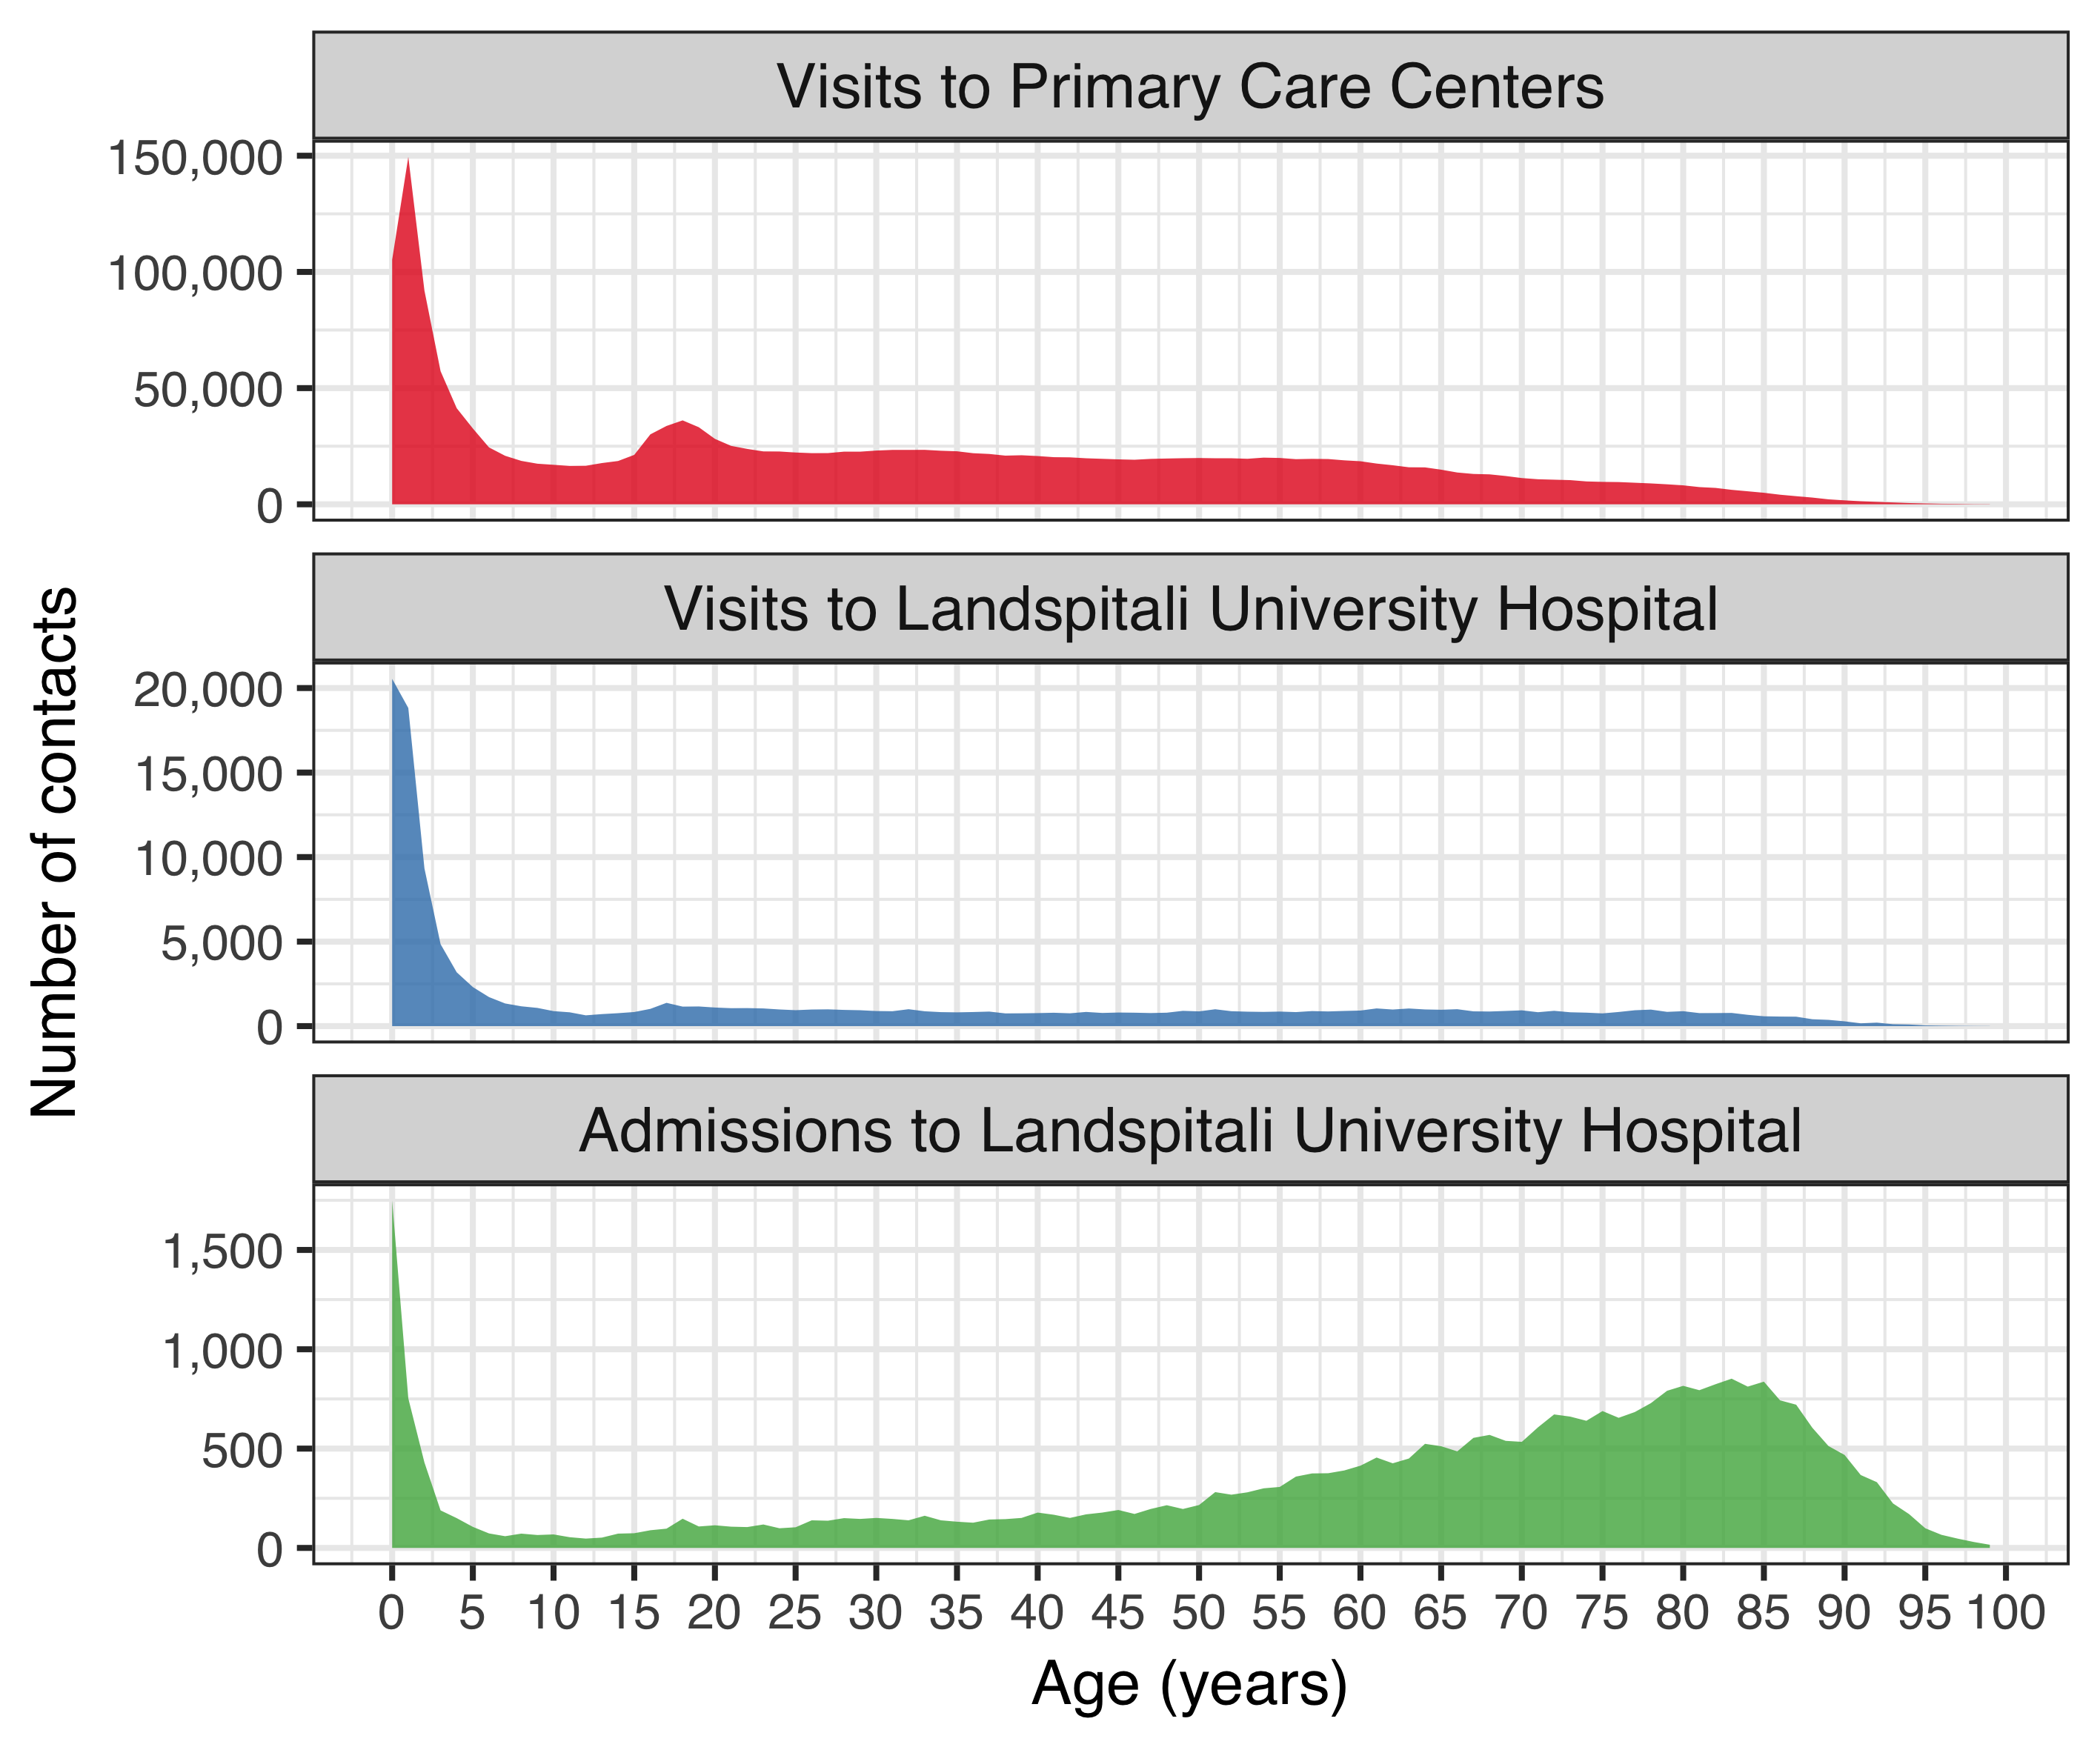

Figure .The total number of contacts to Landspitali University Hospital and Primary Care Centers in Iceland associated with International Classification of Diseases, 10th revision (ICD-10) codes compatible with respiratory infections.

Data on hospital contacts were extracted from Landspitali University Hospital’s patient registry from 1 January 2005 to 31 December 2017. Primary care contacts were obtained from the Primary Care Registry of the Icelandic Directorate of Health from 1 January 2005 to 31 December 2015. The number of contacts is shown as a function of age. Different Y-axis scales are used for each category. The figure demonstrates disproportionate hospitalizations among older adults, compared to primary care contacts and hospital visits.

In addition to the increased frequency of hospitalization among older adults, the cost associated with each visit and hospitalization was higher (Figure 2).

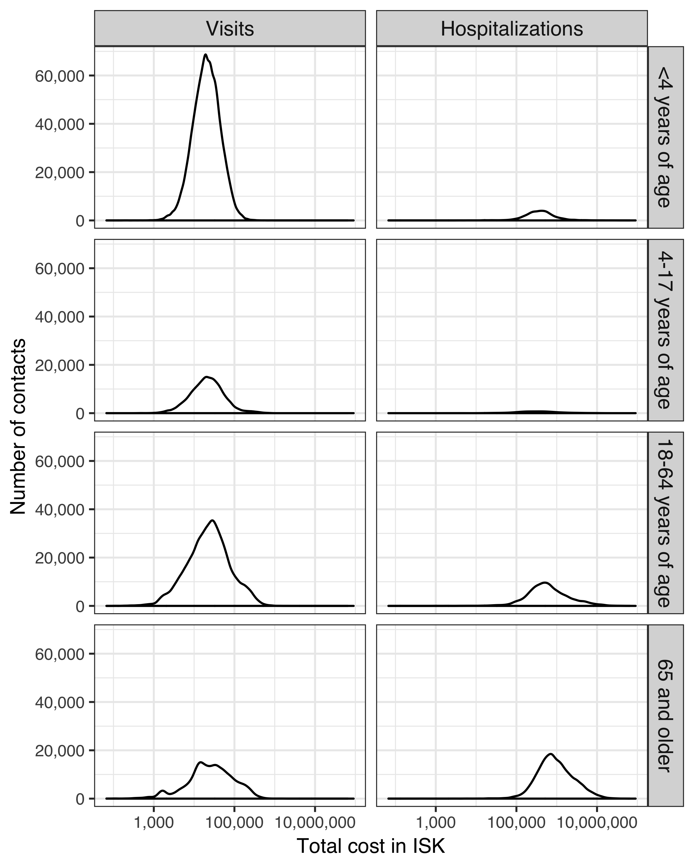

Figure . The distribution in the cost associated with contacts to Landspitali University Hospital

was extracted from the patient registry for the period of 1 January 2005 to 31 December 2017. Costs are presented in Icelandic Krona (ISK) at the value of the calendar year in which they occurred. Distributions are presented separately for visits and hospitalizations, and are further divided into age-groups. The X-axis has been logarithmically scaled. The figure shows that costs associated with visits range from 1,000 ISK to 100,000 ISK, while hospitalizations range from 100,000 ISK to 10,000,000 ISK. As age increases, the distribution shifts towards higher costs.

### The Primary Care Registry

The Primary Care Registry contains information on all primary care health contacts for the period 2005-2015. All contacts associated with the ICD-10 codes listed in Table 8, regardless of age, were extracted. A total of 1,963,439 separate contacts were recorded between 298,307 individual patients and 1,266 different physicians. The most visits recorded for a single individual was 212. The distribution of contacts by age can be seen in Figure 1.

### The National Vaccine Registry

The National Vaccine Registry contains information on all administered vaccine doses for the period 2005-2017. All recorded pneumococcal vaccine doses were extracted using ATC code J07 and sub-levels. A total of 110,712 doses of pneumococcal vaccines were administered to 51,601 individuals during the study period. The monthly number of administered doses per age-group and vaccine is shown in Figure 3.

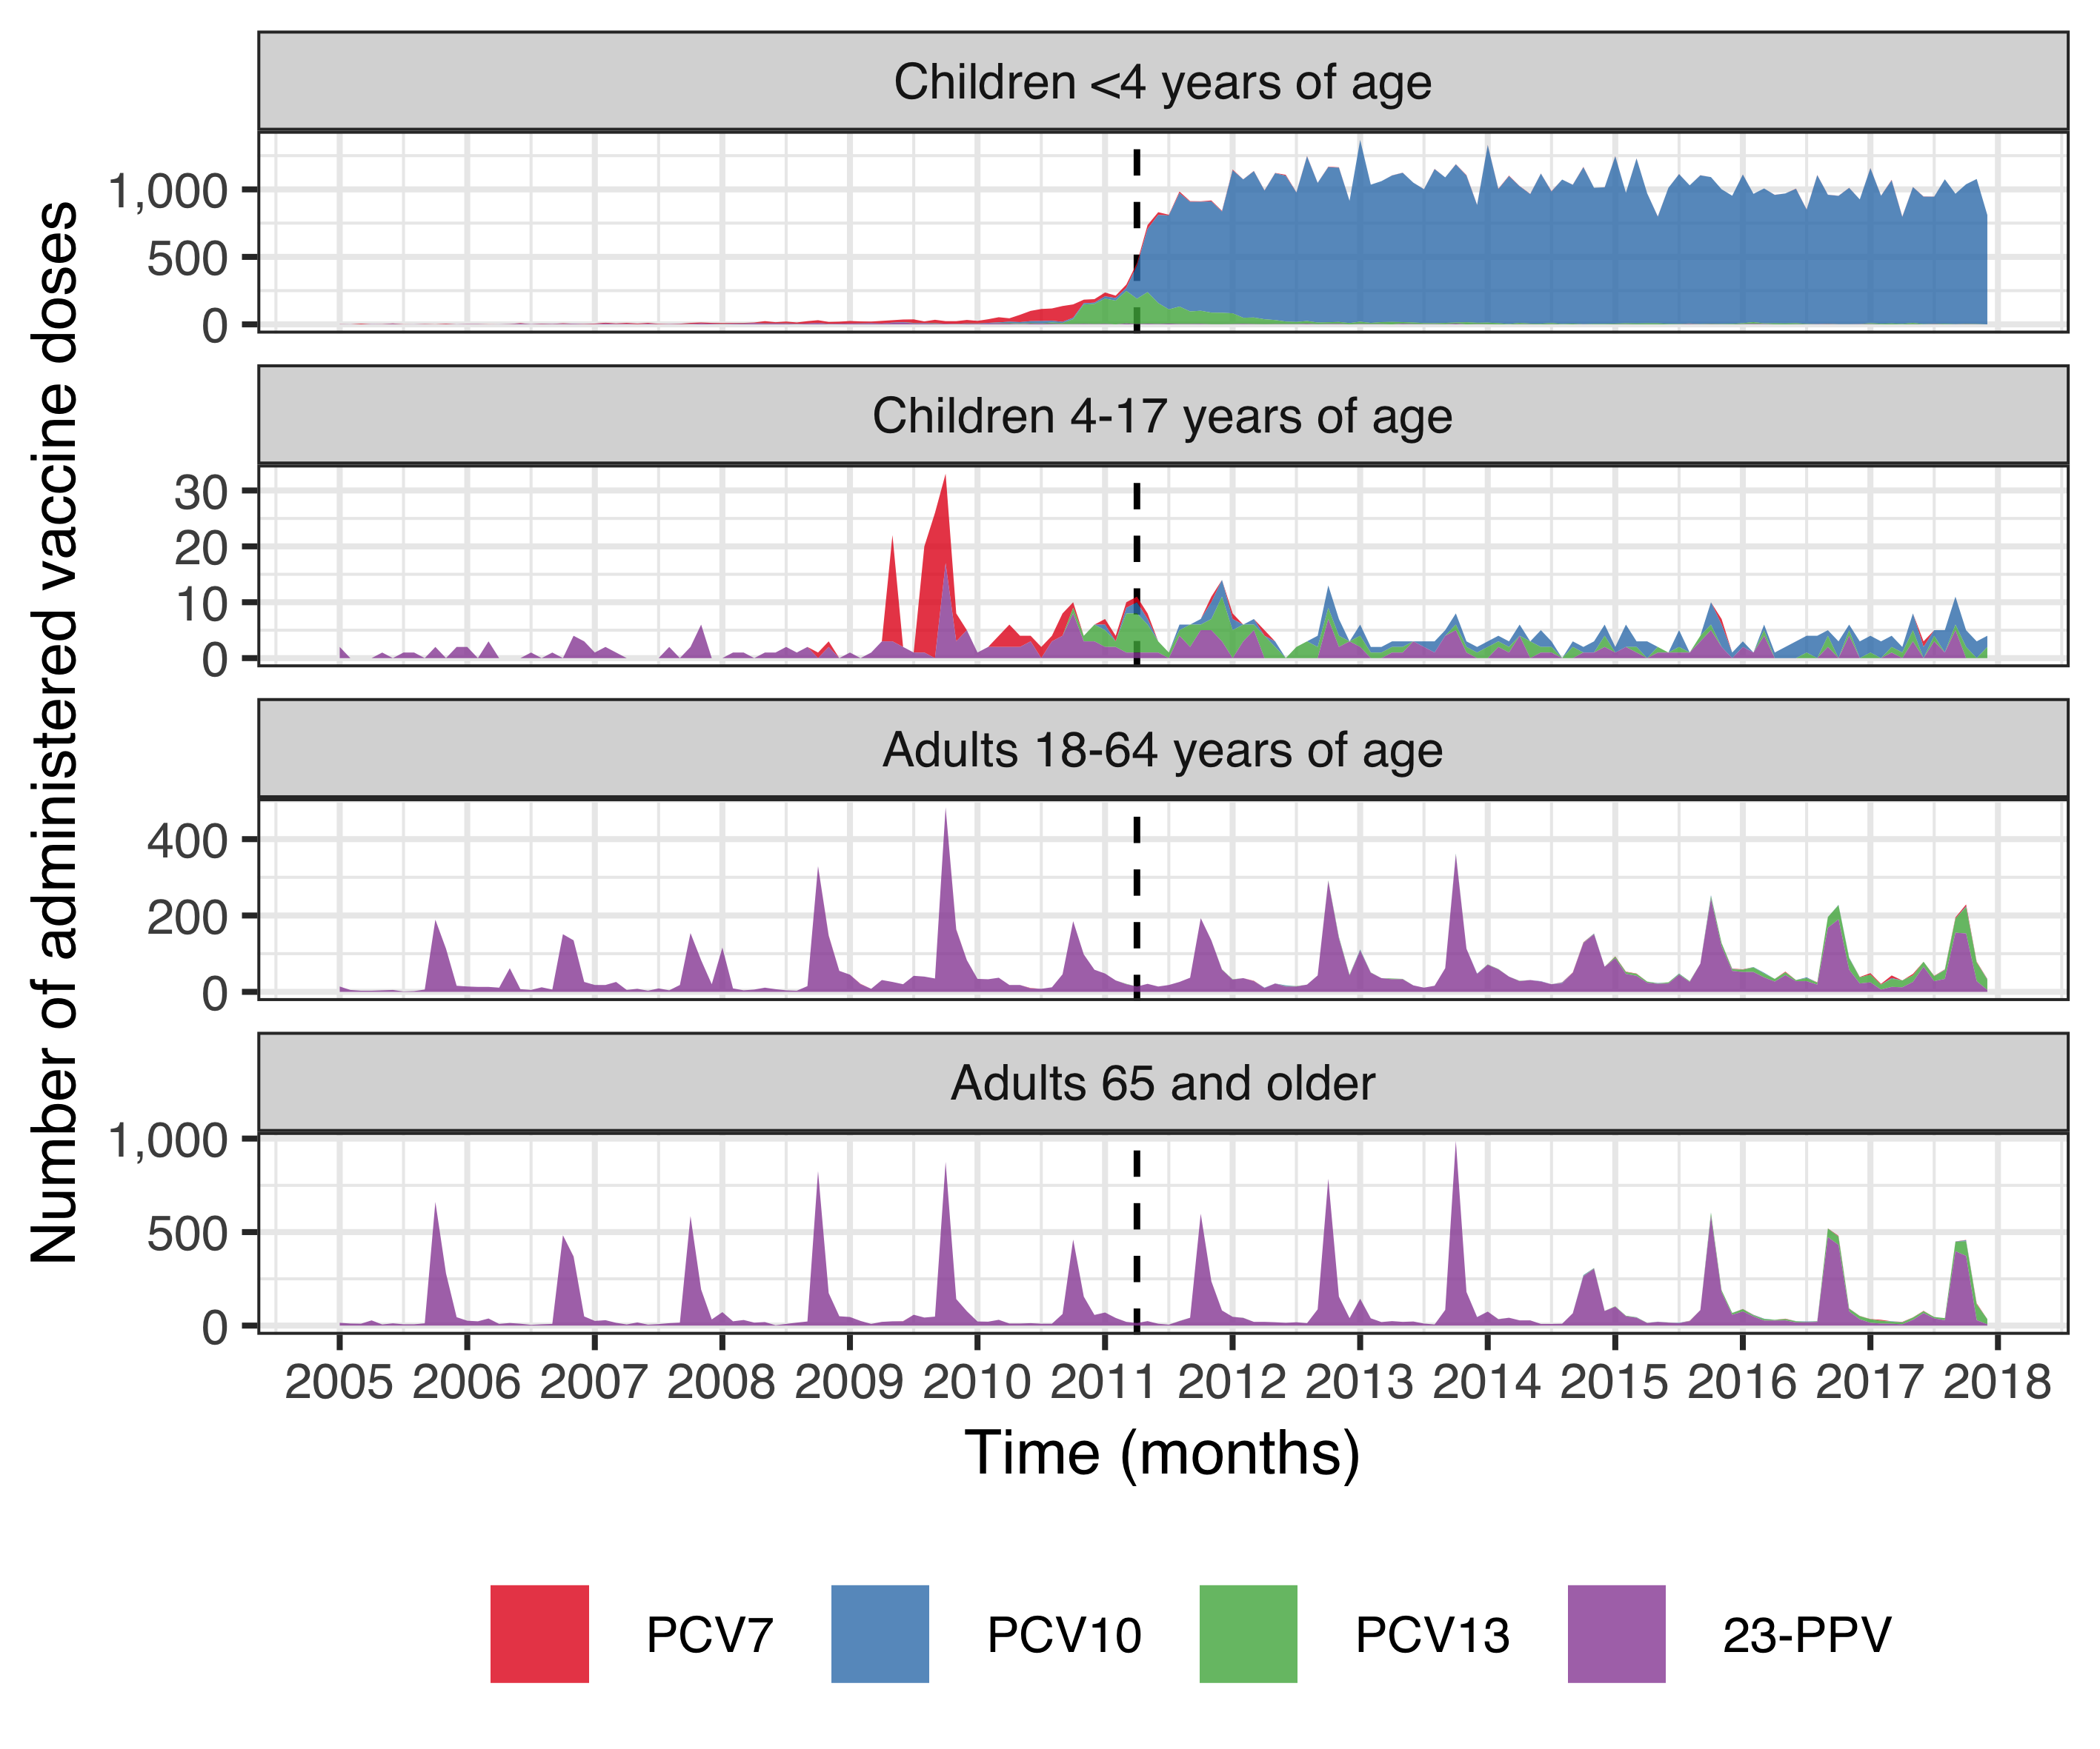

Figure . The monthly number of administered doses of pneumococcal vaccines in Iceland from 1 January 2005 to 31 December 2017.

Data were extracted from the National Vaccine Registry of the Icelandic Directorate of Health using Anatomical Therapeutic Chemical code J07. Records were available for four different pneumococcal vaccines; the 23-valent pneumococcal polysaccharide vaccine (23-PPV, purple), seven-valent pneumococcal conjugate vaccine (PCV7, red), the 10-valent pneumococcal conjugate vaccine (PCV10, blue) and the 13-valent pneumococcal conjugate vaccine (PCV13, green). The introduction of PCV10 into the Icelandic pediatric vaccination program on 1 April 2011, is shown with a dotted line. Different Y-axis scales are used for each category of age. The figure demonstrates the abrupt and sustained increase in the number of administered doses of PCV10 following introduction into the vaccine program. Adult vaccination with 23-PPV does not appear to have increased during the study period.

Table 17 shows the number of children in each birth-cohort who had received zero, one, two, or three doses of a pneumococcal conjugate vaccine by four years of age. An abrupt shift is observed in the first vaccine eligible cohort, of which over 90% received three or more doses of a pneumococcal conjugate vaccine. Children who moved to or from the country before four years of age, were excluded from the table.

Table . The number of children in each birth-cohort who received zero to three doses of a pneumococcal conjugate vaccine before four years of age.

The percentage of children receiving each number of doses is given within parentheses. Children who were documented to have immigrated or emigrated from Iceland before four years of where excluded. For the remaining children, data were obtained from the National Vaccine Registry of the Icelandic Directorate of Health using Anatomical Therapeutic Chemical code J07 for the period from 1 January 2005 to 31 December 2017. Seven-, 10- and 13- valent pneumococcal conjugate vaccines were included. At the end of the observational period, some children in the 2016 birth-cohort had not yet reached the age during which it is common to receive the third vaccine dose.

|  |  |  |  |  |
| --- | --- | --- | --- | --- |
| Birth-cohort | Zero doses | One dose | Two doses | Three doses |
| 2005 | 4,207 (99.6) | 10 (0.2) | 5 (0.1) | 4 (0.1) |
| 2006 | 4,278 (99.1) | 26 (0.6) | 8 (0.2) | 3 (0.1) |
| 2007 | 4,345 (98.1) | 51 (1.2) | 18 (0.4) | 13 (0.3) |
| 2008 | 4,348 (94.8) | 140 (3.1) | 62 (1.4) | 37 (0.8) |
| 2009 | 4,292 (89.8) | 166 (3.5) | 237 (5.0) | 87 (1.8) |
| 2010 | 3,660 (77.8) | 158 (3.4) | 336 (7.1) | 549 (11.7) |
| 2011 | 263 (5.9) | 44 (1.0) | 144 (3.3) | 3,976 (89.8) |
| 2012 | 199 (4.5) | 45 (1.0) | 154 (3.5) | 4,059 (91.1) |
| 2013 | 165 (3.9) | 44 (1.0) | 122 (2.9) | 3,940 (92.3) |
| 2014 | 127 (2.9) | 54 (1.2) | 191 (4.4) | 3,978 (91.4) |
| 2015 | 70 (1.7) | 60 (1.5) | 283 (6.9) | 3,672 (89.9) |
| 2016 | 45 (1.1) | 76 (1.9) | 466 (11.4) | 3,514 (85.7) |

Some children in vaccine non-eligible cohorts received one, two or three doses of pneumococcal conjugate vaccines before four years of age. This generally occurred at an older age than children in the vaccine eligible cohorts Figure 4.

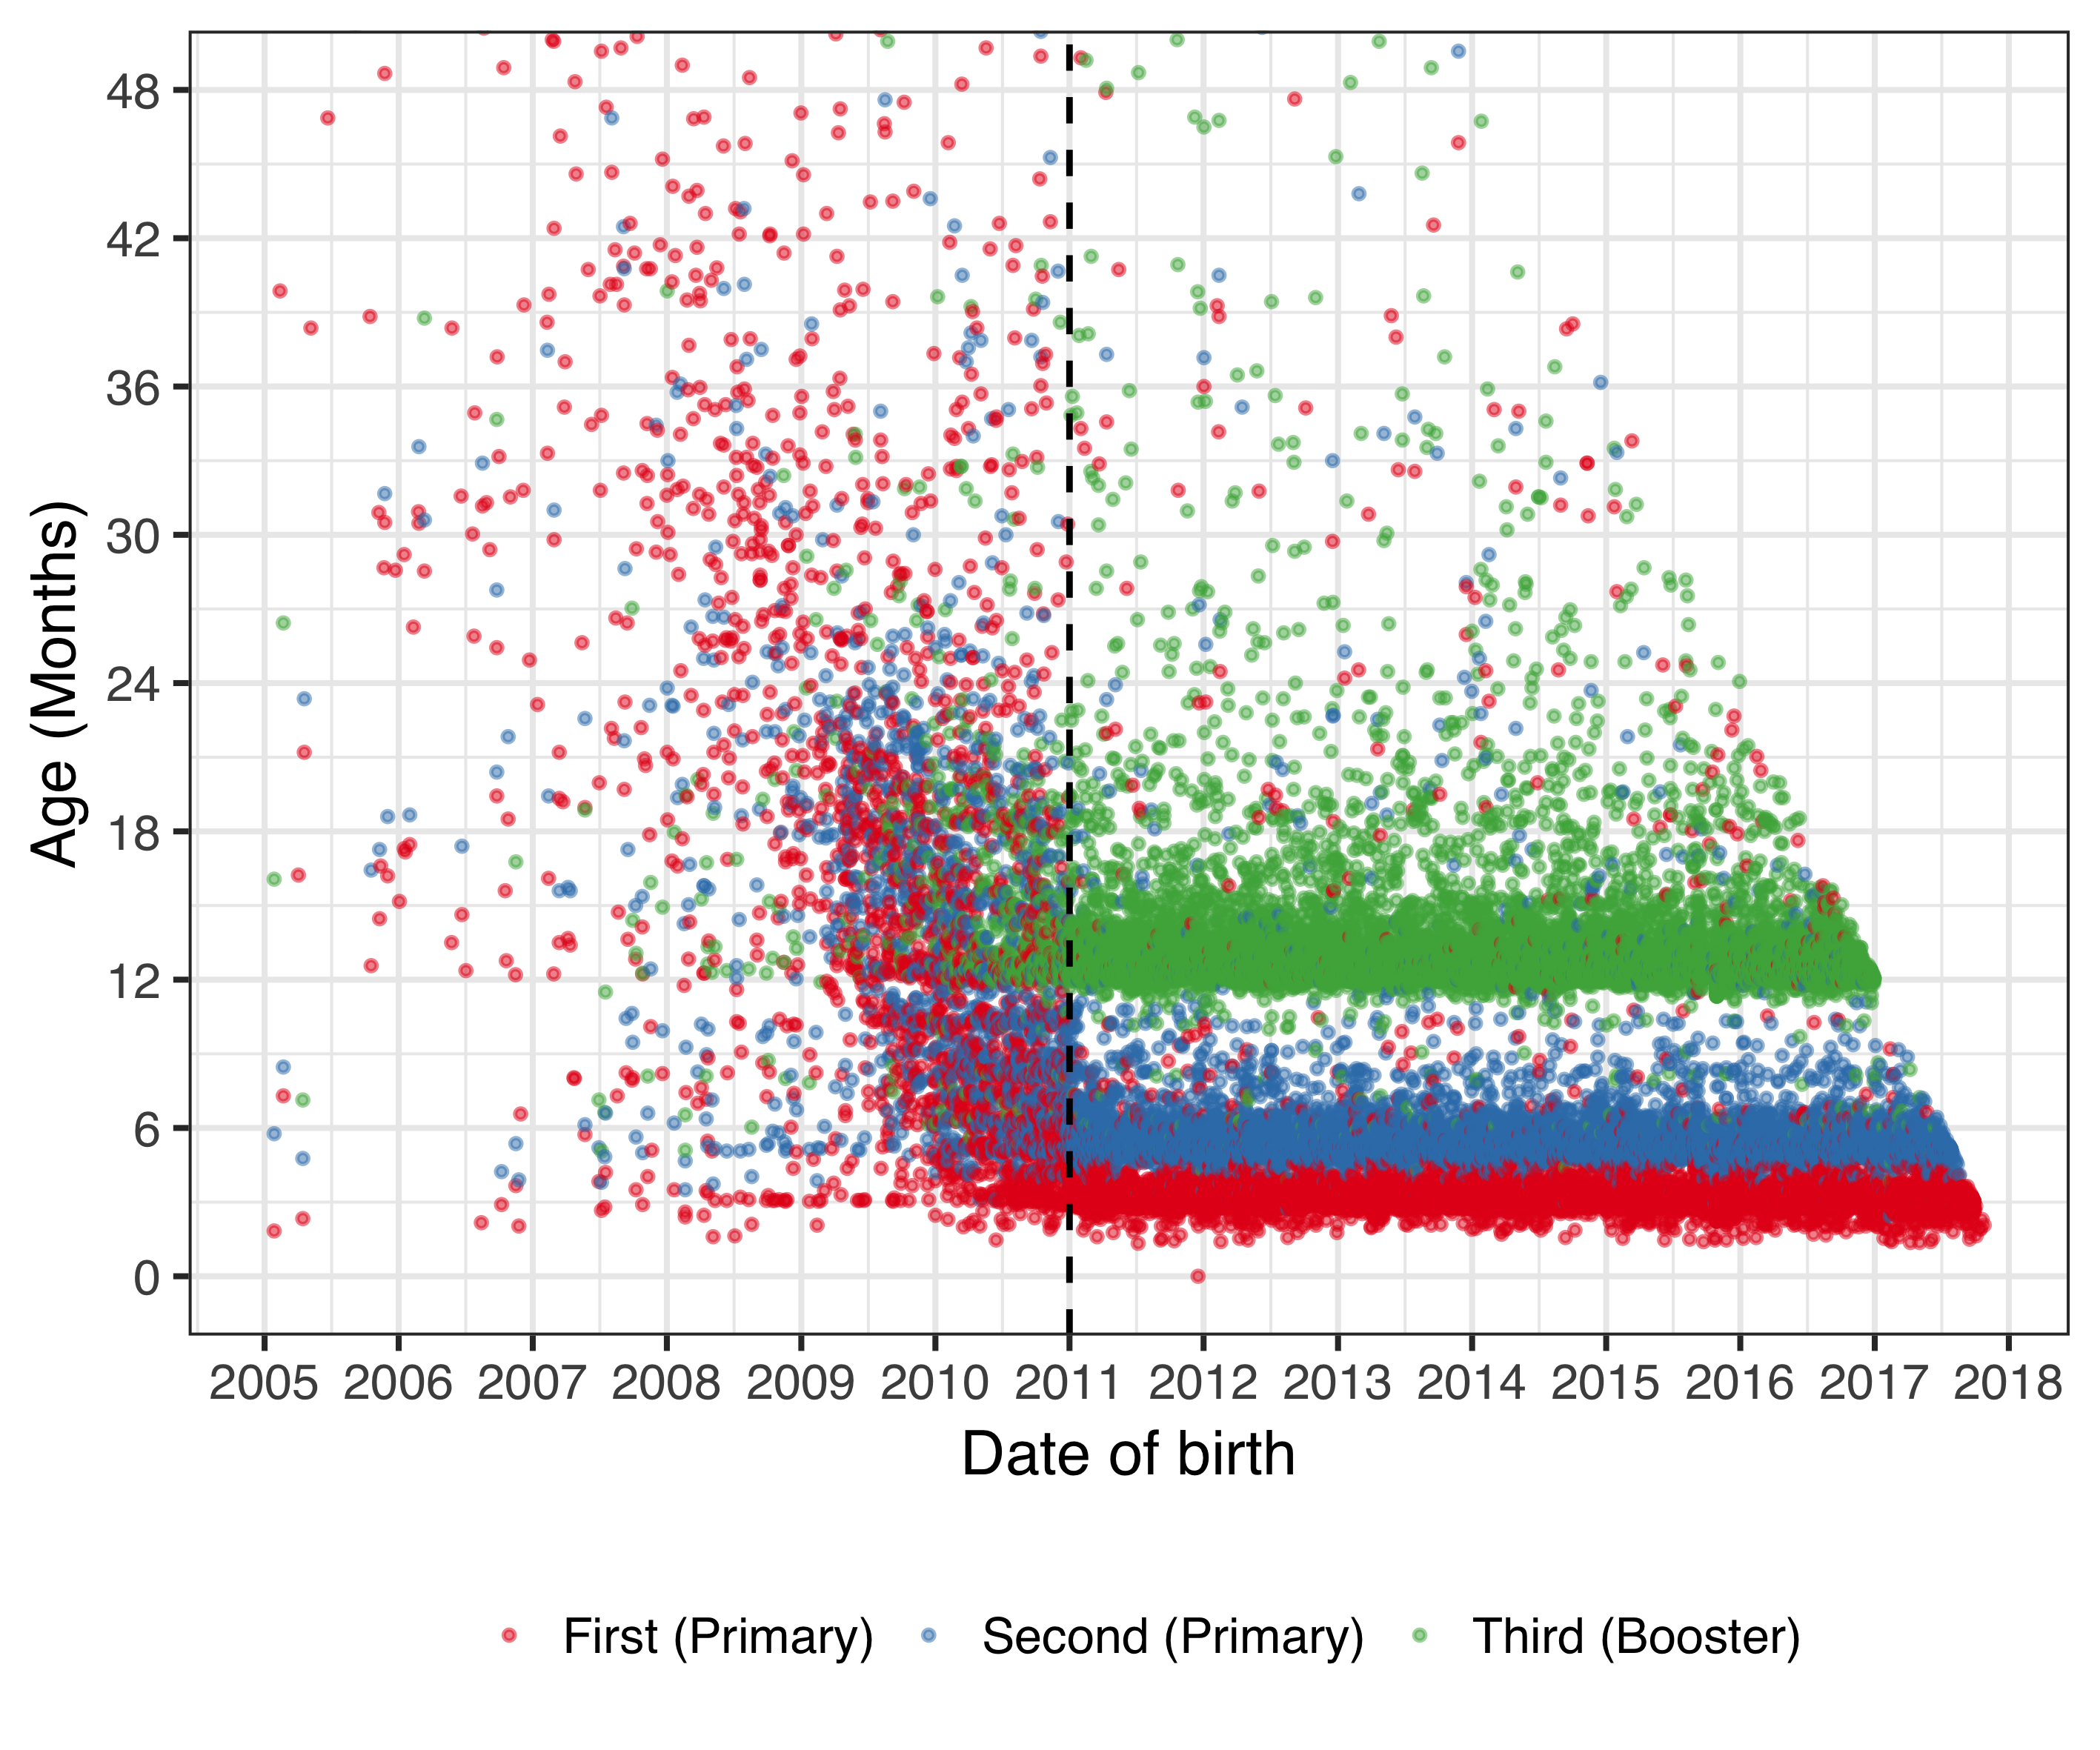

Figure . The age at which children receive their first, second and third dose of a pneumococcal conjugate vaccine (PCV) as a function of birth-date.

All administered doses of PCV were extracted from the National Vaccine Registry of the Icelandic Directorate of Health from 1 January 2005 to 31 December 2017, using Anatomical Therapeutic Chemical code J07. The age at which each individual child received a dose of PCV is illustrated with a point. The child’s first documented dose is indicated in red color, their second dose in blue and their third dose in green. The introduction of PCV10 into the Icelandic pediatric vaccination program on 1 April 2011, is shown with a dotted line. Though some children received PCV prior to the vaccine introduction, they did so sporadically, and few achieved two or more doses. Those who did were almost invariably born in the latter half of 2010. An obvious change occurs after vaccine introduction. The apparent oblique cut-off in points starting for children born in 2014 is explained by censored follow-up time.

The National Drug Prescription Registry (NDPR) contains all filled outpatient prescriptions from 2005-2017. From this registry, all antibacterials for systemic use (ATC code J01 and sub-levels), vaccines (J07 and sub-levels), opthalmologicals (S01 and sub-levels) and otologicals (S02 and sub-levels) were extracted. A total of 4,020,624 prescriptions were recorded among 360,560 individuals. The number of prescriptions by the chemical sub-levels of the ATC classification system are shown in Table 18. The highest number of antimicrobial prescriptions filled by a single individual was 336 during the study period.

Table . The number of filled outpatient prescriptions by Anatomical Therapeutic Chemical (ATC) is shown for the period from 1 January 2005 to 31 December 2017.

Data were extracted from the National Drug Prescription Registry of the Icelandic Directorate of Health.

|  |  |  |
| --- | --- | --- |
| ATC chemical sub-level code | Description | No of prescriptions |
| J01A | Tetracyclines | 357,498 |
| J01B | Amphenicols | 0 |
| J01C | Beta-lactam antibacterials, penicillins | 1,720,661 |
| J01D | Other beta-lactam antibacterials | 106,757 |
| J01E | Sulfonamides and trimethoprim | 168,045 |
| J01F | Macrolides, lincosamides and streptogramins | 344,098 |
| J01G | Aminoglycoside antibacterials | 71 |
| J01M | Quinolone antibacterials | 135,864 |
| J01R | Combinations of antibacterials | 0 |
| J01X | Other antibacterials | 96,318 |
| J07A | Bacterial vaccines | 9,687 |
| J07B | Viral vaccines | 16,703 |
| J07C | Bacterial and viral vaccines | 496 |
| J07X | Other vaccines | 0 |
| S01A | Anti-infective opthalmologicals | 287,904 |
| S02A | Anti-infective otologicals | 1 |
| S01C | Anti-inflammatory agents and anti-infectives opthalmologicals | 40,315 |
| S02C | Anti-inflammatory agents and anti-infectives otologicals | 25,218 |

The distribution in the number of prescriptions for selected chemical sub-levels of the ATC classification system are shown as a function of age in Figure 5.

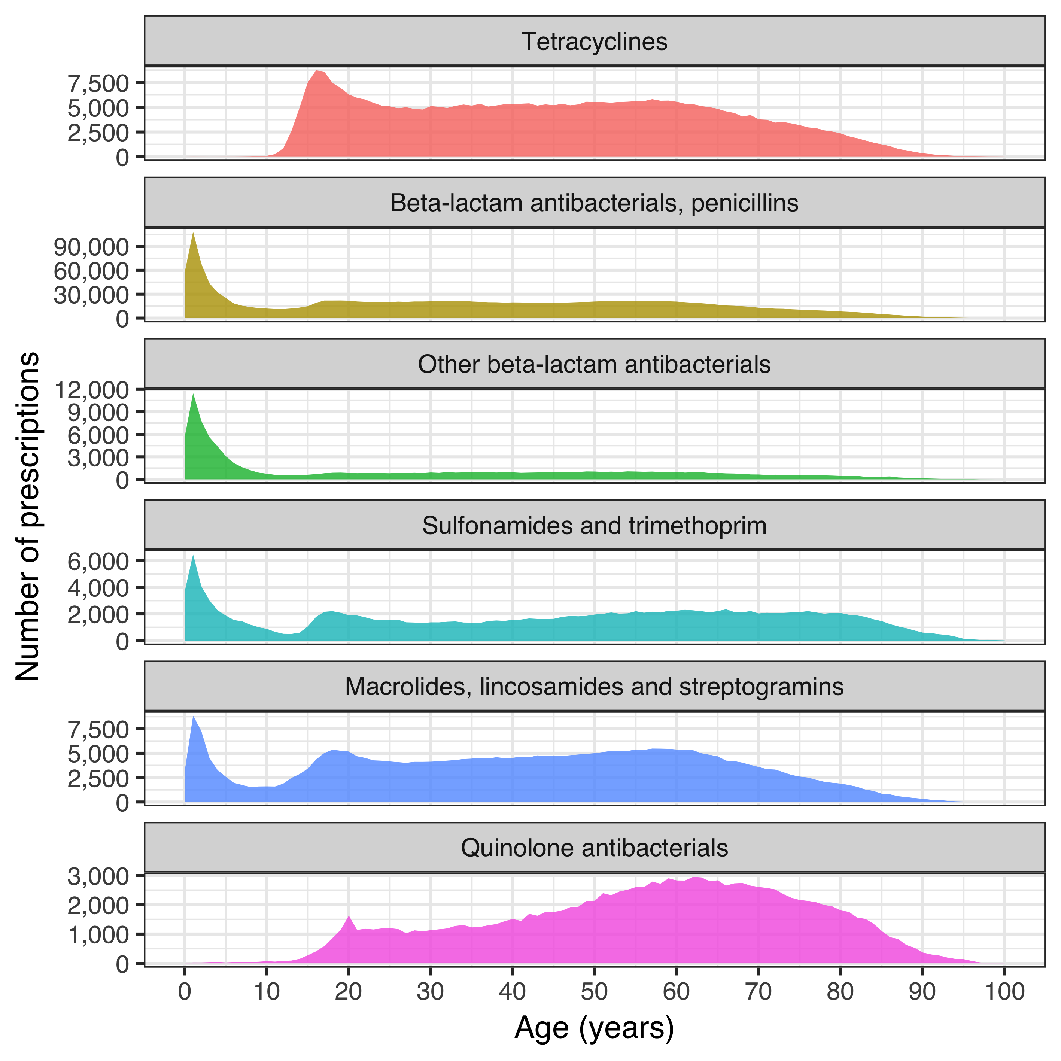

Figure . The number of filled antimicrobial prescriptions as a function of age for selected chemical sub-levels of the Anatomical Therapeutic Chemical (ATC) classification system.

Data were extracted from the National Drug Prescription Registry of the Icelandic Directorate of Health for the period of 1 January 2005 to 31 December 2017. Different Y-axis scales are used for each category. The figure demonstrates a similar age-distribution for beta-lactam antibacterials, sulfonamides and macrolides, with most prescriptions being filled by young children. Tetracyclines and quinolones are more commonly filled by adults.

### Reimbursement database of Icelandic Health Insurance

All interactions with independent health care practitioners were recorded in Icelandic Health Insurance’s reimbursement database. From this database, all records of otolaryngological procedures were extracted. A total of 51,814 procedures were recorded among 34,084 individuals (Table 19). In total, 16,096 tonsillectomies and 29,689 tympanostomy tube placements were performed. The absolute number of adenoidectomies performed in Iceland cannot be deduced from the reimbursement database as the reimbursement codes for tonsillectomies are the same whether or not an adenoidectomy was performed concurrently.

Table . The number of procedures reimbursed to independently practicing otolaryngologists from 1 January 2005 to 31 December 2016.

Data were extracted from the reimbursement database of Icelandic Health Insurance. Tympanostomy tube placements for which an anesthesiologist also received reimbursement were performed under general anesthesia. Others were categorized as TTP without mention of anesthetic. The total number of adenoidectomies performed in Iceland cannot be deduced from the reimbursement data, because the same reimbursement code is used for tonsillectomies with or without adenoidectomies. However, a separate reimbursement code always exists for procedures including TTP.

|  |  |
| --- | --- |
| Procedure | No of procedures |
| Adenoidectomy | 2,442 |
| Adenoidectomy and TTP | 10,849 |
| Myringoplasty | 135 |
| Myringotomy under local anesthetic | 1,004 |
| Tonsillectomy (+/- adenoidectomy) | 9,383 |
| Tonsillectomy (+/- adenoidectomy) and TTP | 31 |
| Tonsillectomy performed with laser (+/- adenoidectomy) | 4,996 |
| Tonsillectomy performed with laser (+/- adenoidectomy) and TTP | 686 |
| TTP under general anesthesia | 16,829 |
| TTP without mention of anesthetic | 294 |
| Tympanostomy tube removal | 5,165 |

## Impact on otitis media with treatment failure (Paper I)

The total number of children under 18 years of age who lived within Children’s Hospital Iceland’s referral region remained stable during the study period from 1 January 2008 to 31 December 2015, decreasing from 62,067 in to 61,798. The variation in the number of children under four years of age in the same region was more pronounced, increasing from 13,562 in 2008 to 14,644 in 2011, and then decreasing again to 13,272 in 2015.

During the study period, 103,220 visits were recorded to the emergency department of Children’s Hospital Iceland. The visits varied over the calendar year, spiking in the winter months and troughing in the summer months. The total number of visits increased steadily during the study period, from 12,229 in 2008 to 14,502 in 2015 (Figure 6).

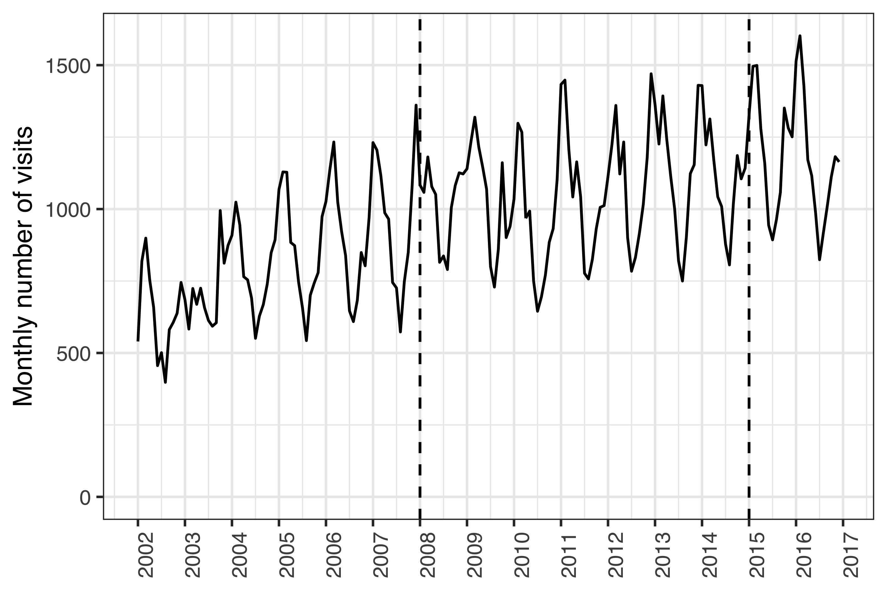

Figure . The monthly number of visits of children zero to 18 years of age to Children’s Hospital Iceland’s emergency department during the period from January 2002 to December 2016.

All visits are included regardless of International Classification of Diseases, 10th revision (ICD-10) diagnostic codes. The study period was from January 2008 to December 2015, and is delineated with two vertical dashed lines.

During the same period, 6,232 visits to the Children’s Hospital Iceland for acute otitis media were recorded for 4,624 individual children under four years of age, representing 4,994 distinct episodes. Of those episodes, 531 were treated with one or more doses of ceftriaxone. The total number of visits, visits for AOM and ceftriaxone treatment episodes are shown in Table 20.

Table . The incidence of visits and ceftriaxone treatment episodes at Children’s Hospital Iceland by calendar-year.

The incidence is both presented for all visits regardless of diagnosis (Total) and visits associated with acute otitis media (AOM). When presented for total visits or treatment episodes regardless of diagnosis, the denominator is children 18 and younger who live within Children’s Hospital Iceland’s referral region and is expressed per 1,000 visits or person-years. The denominator of AOM associated visits or treatment episodes are children younger than four years of age in the same region. The incidence rate and incidence risk are shown with the number of events within parentheses

|  |  |  |  |  |  |  |
| --- | --- | --- | --- | --- | --- | --- |
|  |  | | Incidence rate of parenteral ceftriaxone | | | |
|  | Incidence rate of visits | | Per 1,000 visits | | Per 1,000 person-years | |
| Year | Total (n) | AOM (n) | Total (n) | AOM (n) | Total (n) | AOM (n) |
| 2008 | 197 (12,229) | 69 (936) | 80.8 (988) | 186 (174) | 15.9 (988) | 72.9 (174) |
| 2009 | 199 (12,514) | 72 (1,012) | 74.8 (936) | 192 (194) | 14.9 (936) | 66.5 (194) |
| 2010 | 181 (11,339) | 64.2 (925) | 81 (918) | 253 (234) | 14.6 (918) | 63.7 (234) |
| 2011 | 201 (12,645) | 60.8 (890) | 63.8 (807) | 178 (158) | 12.8 (807) | 55.1 (158) |
| 2012 | 215 (13,150) | 58.4 (830) | 52.5 (691) | 163 (135) | 11.3 (691) | 48.6 (135) |
| 2013 | 221 (13,518) | 55.2 (772) | 54.7 (739) | 105 (81) | 12.1 (739) | 52.8 (81) |
| 2014 | 216 (13,323) | 52 (708) | 48.9 (652) | 76.3 (54) | 10.6 (652) | 47.9 (54) |
| 2015 | 235 (14,502) | 55.1 (731) | 56.7 (822) | 88.9 (65) | 13.3 (822) | 61.9 (65) |

The incidence rate of AOM visits to Children’s Hospital Iceland decreased significantly in the post-vaccine period as compared to the pre-vaccine period; from 47.4 visits to 41.8 per 1,000 person-years. The crude IRR was 0.88 (95% CI 0.83 to 0.93). Mantel-Haenszel adjustment was not appropriate due to effect heterogeneity ( $χ^{2}$ = 15.2, *P*<0.001). When each age-group was examined separately, a significant decrease in AOM visits was observed among children between one and two years of age (IRR 0.89) and between two and three years of age (IRR 0.79) as shown in Table 21. Children younger than one year of age and children between three and four years of age, visited the Children’s Hospital Iceland because of AOM 471 times and 379 times, respectively.

Table . The incidence rate ratios (IRR) of acute otitis media (AOM) associated visits between the pre- and post-vaccine periods by age.

The 95% confidence intervals are presented within parentheses. The chi-squared statistic and P-value are also presented.

|  |  |  |  |
| --- | --- | --- | --- |
| Age (years) | IRR (95% CI) | Chi-squared | P-value |
| <1 | 1.10 (0.90-1.30) | 0.80 | 0.370 |
| 1-2 | 0.89 (0.83-0.96) | 8.60 | 0.003 |
| 2-3 | 0.79 (0.71-0.88) | 17.0 | < 0.001 |
| 3-4 | 1.00 (0.85-1.30) | 0.22 | 0.639 |

Independent of the decrease in AOM associated visits to the Children’s Hospital, the incidence of ceftriaxone treatment episodes for AOM was also found to decrease significantly in the post-vaccine period compared to the pre-vaccine period. The effect was heterogeneous across age-strata ( $χ^{2}$ = 57, *P*<0.001) and the crude overall IRR was 0.48 (95% CI 0.40 to 0.58). The stratum specific results are shown in Table 22. During the study period, only 17 episodes of AOM were treated with ceftriaxone among children zero to one years of age and 19 episodes were treated among children three to four years of age.

Table . The incidence rate ratios (IRR) of ceftriaxone treatment episodes of otitis media (AOM) between the pre- and post-vaccine periods by age.

The 95% confidence intervals are presented within parentheses. The chi-squared statistic and P-value are also presented.

|  |  |  |  |
| --- | --- | --- | --- |
| Age (years) | IRR (95% CI) | Chi-squared | P-value |
| <1 | 0.61 (0.19-1.80) | 0.96 | 0.326 |
| 1-2 | 0.47 (0.37-0.60) | 41.0 | <0.001 |
| 2-3 | 0.47 (0.32-0.68) | 18.0 | <0.001 |
| 3-4 | 0.85 (0.31-2.30) | 0.12 | 0.732 |

The risk of receiving ceftriaxone treatment if presenting to Children’s Hospital Iceland with AOM was calculated in order to correct for the possibility that observed decreases in ceftriaxone treatment episodes were due only to a decrease in the number of AOM associated visits. The risk decrease was not homogeneous across age-strata ( $χ^{2}$ = 33.8, *P*<0.001) and the overall relative risk ratio was 0.58 (95% CI 0.48 to 0.69). The stratum specific effects are shown in Table 23.

Table . The incidence risk ratio (IRR) of receiving ceftriaxone treatment if presenting to Children’s Hospital Iceland with acute otitis media (AOM) between the pre- and post-vaccine periods by age.

The 95% confidence intervals are presented along with the corresponding Chi-squared statistic and P-value.

|  |  |  |  |
| --- | --- | --- | --- |
| Age (years) | IRR (95% CI) | Chi-squared | P-value |
| <1 | 0.56 (0.17-1.70) | 1.30 | 0.258 |
| 1-2 | 0.53 (0.42-0.67) | 26.0 | < 0.001 |
| 2-3 | 0.59 (0.40-0.86) | 7.50 | 0.006 |
| 3-4 | 0.81 (0.29-2.20) | 0.19 | 0.662 |

Thus, the study found significant decreases in the incidence of AOM visits, ceftriaxone treatment episodes of AOM and risk of ceftriaxone treatment if presenting to the Children’s Hospital Iceland with AOM. Similar decreases were established in the ceftriaxone treatment episodes for pneumonia. In the pre-vaccine period, 251 treatment episodes were recorded, compared to only 90 in the post-vaccine period. The effect was not consistent across age-strata ( $χ^{2}$ = 72, *P*<0.001). The overall IRR was 0.37 (95% CI 0.29 to 0.47). The stratum specific effects are shown in Table 24.

Table . The incidence rate ratio (IRR) of ceftriaxone treatment episodes of pneumonia between the pre- and post-vaccine periods are presented along with 95% confidence intervals.

The chi-squared statistic and P-values are also shown.

|  |  |  |  |
| --- | --- | --- | --- |
| Age (years) | IRR (95% CI) | Chi-squared | P-value |
| <1 | 0.15 (0.017-0.64) | 8.6 | 0.003 |
| 1-2 | 0.34 (0.220-0.51) | 33.0 | < 0.001 |
| 2-3 | 0.36 (0.230-0.54) | 28.0 | < 0.001 |
| 3-4 | 0.51 (0.290-0.89) | 6.4 | 0.012 |

To ascertain whether a decrease in ceftriaxone use occurred in vaccinated children for non-vaccine related indications, the incidence of ceftriaxone treatment episodes for all other indications was examined. No heterogeneity across age-strata was detected ( $χ^{2}$ = 0.56, *P*=0.455). The Mantel-Haenszel adjusted IRR was 0.96 (95% CI 0.87 to 1.06), and the null hypothesis of no difference in the incidence rate of treatment episodes could not be rejected. The number of treatment episodes by age and vaccine period ranged from 117 to 295. The stratum specific IRR are shown in Table 25.

Table . The incidence rate ratios (IRR) of ceftriaxone treatment episodes for indications other than acute otitis media and pneumonia between the pre- and post-vaccine periods for each age.

The 95% confidence intervals are presented within parentheses. The chi-squared statistic and P-value are also presented.

|  |  |  |  |
| --- | --- | --- | --- |
| Age (years) | IRR (95% CI) | Chi-squared | P-value |
| <1 | 1.30 (1.10-1.50) | 7.60 | 0.00597 |
| 1-2 | 0.86 (0.70-1.00) | 2.40 | 0.12100 |
| 2-3 | 0.73 (0.58-0.91) | 8.00 | 0.00473 |
| 3-4 | 0.90 (0.70-1.20) | 0.62 | 0.43200 |

The quarterly incidence of ceftriaxone treatment episodes by indication are shown in Figure 7.

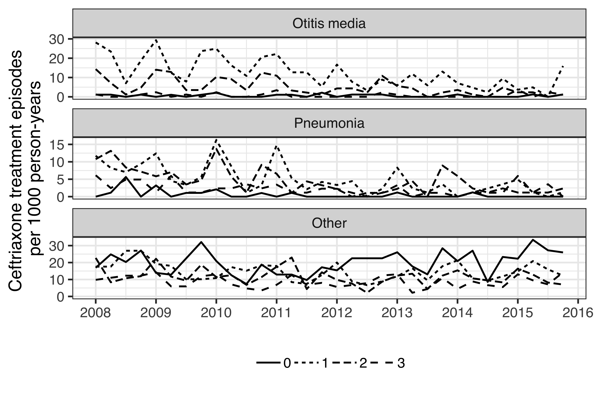

Figure . The quarterly incidence rate (IR) of ceftriaxone treatment episodes stratified by age and indication for the period from January 2008 to December 2015.

The IR per 1,000 person-years is presented for children one, two, three and four years of age using different line-types. The figure is stratified by indication, and demonstrates a decrease in the IR of ceftriaxone treatment episodes for acute otitis media and pneumonia in the post-vaccine period January 2012 to December 2016. No such decrease is visible for ceftriaxone treatment episodes for all other indications.

To further test whether a general decrease was occurring in the overall use of ceftriaxone, rather than a specific decrease for vaccine-related indications in vaccinated children, an examination of ceftriaxone treatment episodes in all children regardless of age and indication was undertaken. An overall decrease in the IR of ceftriaxone treatment episodes was found among children under 18 years of age regardless of indication. The IR declined from 11.1 to 9.55 treatment episodes per 1,000 person-years, IRR 0.86 (95% CI 0.81-0.91). The effect was not consistent across age-groups ( $χ^{2}$ = 23.6, *P*<0.001). When examined by age-group, the overall decrease proved to be driven by the youngest age-group – i.e. the children who were protected by the vaccination. The incidence of ceftriaxone treatment episodes did not decrease significantly in other age groups (Figure 8).

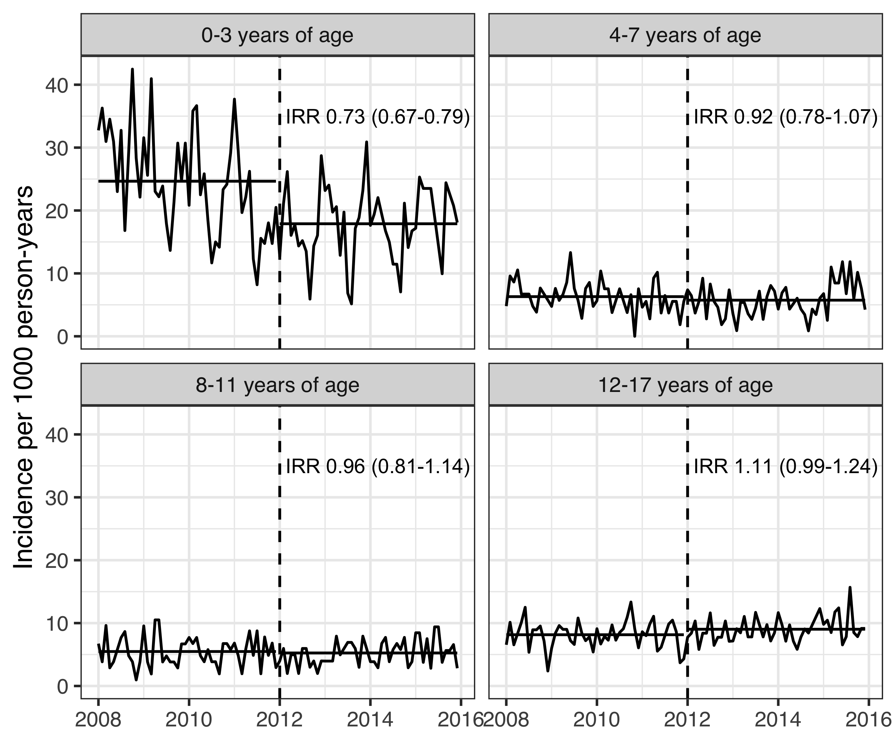

Figure . The monthly incidence rates (IR) of ceftriaxone treatment episodes per 1,000 person-years regardless of indication stratified by age-groups for the period from January 2005 to December 2016.

The delineation between the pre- and post-vaccine periods on January 2012 is illustrated with a dashed vertical line. For each age-group, the mean IR in the pre- and post-vaccine periods are depicted with a solid horizontal line. The incidence rate ratio (IR) between the two vaccine periods is shown for each age-group along with 95% confidence intervals within parentheses. The figure demonstrates a significant decrease in the IR of ceftriaxone treatment episodes for children zero to three years of age. No change is detectable in other age-groups.

The demographics of the study birth-cohorts are described in chapter 4.1 and Table 14. A total of 92,935 primary care visits for acute otitis media were recorded among birth-cohorts 2005-2015 during the study period from 1 January 2005 to 31 December 2015. The crude incidence rate of AOM visits to primary care per 100 person-years in the VNEC and VEC was 45.3 and 39.8 respectively. The IR and number of AOM visits by birth-cohort and gender are shown in Table 26.

Table . The incidence rate (IR) of acute otitis media visits to primary care physicians for each birth-cohort and gender.

The absolute number of visits are presented within parentheses.

|  |  |  |
| --- | --- | --- |
| Birth-cohort | Females | Males |
| 2005 | 41.9 (2,777) | 49.0 (3,439) |
| 2006 | 46.1 (3,096) | 50.9 (3,605) |
| 2007 | 45.7 (3,118) | 50.3 (3,646) |
| 2008 | 46.2 (3,259) | 45.3 (3,419) |
| 2009 | 40.9 (2,981) | 47.0 (3,649) |
| 2010 | 45.0 (3,207) | 47.0 (3,523) |
| 2011 | 39.1 (2,631) | 44.1 (3,164) |
| 2012 | 40.6 (2,760) | 41.8 (2,977) |
| 2013 | 38.0 (2,125) | 42.8 (2,322) |
| 2014 | 37.4 (1,200) | 44.0 (1,465) |
| 2015 | 15.8 (157) | 20.8 (222) |

The lowest incidence was observed in children zero to three months of age, ranging from 3-6 visits per 100 person-years. Thereafter, the incidence increased sharply, and peaked in children eight to eleven and twelve to fifteen months of age, ranging from 50 to 80 visits per 100 person-years. The crude IR decreased significantly in all age-groups, with incidence rate ratios ranging from 0.60 to 0.94. The largest and visually most consistent decrease in incidence was observed among children zero to three months of age, IRR 0.6 (95%CI 0.51 to 0.69), Figure 9.

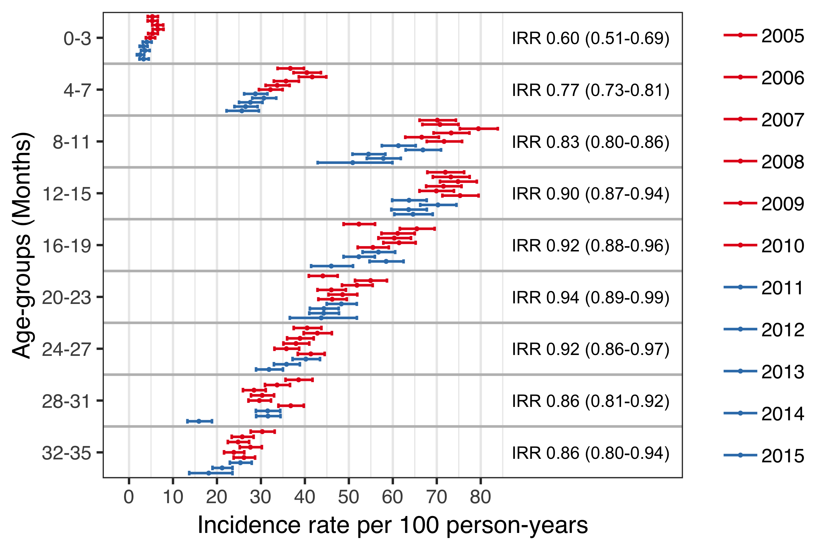

Figure . The incidence rate (IR) of acute otitis media (AOM) visits to primary care physicians stratified by birth-cohort and four-month age-groups.

The estimated IR is illustrated with a point and 95% confidence intervals are depicted with horizontal error-bars. The vaccine non-eligible birth-cohorts (VNEC) are illustrated in red, and the vaccine eligible birth-cohorts in blue. The incidence rate ratio (IRR) between the VEC and VNEC is shown for each age-group and 95% confidence intervals are presented within parentheses.

When tabulated by the cumulative number of AOM episodes experienced by each child, the proportion of children experiencing zero episodes of AOM increased in the VEC compared to the VNEC, while the proportion experiencing one to four episodes and five or more decreased, as shown in Table 27.

Table . The proportion of each vaccine eligibility cohort that experienced zero, one to four and five to twelve cumulative episodes of AOM by 36 months of age.

The incidence risk ratio (IRR) between the vaccine eligible cohorts (VEC) and vaccine non-eligible cohorts (VNEC) is presented along with 95% confidence intervals within parentheses.

|  |  |  |  |
| --- | --- | --- | --- |
| No. visits | VNEC (%) | VEC (%) | Incidence risk (95%CI) |
| 0 | 40.0 | 43.2 | 1.14 (1.10-1.18) |
| 1-4 | 55.7 | 53.2 | 0.904 (0.876-0.932) |
| 5-12 | 4.23 | 3.58 | 0.84 (0.744-0.946) |

Discrimination indices for the Andersen-Gill multiple event model were adequate, Nagelkerke’s $R^{2}$ = 0.110 and Somer’s $D_{xy}$ = 0.238. No systematic deviations in Schoenfeld residuals were detected on diagnostic plots indicating that the proportional hazard assumption for each covariate were met. There was little variation in the hazard of AOM between vaccine non-eligible birth-cohorts. Only the 2007 birth-cohort differed significantly, with a hazard ratio of 1.06 (95%CI 1.01 to 1.12) compared to the 2010 birth-cohort. An abrupt and significant decrease in the hazard of AOM was noted in the first vaccine eligible cohort, which continued for all remaining VEC (Figure 10). The estimated impact of PHiD-CV10 on AOM episodes in the primary care setting among children younger than three years of age was 21% (95%CI 11% to 30%).

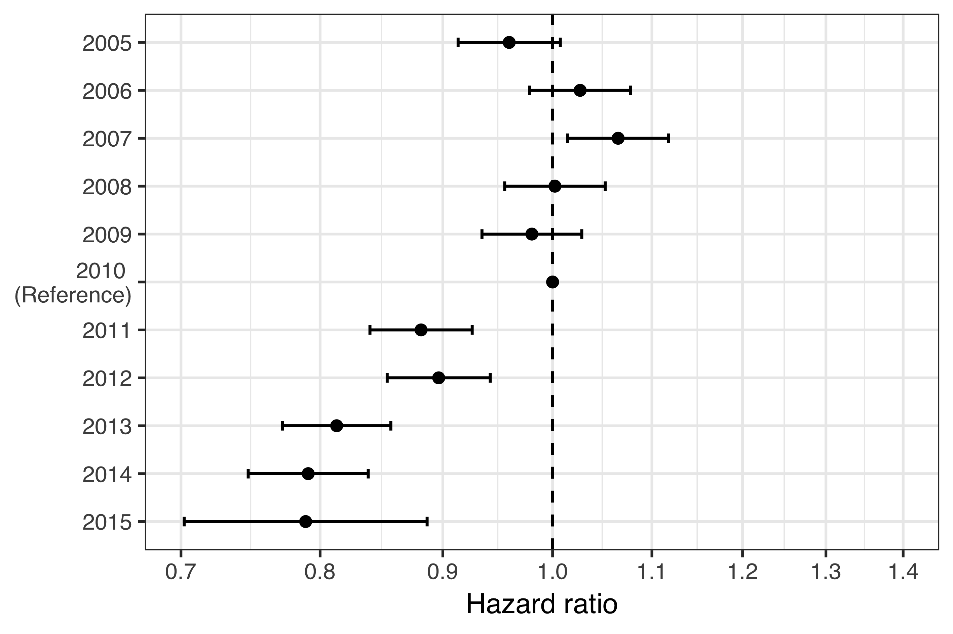

Figure . The hazard ratio (HR) of acute otitis media (AOM) between each birth-cohort and the last vaccine non-eligible birth-cohort is shown.

The estimated HR is presented with a point, and 95% confidence intervals are illustrated with horizontal error-bars. The 2010 birth-cohort is used as a reference and therefore no confidence intervals are presented. A dashed vertical line is placed on the ratio value of one to assist in visually estimating significance. The X-axis is on the logarithmic scale. The figure demonstrates an abrupt decrease in the hazard of AOM in the first vaccine eligible birth-cohort.

When the hazard ratio of AOM between VEC and VNEC was stratified by the number of previous AOM episodes, the vaccine impact was discernible in children who had experienced either no or only one previous AOM episode. Among children who had more than one previous AOM episode, no effect was found (Figure 11).

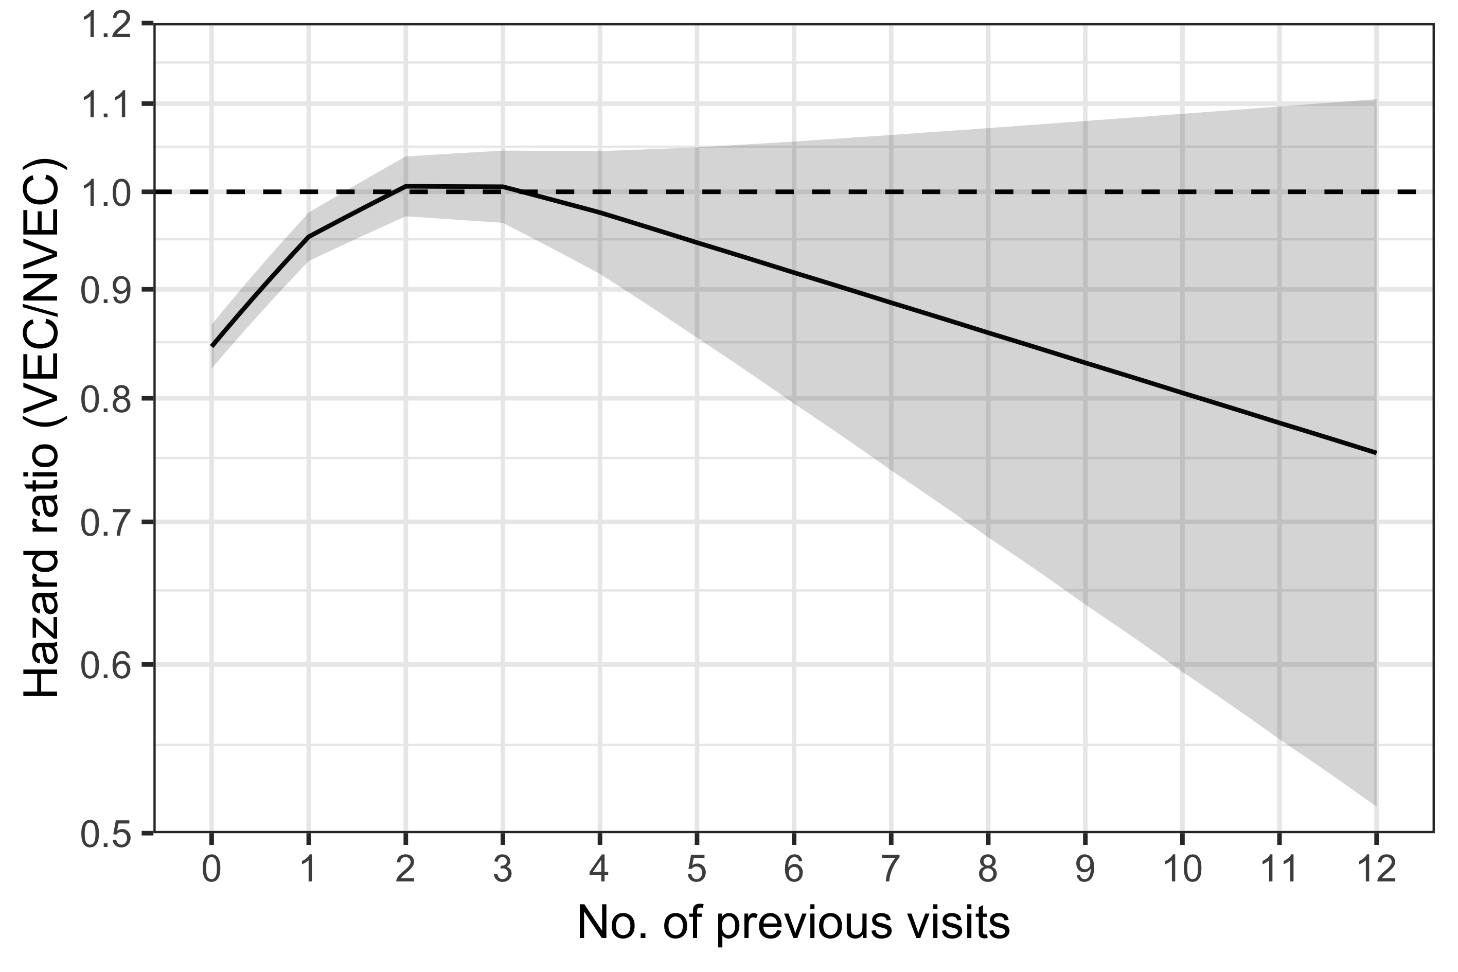

Figure . The hazard ratio (HR) of acute otitis media (AOM) between the vaccine eligible (VEC) and vaccine non-eligible cohorts (VNEC) stratified by the number of previous AOM episodes.

The estimated HR is illustrated as a solid black line, and 95% confidence intervals are presented as a shaded area. A dashed horizontal line is placed on the ratio value of one to assist in visually assessing significance. The Y-axis is truncated at a HR of 0.5 and is presented on the logarithmic scale. The figure demonstrates a significantly lower hazard of experiencing an additional episode of AOM among vaccine eligible children who have previously experienced zero or one episodes.

The mean number of AOM episodes in primary care was calculated as a function of age using the generalized Nelson-Aalen estimate of the underlying Andersen-Gill model. By their third birthday, the average child in the VNEC had experienced 1.61 episodes of AOM. The average child in the VEC had experienced 1.37. The mean number of AOM episodes by age is shown in Figure 12.

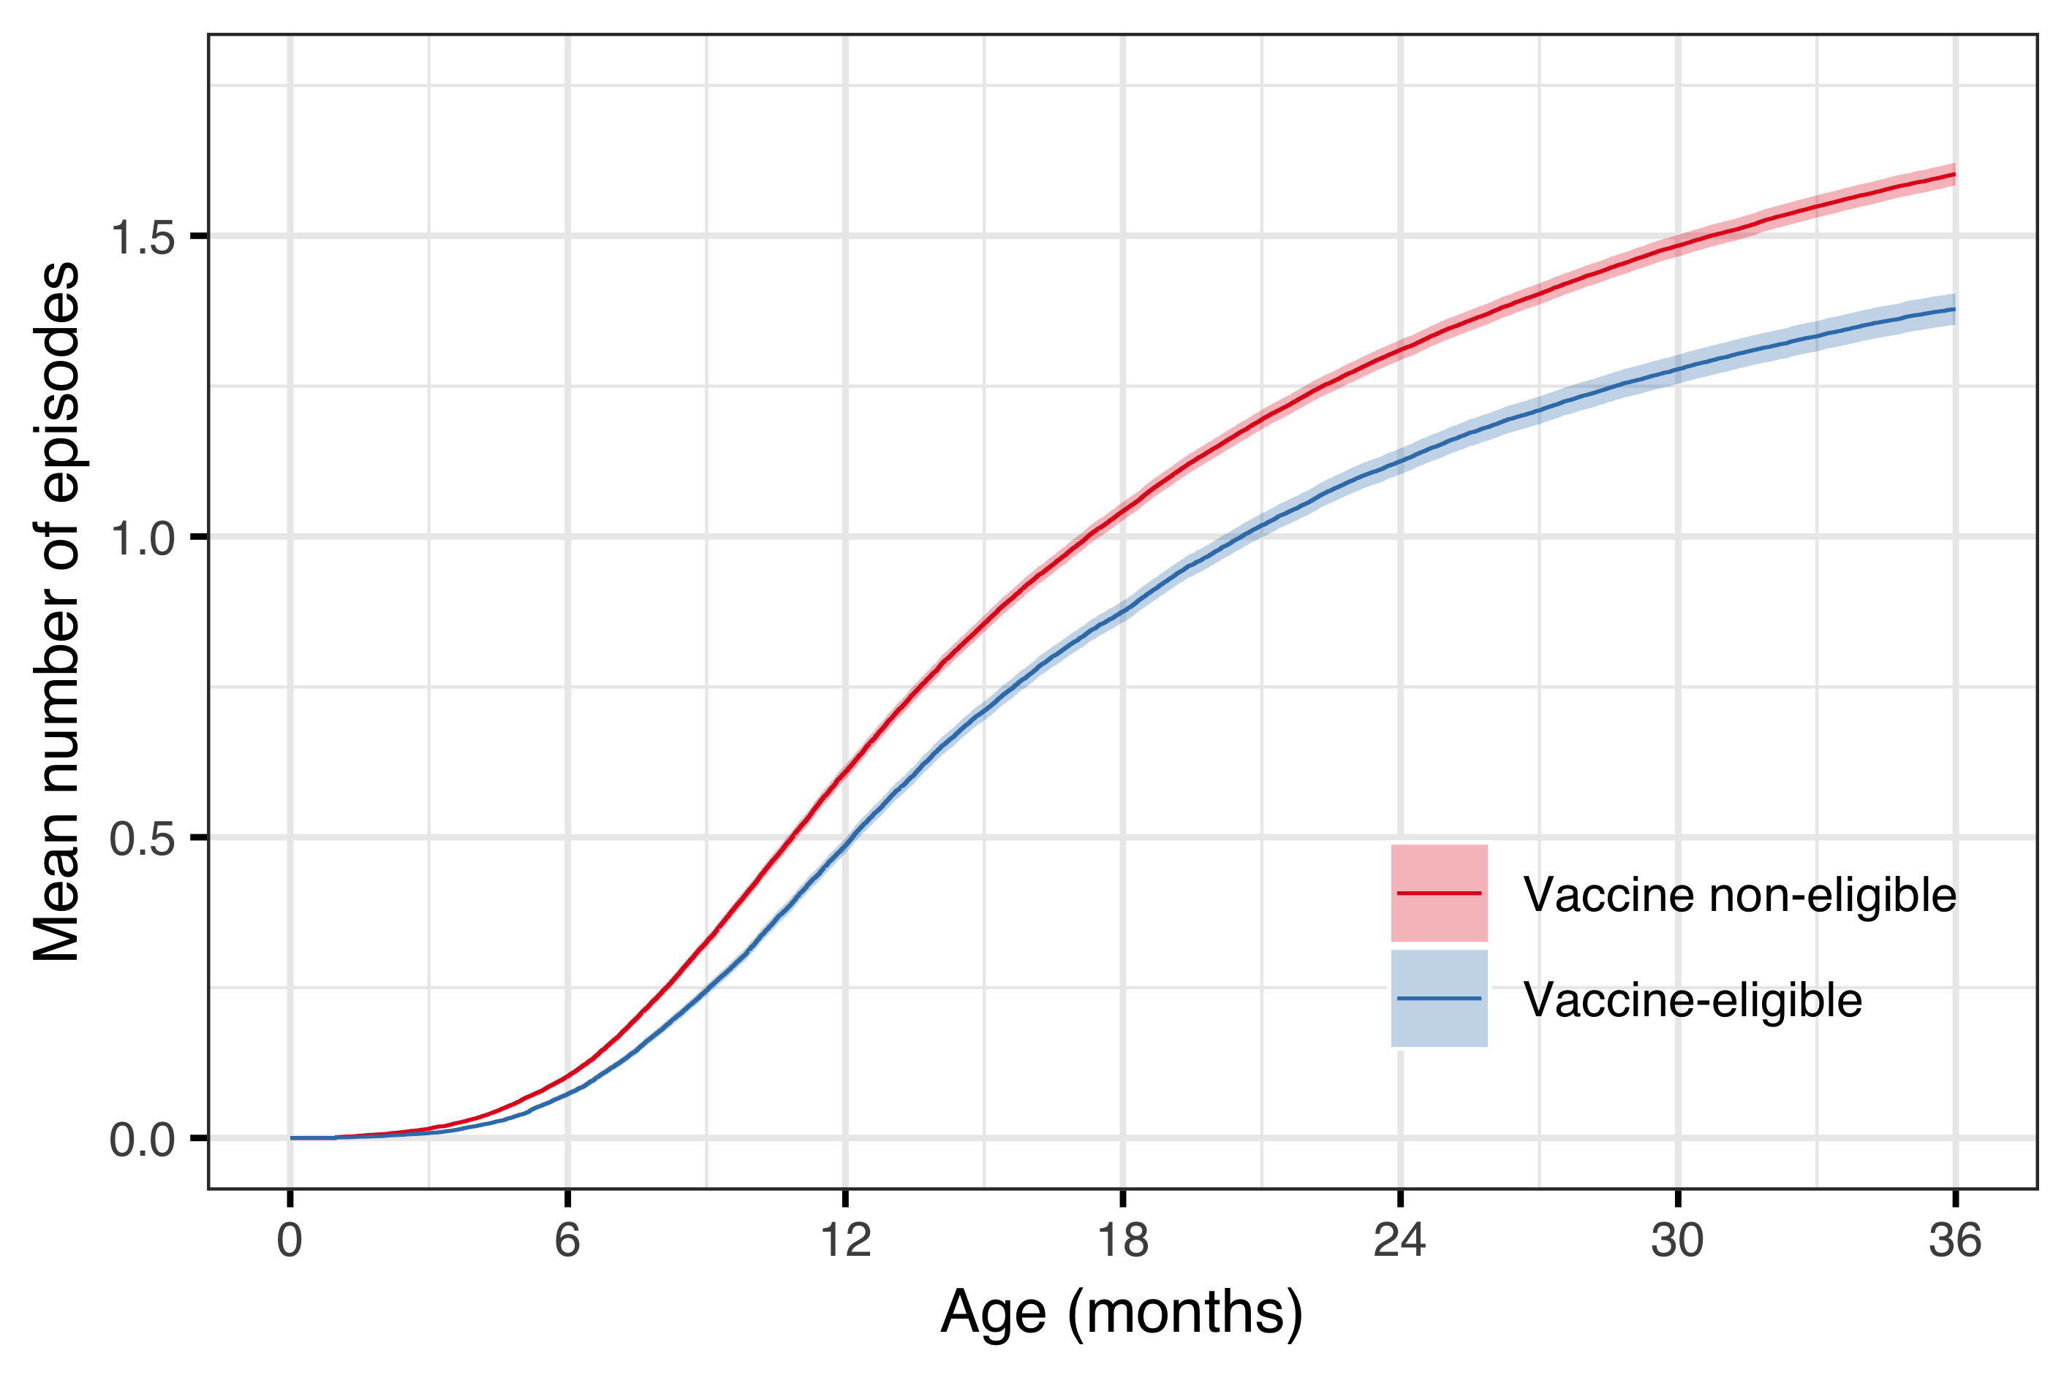

Figure . The mean number of acute otitis media (AOM) episodes is shown as a function of age.

The estimated mean is presented as a solid red line for the vaccine non-eligible cohorts and a blue line is used for the vaccine eligible cohorts. The 95% confidence intervals are illustrated as shaded areas. The figure demonstrates an early divergence in the mean number of episodes between the two cohorts.

## Impact on outpatient antimicrobial prescriptions (Paper III)

Demographic data regarding the study birth-cohorts are summarized in chapter 4.1 and Table 14. During the study period from 1 January 2005 to 31 December 2016, a total of 276,109 prescriptions were filled for 55,599 Icelandic children under three years of age. From 2005-2012, first-line penicillins were the most commonly prescribed antimicrobials and represented between 41% and 47% of all antimicrobial prescriptions in this age-group. Their use decreased suddenly to 32% in 2013, and represented only 18% of all antimicrobial prescriptions in 2014 and 2015. During this same period, the use of second-line penicillins increased from 35%-40% from 2005-2012, to 48%, 55% and 54% in 2013, 2014 and 2015. Use of cephalosporins followed a similar trend – their use represented between 5.2% and 7.8% of all prescriptions 2005–2012, and increased to 10–15% between 2013–2016. Antimicrobial prescriptions by calendar year are shown in Table 28.

Table . The incidence rate (IR) of outpatient antimicrobial prescriptions among children younger than three years of age is shown by calendar-year.

Antimicrobials were grouped based on a previously published classification system (Youngster et al. 2017). First-line penicillin includes amoxicillin, dicloxacillin and phenoxymethylpenicillin. Amoxicillin-clavulanate is the only antimicrobial included in the second-line penicillin category and erythromycin is the only first-generation macrolide. Second-generation macrolides include azithromycin and clarithromycin. Cefuroxime and cephalexin are the most common cephalosporins and the category Other includes mostly trimethoprim and trimethoprim and sulfamethoxazole.

|  |  |  |  |  |  |  |  |
| --- | --- | --- | --- | --- | --- | --- | --- |
|  |  | Penicillin | | Macrolide | | Cephalosporin | Other |
| Year | IR (n) | 1st-line (%) | 2nd-line (%) | 1st-gen (%) | 2nd-gen (%) | (%) | (%) |
| 2005 | 204 (12,570) | 41.4 | 37.9 | 1.5 | 6.5 | 5.4 | 7.3 |
| 2006 | 206 (12,844) | 40.3 | 39.6 | 1.3 | 6.2 | 5.4 | 7.2 |
| 2007 | 192 (13,111) | 45.0 | 36.8 | 1.6 | 6.4 | 5.2 | 5.1 |
| 2008 | 178 (13,474) | 46.7 | 35.2 | 0.2 | 6.4 | 5.9 | 5.6 |
| 2009 | 159 (14,062) | 46.4 | 37.2 | 0.0 | 5.5 | 6.3 | 4.5 |
| 2010 | 167 (14,382) | 43.7 | 38.5 | 0.0 | 5.5 | 7.0 | 5.2 |
| 2011 | 164 (14,588) | 44.7 | 37.9 | 0.0 | 5.9 | 7.5 | 4.0 |
| 2012 | 160 (14,225) | 43.5 | 39.0 | 0.0 | 6.9 | 7.8 | 2.8 |
| 2013 | 152 (13,893) | 32.1 | 48.1 | 0.0 | 6.6 | 10.0 | 3.2 |
| 2014 | 152 (13,390) | 18.5 | 55.5 | 0.0 | 6.6 | 14.5 | 4.9 |
| 2015 | 150 (13,284) | 18.5 | 53.9 | 0.1 | 7.3 | 15.0 | 5.3 |
| 2016 | 160 (12,813) | 35.3 | 41.7 | 0.0 | 5.5 | 12.9 | 4.6 |

The proportion of visits resulting in antimicrobial prescription and the incidence of antimicrobial prescriptions linked to each of the study’s diagnostic groups are shown in Figure 13. The proportion of otitis media visits resulting in an antimicrobial prescription remained stable at between 57% and 64% of visits. The incidence of otitis media associated prescriptions decreased from a high of 54.9 prescriptions per 100 person-years in 2008 to 39.8 prescriptions per 100 person-years in 2015.

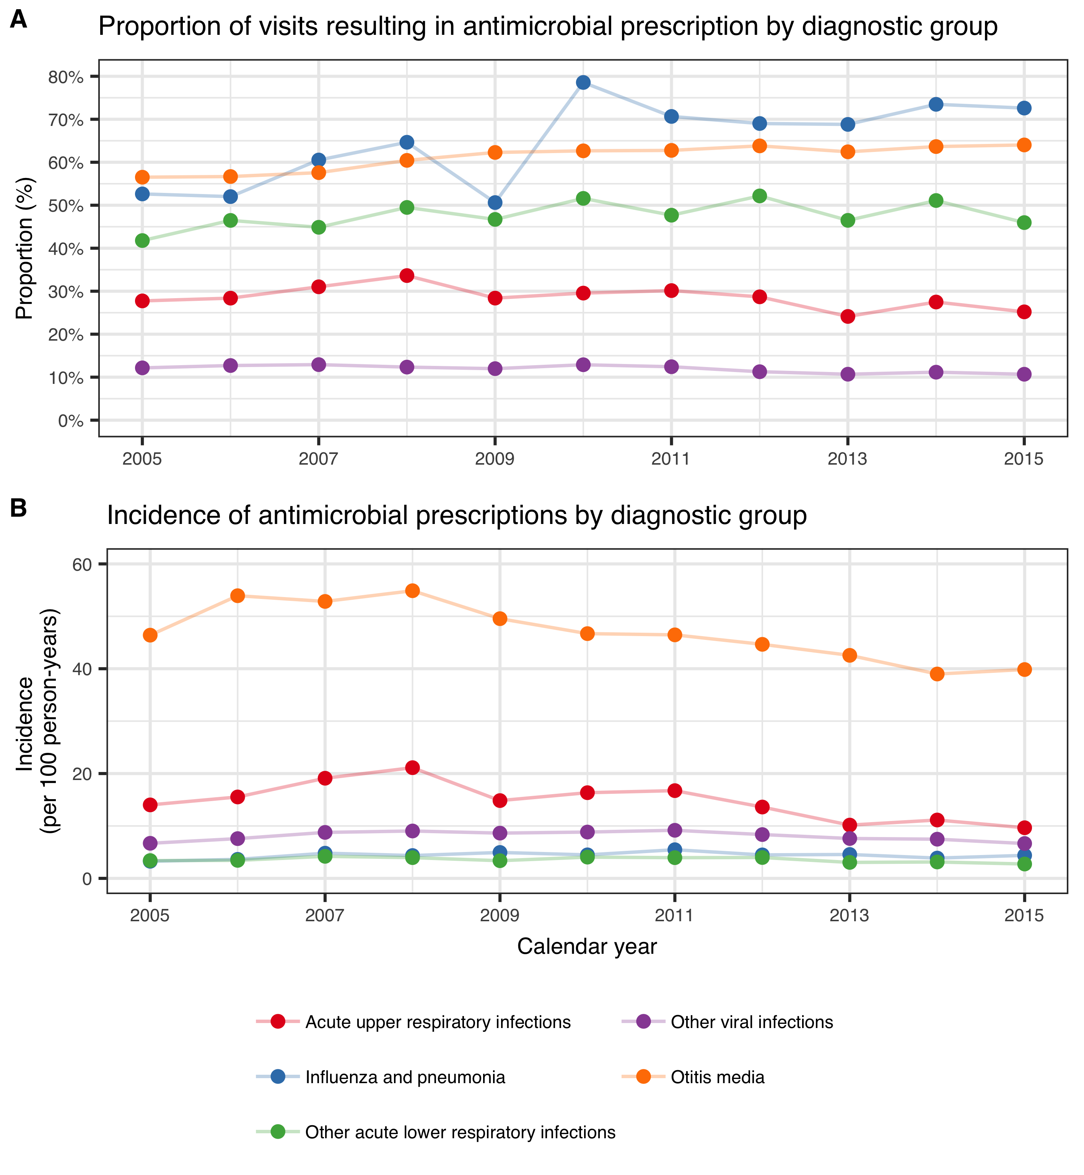

Figure . The proportion of visits resulting in antimicrobial prescription and the incidence of prescriptions for each diagnostic group for the period from 2005 to 2015.

The diagnostic groups and their corresponding color are presented in the figure legend. The figure demonstrates that the proportion of visits resulting in antimicrobial prescriptions remains fairly stable for most diagnostic groups, while the incidence is decreasing.

During the study period, a total of 226,084 outpatient antimicrobial prescriptions were recorded among birth-cohorts 2005-2015. The crude incidence rate of outpatient antimicrobial prescriptions per 100 person-years in the VNEC and VEC was 164.6 and 150.2 respectively. The incidence rate and number of outpatient antimicrobial prescriptions by birth-cohort and gender is shown in Table 29.

Table . The incidence rate (IR) of outpatient antimicrobial prescriptions is presented by birth-cohort and gender.

The absolute number of prescriptions are shown within parentheses.

|  |  |  |
| --- | --- | --- |
| Birth-cohort | Females | Males |
| 2005 | 176.0 (11,178) | 200.0 (13,423) |
| 2006 | 167.0 (10,843) | 190.0 (13,109) |
| 2007 | 153.0 (10,140) | 174.0 (12,339) |
| 2008 | 153.0 (10,543) | 171.0 (12,492) |
| 2009 | 151.0 (10,699) | 169.0 (12,775) |
| 2010 | 150.0 (10,366) | 161.0 (11,854) |
| 2011 | 142.0 (9,230) | 156.0 (10,906) |
| 2012 | 142.0 (9,447) | 158.0 (11,058) |
| 2013 | 138.0 (9,015) | 158.0 (10,180) |
| 2014 | 145.0 (7,726) | 167.0 (9,234) |
| 2015 | 138.0 (4,075) | 173.0 (5,452) |

When stratified by six-month age-groups, the lowest incidence was observed in children zero to five months of age and ranged from 30 to 50 prescriptions per 100 person-years. The observed incidence increased sharply thereafter and peaked among children twelve to seventeen months of age, ranging from 225 to 280 prescriptions per 100 person-years. The crude IR decreased significantly in all age-groups, with incidence rate ratios ranging from 0.82 to 0.94 (Figure 14).

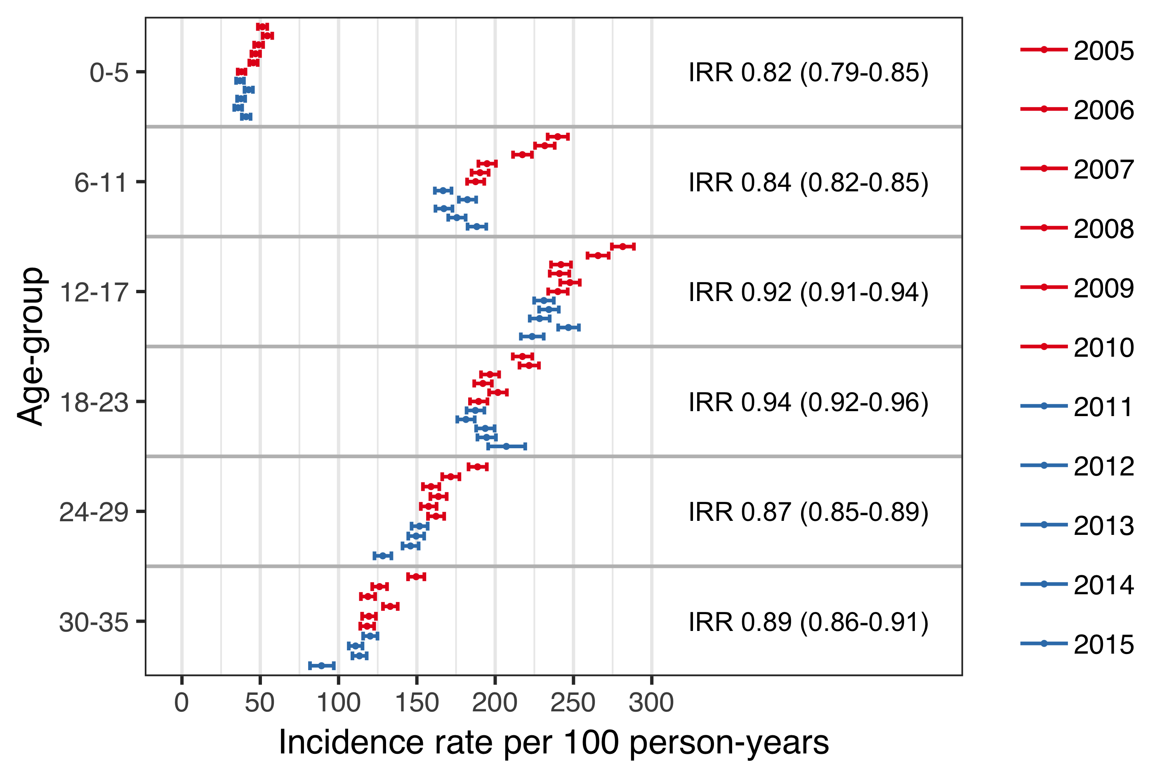

Figure . The incidence rate (IR) of outpatient antimicrobial prescriptions is shown stratified by birth-cohort and six-month age-groups.

The estimated IR is shown as a point and 95% confidence intervals are illustrated with horizontal error-bars. The vaccine non-eligible cohorts (VNEC) are depicted in red, and the vaccine eligible cohorts (VEC) in blue. The incidence rate ratio (IRR) between the VEC and VNEC is shown for each age-group and 95% confidence intervals are presented within parentheses.

The proportion of children in the VNEC and VEC who filled at least one antimicrobial prescription by three years of age was 88.6% and 86.8 respectively. Children in the VEC were significantly more likely than children in the VNEC not to have filled an antimicrobial prescription (incidence risk ratio 1.16, 95%CI 1.10 to 1.23) or to have filled only between one and four antimicrobial prescriptions (incidence risk ratio 1.08, 95%CI 1.06 to 1.11). The cumulative number of prescriptions by vaccine eligibility cohort in shown in Table 30.

Table . The proportion of children in the vaccine non-eligible cohorts (VNEC, 2005–2010) and vaccine eligible cohorts (VEC, 2011–2013) who filled 0, 1–4, 5–9, 10–14 and ≥15 antimicrobial prescriptions by 36 months of age.

|  |  |  |  |
| --- | --- | --- | --- |
| No. prescriptions | VNEC (%) | VEC (%) | Incidence risk (95%CI) |
| 0 | 11.4 | 13.2 | 1.16 (1.10-1.23) |
| 1-4 | 43.7 | 47.3 | 1.08 (1.06-1.11) |
| 5-9 | 31.6 | 29.0 | 0.918 (0.889-0.947) |
| 10-14 | 9.79 | 7.52 | 0.768 (0.716-0.823) |
| ≥15 | 3.51 | 2.91 | 0.831 (0.74-0.934) |

Discrimination indices for the Andersen-Gill multiple event model were adequate, Nagelkerke’s $R^{2}$ = 0.212 and Somer’s $D_{xy}$ = 0.295, and no significant deviations from the model assumptions were visible on diagnostic plots. The model was used to estimate the hazard ratio of outpatient antimicrobial prescriptions between each of the study’s birth-cohorts and the last vaccine non-eligible cohort, 2010. Visually, there seemed to be a decreasing trend in hazard of prescription among the vaccine non-eligible birth-cohorts (Figure 15). The hazard did not change significantly between the last vaccine non-eligible birth-cohort and the preceding two cohorts. It did decrease significantly thereafter, with each vaccine eligible cohort having a significantly lower hazard of outpatient antimicrobial prescription. The estimated impact of PHiD-CV10 on outpatient antimicrobial prescriptions among children younger than three years of age was 8% (95%CI 4% to 12%).

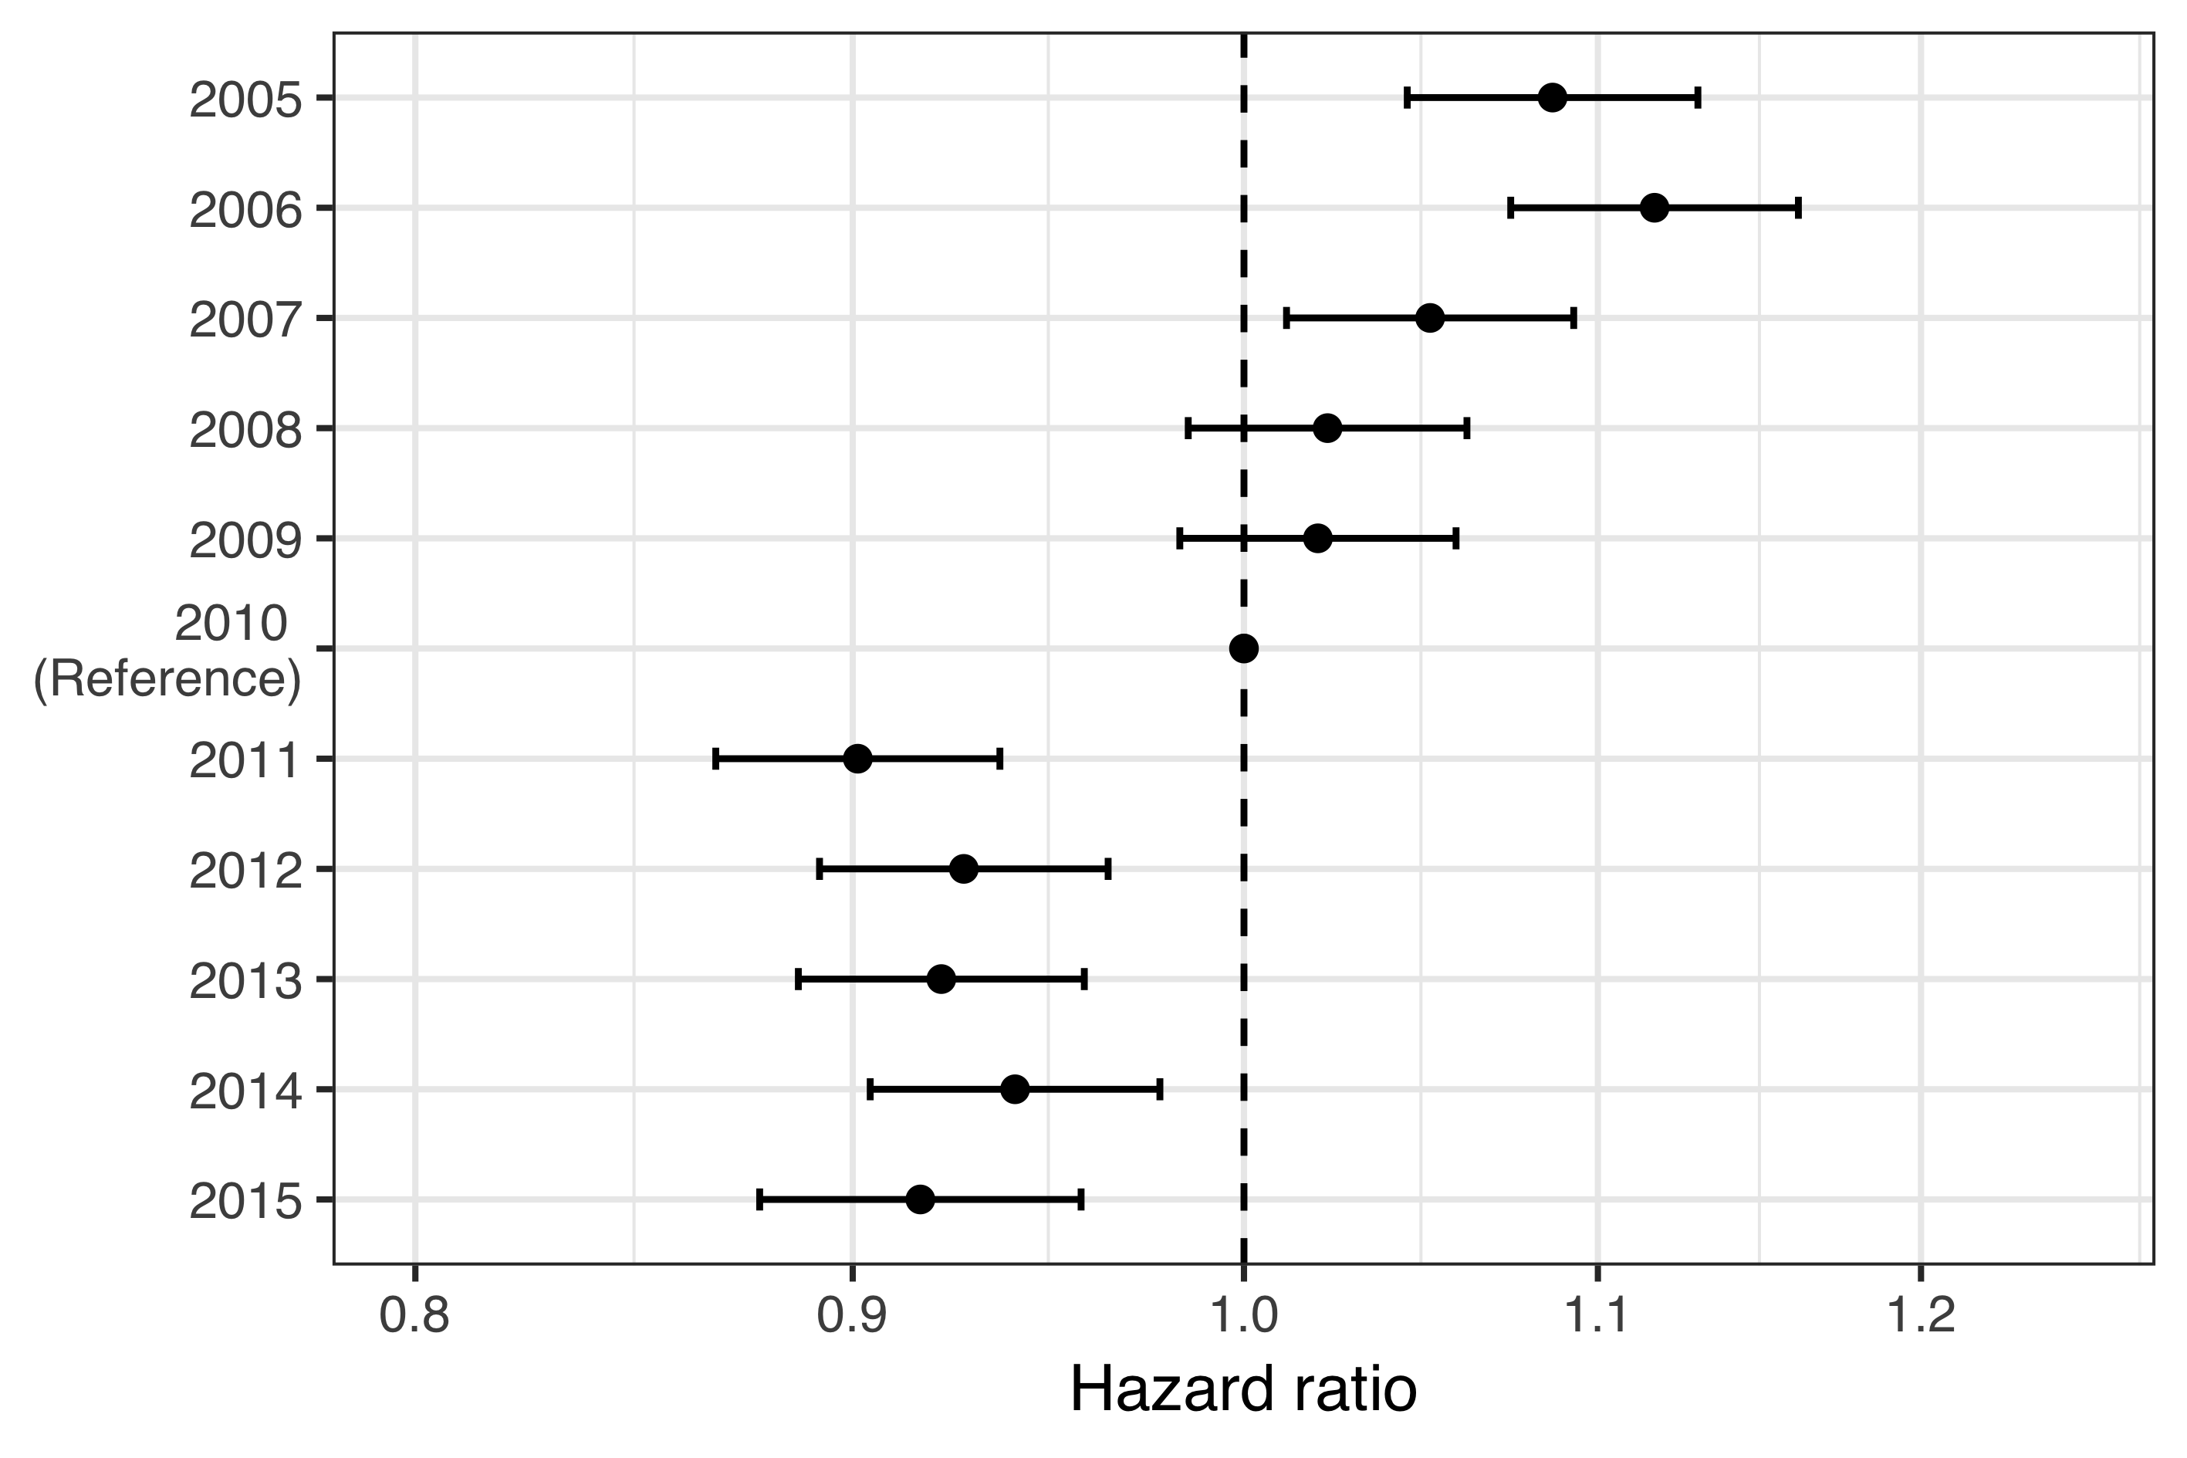

Figure . The hazard ratio (HR) of outpatient antimicrobial prescription between each birth-cohort and the last vaccine non-eligible birth-cohort.

The estimated HR is depicted as a point, and 95% confidence intervals are illustrated with horizontal error-bars. The 2010 birth-cohort is used as a reference and by definition, no uncertainty is present. Therefore, no confidence intervals are presented. A dashed vertical line is placed on the ratio value of one to assist in visually estimating significance. The X-axis is on a logarithmic scale. The figure demonstrates a decreasing trend in the hazard of outpatient antimicrobial prescription in the vaccine non-eligible cohorts. An abrupt decrease in the hazard is observed in the first vaccine eligible birth-cohort.

When stratified by the number of previous prescriptions, an independent vaccine impact on subsequent prescriptions was still discernible in children who had received up to three prior antimicrobial prescriptions. Among children who had received more than three prior prescriptions, no effect was found (Figure 16).

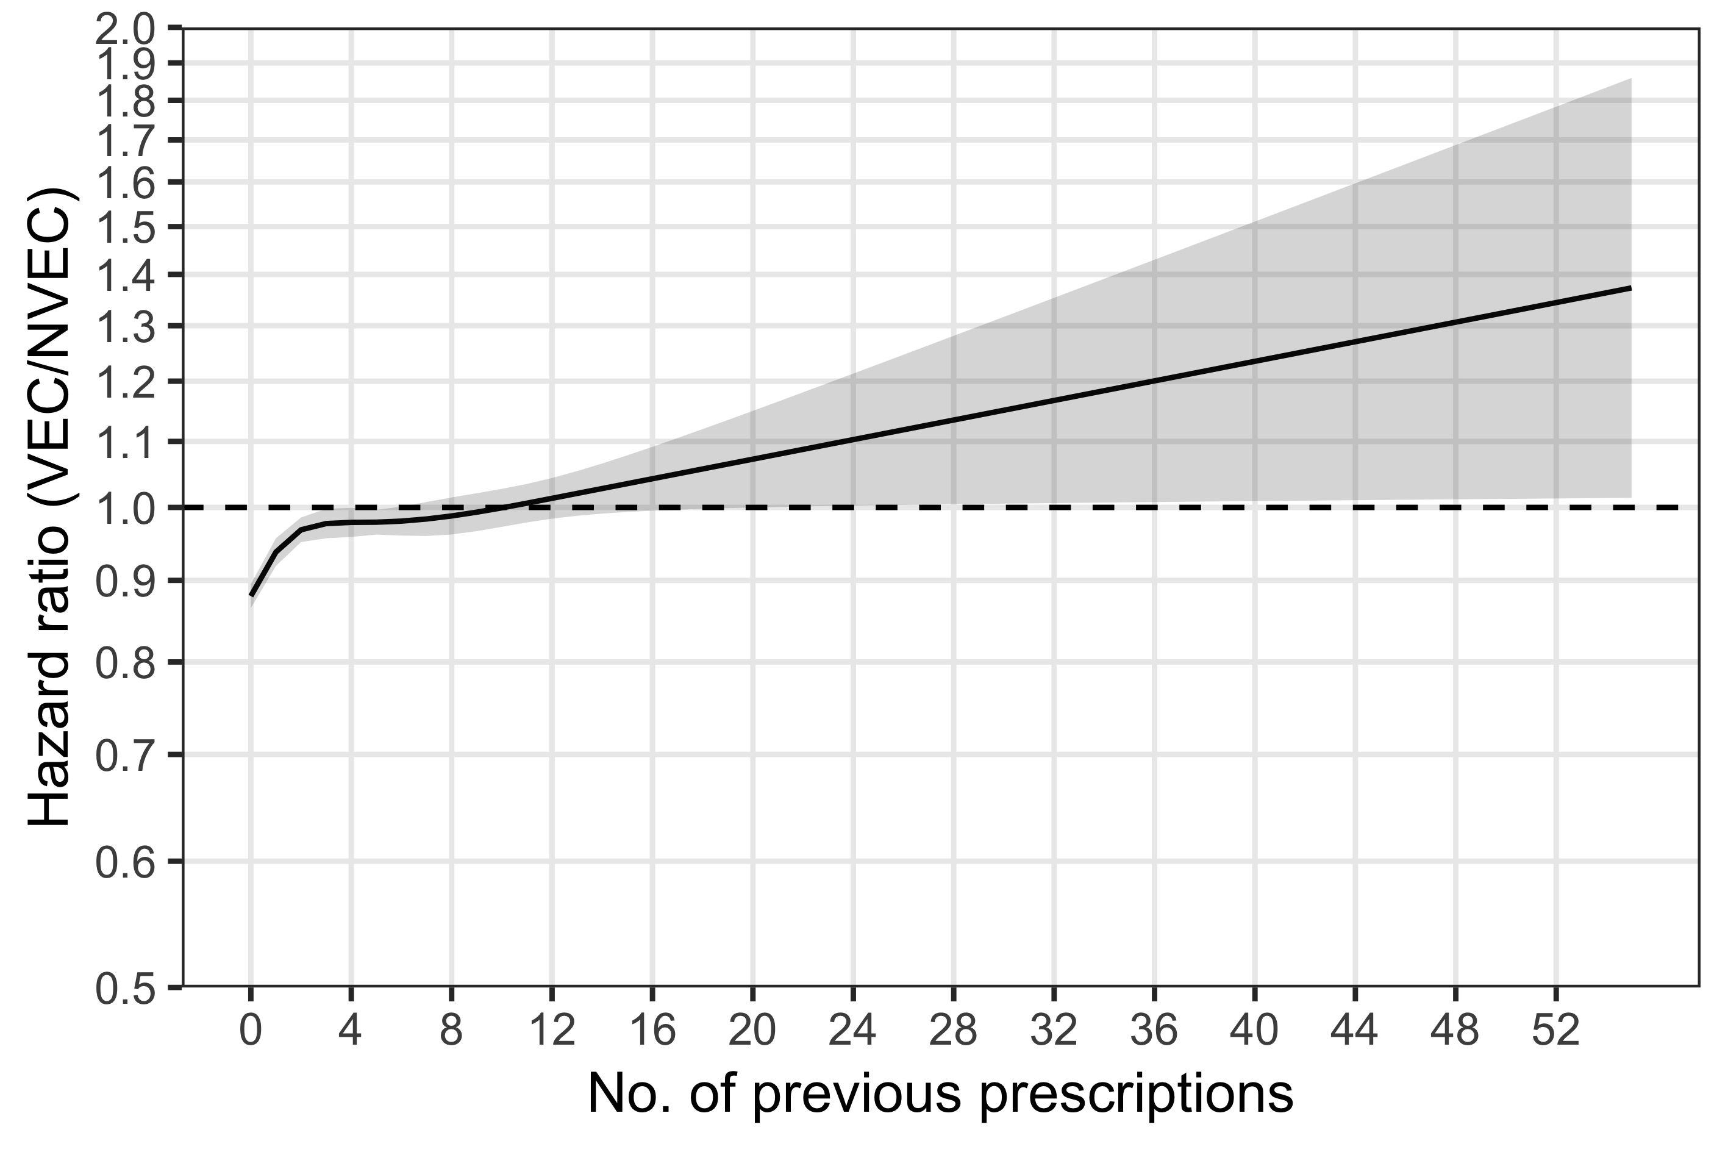

Figure . The hazard ratio (HR) of outpatient antimicrobial prescriptions between the vaccine eligible (VEC) and vaccine non-eligible cohorts (VNEC) stratified by the number of previous prescriptions.

The estimated HR is depicted as a solid black line, and 95% confidence intervals are illustrated as a shaded area. A dashed horizontal line is placed on the ratio value of one to assist in visually assessing significance. The Y-axis is truncated at a HR of 0.5 and is presented on a logarithmic scale. The figure demonstrates a significantly lower hazard of filling additional outpatient antimicrobial prescriptions among vaccine eligible children who had previously filled fewer than four prescriptions.

The mean number of outpatient antimicrobial prescriptions as a function of age was calculated using the generalized Nelson-Aalen estimate of the underlying Andersen-Gill model. The average male child in the VNEC had filled 6.48 antimicrobial prescriptions by his fourth birthday, and the average female child had filled 6.07. The average male and female children in the VEC had filled 5.84 and 5.46 prescriptions respectively. The mean number of antimicrobial prescriptions by age and gender is shown in Figure 17.

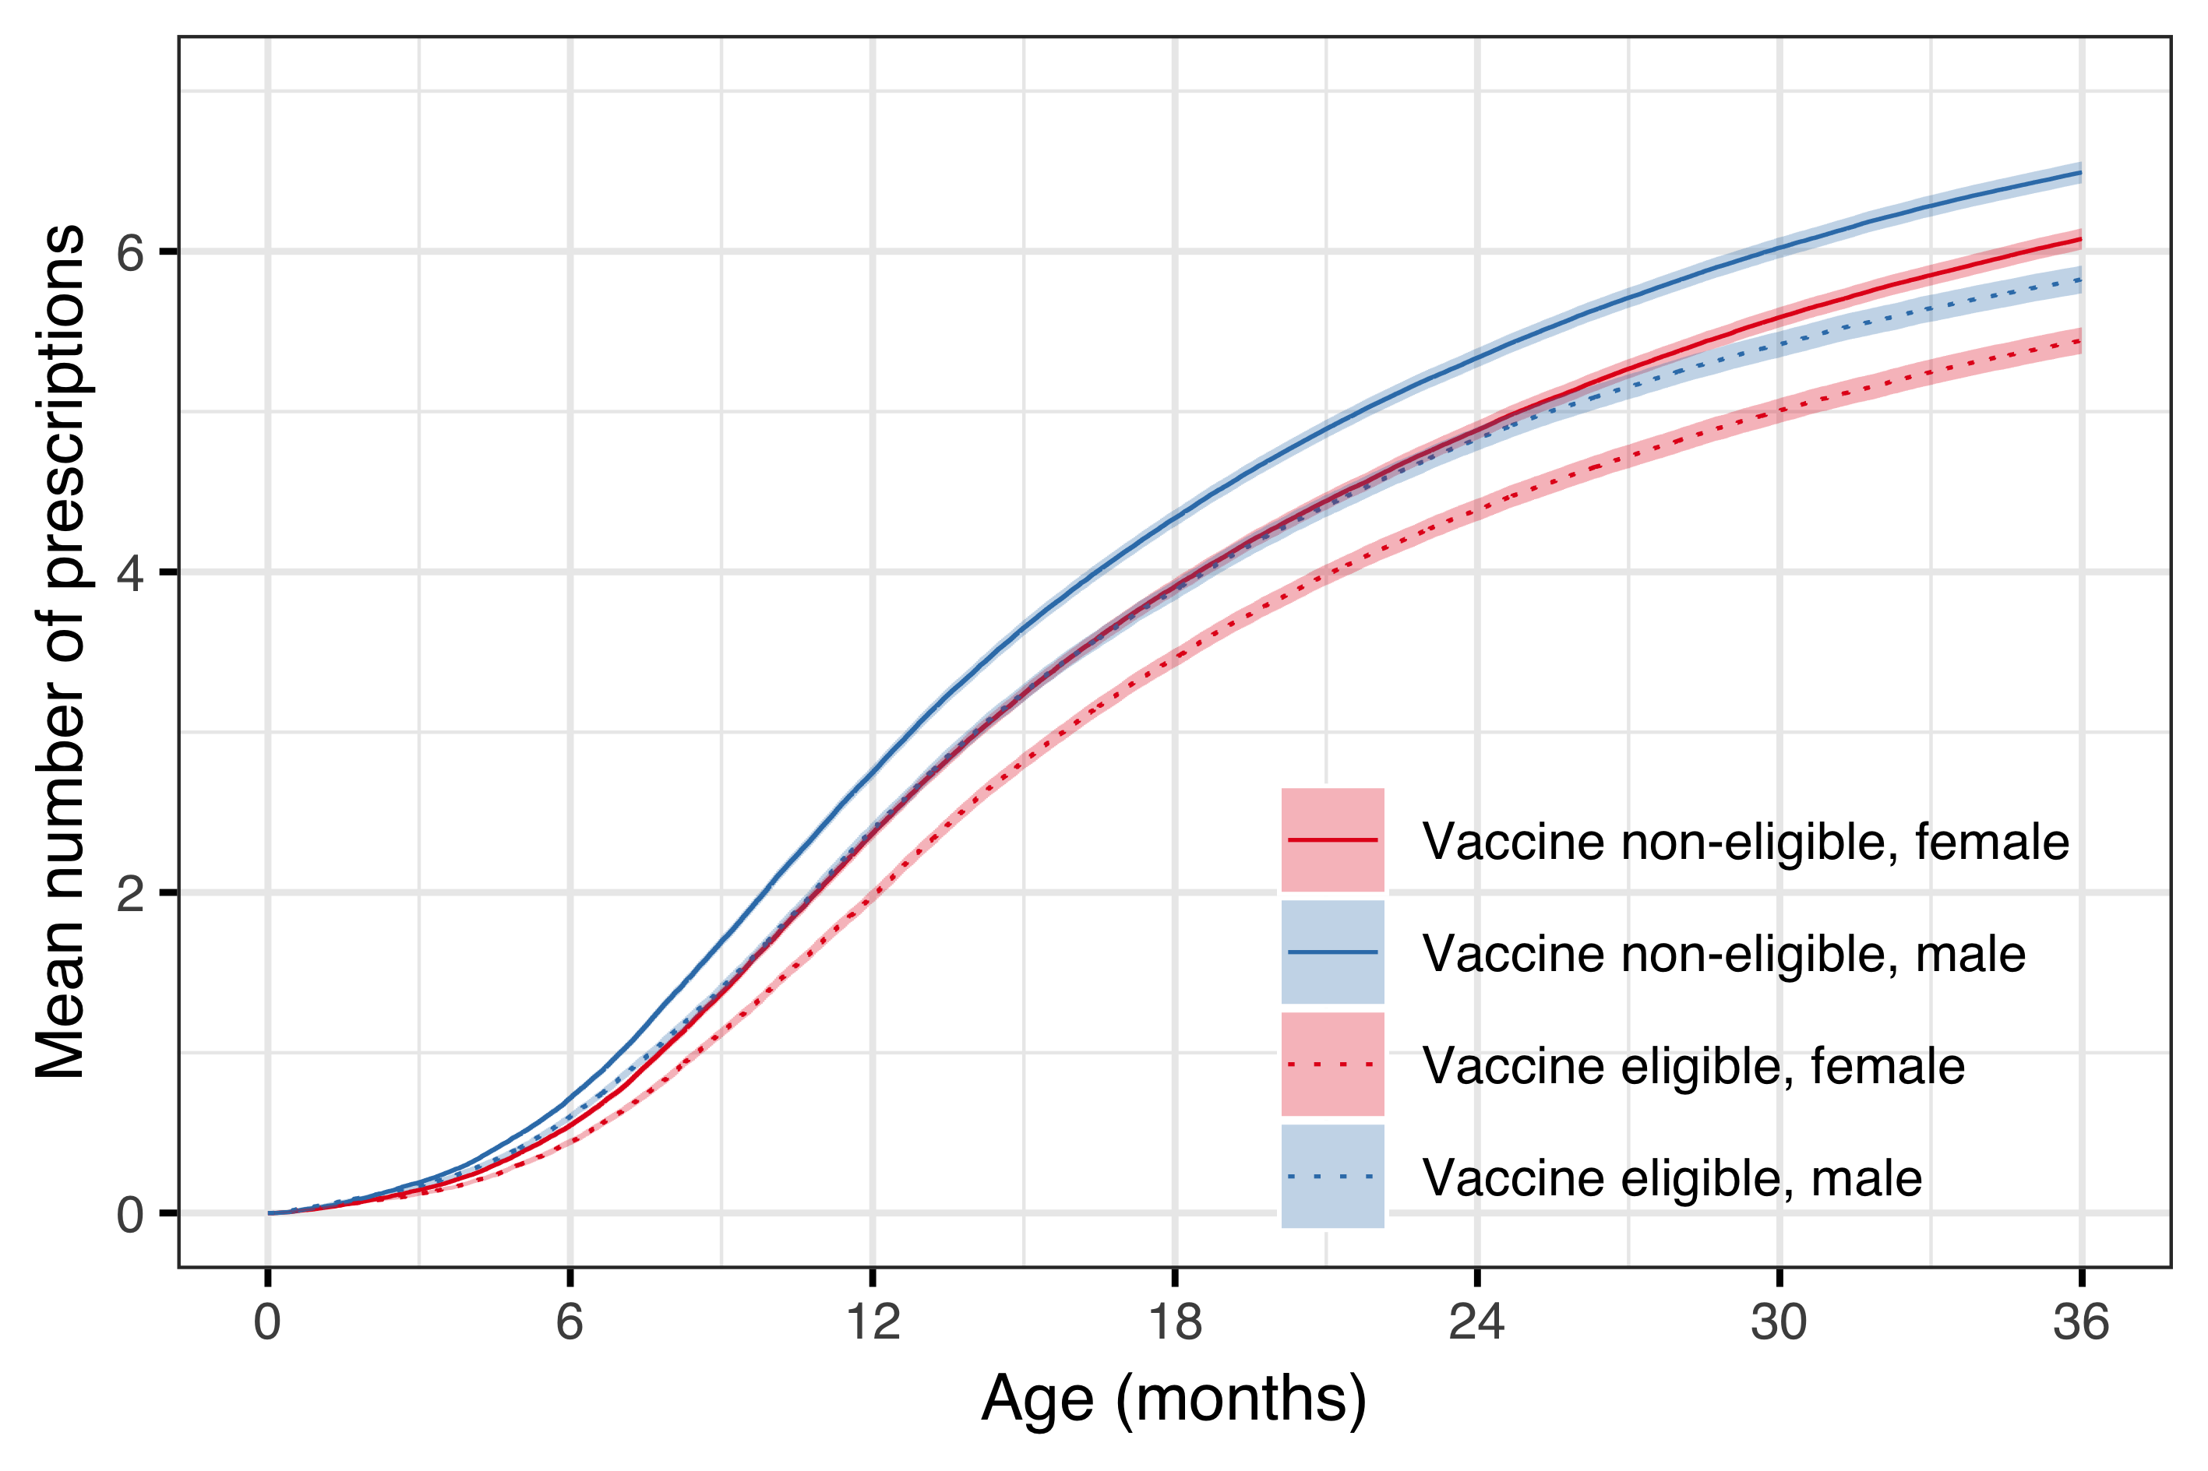

Figure . The mean number of outpatient antimicrobial prescriptions are shown as a function of age, and stratified by vaccine eligibility cohort and gender.

The figure deviates from the color schema used in other figures that compromise this thesis. Here, the estimates for females are illustrated in red and males in blue. Vaccine non-eligible cohorts are represented with solid lines and vaccine eligible cohorts with dashed lines. The 95% confidence intervals are illustrated as shaded areas. The figure demonstrates an early divergence in the mean number of prescriptions, and a consistent difference between genders.

## Impact on tympanostomy tube procedures (Paper IV)

Demographic data regarding the study birth-cohorts are summarized in chapter 4.1. In total, during the study period from 1 January 2005 to 31 December 2016, 14,351 children underwent 20,373 tympanostomy tube placements, 57% of whom were male.

The median age of children undergoing their first tympanostomy procedure was 17 months (IQR 13-24, 18% younger than one year of age). In the subset of children who underwent a TTP during the study period, 10,248 (71%) underwent only one procedure, 2,902 (20%) underwent two, and 1201 (8%) underwent three or more. Almost all (98%) of the procedures were performed in private outpatient clinics. The number of otolaryngologists performing outpatient TTP increased from 15 in 2005 to 23 in 2016. Each surgeon performed a median of 123 (IQR: 56.5-196) procedures each year. The study’s population is summarized in Table 31.

Table . An overview of the birth-cohorts included in paper IV.

The number of observed tympanostomy tube placements (TTP) in each cohort is presented, with the number of children undergoing the procedures within parentheses. The median age in months at the time of a child’s first procedure is shown along with the interquartile range. The observational period is 1 January 2005 to 31 December 2016. Birth-cohorts 2012-2015 do not attain full follow-up time, as indicated by fewer person-years included in the study. Thus, the decrease in the number of procedures and median age in those cohorts is not indicative of a true decrease. These cohorts are colored with darker gray banded rows for emphasis.

|  |  |  |  |  |
| --- | --- | --- | --- | --- |
| Birth-cohort | Number of children | Person-years | Number of procedures (n children) | Median age (months) |
| 2005 | 4,541 | 21,409 | 1,946 (1,280) | 17 (12-25) |
| 2006 | 4,665 | 21,988 | 1,931 (1,303) | 18 (13-27) |
| 2007 | 4,770 | 22,500 | 1,974 (1,335) | 18 (13-27) |
| 2008 | 4,949 | 23,313 | 2,140 (1,428) | 18 (13-26) |
| 2009 | 5,128 | 24,141 | 2,145 (1,514) | 18 (13-25) |
| 2010 | 4,984 | 23,580 | 2,203 (1,547) | 18 (13-26) |
| 2011 | 4,642 | 22,056 | 1,997 (1,382) | 18 (13-24) |
| 2012 | 4,668 | 20,195 | 2,057 (1,419) | 16 (12-23) |
| 2013 | 4,442 | 14,964 | 1,642 (1,200) | 16 (13-23) |
| 2014 | 4,444 | 10,744 | 1,582 (1,251) | 16 (13-20) |
| 2015 | 4,136 | 5,983 | 756 (692) | 13 (11-15) |

The crude incidence rate of TTP in the vaccine eligible cohorts was 10.6 procedures per 100 person-years. This was significantly higher than the crude incidence rate in the vaccine non-eligible cohorts, 8.7 procedures per 100 person-years (IRR 1.20, 95%CI 1.17 to 1.24). When stratified by age-groups, the crude incidence rate was highest among 12-17 month old children, ranging from 19 to 27 procedures per 100 person-years (Figure 18).

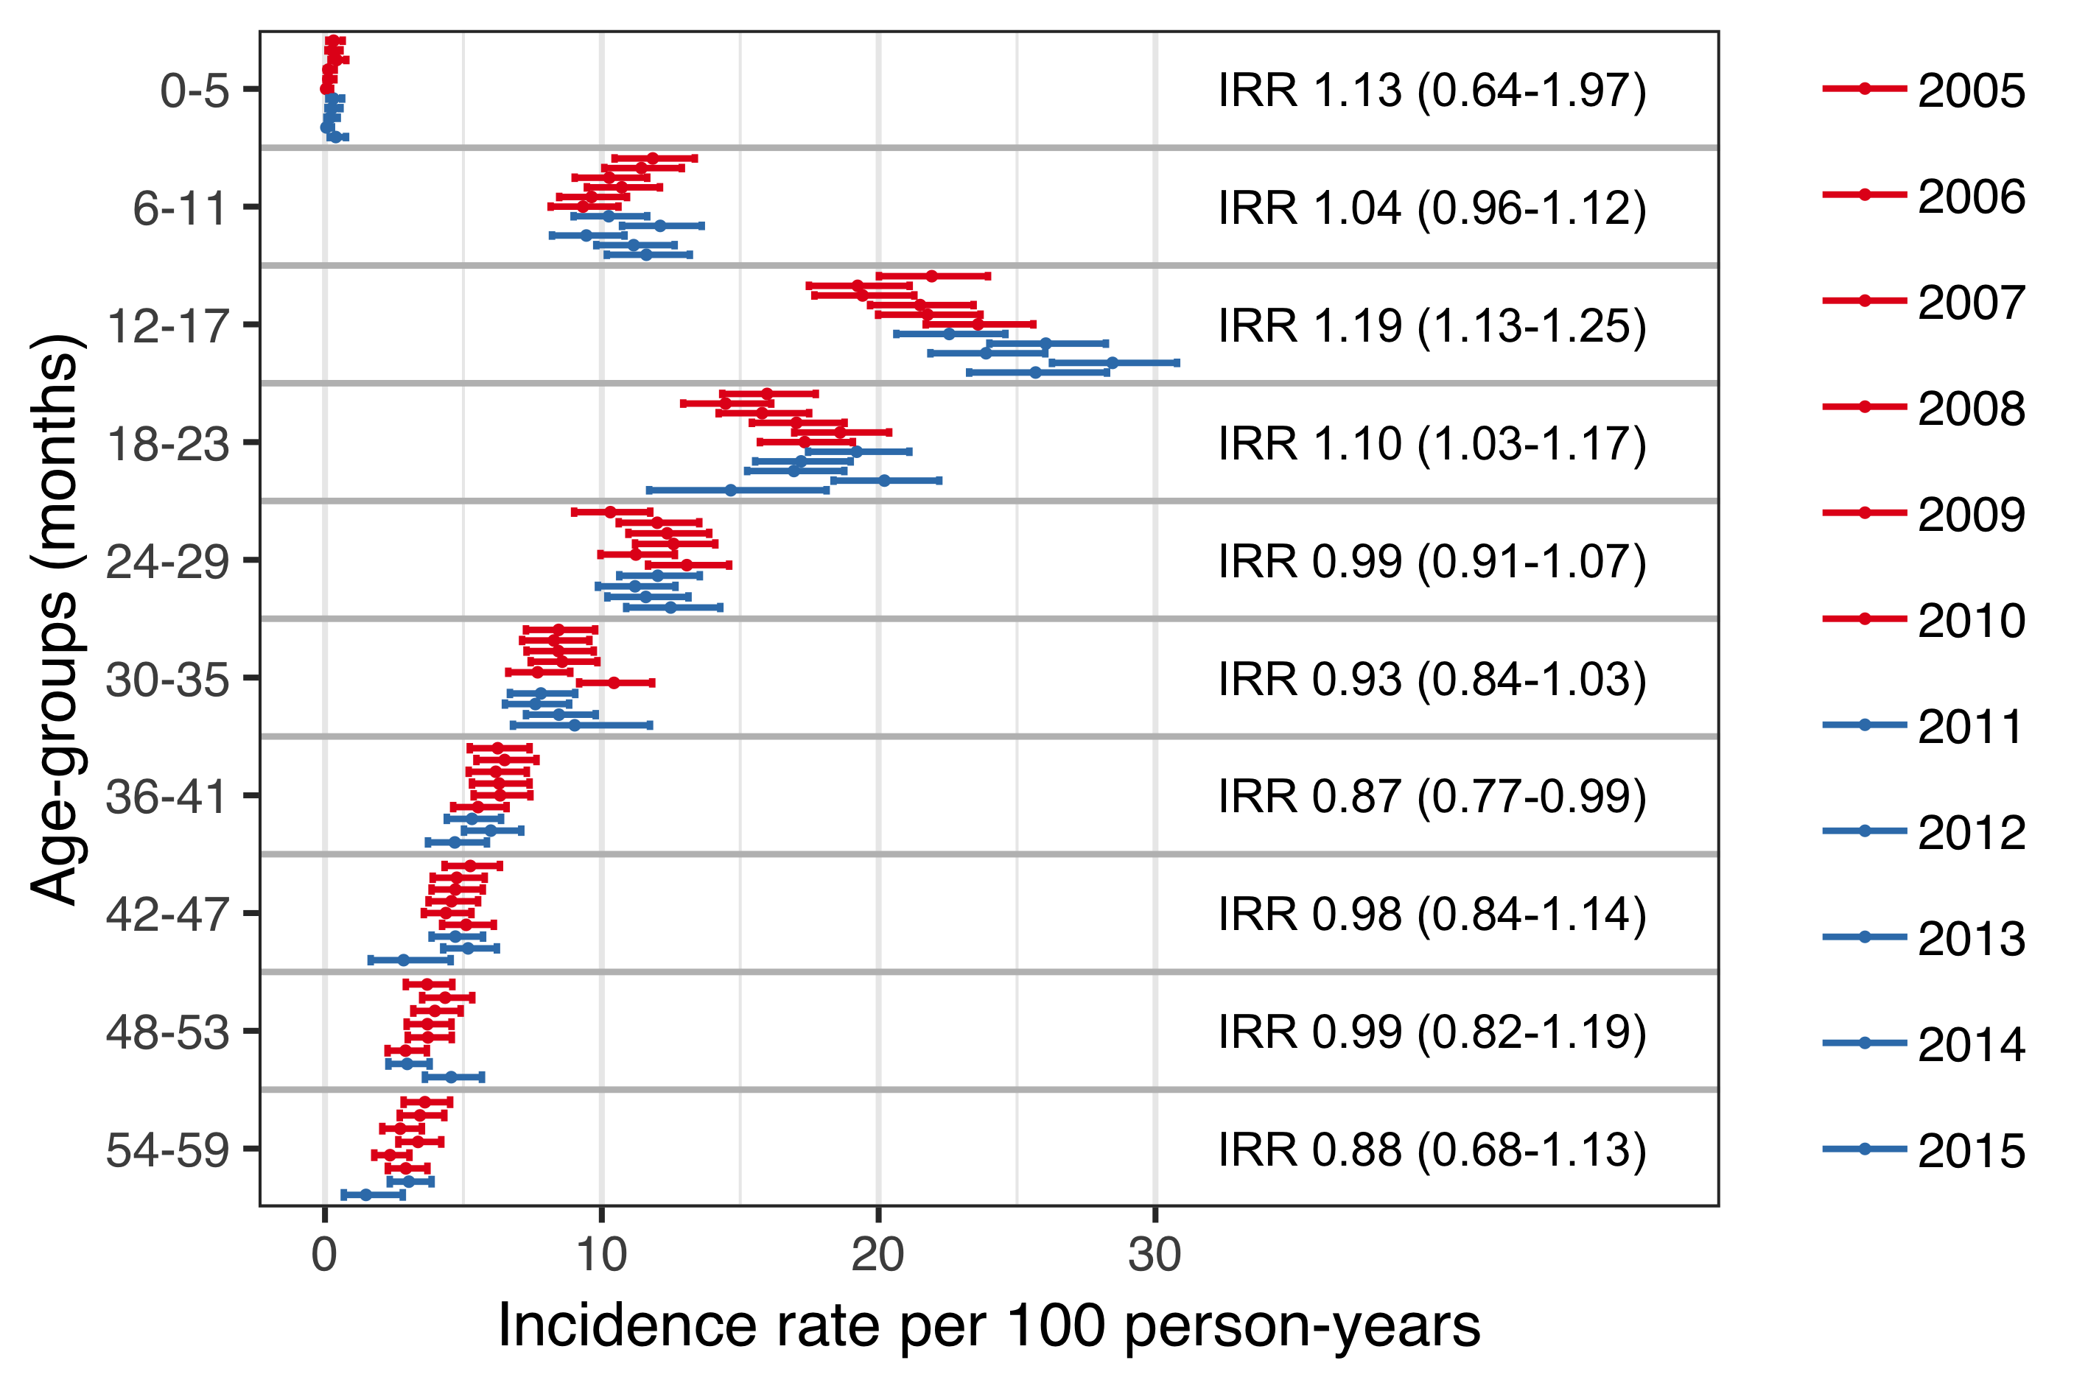

Figure . The incidence rate (IR) of tympanostomy tube placements (TTP) stratified by birth-cohort and six-month age-groups.

The estimated IR is represented with a point, and 95% confidence intervals are illustrated with horizontal error-bars. The vaccine non-eligible cohorts (VNEC) are depicted in red, and the vaccine eligible cohorts (VEC) in blue. The incidence rate ratio (IRR) between the VEC and VNEC is shown for each age-group and 95% confidence intervals are presented within parentheses.

The cumulative incidence of children who had undergone at least one TTP by five years of age was highest in birth-cohort 2010 (31.7%), and lowest in birth-cohort 2006 (28.6%), Table 32. The cumulative incidence of tympanostomy procedures was significantly higher in the VEC compared to VNEC regardless of age (Figure 19).

Table . The cumulative incidence of having undergone at least one tympanostomy tube placement (TTP) at six-month age intervals is presented.

Birth-cohorts 2006 and 2008 are removed because of lack of space. Their absence is indicated by an ellipsis (…). The cumulative incidence is presented as a percentage (%) of all children in the respective cohort. Birth-cohorts 2012-2015 do not attain full follow-up time. Lack of information due to censoring is indicated with a hyphen (-).

|  |  |  |  |  |  |  |  |  |  |
| --- | --- | --- | --- | --- | --- | --- | --- | --- | --- |
| Age | 2005… | 2007… | 2009 | 2010 | 2011 | 2012 | 2013 | 2014 | 2015 |
| 6 | 0.4 | 0.4 | 0.3 | 0.1 | 0.4 | 0.2 | 0.3 | 0.2 | 0.5 |
| 12 | 7.2 | 6.6 | 6.5 | 6.6 | 6.6 | 7.8 | 6.5 | 6.9 | 7.6 |
| 18 | 16.4 | 14.9 | 15.7 | 16.5 | 16.3 | 18.3 | 16.3 | 19.1 | 18.4 |
| 24 | 21.1 | 19.7 | 22.0 | 22.4 | 23.3 | 23.9 | 21.7 | 26.1 | - |
| 30 | 23.7 | 23.4 | 25.1 | 26.3 | 26.3 | 26.7 | 24.9 | 29.0 | - |
| 36 | 25.8 | 25.3 | 27.2 | 28.8 | 27.9 | 28.3 | 26.9 | - | - |
| 42 | 26.9 | 26.7 | 28.5 | 30.1 | 28.7 | 29.5 | 27.5 | - | - |
| 48 | 27.8 | 27.8 | 29.1 | 31.0 | 29.4 | 30.4 | - | - | - |
| 54 | 28.4 | 28.4 | 29.9 | 31.4 | 30.1 | 30.9 | - | - | - |
| 59 | 28.8 | 28.6 | 30.2 | 31.7 | 30.4 | 31.3 | - | - | - |

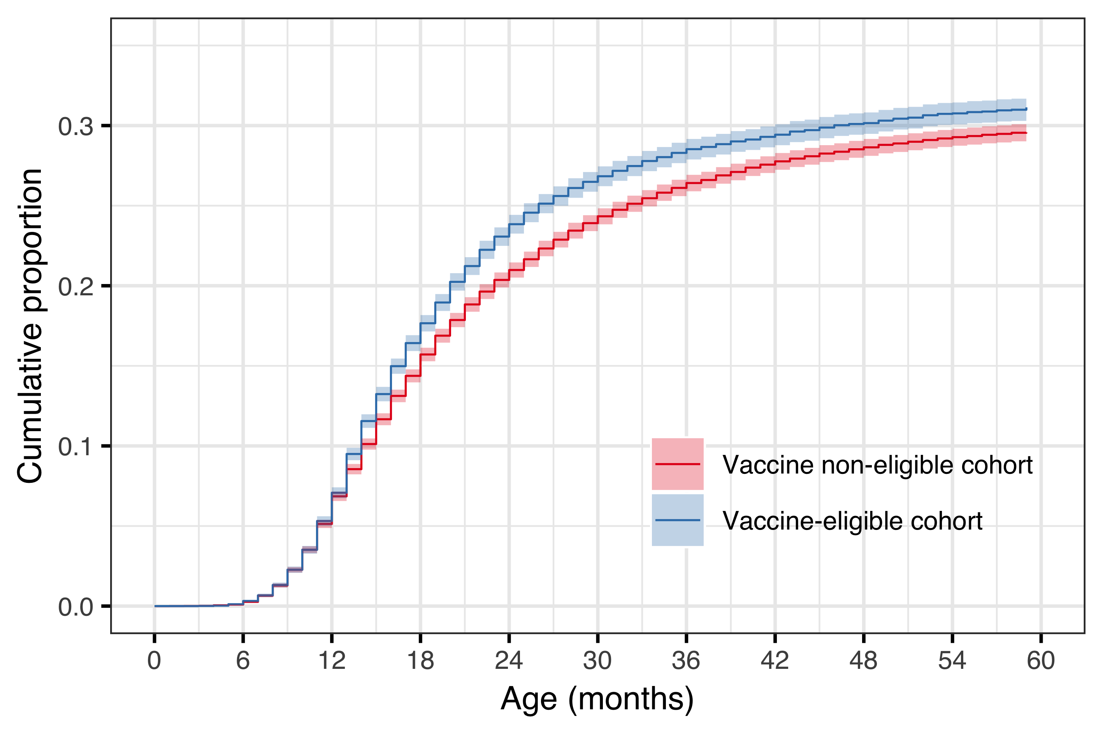

Figure . The cumulative incidence of tympanostomy tube placements (TTP) is shown for the vaccine eligible (VEC) and vaccine non-eligible cohorts (VNEC) as a continuous function of age.

Cumulative incidence is presented as a proportion of all children in the respective vaccine eligibility cohort. The estimated cumulative incidence is illustrated with a solid red line for the VNEC, and a solid blue line for the VEC, and 95% confidence intervals are depicted with a shaded area.

In the subset of children who underwent TTP, the mean (median) number of otitis media associated visits to primary care or to the pediatric emergency department was 2.05 (2) visits in the vaccine non-eligible cohorts, compared to 1.72 (1) visits in the vaccine eligible cohorts. The distribution in the number of previous visits was significantly different between the VNEC and VEC (Chi-Squared test statistic 63.8, P<.001). The proportion of children who did not have a single recorded visit prior to undergoing the procedure increased from 20.6% in the VNEC to 28.9% in the VEC, RR 1.40 (95%CI 1.28-1.54). Children in the vaccine eligible cohorts had received significantly fewer antimicrobial prescriptions prior to undergoing the procedure (Chi-Squared test statistic 53.6, P<.001). The mean (median) number of previous antimicrobial prescriptions was 3.19 (4) in the vaccine eligible cohorts compared to 3.62 (4) in the vaccine non-eligible cohorts. Children in the VEC were more likely to have never been prescribed antimicrobials prior to undergoing tympanostomy placement, RR 1.52, 95%CI 1.18-1.96). The comparison between VEC and VNEC is summarized in Tables 33 and 34.

Table . The cumulative number of previous antimicrobial prescriptions for those children in the vaccine non-eligible (VNEC) and vaccine eligible cohorts (VEC) who underwent at least one tympanostomy tube placement.

The proportion of each cohort who had the corresponding number of previous prescriptions is shown with the absolute number of children within parentheses. The relative risk (RR) and absolute risk difference (ARD) between the VEC and VNEC is shown with 95% confidence intervals.

|  |  |  |  |  |
| --- | --- | --- | --- | --- |
| Cum. presc. | VNEC % (n) | VEC % (n) | RR (95%CI) | ARD (95%CI |
| 0 | 3.4 (286) | 5.2 (72) | 1.18  (1.52 to 1.96) | 1.79 (0.51 to 3.07) |
| 1 | 11.6 (966) | 12.8 (177) | 0.95  (1.11 to 1.29) | 1.26 (-0.68 to 3.19) |
| 2 | 19.3 (1,610) | 22.6 (311) | 1.05  (1.17 to 1.30) | 3.28 (0.87 to 5.68) |
| 3-4 | 37.8 (3,150) | 37.4 (516) | 0.92  (0.99 to 1.07) | -0.39 (-3.19 to 2.41) |
| 5-7 | 22.3 (1,860) | 19.3 (266) | 0.77  (0.86 to 0.97) | -3.01 (-5.32 to -0.70) |
| 8+ | 5.6 (468) | 2.7 (37) | 0.34  (0.48 to 0.67) | -2.93 (-3.95 to -1.90) |

A diagnostic plot of Schoenfeld residuals did not reveal deviations from the proportional hazard’s assumption. The hazard of undergoing TTP was considerably higher in children who had previously visited a physician for otitis media or received an antimicrobial prescription.

Table . The cumulative number of previous otitis media visits for those children in the vaccine non-eligible (VNEC) and vaccine eligible cohorts (VEC) who underwent at least one tympanostomy tube placement.

The proportion of each cohort who had the corresponding number of prior visits is shown with the absolute number of children within parentheses. The relative risk (RR) and absolute risk difference (ARD) between the VEC and VNEC is shown with 95% confidence intervals.

|  |  |  |  |  |
| --- | --- | --- | --- | --- |
| Cum. visit | VNEC % (n) | VEC % (n) | RR (95%CI) | ARD (95%CI |
| 0 | 20.6 (1,720) | 28.9 (398) | 1.28  (1.40 to 1.54) | 8.29 (5.7 to 10.9) |
| 1 | 24.9 (2,080) | 24.4 (337) | 0.89  (0.98 to 1.09) | -0.45 (-2.94 to 2.04) |
| 2 | 20.4 (1,700) | 19.6 (270) | 0.85  (0.96 to 1.07) | -0.86 (-3.17 to 1.45) |
| 3-4 | 24.9 (2,080) | 20.2 (279) | 0.73  (0.81 to 0.91) | -4.64 (-7.0 to -2.29) |
| 5-7 | 8.0 (666) | 6.5 (89) | 0.65  (0.81 to 1.00) | -1.53 (-2.99 to -0.07) |
| 8+ | 1.3 (104) | 0.4 (6) | 0.15  (0.35 to 0.79) | -0.81 (-1.28 to -0.35) |

Children who had one prior documented visit were considerably more likely to undergo the procedure than children who had no documented visits, HR of 3.12 (95%CI 2.93 to 3.32). Likewise, children who had previously filled one antimicrobial prescription were more likely to receive a tympanostomy tube than children who had received no prescription, 6.98 (95%CI 6.13 to 7.95). The hazard of tympanostomy tube placement increased gradually from birth-cohort 2005 to 2015 (Figure 20).

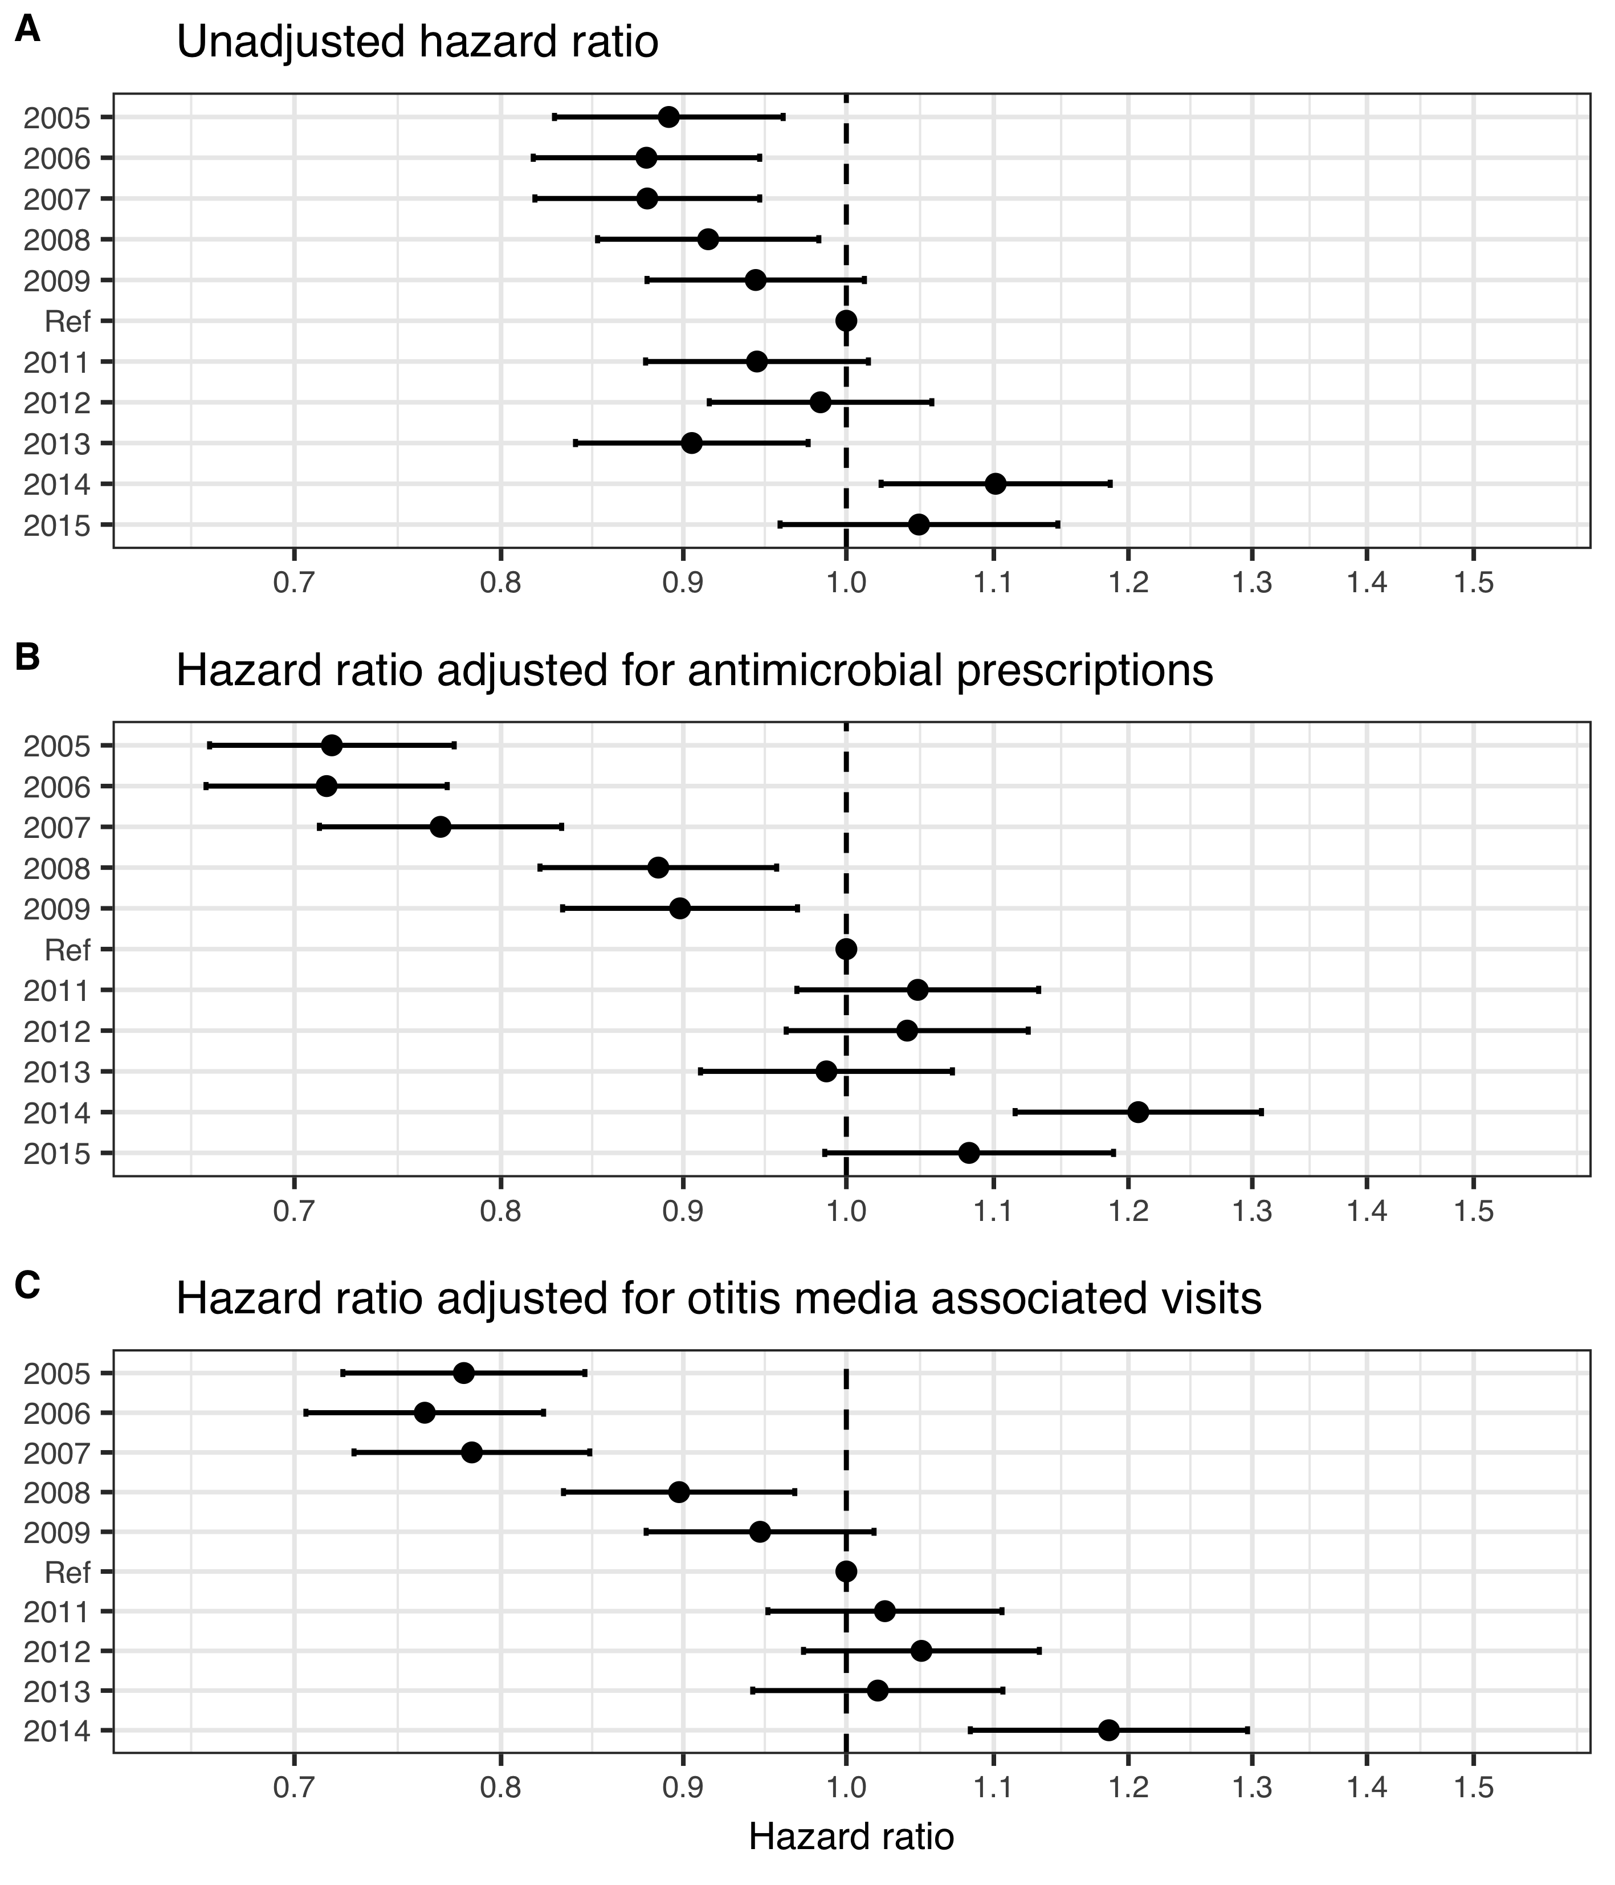

Figure . The hazard ratio (HR) of tympanostomy tube placements (TTP) is depicted between each birth-cohort and the last vaccine non-eligible birth-cohort, as estimated by three Cox regression models.

In panel A, the unadjusted HR estimates are shown. Panel B shows HR estimates adjusted for antimicrobial prescriptions, and panel C illustrates the HR estimates adjusted for otitis media associated visits. Primary care visits are obtained from the Primary Care Registry of the Directorate of Health, and the observation period is restricted to December 2015. Because of this the data presented in panel C is restricted to birth-cohorts 2005-2014. The figure demonstrates an increasing hazard of TTP with each successive birth-cohort. The effect is more pronounced when adjustment is made for antimicrobial prescriptions and visits.

## Impact on respiratory associated hospitalizations (Paper V)

Demographic data regarding the study birth-cohorts are summarized in chapter 4.1. In total, 51,264 children were followed for a median of 1,096 days (range 6-1,096) resulting in 142,315 person-years of follow-up time. Of those, 1,414 children were admitted to hospital 1,703 times with diagnoses compatible with the study’s diagnostic groups. The total number of hospital admissions regardless of indication was 4,842. An overview of the demographic data is presented in Table 35.

Table . An overview of the birth-cohorts included in paper V.

The total number of hospitalizations, hospital admissions due to the study’s diagnoses, and admissions to the intensive care unit (ICU) are presented. The number of children is presented within parentheses. The proportion of all hospital admissions that were due to the study’s diagnoses is shown. The observational period is 1 January 2005 to 31 December 2017. Birth-cohorts 2014 and 2015 do not attain full follow-up time, as indicated by fewer person-years included in the study.

|  |  |  |  |  |  |
| --- | --- | --- | --- | --- | --- |
| Birth-cohort | No. children (person-years) | All cause admissions | Study admissions, *n* (children) | Prop. due to study diagnoses, *%* | ICU, *n* (children) |
| 2005 | 4,541 (13,277) | 446 | 219 (160) | 49.1 | 7 (7) |
| 2006 | 4,668 (13,658) | 415 | 176 (140) | 42.4 | 10 (8) |
| 2007 | 4,770 (13,985) | 423 | 186 (160) | 44.0 | 6 (5) |
| 2008 | 4,953 (14,472) | 442 | 117 (101) | 26.5 | 5 (4) |
| 2009 | 5,130 (14,965) | 484 | 124 (109) | 25.6 | 7 (6) |
| 2010 | 4,988 (14,592) | 384 | 158 (138) | 41.1 | 7 (7) |
| 2011 | 4,644 (13,640) | 392 | 129 (112) | 32.9 | 4 (4) |
| 2012 | 4,668 (13,753) | 576 | 196 (155) | 34.0 | 0 (0) |
| 2013 | 4,442 (13,044) | 472 | 149 (119) | 31.6 | 9 (8) |
| 2014 | 4,446 (10,930) | 431 | 144 (122) | 33.4 | 6 (5) |
| 2015 | 4,136 (6,140) | 377 | 105 (98) | 27.9 | 3 (3) |

Of the children in the study birth-cohorts, 550 were hospitalized 660 times with ICD-10 discharge diagnoses consistent with pneumonia. In the same cohorts, 508 children were admitted 550 times with diagnoses consistent with other acute lower respiratory tract infections. In the vaccine non-eligible cohorts, the crude incidence rate of pneumonia requiring hospital admission was 4.94 per 1,000 person-years, which decreased to 4.18 per 1,000 in the vaccine eligible cohorts. The analogous crude incidence rate of hospitalizations for other acute lower respiratory tract infections was 2.94 and 5.23 per 1,000 person-years. Though the absolute number of admissions was similar between these two groups, the distribution of cases was different. The crude incidence rate of hospital admissions for pneumonia was highest in children 12-17 months of age, while the incidence rate of hospitalizations for other lower respiratory tract infections was highest in children <6 months of age (Figure 21). Children admitted for other acute lower respiratory tract infections were significantly younger than children admitted for pneumonia (mean age 8.0 months and 13.6 months respectively, P<.001). Using crude age-group stratified incidence rate ratios between the vaccine eligible and non-eligible cohorts, the incidence rate of pneumonia hospitalizations was found to have decreased significantly only among children 12-17 months of age, crude incidence rate ratio 0.52 (95%CI: 0.35-0.77). Using the same method, the incidence rate of hospital admissions for other acute lower respiratory tract infections admissions was found to have increased significantly among children 0-5 months of age, crude incidence rate ratio 1.50 (95%CI 1.23-1.84).

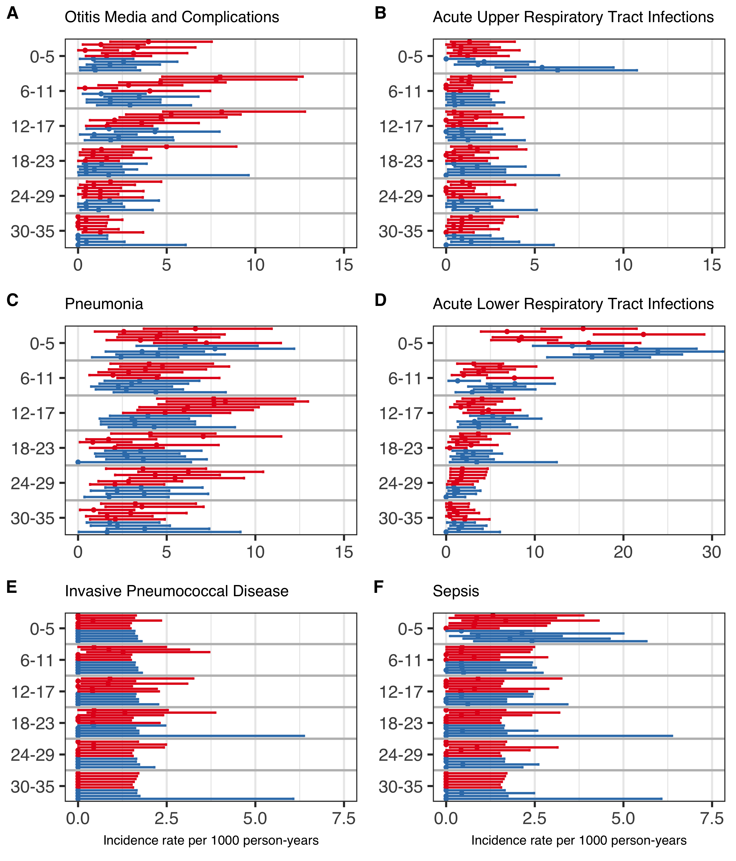

Figure . Crude incidence rates (IR) of the six diagnostic groups (A-F) per 1,000 person-years for each of the birth-cohorts.

Panels A-D and F depict the IR of admissions based on the International Classification of Diseases, 10th revision (ICD-10) discharge diagnoses, while panel E depicts the IR of admissions with culture confirmed invasive pneumococcal disease (IPD), regardless of ICD-10 diagnosis. Birth-cohorts are compared in six-month age-groups which are illustrated on the Y-axis. The vaccine non-eligible cohorts (VNEC) are illustrated in red and the vaccine eligible cohorts (VEC) in blue.

A significant difference was detected in the cumulative rate of hospital admissions for both pneumonia and acute lower respiratory tract infections between the vaccine eligible and non-eligible cohorts (Figure 22). The hazard ratio of hospital admission for pneumonia was 0.80 (95%CI:0.67-0.95), with an E-value of 1.81 and a lower bound of 1.29. When the risk-set was restricted to children younger than 90 days and 90 days and older, respectively, the hazard ratio was 1.22 (95%CI 0.81-1.85) and 0.73 (95%CI 0.60-0.89) respectively. The hazard ratio for hospital admission due to acute lower respiratory tract infection was 1.32 (95%CI:1.14-1.53), with an E-value of 1.97 and a lower bound of 1.54. The hazard ratio was augmented when children younger than 90 days were analyzed separately, HR 1.54 (95%CI 1.23-1.94). It was not significant in children 90 days and older, HR 1.18 (95%CI 0.97-1.44).

A total of 131 hospitalizations for acute upper respiratory tract infections were recorded for 123 children. During the same period, 256 children were admitted to hospital 280 times for otitis media and complications. The crude incidence rate of hospital admissions for otitis media was higher than the incidence rate of admissions for acute upper respiratory tract infections; 2.32 and 1.45 per 1,000 person-years in the vaccine eligible and vaccine non-eligible cohorts respectively, compared to 0.78 and 1.13 per 1,000 person-years. The mean age of children admitted for acute upper respiratory tract infections was 13.5 months compared to 12.8 months for children admitted for otitis media and complications. The crude incidence rate by age-group is shown in Figure 21. The cumulative incidence rate of hospitalization per 1000 person-years for acute upper respiratory tract infections and otitis media and complications are shown in Figure 22. The hazard ratio of otitis media hospitalizations between the vaccine eligible and non-eligible cohorts was 0.57 (95%CI:0.43-0.73) with an E-value of 2.9 .and a lower bound of 2.08. When restricted to children younger than 90 days of age, the hazard ratio was 0.72 (95%CI 0.33-1.57), and when evaluating children 90 days and older it was 0.55 (95%CI 0.42-0.72). The hazard ratio for hospital admission for acute upper respiratory tract infections was 1.56 (95%CI:1.11-2.19), with an E-value of 2.49 and a lower bound of 1.46. Among children younger than 90 days, and 90 days and older respectively, the hazard ratio was 3.4 (95%CI 1.72-6.90) and 1.13 (95%CI 0.75-1.71).

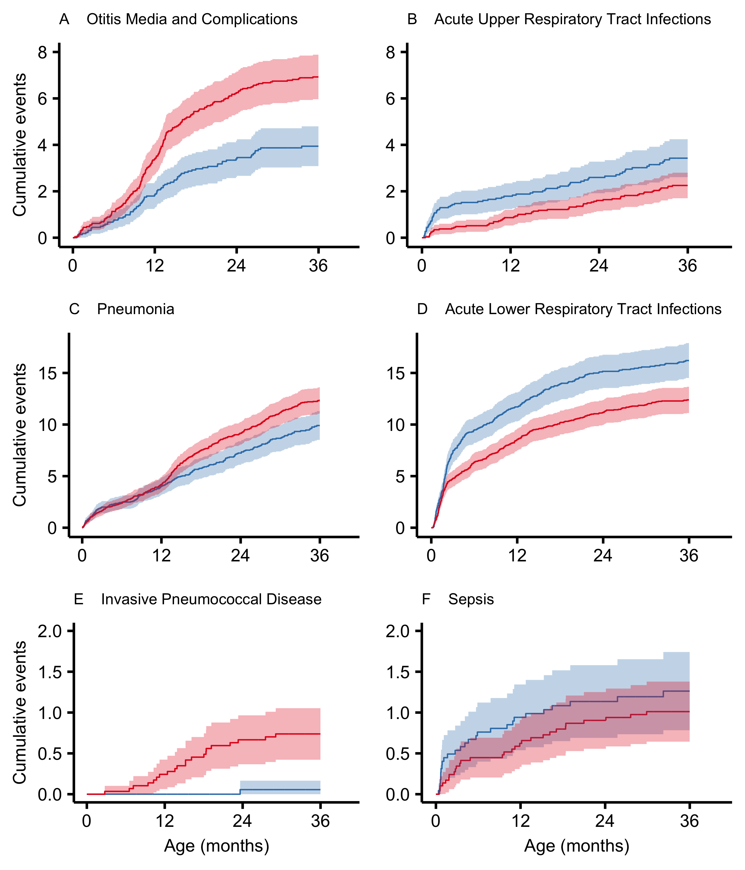

Figure . Kaplan-Meier cumulative event curves per 1,000 person-years for each of the diagnostic groups.

The vaccine non-eligible cohorts (VNEC) are illustrated in red and the vaccine eligible cohorts (VEC) in blue. The 95% confidence intervals are represented with a shaded area. The Y-axis is scaled independently for each pair of diagnostic groups (A-B, C-D and E-F).

A total of 15 children were admitted to hospital 19 times for meningitis, and 61 children were admitted 63 times for sepsis. The crude incidence rate of meningitis hospitalization was 16.5 and 8.7 per 100,000 person-years in the vaccine non-eligible and vaccine eligible cohorts respectively, and the analogous crude incidence rate for sepsis hospitalizations was 38.8 and 52.3. Culture confirmed invasive pneumococcal disease was diagnosed in 37 children under three years of age in the study birth-cohorts. Of those, 23 (59%) were admitted for inpatient treatment. Of the admitted children, eight children had a primary discharge diagnosis of Sepsis due to Streptococcus pneumoniae (A40.3), eight were diagnosed with Pneumococcal meningitis (G00.1), two with Pneumonia due to Streptococcus pneumoniae (J13), two with Bacterial pneumonia, not elsewhere classified (J15) and the remaining three were diagnosed with Bacterial meningitis, unspecified (G00.9), Pyogenic arthritis, unspecified (M00.9) and Fever, unspecified (R50.9). The crude incidence of invasive pneumococcal disease, regardless of whether the child was admitted to hospital, was 24.7 per 100,000 person-years in the VNEC compared to 1.74 per 100,000 person-years in the VEC. When only considering hospitalized invasive pneumococcal disease, the crude IR was 24.7 and 1.74 per 100,000 person-years. No vaccine-type invasive pneumococcal disease was diagnosed in the VEC. Crude incidence rates of hospitalization by age-group are shown in Figure 21.

Table . Hazard ratios (HR) between the vaccine eligible (VEC) and vaccine non-eligible birth-cohorts (VNEC) for each disease-group.

A HR lower than one indicates a relative decrease in disease-group in the VEC compared to the VNEC, while a HR higher than one indicates an increase. A HR was not calculated for vaccine-type invasive pneumococcal disease as not cases were diagnosed and the VEC.

|  |  |
| --- | --- |
| Disease group | Hazard ratio (95%CI) |
| Otitis Media and Complications | 0.56 (0.44-0.73) |
| Acute upper respiratory infection | 1.55 (1.10-2.18) |
| Pneumonia | 0.80 (0.67-0.95) |
| Acute Lower Respiratory Tract Infections | 1.32 (1.14-1.53) |
| Sepsis | 1.26 (0.74-2.12) |
| Invasive Pneumococcal Disease | 0.07 (0.01-0.50) |

The mean age of children admitted for meningitis, sepsis and invasive pneumococcal disease was 9.7 months, 8.4 months and 14.4 months respectively. The cumulative incidence rates of hospitalization per 1000 person-years for sepsis and invasive pneumococcal disease are depicted in Figure 22. The hazard ratio of hospitalization for meningitis between the vaccine eligible and non-eligible cohorts was 0.45 (95%CI 0.15-1.41). An E-value was not computed as the hazard ratio was not significant. The hazard ratio for hospital admissions due to invasive pneumococcal disease between the vaccine eligible and vaccine non-eligible cohorts was 0.07 (95%CI:0.01-0.50), with an E-value of 28.06. and a lower bound of 3.41. The hazard ratio of a sepsis hospitalization between the vaccine eligibility cohorts was 1.26 (95%CI:0.75-2.13). No E-value was calculated as the ratio was not significant. Restricted analyses in these three diagnostic groups did not alter results significantly.

## Impact and cost-effectiveness analysis (Paper VI)

### Population impact on acute otitis media among children younger than 20 years of age

From 1 January 2005 to 31 December 2015, children younger than 20 years of age visited primary care physicians 164,453 times for acute otitis media and its complications. Strong seasonal variation was detected, with more visits occurring in December through March, and few visits occurring in June and July (Panels A and B of Figure 23). The monthly number of AOM visits during the post-vaccine period was lower than average in all age-groups (Panel B of Figure 23). Though visits regardless of diagnosis also decreased during the post-vaccine period (Panel C of Figure 23), the degree by which visits for AOM decreased was larger in magnitude.

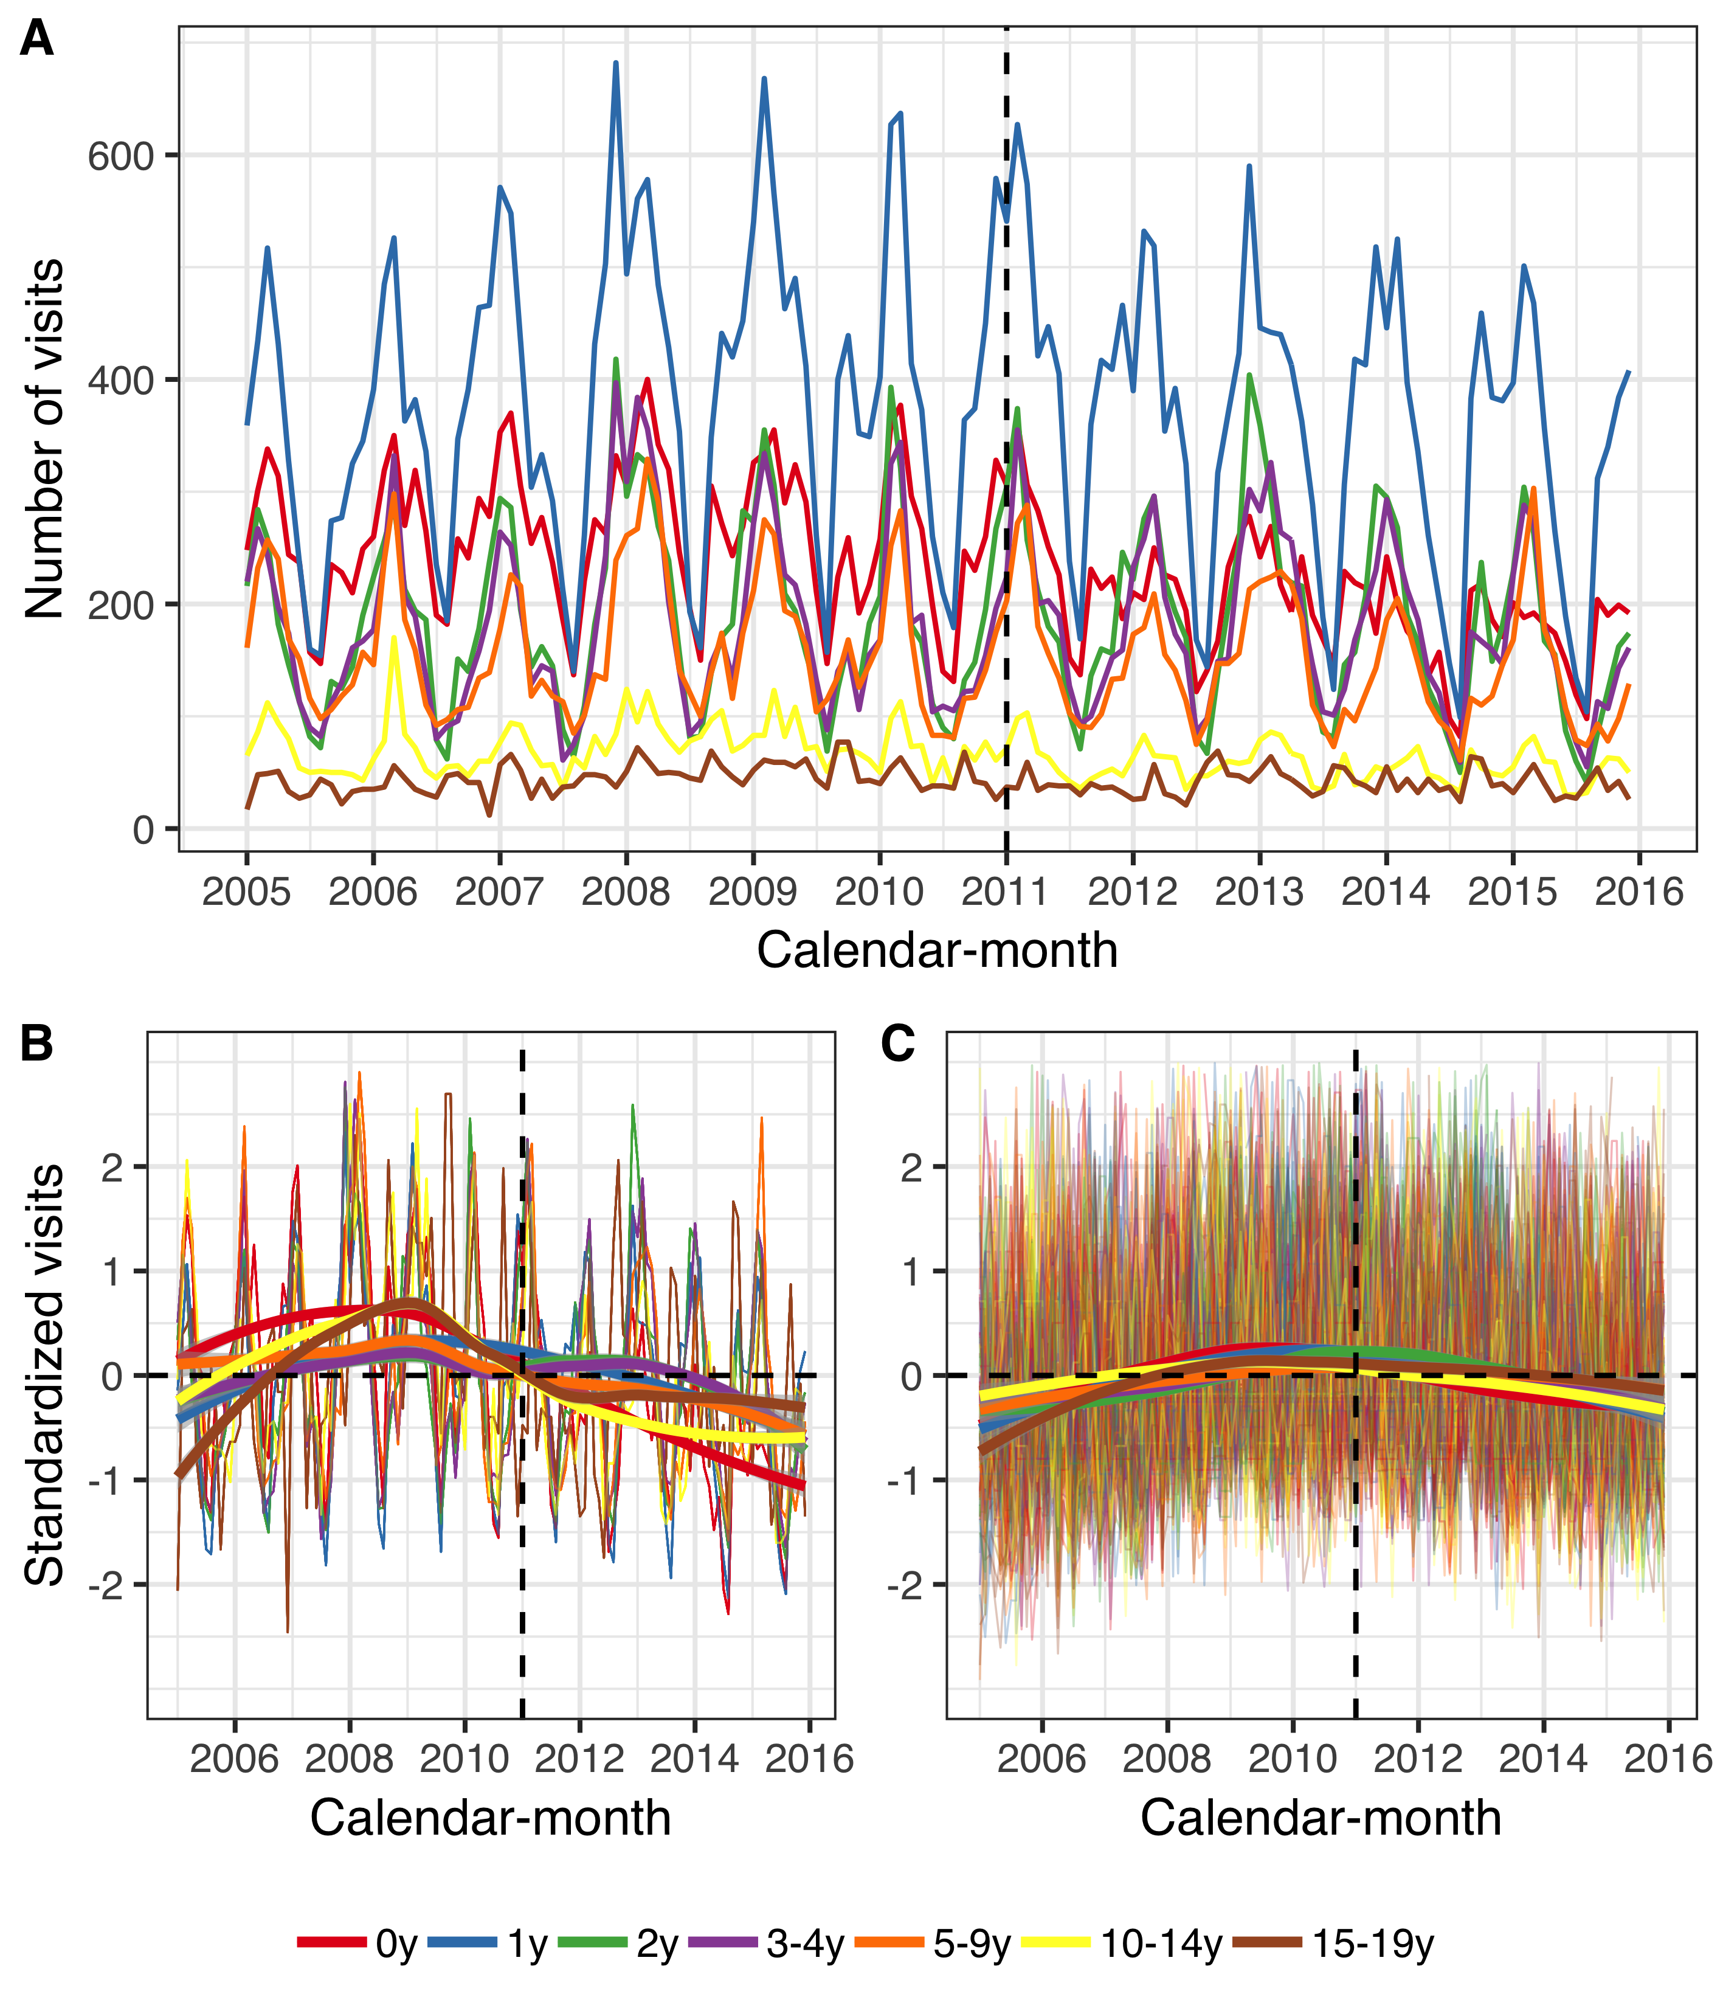

Figure . The number of primary care visits among children younger than 20 years of age per calendar-month from 1 January 2005 to 31 December 2015.

Children are divided into seven age-groups, listed in the figure legend. Panel A shows the monthly number of visits due to acute otitis media and its complications (AOM). Panels B and C, depict the standardized monthly number of AOM visits (Panel B) and all other visits (Panel C) per age-group. The Y-axis represents the number of standard deviations the observed visits are from the mean of the entire period for each diagnosis and age-group. The horizontal dotted lines represent values that are zero standard deviations from the mean and the vertical dotted lines represent the beginning of the vaccine intervention. Locally estimated scatter-plot smoothing (LOESS) is used to produce an average trend. Panels B and C suggest that the number of both AOM visits and all other visits have decreased in the post-vaccine period, and that AOM visits have decreased to a larger degree.

The posterior predictions of the component models are shown in Figure 24. Each posterior prediction is based on the median of the corresponding marginal posterior predictive distribution. The ITS model with offset consistently predicted the fewest visits in the post-vaccine period. The ITS model without offset consistently predicted the highest number of visits.

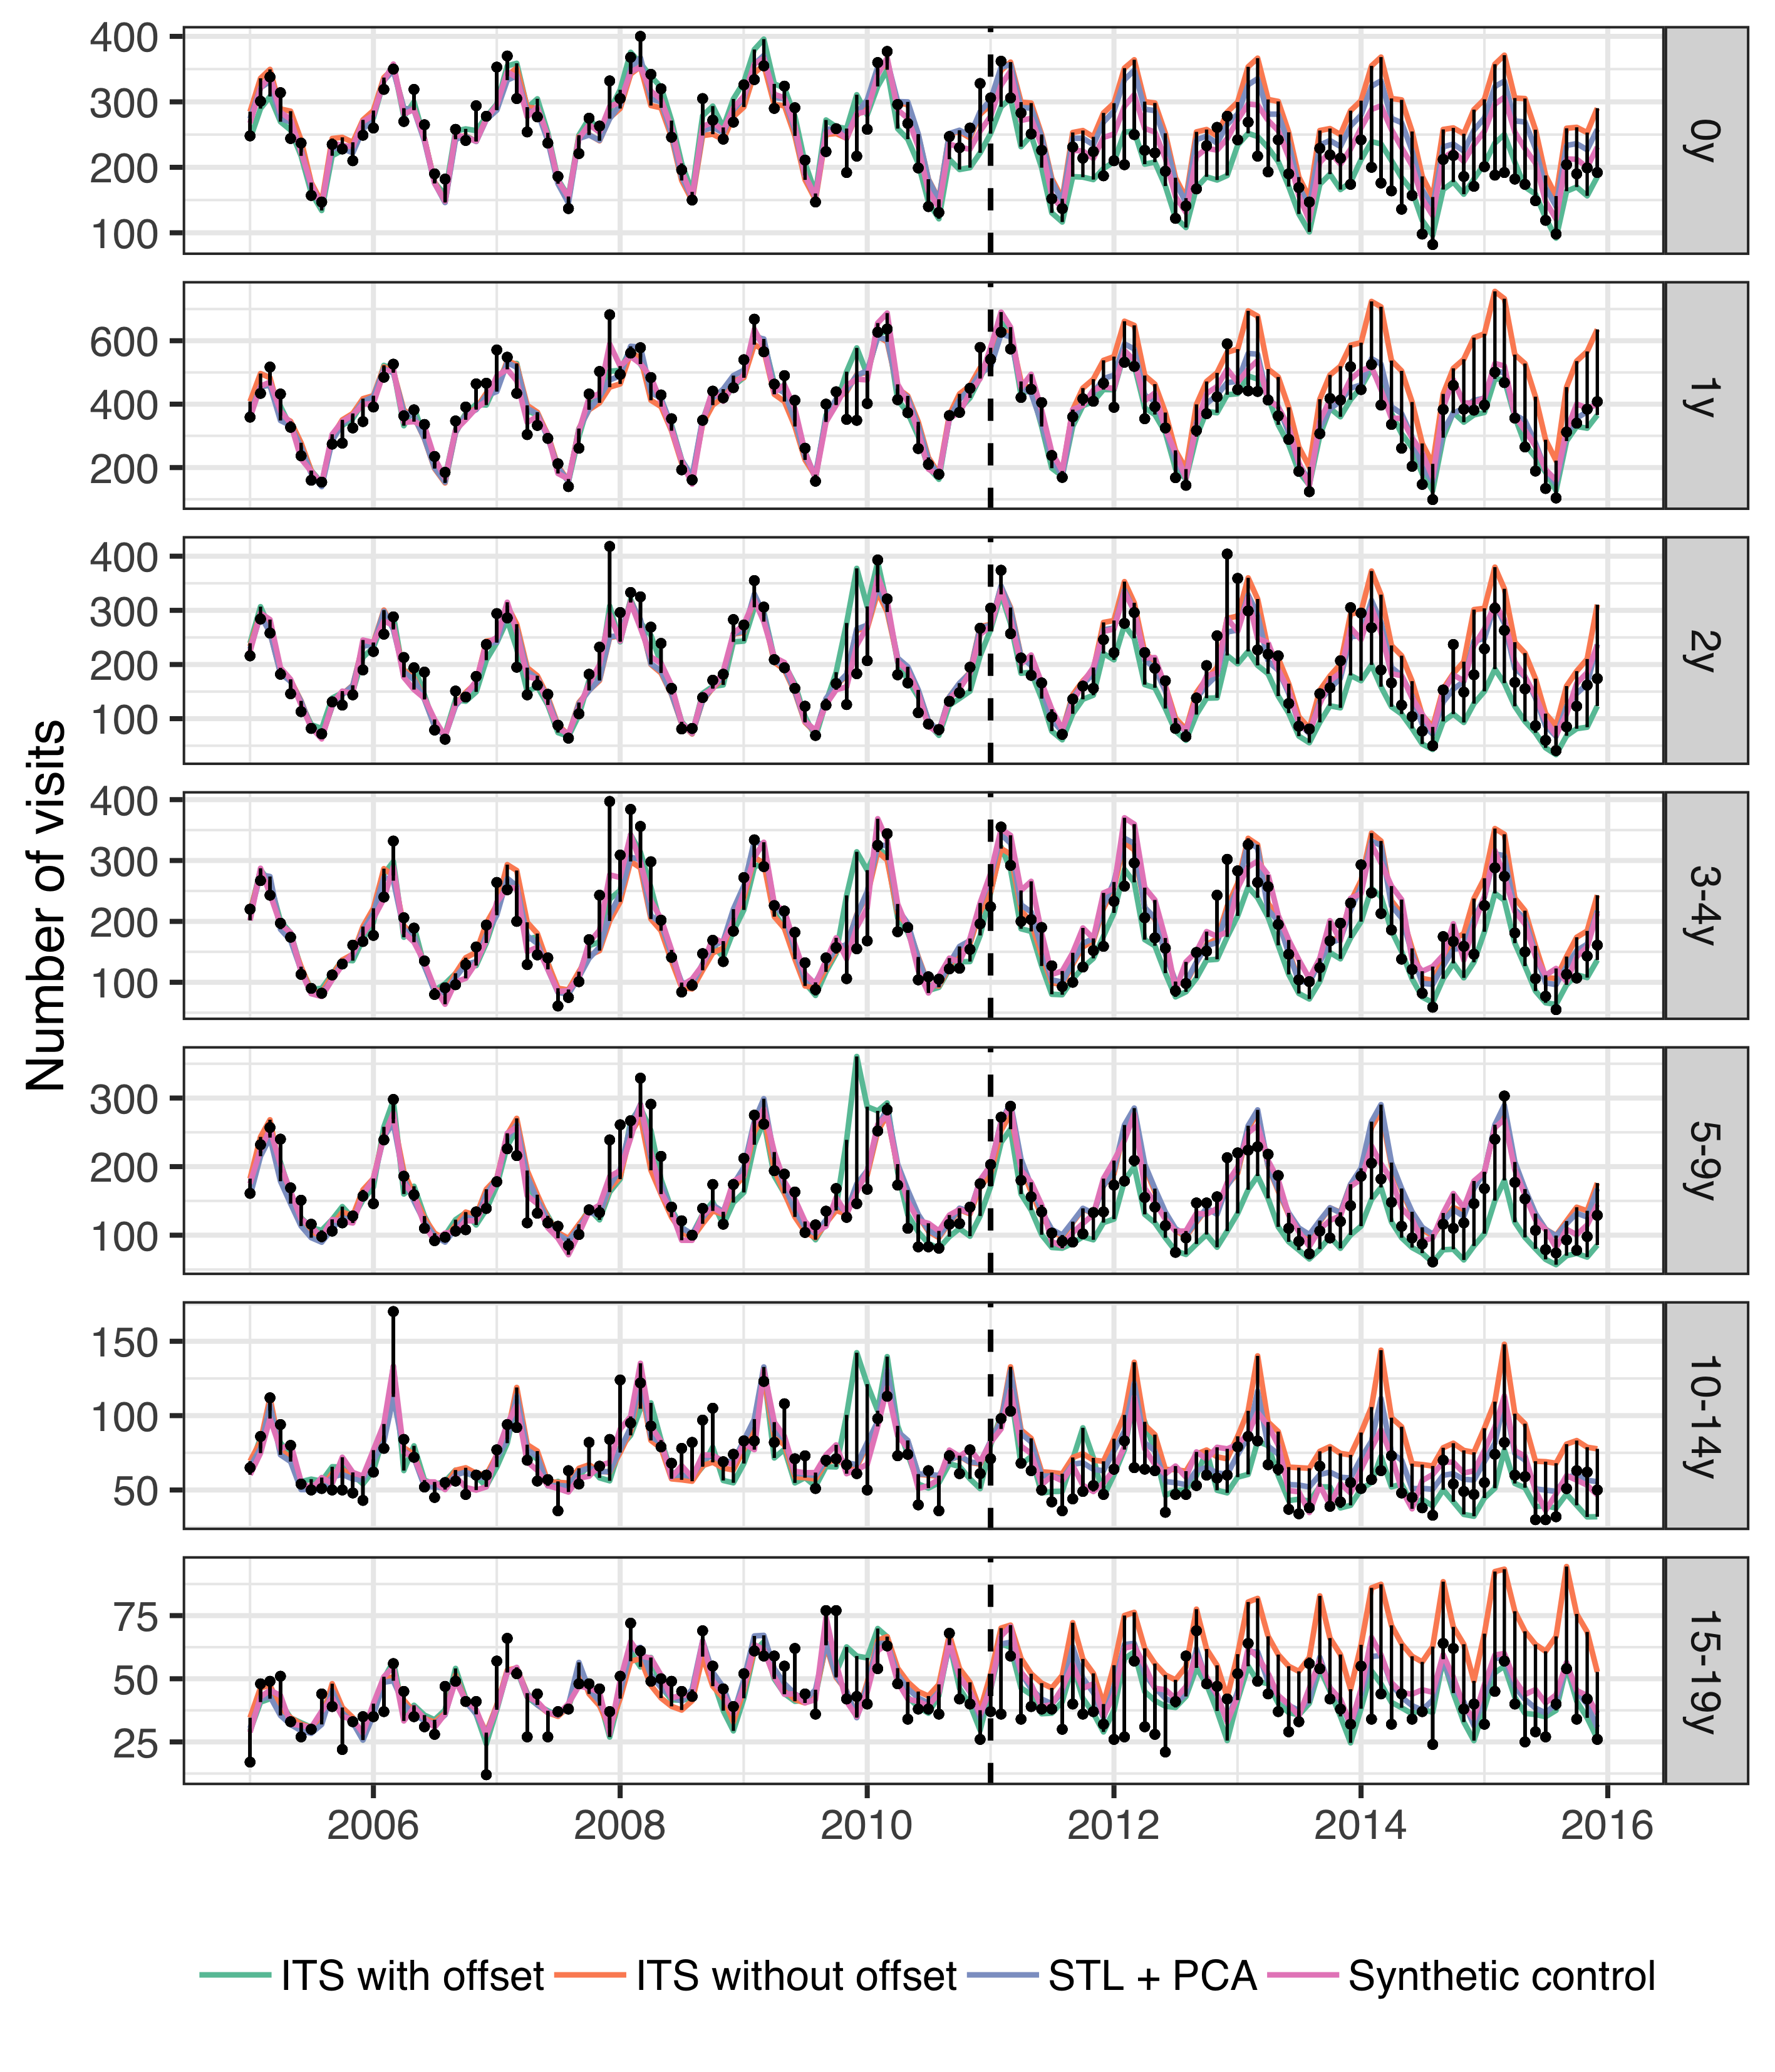

Figure . The observed and predicted number of visits for acute otitis media and its complications (AOM) from 1 January 2005 to 31 December 2015 for each age-group.

Observed visits are illustrated as black points and the predicted number of visits are drawn as lines for each of the component models. The start of the vaccine period is delineated with a vertical black dotted line. Each component model was fitted to the observed visits in the pre-vaccine period, and then used to predict the number of visits in the post-vaccine period, had the vaccine not been introduced. The distance between the observed and predicted visits for each calendar-month is depicted with a thin black line. Longer distances suggest a larger discrepancy. Note that the scale of the Y-axis differs between age-groups.

These component models were stacked using LOOCV to produce the final stacked model. The weights used to stack the component models are shown in Table 37.

Table . The weights used to produce the final stacked model from the component models.

The weights for each component model were obtained by minimizing the leave-one-out mean squared error.

|  |  |  |  |  |  |
| --- | --- | --- | --- | --- | --- |
| Disease category | Age-group | Synthetic controls | ITS with offset | ITS without offset | STL + PCA |
| AOM visits | 0y | 0.221 | 0.000 | 0.121 | 0.659 |
| 1y | 0.149 | 0.000 | 0.610 | 0.241 |
| 2y | 0.000 | 0.000 | 0.479 | 0.521 |
| 3-4y | 0.661 | 0.000 | 0.339 | 0.000 |
| 5-9y | 0.726 | 0.000 | 0.274 | 0.000 |
| 10-14y | 1.000 | 0.000 | 0.000 | 0.000 |
| 15-19y | 0.018 | 0.000 | 0.078 | 0.904 |
| Pneumonia hospitalizations | 0-4y | 0.912 | 0.001 | 0.087 | 0.000 |
| 5-19y | 1.000 | 0.000 | 0.000 | 0.000 |
| 20-39y | 0.246 | 0.124 | 0.000 | 0.629 |
| 40-64y | 0.241 | 0.000 | 0.000 | 0.759 |
| 65-79y | 0.000 | 0.934 | 0.066 | 0.000 |
| 80+ | 0.000 | 0.472 | 0.528 | 0.000 |
| IPD hospitalizations | 0-4y | 0.001 | 0.999 | 0.000 | 0.000 |
| 5-64y | 1.000 | 0.000 | 0.000 | 0.000 |
| 65y+ | 1.000 | 0.000 | 0.000 | 0.000 |

The posterior predicted AOM visits and 95% credible intervals are shown in Figure 25. With few exceptions, the observed number of AOM visits are fewer than predicted in the post-vaccine period, indicating that the vaccine prevented visits from occurring.

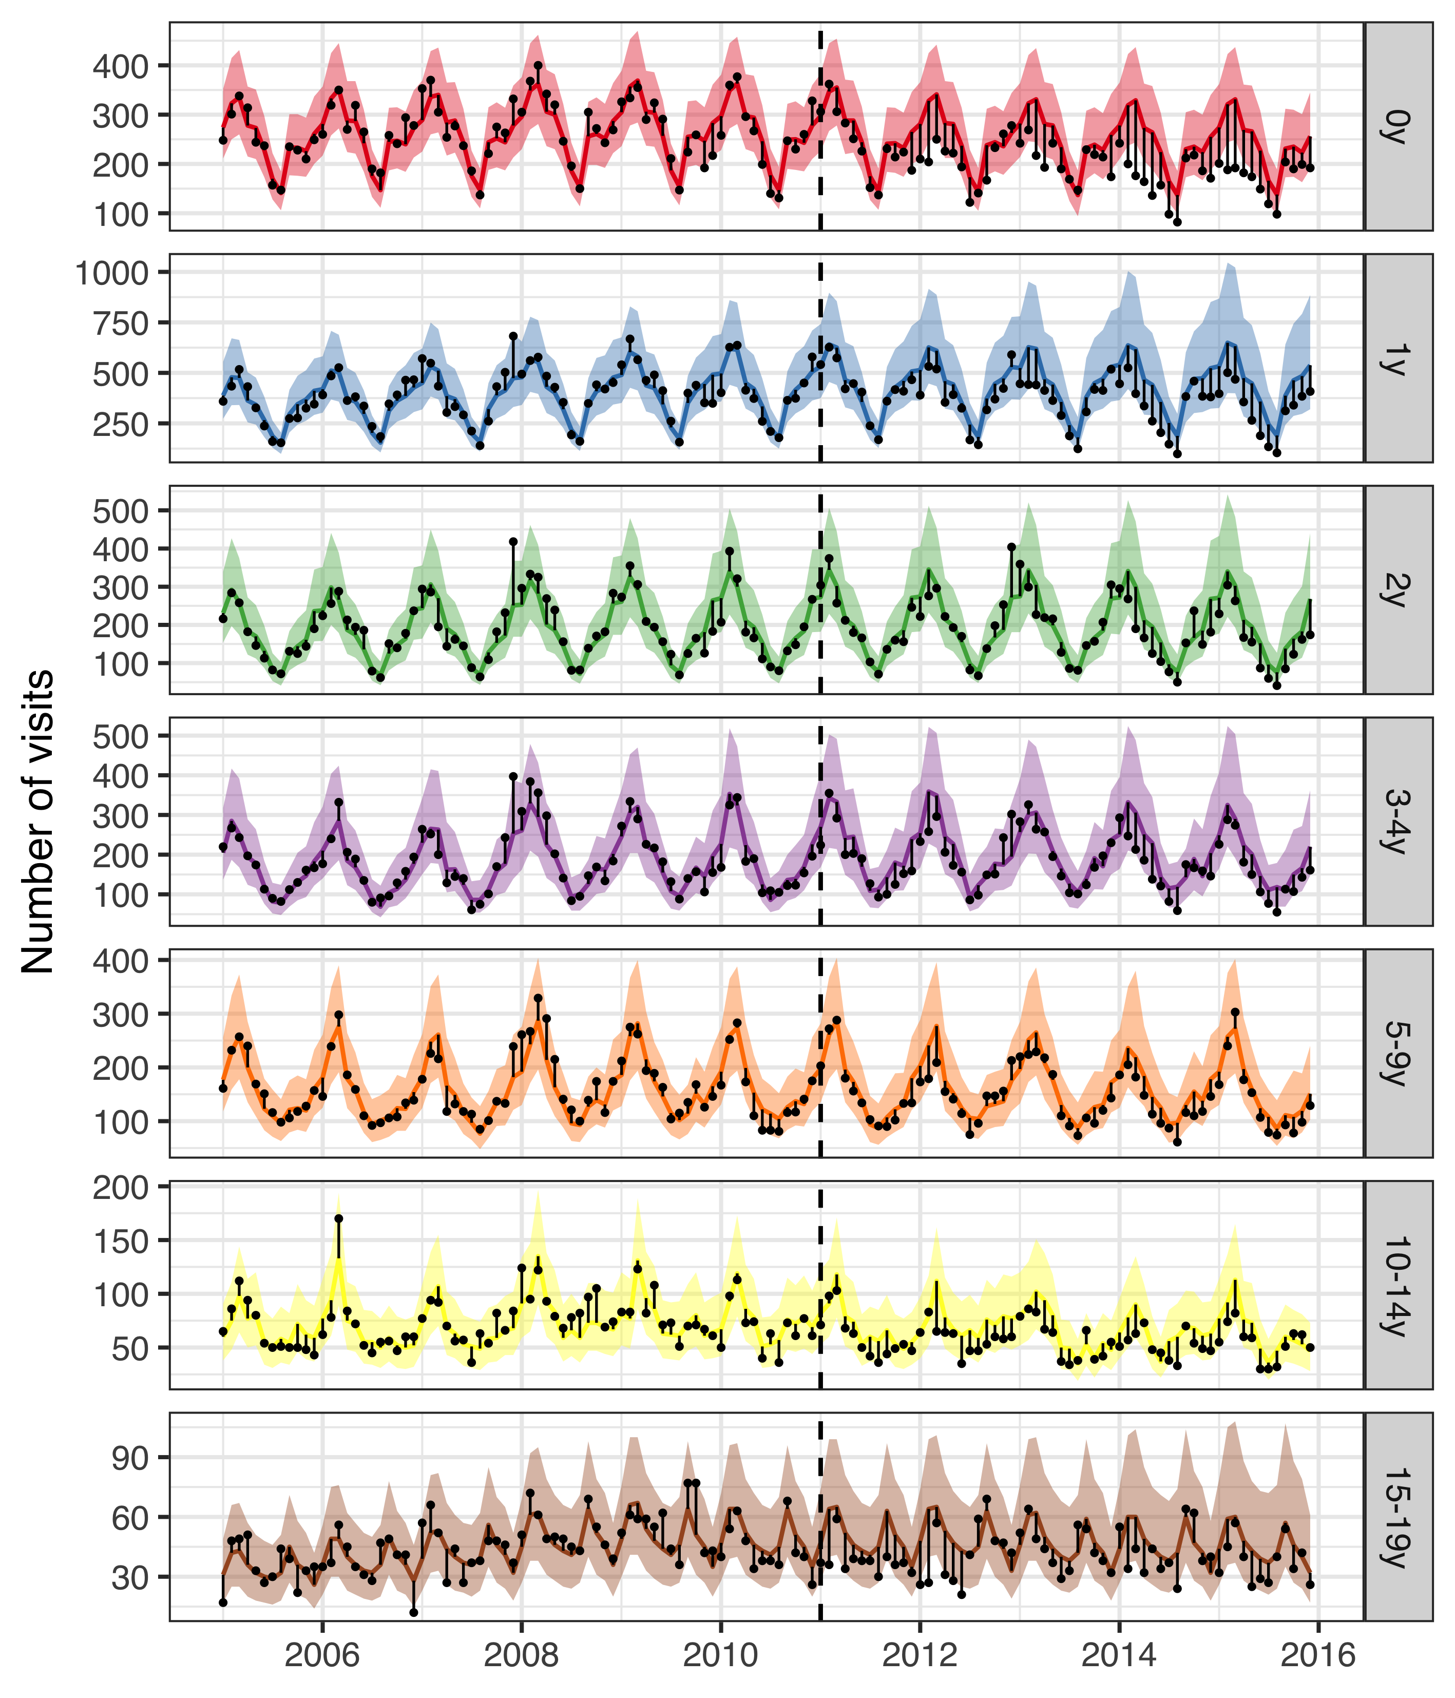

Figure . The observed and predicted number of AOM visits from 1 January 2005 to 31 December 2015 for each age-group.

Observed visits are illustrated as black points, the posterior predicted visits are presented as lines and 95% credible intervals as a shaded area. The start of the vaccine period is delineated with a vertical black dotted line. The distance between the observed and predicted visits for each calendar-month is depicted with a thin black line. Assuming that the model is correct, and that no intervention had taken place, the black points would have an equal probability of occurring above and below the prediction line. Points below the lower bound of the shaded area would then represent observations that would have had less than a 2.5% probability of occurring. Given that the majority of points are located below the prediction line, and many located below the lower bound of the shaded area, the figure suggests that the vaccine resulted in fewer AOM visits. Note that the scale of the Y-axis differs between age-groups.

The rate ratios between the observed and predicted number of AOM cases are shown in Table 38. The 95% credible interval of the rate ratio was lower than one in all age-groups, indicating that there was a 97.5% or greater probability that the rate of AOM decreased due to the introduction of PHiD-CV10 in all age-groups. The decrease was largest among young children; 16% (12%-36%) in children younger than one year of age and 18% (5%-42%) in children one year of age. A 12-month rolling rate ratio between the observed and predicted number of AOM cases is presented in Panel A of Figure 26. Visually, the rate of AOM cases among children younger than one seems to begin to decline in January 2012, and cases among children one year of age seems to decline in July 2012.

Table 38 The rate ratio between observed and predicted number of primary care visits due acute otitis media and complications (AOM) during the post-vaccine period (2013-2015

Table . The rate ratio between observed and predicted number of primary care visits due acute otitis media and complications (AOM) during the post-vaccine period (2013-2015)

, is presented with 95% credible intervals (95% CI) for the seven age-groups included in the study. The predicted cumulative number of prevented cases as of 1 December 2015 is also presented. A negative number indicates that there is a non-zero probability that the vaccine caused more AOM visits to occur. Direct and indirect savings are presented in constant 2015 USD.

|  |  |  |  |  |
| --- | --- | --- | --- | --- |
| Age-group | Rate ratio (95% CI) | Cumulative prevented  (95% CI) | Direct savings  (95% CI) | Indirect savings (95% CI) |
| 0y | 0.74  (0.64-0.88) | 3,234  (1,008 to 5,195) | 305,330$ (90,933$ to 514,848$) | 45,386$ (11,143$ to 84,654$) |
| 1y | 0.72  (0.58-0.95) | 5,802  (817 to 11,526) | 530,468$ (57,564$ to 1,150,759$) | 74,298$  (3,778$ to 193,180$) |
| 2y | 0.88  (0.66-0.98) | 900  (-185 to 3,817) | 92,117$  (-52,649$ to 407,227$) | 14,377$  (-11,004$ to 64,562$) |
| 3-4y | 0.86  (0.69-0.97) | 1,702  (21 to 3,576) | 135,274$  (-16,985$ to 357,905$) | 23,880$  (-4,324$ to 62,811$) |
| 5-9y | 0.88  (0.73-0.96) | 979  (229 to 2,521) | 134,548$  (-38,612$ to 430,729$) | 14,242$  (-1,030$ to 40,961$) |
| 10-14y | 0.83  (0.75-0.92) | 720  (411 to 1,086) | 113,333$ (4,669$ to 285,816$) | 10,313$  (-3,098$ to 20,035$) |
| 15-19y | 0.89  (0.56-0.98) | 430  (210 to 1,689) | 55,819$  (-8,278$ to 227,493$ | 6,169$  (698$ to 25,248$) |

The cumulative number of prevented AOM cases reflect both the rate of AOM cases in each age-group, and the consistency and magnitude of the vaccine effect. The cumulative prevented cases per age-group as of December 2015 are presented Table 38. The largest effects are seen in the youngest age-groups, who both had the highest baseline rates and experienced the largest relative declines following vaccine introduction. The cumulative number of prevented cases as a function of time during the post-vaccine period is shown in Panel B of Figure 26.

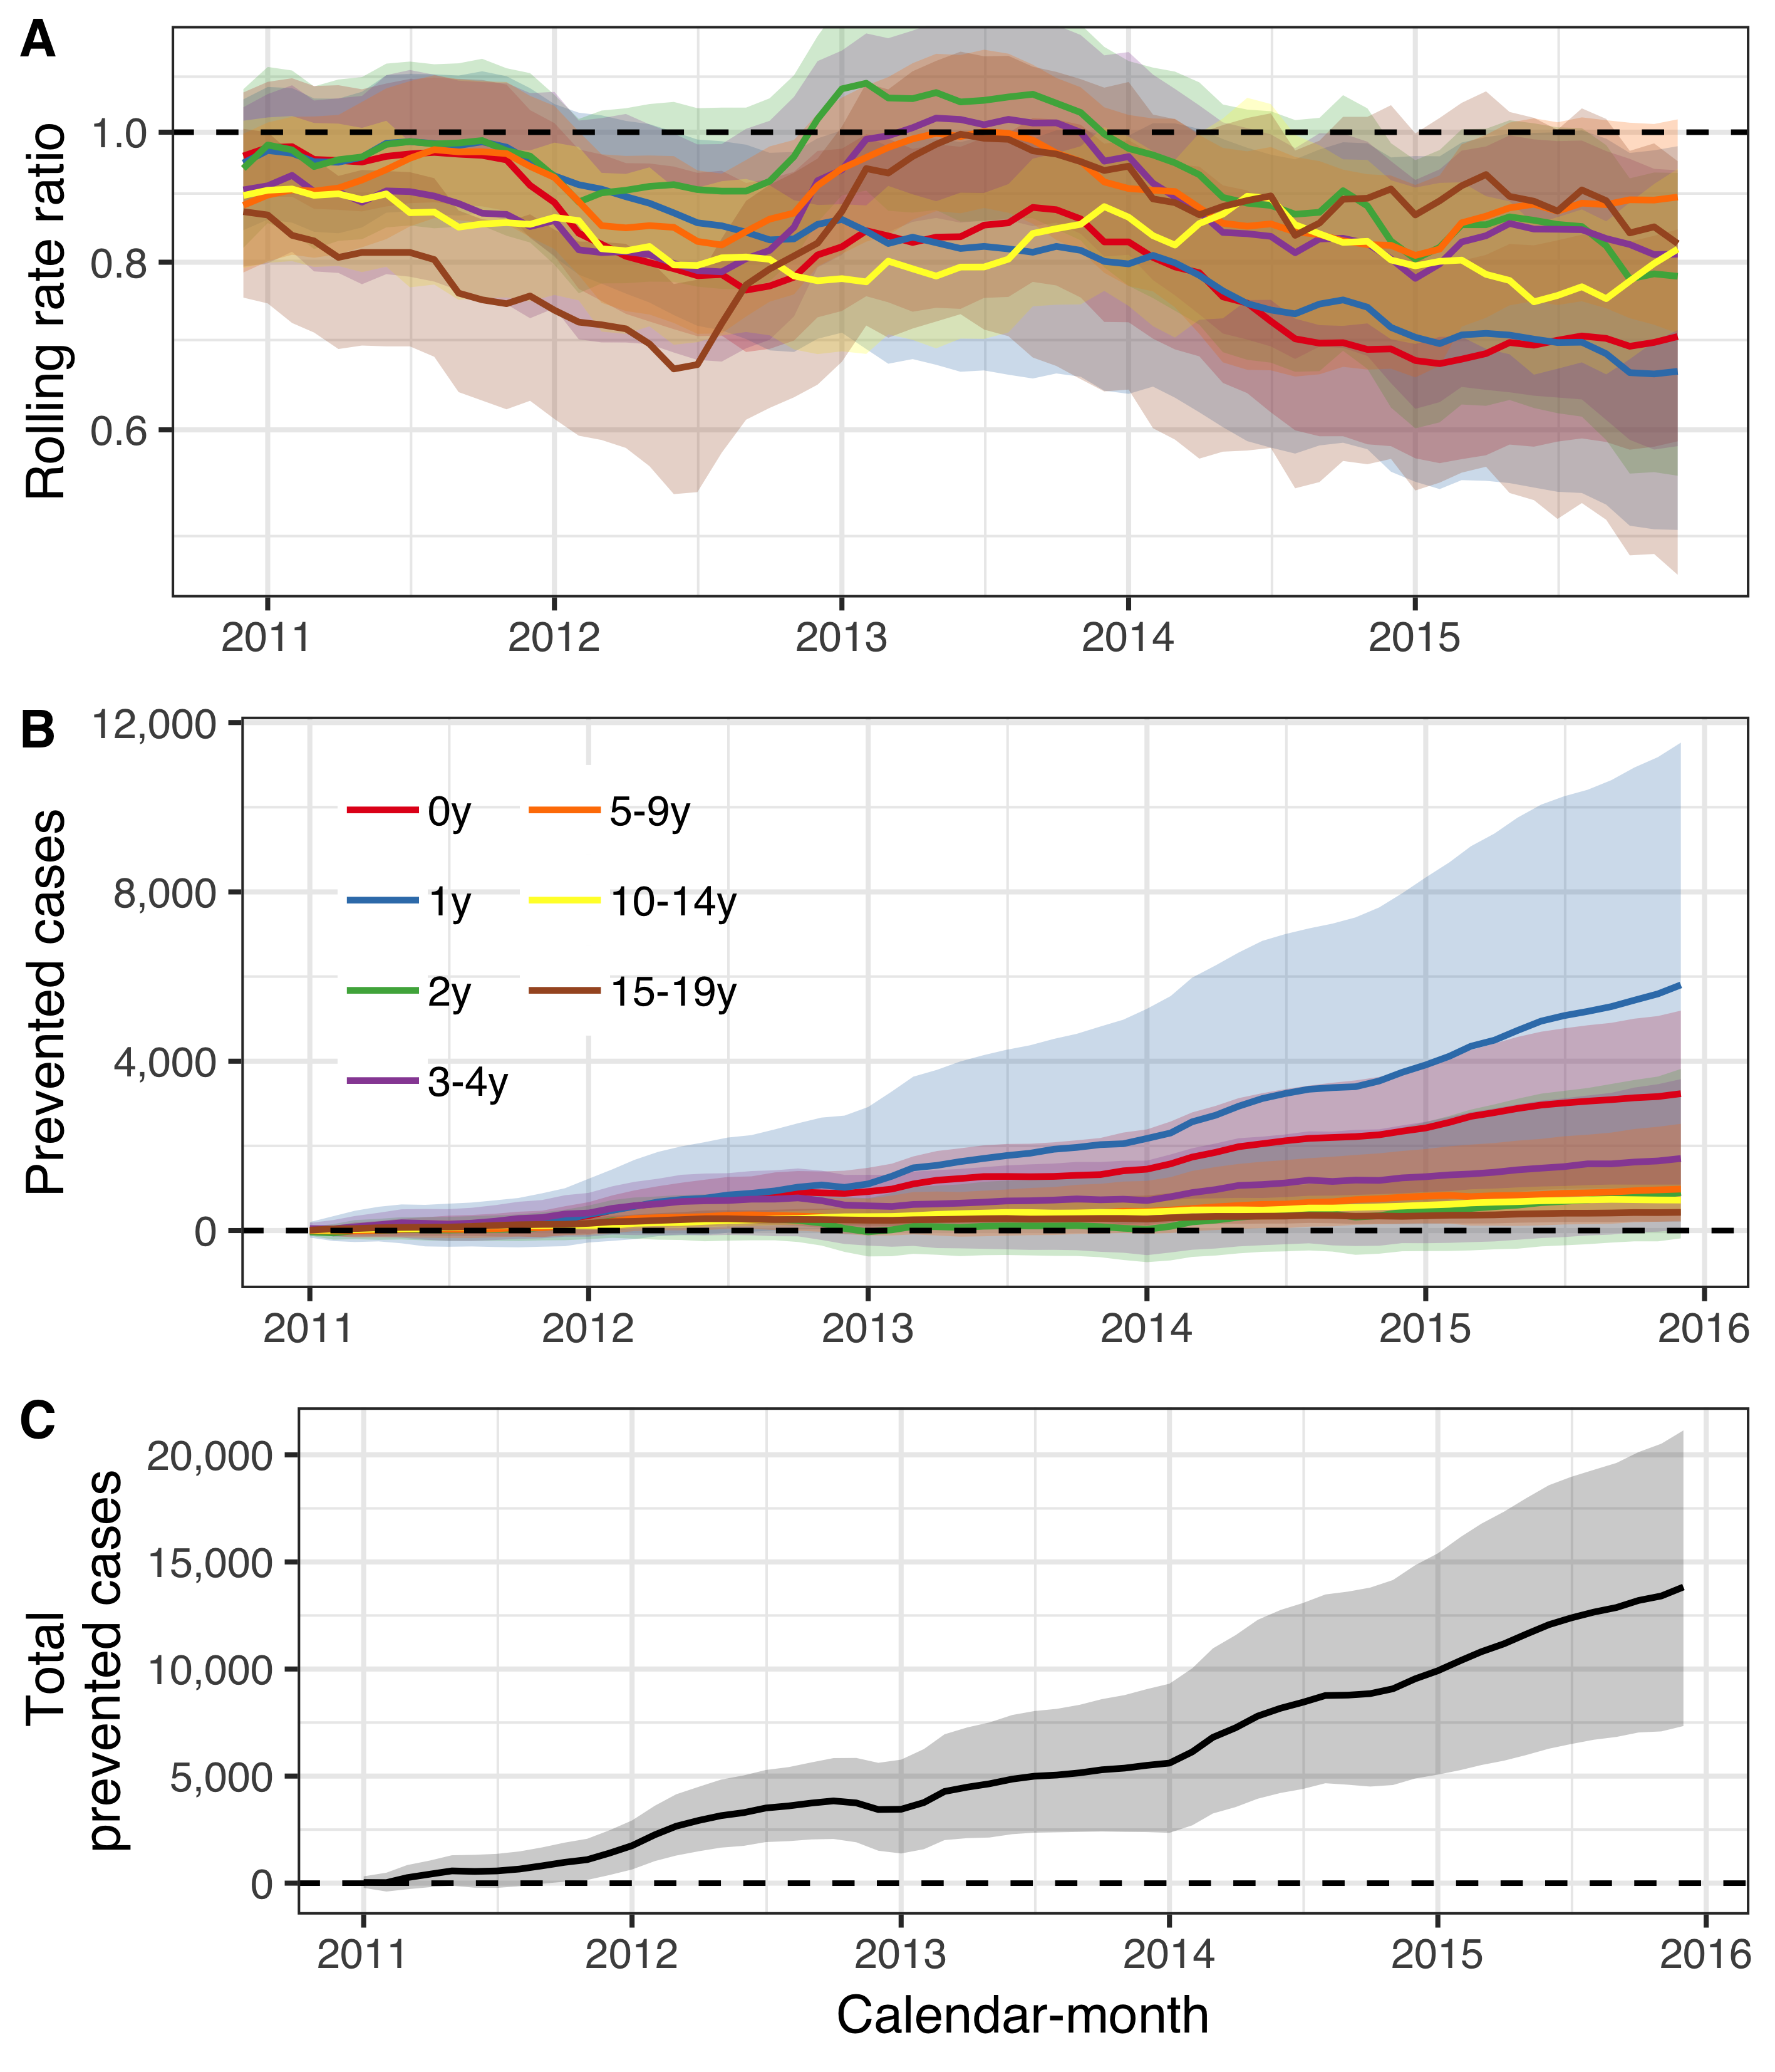

Figure . The impact of the 10-valent Haemophilus influenzae protein D pneumococcal conjugate vaccine (PHiD-CV10) on acute otitis media and complications (AOM) among children younger than 20 years of age is summarized.

In Panel A, the estimated 12-month rolling rate ratio between observed and predicted AOM cases is shown per age-group, and the 95% credible intervals (CI) are illustrated as a shaded area. Panel B depicts the cumulative number of prevented AOM cases during the post-vaccine period (2011-2015) for each age-group, along with 95% CI. The total cumulative prevented AOM cases regardless of age-group is shown in Panel C.

The total cost of introducing PHiD-CV10 into the Icelandic pediatric vaccination program from 1 January 2011 to 31 December 2015 was 2,652,364$ in constant 2015 USD. The vaccination resulted in 13,829 (7,337 to 21,114) prevented cases of AOM among children younger than 20 years of age by 1 December 2015 (Panel C of Figure 26). Given the observed distribution of costs associated with each AOM visit, the direct savings resulting from vaccine-prevented cases was 1,389,900$ (95% credible interval 704,319$ to 2,201,925$). If the vaccine was assumed to have no other benefits other than preventing AOM, and only direct costs were considered, the incremental cost-effectiveness ratio was 91$ (95% credible interval 21$ to 259$) per prevented AOM case from the health care perspective. The vaccine introduction prevented 10,911 days of work lost (95% credible interval 5,116 to 18,801), which translated to 194,152$ (95% credible interval 78,200$ to 364,155$) in productivity gains. The ICER from the societal perspective was 76$ (95% credible interval 6$ to 244$) per prevented AOM case, assuming the vaccine did not result in benefits in other manifestations of pneumococcal infections. When cost-savings due to reductions in hospital admissions for pneumonia and invasive pneumococcal disease were also included, the direct cost of the PHiD-CV10 introduction was -7,463,176$ (95% credible intervals -16,159,551$ to -582,135$) as of 31 December 2015. From the health care perspective, the vaccination program was already cost-saving 7,463,176$ in the first five years of the program. The corresponding ICER was -543$ (95% credible interval -1,508$ to -48$) per prevented AOM case. When days of work lost due to hospitalized pneumonia and IPD cases were also included, the total cost of including PHiD-CV10 in the pediatric vaccination program was -8,164,894$ (95% credible interval -17,197,959$ to -1,004,553$) as of 31 December 2015. The corresponding ICER was -594$ (95% credible interval -1,597$ to -76$) per AOM case prevented.

### Population impact on pneumonia hospitalizations

From 1 January 2005 to 31 December 2017, 13,373 hospitalizations for pneumonia were recorded. Monthly pneumonia hospitalizations displayed complex trends over the study period (Panel B of Figure 27). Pneumonia hospitalizations increased fairly rapidly during the pre-vaccine period among adults 40 years and older, and subsequently decreased at variable times in the post-vaccine period. Similarly, hospitalizations regardless of diagnosis increased among adults 20 years and older during the pre-vaccine period (Panel C of Figure 27).

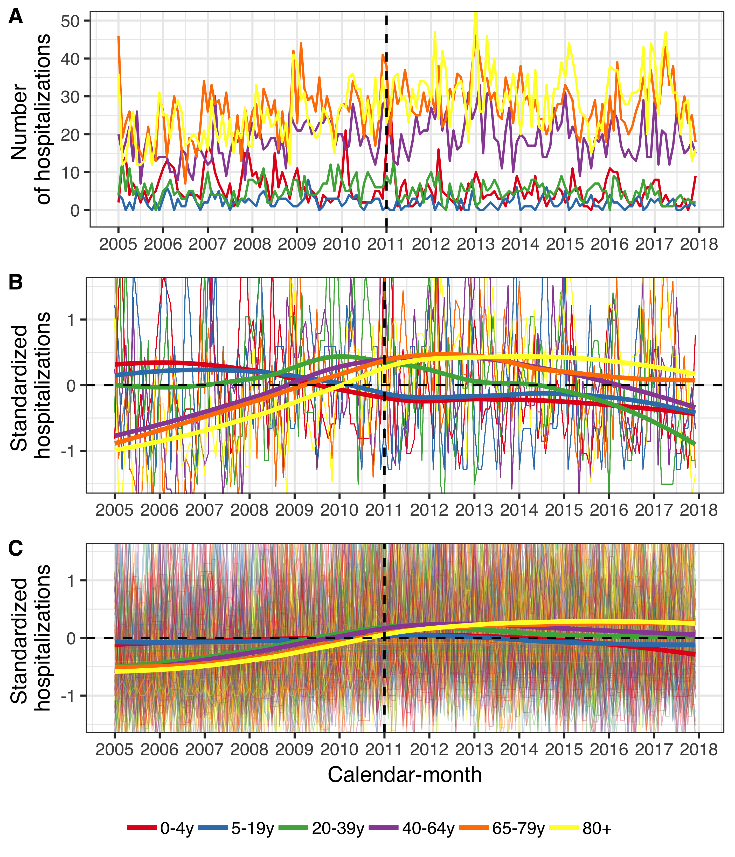

Figure . The monthly number of hospital admissions for pneumonia and hospitalizations regardless of diagnosis from 1 January 2005 to 31 December 2017.

Panel A shows the monthly number of pneumonia hospitalizations. Panels B and C depict the standardized monthly number of pneumonia hospitalizations (Panel B) and all other hospitalizations (Panel C) per age-group. The Y-axis shows how many standard deviations from the mean the observed hospitalizations are by diagnosis and age-group. The horizontal dotted lines represent values that are zero standard deviations from the mean and the vertical dotted lines represent the start of the vaccine intervention. Locally estimated scatter-plot smoothing (LOESS) is used to produce an average trend.

The posterior predictions of the component models are shown in Figure 28. The predictions made by the ITS model without offset diverged from the other models for all age-groups older than 20 years of age, and consistently predicted higher numbers of pneumonia hospitalizations.

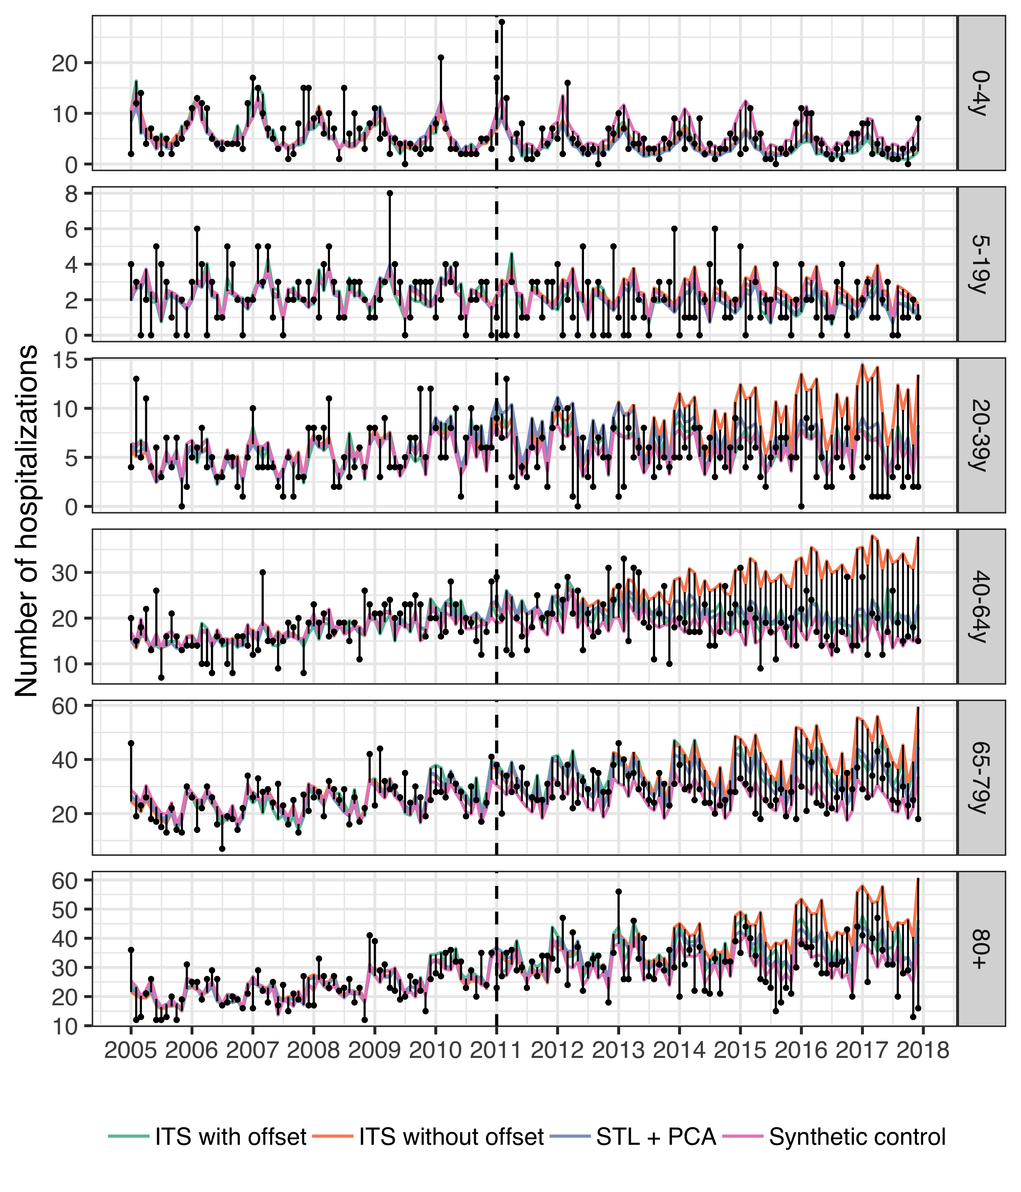

Figure . The observed and predicted number of pneumonia hospitalizations from 1 January 2005 to 31 December 2017 for each age-group.

Observed cases are illustrated as black points and the predicted number of cases are drawn as lines for each of the component models. The start of the vaccine period is delineated with a vertical black dotted line. Each component model was fitted to the observed number of cases in the pre-vaccine period. They were then used to predict the number of cases that would have occurred in the post-vaccine period, had the vaccine not been introduced. The distance between the observed and predicted cases for each calendar-month is depicted with a thin black line. Longer distances suggest a larger discrepancy between observed and predicted cases. Note that the scale of the Y-axis differs between age-groups.

These component models were stacked using LOOCV to produce the final stacked model. The weights used to stack the component models are shown in Table 37. The predicted number of cases and 95% credible intervals are shown in Figure 29. During most of the post-vaccine period, the observed number of hospitalizations were equal to or below the prediction line among children zero to four years of age, and among adults 20 to 39, 65-79 and 80 years of age and older.

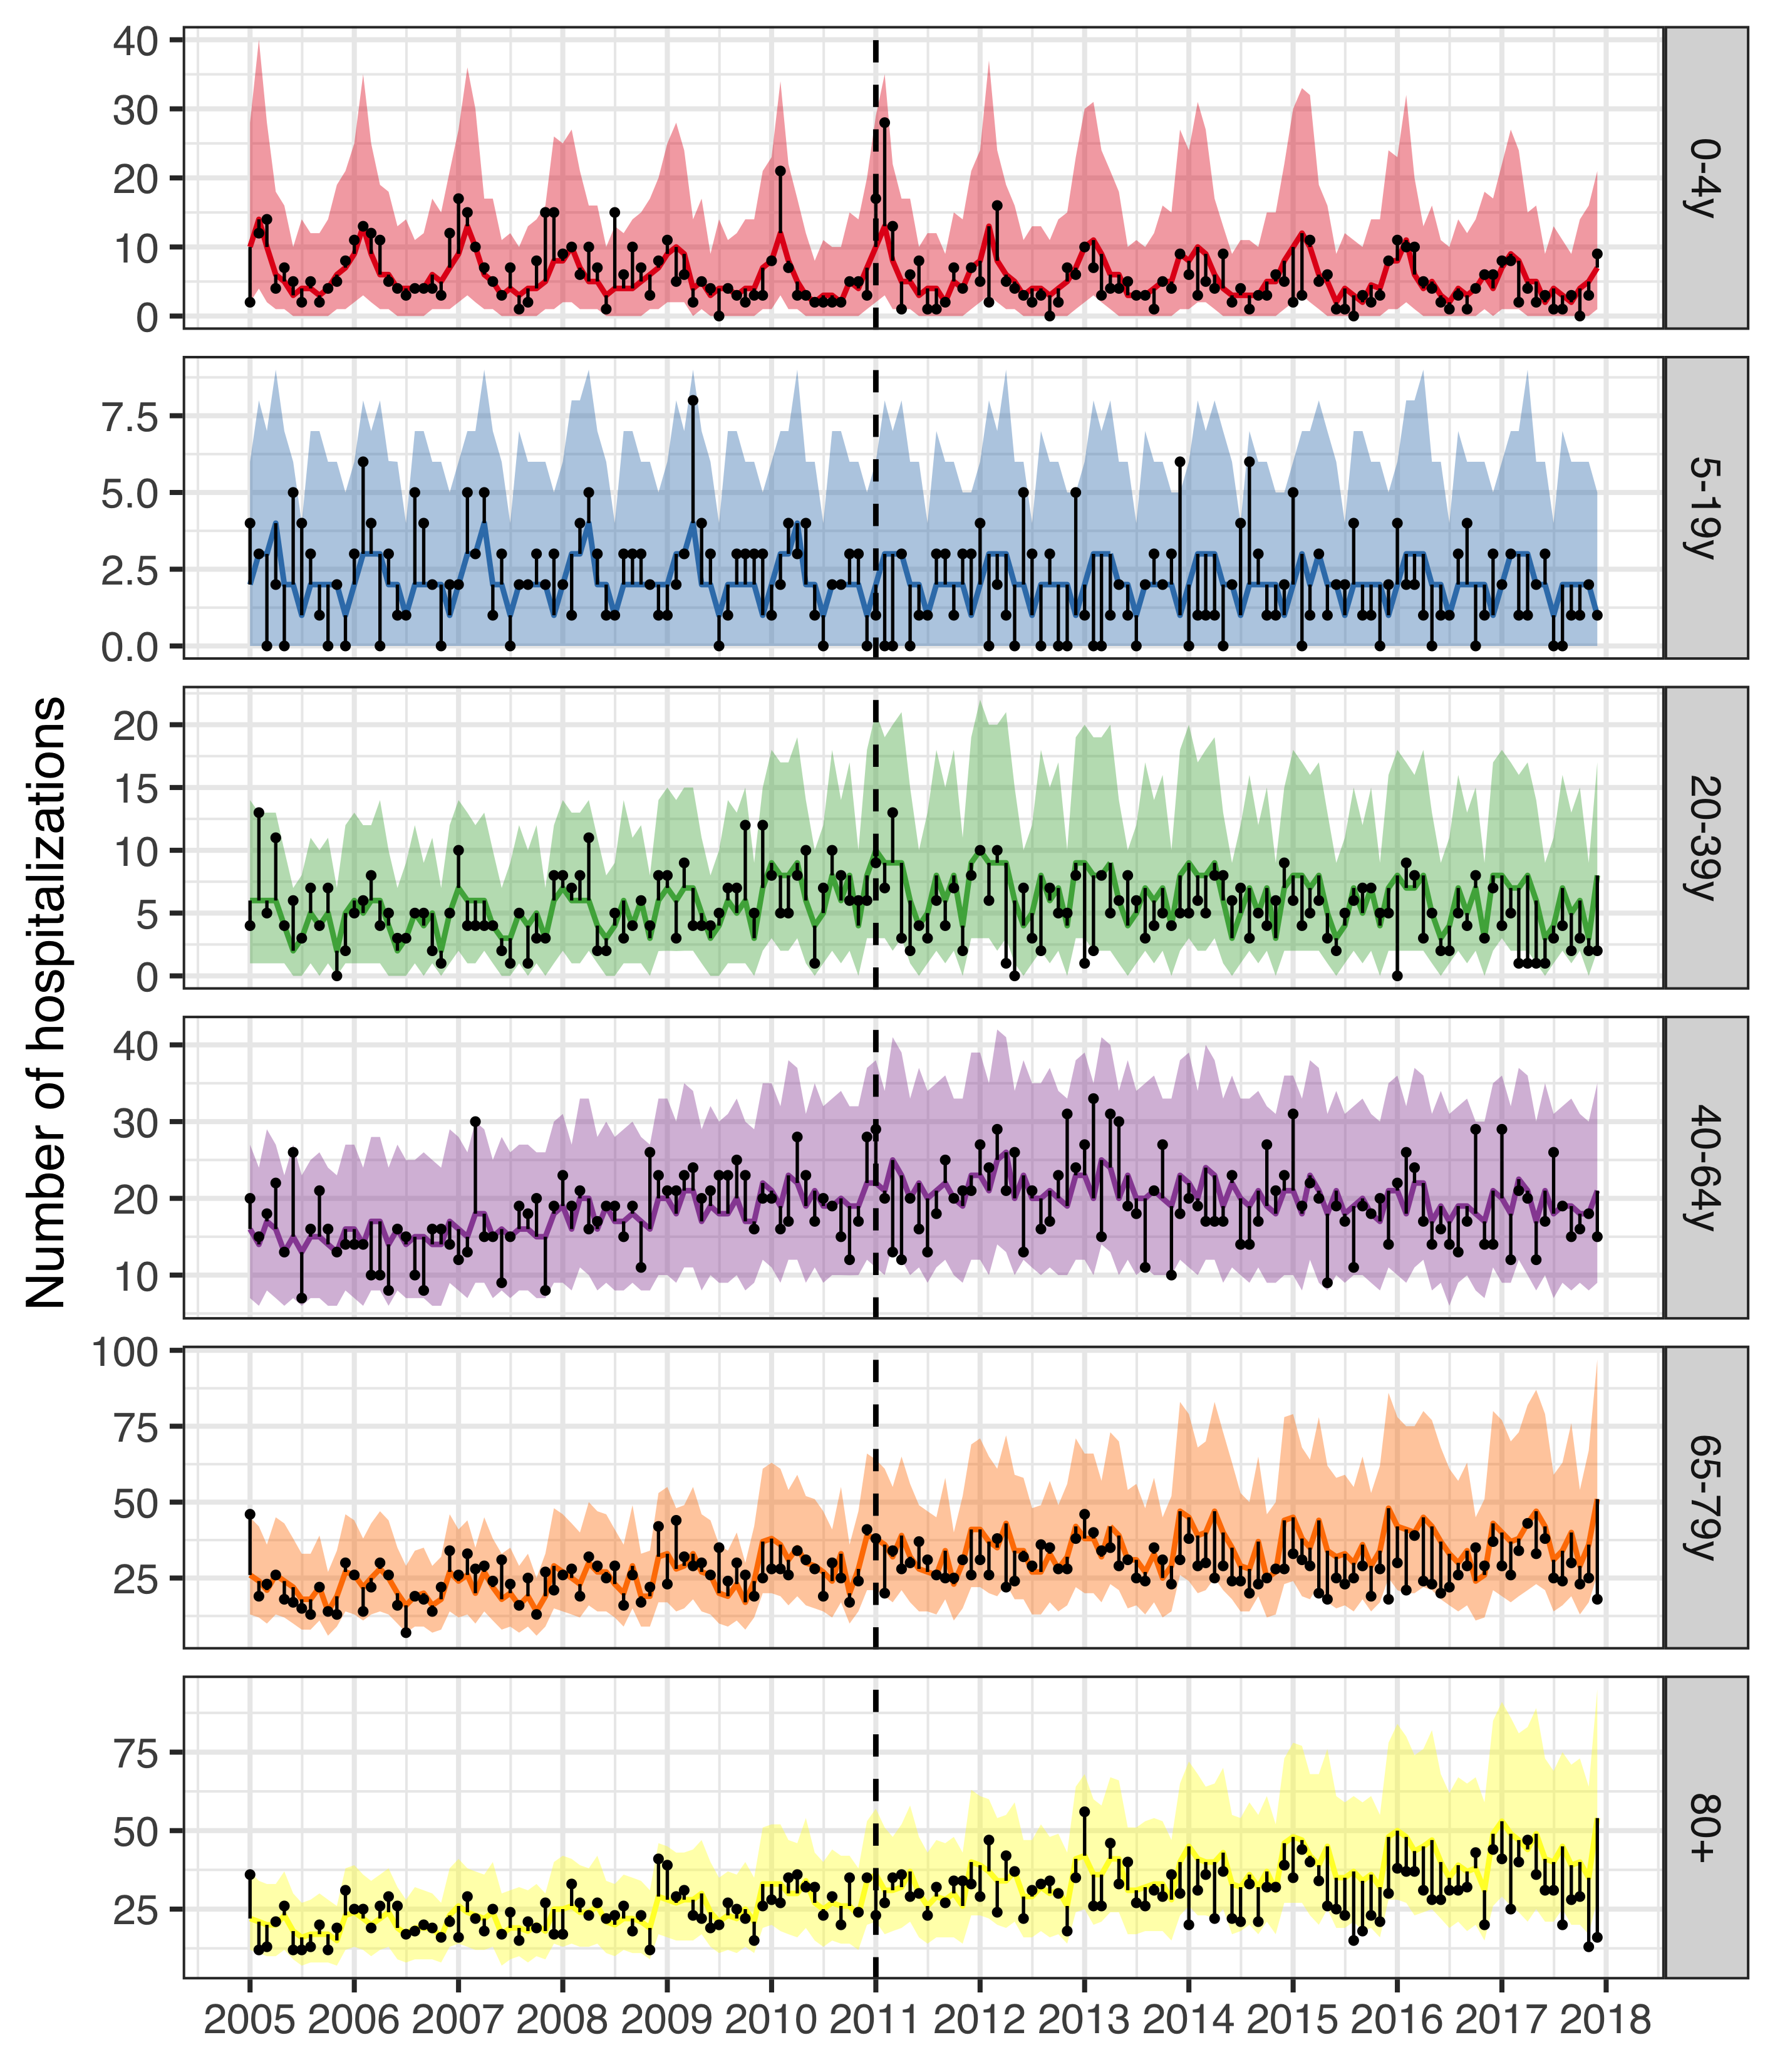

Figure . The observed and predicted number of pneumonia hospitalizations from 1 January 2005 to 31 December 2017 for each age-group.

Observed cases are illustrated as black points. The predicted number of hospitalizations are presented as lines and 95% credible intervals as a shaded area. The start of the vaccine period is delineated with a vertical black dotted line. The distance between the observed and predicted cases for each calendar-month is depicted with a thin black line. Assuming that the model is correct, and that no intervention had occurred, the black points would have an equal probability of appearing above and below the prediction line. Given that the majority of points are located below the prediction line, the figure suggests that the vaccine resulted in fewer pneumonia hospitalizations. Note that the scale of the Y-axis differs between age-groups.

The rate ratios between the observed and predicted number of pneumonia hospitalizations are shown in Table 39. Among children zero to four years of age, the posterior median of the rate ratio was 0.67, and the 2.5% credible limit was 0.51. This was consistent with a 2.5% probability that the rate ratio was lower than 0.51 and a 47.5% probability that the rate ratio laid between 0.51 and 0.67. Though the 97.5% credible limit was above the threshold value of one, there was a 94% probability that the rate ratio was lower than one, and a 90% probability that it was lower than 0.83. Similarly the posterior median of the rate ratio was 0.74 among children five to 19 years of age, and there was a 90% probability that the rate ratio was lower than one. Among adults 65 to 79 years of age, and 80 years of age and older, the posterior median of the rate ratio was 0.75 and 0.76 respectively, and both had a 97% probability of being lower than one.

A 12-month rolling rate ratio between the observed and predicted number pneumonia hospitalizations is presented in Panel A of Figure 30. Visually, the rate of pneumonia hospitalizations among children zero to four years of age seems to begin to decline in January 2012 (the first rolling 12-month period to include only post-vaccine months), and hospitalizations among adults 65 years of age and older seems to begin to decline in January 2014.

Table . The posterior median of the rate ratio between observed and predicted number pneumonia hospitalizations during the post-vaccine period (2013-2017)

is presented with 95% credible intervals (95% CI) for the six age-groups included in the study. The predicted cumulative number of prevented cases as of 1 December 2017 is also presented. A negative number indicates that there is a non-zero probability that the vaccine caused more pneumonia hospitalizations to occur. Direct and indirect savings are presented in constant 2015 USD.

|  |  |  |  |  |
| --- | --- | --- | --- | --- |
| Age-group | Rate ratio (95% CI) | Cumulative prevented (95% CI) | Direct savings (95% CI) | Indirect savings (95% CI) |
| 0-4y | 0.67  (0.51-1.39) | 142  (-115 to 307) | 444,533$  (-44,181$ to 1,309,917$) | 52,535$  (-59,043$ to 136,715$) |
| 5-19y | 0.74  (0.54-1.35) | 52  (-27 to 113) | 234,848$  (-236,236$ to 748,522$) | 20,472$  (-18,876$ to 61,481$) |
| 20-39y | 0.68  (0.51-0.95) | 182  (14 to 384) | 968,662$  (-203,048$ to 2,567,059$) | 70,071$  (-9,442$ to 164,747$) |
| 40-64y | 0.92  (0.79-1.22) | 141  (-270 to 445) | 933,290$  (-2,748,49$ to 4,848,557$) | 71,953$  (-113,414$ to 223,171$) |
| 65-79y | 0.75  (0.55-1.02) | 666  (-49 to 1,648) | 5,476,585$  (-910,021$ to 15,590,280$) | 323,964$  (-4,745$ to 786,252$) |
| 80+ | 0.76  (0.56-1.02) | 631  (-76 to 1,615) | 4,664,256$  (-817,266$ to 13,013,699$) | 287,270$  (-37,961$ to 742,168$) |

The cumulative prevented pneumonia hospitalizations per age-group as of December 2017 are presented in Table 38. The largest effects were seen in adults 65 years of age and older, which reflects the baseline number of cases. The predicted cumulative number of prevented hospitalizations as a function of time during the post-vaccine period is shown in Panel B of Figure 30.

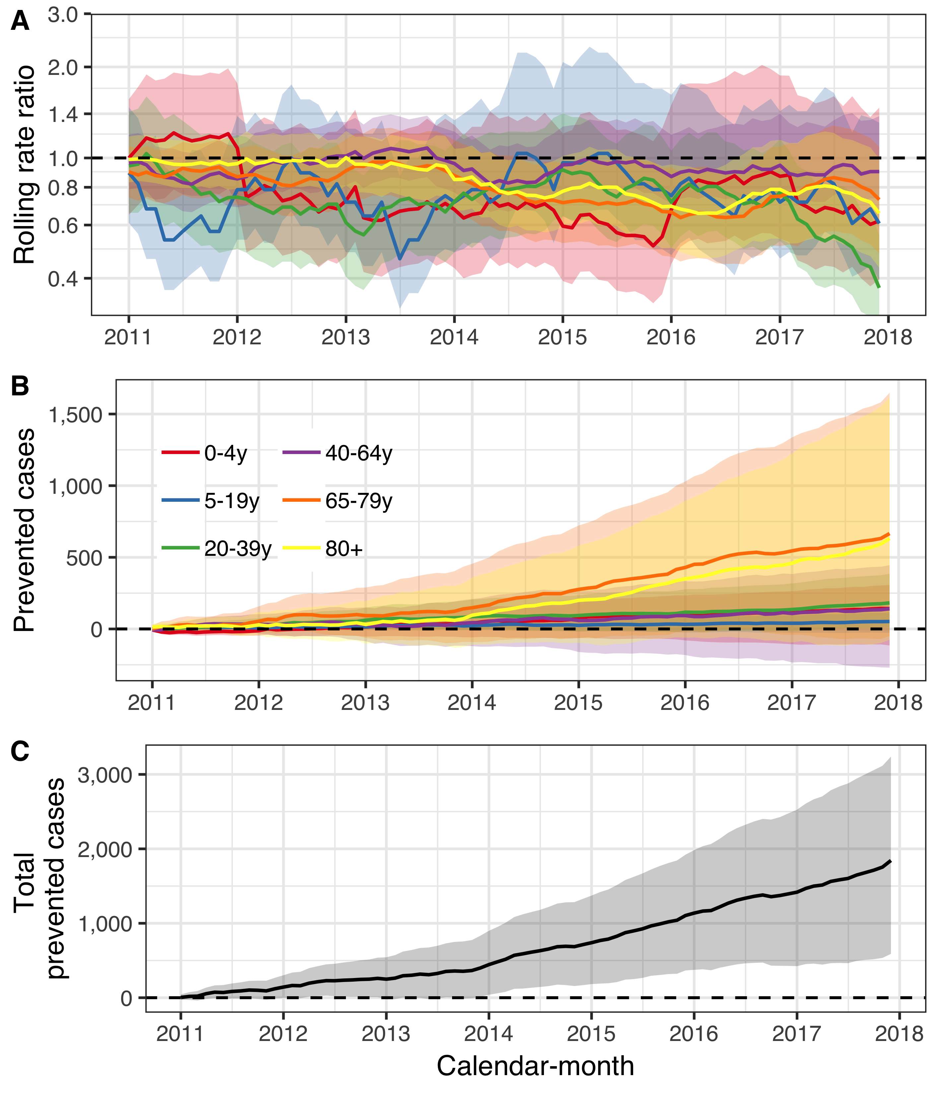

Figure . The population impact of the 10-valent Haemophilus influenzae protein D pneumococcal conjugate vaccine (PHiD-CV10) on pneumonia hospitalizations is summarized.

In Panel A, the estimated 12-month rolling rate ratio between observed and predicted pneumonia hospitalizations is shown per age-group, and the 95% credible intervals (CI) are illustrated as a shaded area. Panel B depicts the cumulative number of prevented pneumonia hospitalizations during the post-vaccine period (2011-2017) for each age-group along with 95% CI. The total cumulative prevented pneumonia hospitalizations regardless of age-group is shown in Panel C.

The total cost of introducing PHiD-CV10 into the Icelandic pediatric vaccination program from 1 January 2011 to 31 December 2017 was 3,451,805$ at constant 2015 USD. In total, the introduction of PHiD-CV10 resulted in 1,844 (589 to 3,239) prevented pneumonia hospitalizations in the Icelandic population by 1 December 2017 (Panel C of Figure 30). Given the observed distribution of costs associated with each pneumonia hospitalization, the direct savings resulting from vaccine-prevented hospitalizations was 13,330,902$ (95% credible interval 2,933,955$ to 26,270,332$), in constant 2015 USD. If the vaccine is assumed to have no other benefits than preventing pneumonia hospitalizations, and only the direct costs are considered, the ICER was -5,315$ (95% credible interval -8,877$ to 711$) per prevented pneumonia hospitalization, indicating a net savings of 5,315$ for each prevented hospitalization from the health care perspective. The vaccination program prevented 29,969 days of work lost (95% credible interval 9,964 to 52,900), which translated to 838,952$ (95% credible interval 273,559$ to 1,493,478$) in productivity gains. From the societal perspective, the ICER was -5,794$ (95% credible interval -9,275$ to 24$) per prevented pneumonia hospitalization, assuming no other vaccine benefit, which implies that the society gains 5,794$ in constant 2015 USD for every pneumonia hospitalization prevented by investing in PHiD-CV10. If the vaccination program’s effects on the other manifestations of pneumococcal disease were included, then the ICER was -5,640$ (95% credible interval -10,336$ to -1,032$) in constant 2015 USD from the health care perspective as of 31 December 2015. Additionally including loss of work resulted in an ICER of -7,440$ (95% credible interval -13,701$ to -1,175$).

### Population impact on hospital admissions for invasive pneumococcal disease

From 1 January 2005 to 31 December 2016, 338 hospitalizations for culture confirmed invasive pneumococcal disease were recorded. Of those, 206 occurred before the introduction of PHiD-CV10 into the pediatric vaccination program in Iceland. Hospital admissions due to vaccine-type IPD were 175, of which 138 occurred prior to vaccine introduction. Only two vaccine-type IPD hospitalizations of children zero to four years of age were recorded in the post-vaccine period. Both cases were unvaccinated, and both occurred in 2011. This is compared to 32 hospital admissions of the same age-group in the pre-vaccine period. The number of vaccine-type IPD cases were not sufficiently many to perform a time series analysis.

Standardized hospitalizations for IPD decreased among children zero to four years of age, while standardized hospital admissions regardless of cause did not decrease to the same extent (Panels B and C of Figure 31). Discrepancies between hospital admissions for IPD and all-cause hospitalizations were also noted in the other age-groups. Hospitalizations for IPD among individuals five to 64 years of age decreased while all-cause hospitalizations remained stable. While hospital admissions for IPD among adults 65 years of age and older did not change visibly, the standardized all-cause hospitalizations increased, suggesting a relative decline in IPD admissions.

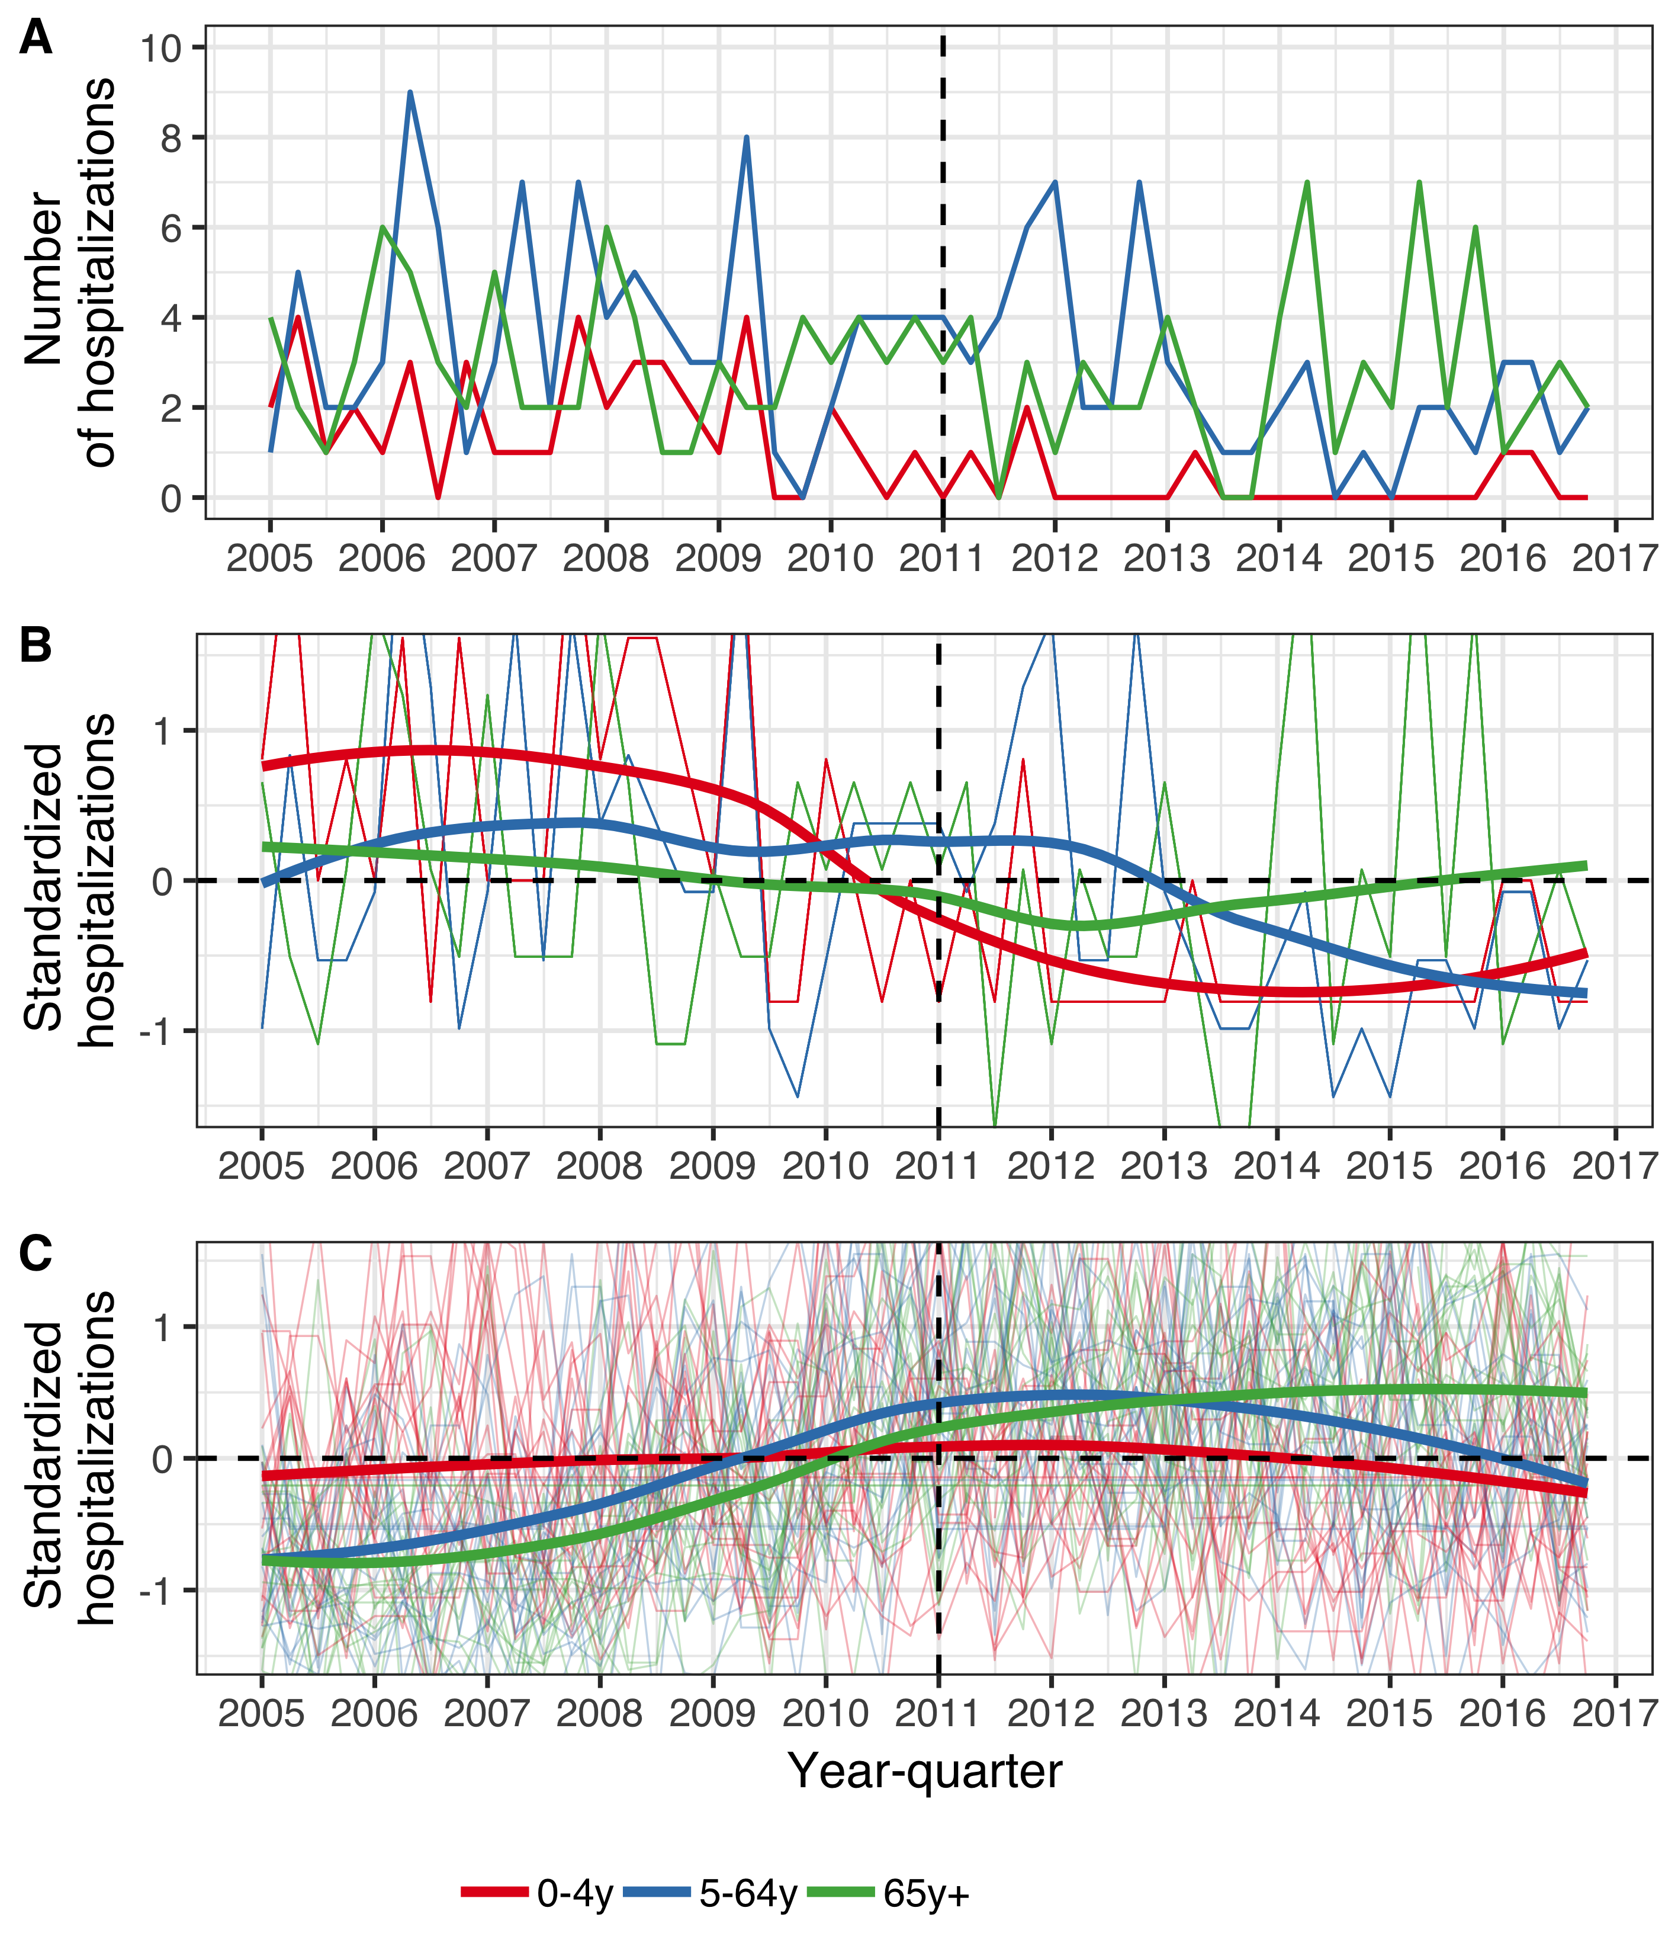

Figure . The number of hospitalizations per year-quarter from 1 January 2005 to 31 December 2016.

The population is divided into three age-groups, listed in the figure legend. Panel A shows the absolute quarterly number of hospital admissions due to invasive pneumococcal disease (IPD) regardless of serotype. Panels B and C, depict the standardized quarterly number of IPD hospitalizations (Panel B) and all-cause hospitalizations (Panel C) per age-group. The Y-axis represents the number of standard deviations from the mean hospitalizations for each quarter and each age-group. The horizontal dotted lines represent values that are zero standard deviations from the mean and the vertical dotted lines represent the start of the vaccine intervention. Locally estimated scatter-plot smoothing (LOESS) is used to produce an average trend. Panels B and C have been magnified to emphasize the interpretation of the trend line. Panels B and C show that standardized hospitalizations for IPD decreased in all age-groups, relative to the standardized hospitalizations regardless of cause.

The posterior predictions of the component models are shown in Figure 32. Both the ITS models consistently predicted fewer IPD cases among children zero to four years of age in the post-vaccine period, compared to the STL + PCA and synthetic control models.

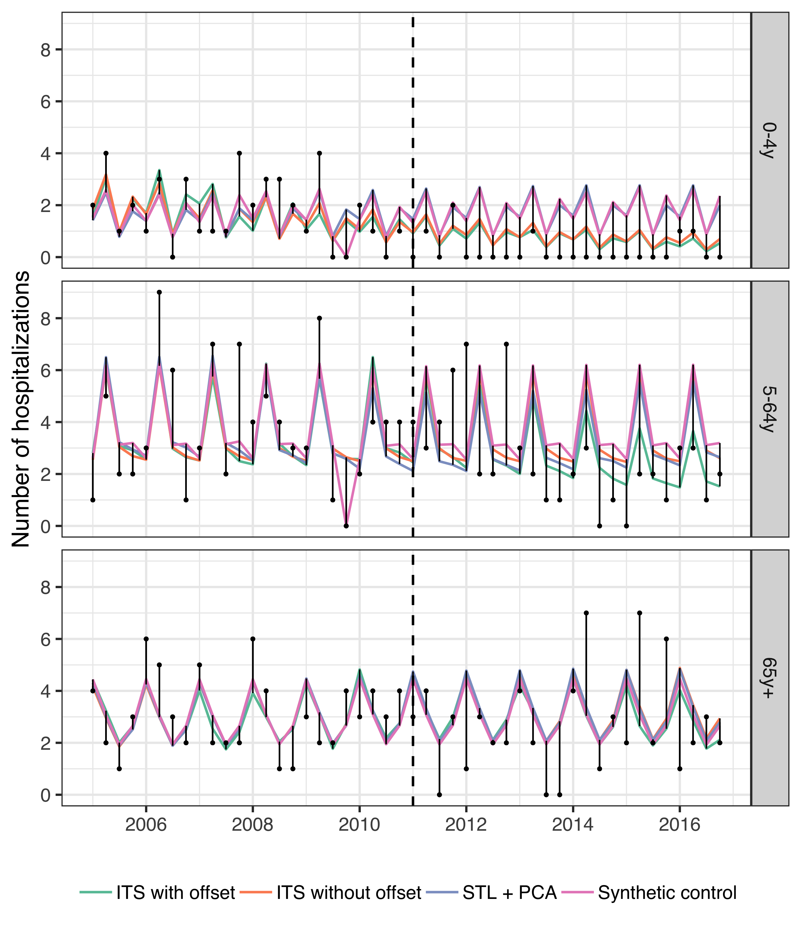

Figure . The observed and predicted number of IPD hospitalizations from 1 January 2005 to 31 December 2016 for each age-group.

Observed cases are illustrated as black points and the predicted number of cases are drawn as lines for each of the component models. The start of the vaccine period is delineated with a vertical black dotted line. Each component model was fitted to the observed number of cases in the pre-vaccine period. They were then used to predict the number of cases that would have occurred in the post-vaccine period, had the vaccine not been introduced. The distance between the observed and predicted cases for each year-quarter is depicted with a thin black line. Longer distances suggest a larger discrepancy between observed and predicted cases.

The stacked model for children zero to four years of age was comprised of the synthetic control model weighted at 0.001 and ITS with offset weighted at 0.999. For individuals five to 64 years of age, and adults 65 years of age and older, the LOOCV procedure assigned full weight to the synthetic control model, excluding contributions from the other three.

The posterior prediction of IPD hospitalizations and 95% credible intervals are shown in Figure 33. Among children zero to four years of age, observed IPD hospitalizations were equal to or fewer than the predicted hospitalizations in all but two quarters. Similarly, observed hospitalizations among individuals five to 64 years of age were fewer than predicted more often than expected. Both suggest that the vaccine prevented cases from occurring.

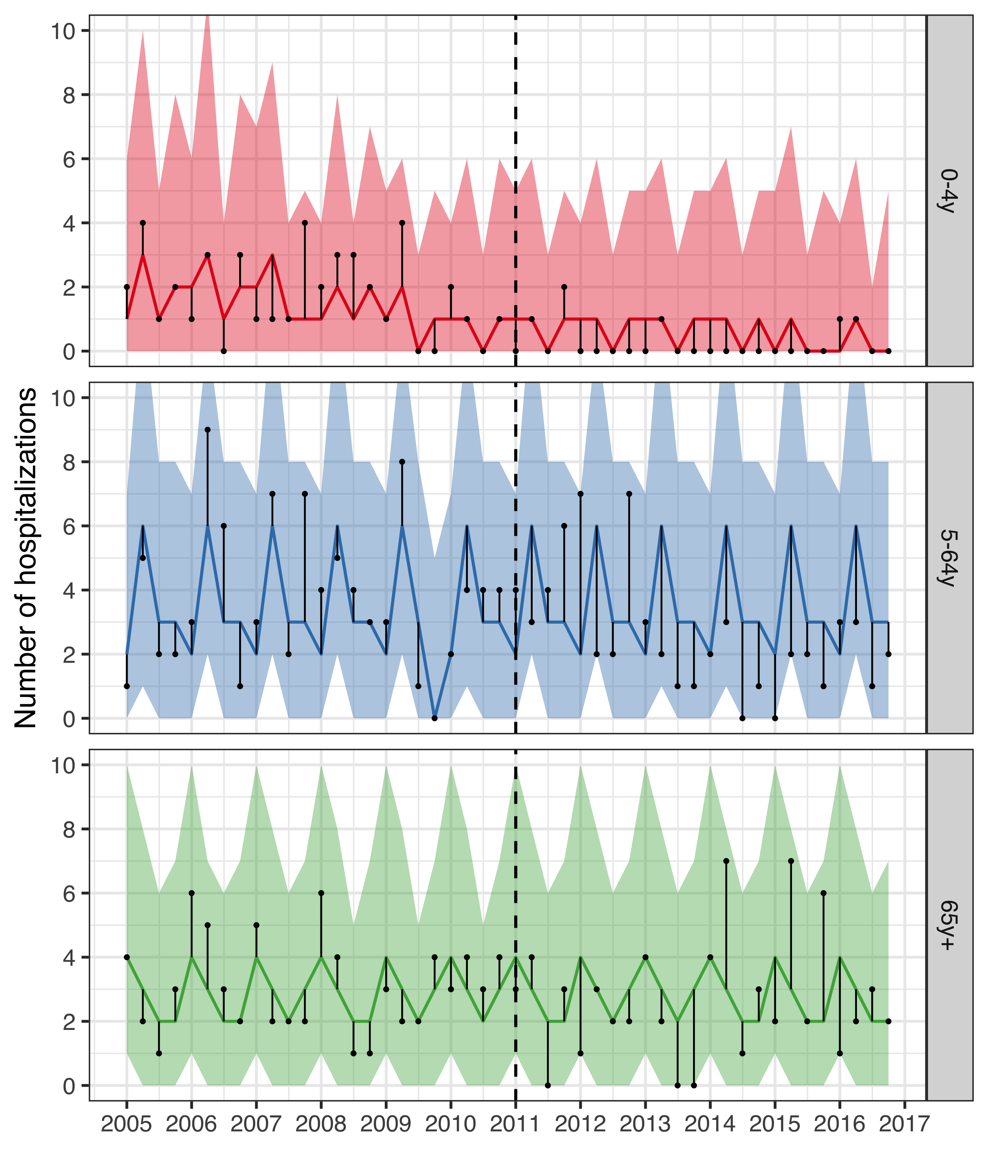

Figure . The observed and predicted number of IPD hospitalizations from 1 January 2005 to 31 December 2016 for each age-group.

Observed cases are illustrated as black points, and the predicted number of cases are presented as lines with 95% credible intervals as a shaded area. The start of the vaccine period is delineated with a vertical black dotted line. The distance between the observed and predicted cases for each year-quarter is depicted with a thin black line. Assuming that the model is correct, and no intervention had taken place, the black points would have an equal probability of occurring above and below the prediction line. Given that the majority of points are located below the prediction line, the figure suggests that the vaccine resulted in fewer IPD hospitalizations.

The rate ratios between the observed and predicted number of IPD hospitalizations in the post-vaccine period are shown in Table 40. The posterior median of the rate ratio for children younger than five years of age was 0.27, corresponding to a 50% probability that the vaccine impact was greater than or equal to 73%. The 95% credible intervals of the rate ratio were wide, reflecting the uncertainty due to the few number of IPD hospitalizations. However, 90% of the MCMC draws of the rate ratio were below 0.75 and 93% were under the threshold value of one. The 95% credible interval of the rate ratio among individuals five to 64 years of age was lower than one, indicating a 97.5% or greater probability that the rate of IPD hospitalization decreased in this age-group following the introduction of PHiD-CV10.

The 12-month rolling rate ratio is presented in Panel A of Figure 34. The rolling rate ratio for children zero to four years of age was unstable due to numerical issues with both the numerator and the denominator. In some 12-month periods, no IPD hospitalizations were observed and the resulting rate ratio was zero regardless of the denominator. In other periods, 2.5% or more of the MCMC draws predicted zero IPD hospitalizations, which resulted in a 95% credible intervals of the rate ratio that extended towards infinity. These issues do not change the overall interpretation of the prediction line presented in Panel A of Figure 34 or the rate ratios presented in 38.

Table . The rate ratio between observed and predicted number of hospital admissions for invasive pneumococcal disease (IPD) during the post-vaccine period (2013-2016)

is presented along with 95% credible intervals (95% CI) for the three age-groups. The predicted cumulative number of prevented cases as of 1 December 2016 is also presented. A negative number indicates that there is a non-zero probability that the vaccine caused more IPD hospitalizations to occur. Direct and indirect savings are presented in 2015 USD.

|  |  |  |  |  |
| --- | --- | --- | --- | --- |
| Age-group | Rate ratio (95% CI) | Cumulative prevented (95% CI) | Direct savings (95% CI) | Indirect savings (95% CI) |
| 0-4y | 0.27  (0.05-3.00) | 14 (-2 to 67) | 227,087$  (71,363$ to 618,919$) | 16,882$  (6,893$ to 38,718$) |
| 5-64y | 0.44  (0.31-0.68) | 29 (1 to 65) | 321,424$  (-455,573$ to 1,649,171$) | 12,983$  (-3,606$ to 33,498$) |
| 65y+ | 0.94  (0.62-1.53) | 10 (-16 to 45) | 73,395$  (-256,856$ to 516,864$) | 4,340$  (-10,903$ to 23,543$) |

The cumulative prevented IPD hospitalizations per age-group as of December 2016 are presented Table 39, and are shown as a function of time in Panel B of Figure 34. The posterior median of the cumulative prevented cases increases from the beginning of the post-vaccine period among children zero to four years of age.

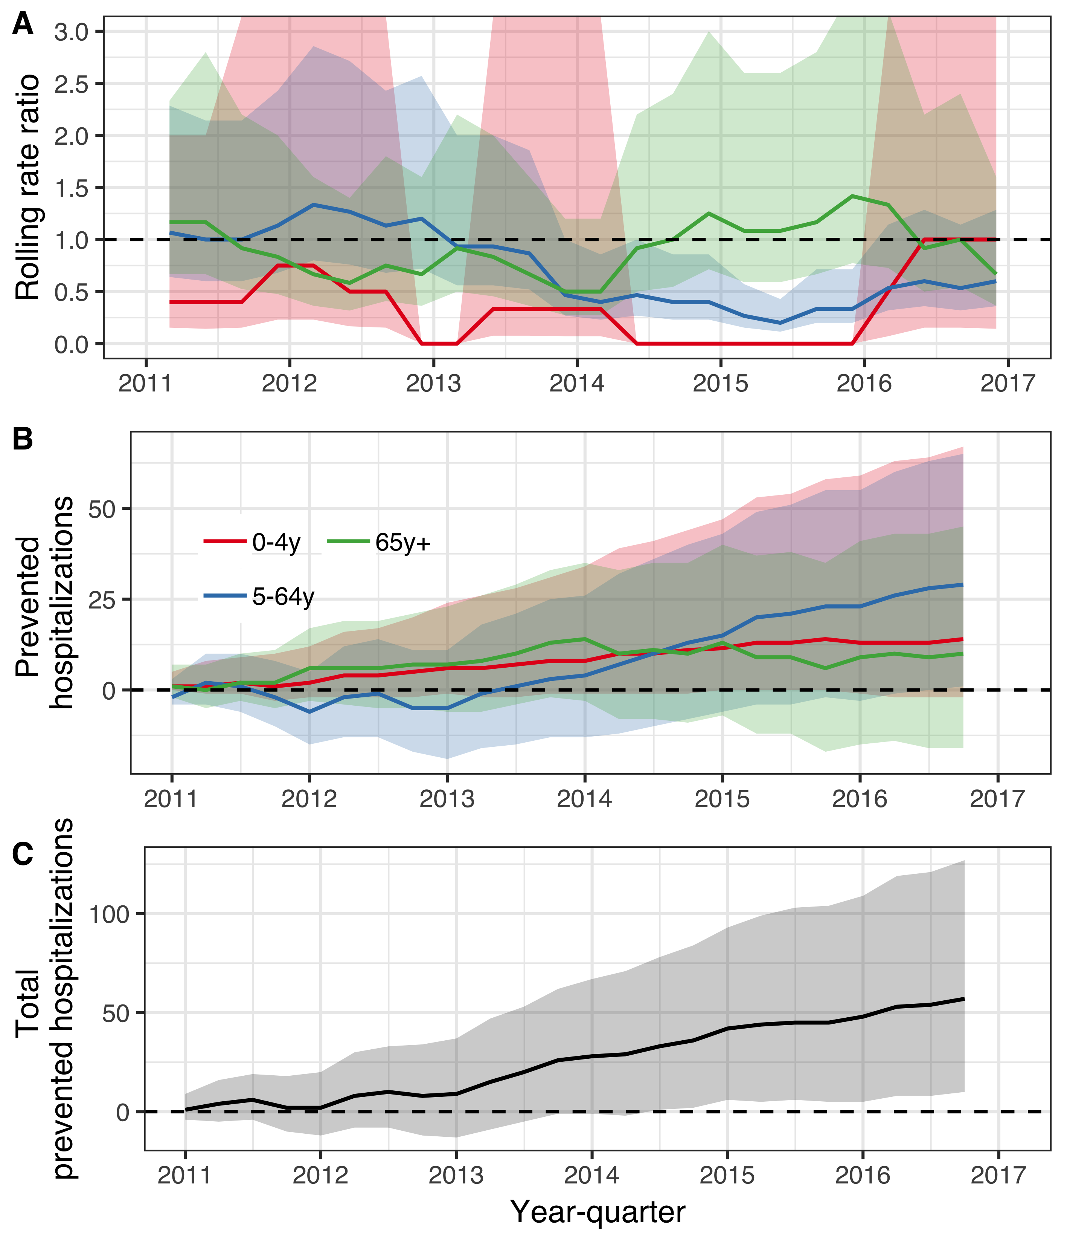

Figure . The population impact of the 10-valent Haemophilus influenzae protein D pneumococcal conjugate vaccine (PHiD-CV10) on hospital admissions for invasive pneumococcal disease is summarized.

In Panel A, the estimated 12-month rolling rate ratio between the observed and predicted number of IPD hospitalizations in the post-vaccine period (2011-2016) is shown per age-group. Panel B depicts the cumulative number of prevented IPD hospitalizations during the post-vaccine period (2011-2015) for each age-group along with 95% credible intervals. The total cumulative prevented IPD hospitalizations regardless of age-group is shown in Panel C.

In total, by December 2016, the introduction of PHiD-CV10 prevented 57 (10 to 127) cases of IPD serious enough to warrant hospital admission (Panel C of Figure 34). The total cost of introducing PHiD-CV10 into the Icelandic pediatric vaccination program from 1 January 2011 to 31 December 2016 was 3,097,861$, in constant 2015 USD. Given the observed distribution of costs associated with each IPD hospitalization, the direct savings resulting from vaccine-prevented hospitalizations of IPD was 673,008$ (95% credible intervals -189,654$ to 2,081,594$). If the vaccine was assumed to have no other benefits than preventing IPD hospitalizations, and only the direct costs are considered, the ICER was 30,134$ (95% credible interval 8,488$ to 80,375$) per prevented IPD hospitalization. The vaccine introduction prevented 1,280 days of work lost (444 to 2,410) due to IPD, which translated to 35,280$ (95% credible intervals 9,437$ to 70,609$) in productivity gains. If the vaccine was assumed to have no other benefits than preventing IPD hospitalizations, the ICER from the societal perspective was 30,134$ (95% credible intervals 8,487$ to 80,375$) per prevented IPD hospitalization. When cost-savings due to reductions in AOM visits or hospital admissions for pneumonia were also included, the ICER was -119,992$ (95% credible interval -387,183$ to -9,542$) per prevented IPD hospitalization from the health care perspective. When days of work lost were also considered, the ICER was -130,791$ (95% credible interval -416,004$ to -15,860$) per prevented IPD hospitalization.

# Discussion

## Main findings

* The pediatric pneumococcal vaccination program that was implemented in Iceland in 2011 achieved excellent coverage. Over 97% of all children in the first six vaccine eligible birth-cohorts received two or more doses of PHiD-CV10 before 24 months of age.
* An impact of PHiD-CV10 introduction was detected on several different facets of otitis media incidence. Pediatric primary care visits due to acute otitis media decreased by 21% and emergency department visits to Children’s Hospital Iceland decreased by 12-21%. Hospital-based treatment of otitis media with parenteral ceftriaxone decreased by 42%.
* All-cause outpatient antimicrobial prescriptions decreased by 8% among children younger than three years of age following the introduction of PHiD-CV10. The incidence of AOM-associated antimicrobial prescriptions decreased even further, 21%.
* The incidence of tympanostomy tube placements did not decrease following the introduction of PHiD-CV10, despite a measurable impact on otitis media visits to primary care and pediatric emergency departments and antimicrobial prescriptions. Approximately one-third of all Icelandic children undergo at least one tympanostomy tube procedure before five years of age.
* Pediatric hospital admissions for pneumonia declined by 20% following PHiD-CV10 introduction. Pneumonia hospitalizations were also shown to have decreased among Icelanders 20-39 years of age, implying a strong herd-effect among adults likely to by the parents of young children.
* Invasive pneumococcal disease requiring hospitalization decreased by 93% among vaccine-eligible children younger than three years of age. No vaccine-type invasive disease was diagnosed among the vaccinated cohorts.
* The pediatric pneumococcal vaccination program in Iceland was cost-effective. During the first five years of the program, PHiD-CV10 resulted in a net-savings of 7,463,176 $ when only considering averted costs of prevented cases. When work-loss was also considered, the estimated net-savings increased to 8,164,894 $.

## Data collection and sources (Papers I-VI)

The data used for the papers in this thesis were collected from several population-based registries. Their quality and scope are extensive.

Three of the registries are maintained by the Icelandic Directorate of Health. Firstly, data on every administered dose of pneumococcal conjugate vaccine were obtained from the National Vaccine Registry. The NVR receives data directly from the electronic health record system. Secondly, information regarding every outpatient antimicrobial prescription was extracted from the National Drug Prescription Registry, which receives electronic data directly from Icelandic pharmacies when each prescription is filled. Compliance is required by law. Finally, primary care visits for respiratory infections were extracted from the Primary Care Registry, which contains records on all visits to primary care physicians in Iceland.

Information on emergency department visits and hospital admissions for respiratory infections were obtained from Landspitali University Hospital’s patient registry. Landspitali University Hospital is the sole tertiary hospital in Iceland, and includes Iceland’s only pediatric hospital. It accounts for 91% of all hospital beds in the country, provides primary and secondary care for 65% of the Icelandic population, and provides tertiary care for the whole population. The patient registry is maintained by administrative staff at Landspitali University Hospital.

Landspitali’s patient registry included a detailed breakdown of costs for each visit and hospitalization. Cost was broken down into categories which included wages of physicians, nurses, and other support staff, as well costs of medications and diagnostic testing. The costs incurred by each department involved in the patient’s care was tabulated. These data were used in the cost-effectiveness analysis.

The reimbursement database of Icelandic Health Insurance provided data on all outpatient otolaryngological procedures. While the reimbursement database is not directly connected to electronic medical records, there is still strong reason to believe that the database is accurate and contains information on all outpatient procedures. Health care in Iceland is a single-payer system with the government guaranteeing equal access for all permanent residents through a single national health insurance, which is funded by taxation. Health care providers are either salaried governmental employees or independent practitioners who work within a framework agreement with Icelandic Health Insurance, and are reimbursed on a per case basis. It is unreasonable to assume that any Icelandic resident would routinely forgo their national health insurance and opt to pay the full cost out-of-pocket. Likewise, independent practitioners have a strong incentive to seek compensation for their labor. The data available from the reimbursement database therefore reflect the total number of procedures.

Immigration and emigration data on children younger than five years of age were provided by Statistics Iceland. The data augmented birth-cohort analyses, allowing longitudinal time-to-event analyses to be performed. Children who immigrated to Iceland after birth could be excluded and the follow-up time of children who emigrated could be censored at the time of emigration.

Data from each registry were transferred directly to the Directorate of Health where the data was anonymized. Each record was associated with a unique study identification number that was created from the individual’s national identification number by staff at the Directorate of Health. Because each Icelandic citizen receives one and only one national identification number over the course of their lifetime, this allowed the data from the various registries to be reliably linked. Unique individuals could be tracked between the different registries but could not be identified.

The linkage between several large population-based registries overcame a common limitation of epidemiological data. Registries record information about an event that occurred, e.g. an antimicrobial prescription, a primary care visit or a hospital admission. Because of this, they generally lack information about those individuals who did not experience the event. Epidemiological studies are therefore often forced to either restrict their scope to individuals who experienced one or more events, or infer the number of individuals who did not experience an event. Individual-level data on those who did not experience the event is missing. By linking large concurrent population-based registries, we were able overcome this common constraint by accurately identifying unique individuals who were alive and living in Iceland during the evaluated period.

The data underlying this study were observational in nature, and their quality was enhanced by several factors. The breadth of the data was extensive. The study contains individual-level information on 375,383 Icelandic citizens over a 13 year period from 2005-2017. Six years of data were collected prior to the introduction of PHiD-CV10 into the pediatric vaccination program, which allowed for an analysis of secular trends in the pre-vaccine period. Similarly, the study included five to seven years of post-vaccine data, providing an opportunity to evaluate the immediate and delayed effect of vaccine introduction. According to Statistics Iceland, the aggregate number of Icelandic citizens was 293,577 on 1 January 2005, and was 338,349 on 1 January 2017 – which strongly suggests that our data contains individual-level information on all Icelandic citizens with few exceptions.

Though the data were extracted from the registries after events occurred, they were collected prospectively, and retain the properties of prospectively collected data. Retrospective observational studies identify a population of individuals who have experienced a certain event, and then determine what risk-factors they had prior to experiencing the event. A prospective study identifies a population of interest and follows them over time to ascertain whether they experience a certain event. Prospective data can produce estimates of relative and absolute risk, and relative and absolute rates.

Electronic medical records were consistent during the entire study period. Not only were all medical records in Iceland stored electronically, but the same software, *Saga*, was used by all health care providers and institutions throughout the study period. Likewise, the International Classification of Diseases, 10th revision (ICD-10), was the only diagnostic coding system in use in Iceland during the study period. Furthermore, all medical procedures were coded with the NOMESCO Classification of Surgical Procedures (NCSP), and drugs were classified using the Anatomical-Therapeutic-Chemical (ATC) classification system of the World Health Organization. Continuity between data systems enhanced the quality of results.

Our data included the date of birth, date of death, as well as data on immigration and emigration of Icelandic children. Through linkage of the registries, individual-level information of those who did not experience an event became available, and accurate time-based at-risk denominators could be constructed. This allowed the study data to be analyzed using survival methods, and repeated events within the same individual taken into account.

Individual-level information was available for each pneumococcal vaccine dose that was administered in Iceland. Unlike prior studies, which were forced to infer the proportion of individuals who were vaccinated using aggregate sales data, we were able to directly check if a person had been vaccinated. We were also able to confirm that few children had been vaccinated in Iceland before the introduction of PHiD-CV10 into the Icelandic pediatric vaccination program. Among birth-cohorts 2005-2009, the proportion of children who received two or more doses of a pneumococcal conjugate vaccine before two years of age was below 3%. Of the non-vaccine eligible birth-cohorts, only the 2010 birth-cohort saw an increase in PCV uptake, especially among children born in the latter half of 2010. This is likely due to heightened awareness among parents because of the impending introduction of the vaccine. In some sense the result is that an unplanned catch-up occurred, with close to 40% of children born in the latter half of 2010 receiving two or more doses of a pneumococcal conjugate vaccine, before two years of age.

## Epidemiology and management of otitis media in Iceland and the impact of PHiD-CV10 introduction (Papers I, II, III, V and VI)

Following the introduction of PHiD-CV10, changes were noted in several facets of otitis media epidemiology and its management. These changes were summarized in papers I, II, III, V and VI.

### Epidemiology of acute otitis media in Iceland (Papers II and V)

Acute otitis media is often a benign temporary infection that will in many cases resolve without intervention (Thornton et al. 2011). The epidemiology of AOM is influenced by the distribution of risk-factors in the population, and by cultural factors that influence the propensity of parents to consult physicians (Blank et al. 2014; Fortanier et al. 2015). The epidemiology of AOM is therefore often highly variable between countries, as documented in Table 1. Despite this, AOM is the most common reason for physician visit among children, a fact which has been frequently documented in multiple countries (Arguedas et al. 2010; Marchisio et al. 2012; Monasta et al. 2012).

The epidemiology of acute otitis media visits to primary care was described in paper II. During the 11 year study period from 2005 to 2015, the overall incidence of AOM episodes among children zero to three years of age was 42 per 100 person-years. Prior to the introduction of PCV into the Icelandic pediatric vaccination program, 59% of children had visited a primary care physician one or more times by their third birthday and each child had experienced 1.6 episodes on average. The impact of PHiD-CV10 is discussed in Chapter 5.3.2. There were large variations in the incidence rate between both gender and age. The incidence was consistently higher in males than females. This gender difference has been documented in several different prospective studies of AOM epidemiology (Baraibar 1997; Macintyre et al. 2010; Paradise et al. 1997). However, the mechanism by which gender affects AOM incidence is unknown. The incidence of AOM increases from birth and peaks among children eight to 15 months of age. The abrupt peak at eight to 15 months of age and subsequent decrease may be hypothesized to be a function of two competing processes; the exposure of the child to pathogens due to daycare center attendance and the development of immunity to common pathogens (Hoog et al. 2014).

The incidence of AOM is highly variable between countries. Generally, the rate of AOM among European children ranges from 15 to 40 episodes per 100 person-years (Adam and Fehnle 2008; Esposito et al. 2007; Gisselsson-Solen 2017; Gribben et al. 2012; Lau et al. 2015; Liese et al. 2014; Marchisio et al. 2012; Todberg et al. 2014; Usonis et al. 2016), while the rate among children in the United States ranges from 95 to 200 episodes per 100 person-years (De Wals et al. 2009; Grijalva et al. 2006; Grijalva, Nuorti, and Griffin 2009; Poehling 2004; Zhou et al. 2008). With an incidence rate of 42 episodes per 100 person-years, the rate of AOM in Iceland seems to be higher than published estimates from most other European countries, but lower than published estimates from the United States. To our knowledge, only one previous study has reported the cumulative incidence of AOM in a modern cohort, demonstrating a 60% cumulative incidence by seven years of age (Todberg et al. 2014). Additionally, two studies from the twentieth century showed an 83% cumulative incidence by three years of age and 66% by two years of age (Bjarnason, Friðriksson, and Benediktsson 1991; Teele, Klein, and Rosner 1989). We observed a cumulative incidence of 59% by four years of age. Though not directly comparable to the other studies, this seems to suggest that the cumulative incidence is higher than a concurrent modern cohort in Denmark, but lower than historical cumulative rates. These differences between countries may be due to a multitude of different factors – some related to the distribution of risk factors in the population, others due to cultural differences that influence the ascertainment rate of AOM cases. Finally, some of the variation is likely due to design of the studies reporting the epidemiology of AOM.

Of studies that have examined the epidemiology of AOM, ours is the only longitudinal population-based study. We followed 11 birth-cohorts from birth until four years of age and accounted for censoring due to emigration. We accounted for follow-up visits for the same episode of AOM by excluding visits within 30 days of the index visit. Most of the other studies obtained aggregated AOM visits within a portion of the population and divided this with the aggregated number of children (De Wals et al. 2009; Gisselsson-Solen 2017; Grijalva et al. 2006; Grijalva, Nuorti, and Griffin 2009; Lau et al. 2015; Poehling 2004; Zhou et al. 2008). By using aggregated AOM visits as the numerator, they cannot exclude re-visits for the same AOM episode, which artificially inflates the incidence of AOM. The remaining studies followed individual children, but were not population-based and ascertained cases at variable time-points after six months of age (Adam and Fehnle 2008; Esposito et al. 2007; Gribben et al. 2012; Liese et al. 2014; Usonis et al. 2016).

The pathophysiology and microbiology of AOM are discussed in chapter 1.1.1. The most common bacterial causes of otitis media are non-typeable *Haemophilus influenzae* (NTHi), *Streptococcus pneumoniae* and *Moraxella catarrhalis* (Bluestone, Stephenson, and Martin 1992; Casey and Pichichero 2004; Casey, Adlowitz, and Pichichero 2009; Ngo et al. 2016; Pumarola et al. 2013). The relative contribution of these three pathogens is remarkably stable between countries and over time (Ngo et al. 2016). This is likely a consequence of how common they are in the nasopharyngeal flora of children. A systematic review of studies from 1970-2014 which reported the etiology of otitis media, found that *Streptococcus pneumoniae* caused 30% of acute otitis media in Europe (Ngo et al. 2016). Our research group has shown that prior to PHiD-CV10 introduction in Iceland, the proportion of otitis media with tympanic perforation that was caused by pneumococcus was 20% (Quirk et al. 2018). This is similar to other countries (Ngo et al. 2016). The contribution of other pathogens has not yet been evaluated in Iceland. There does not seem to be strong evidence to suggest that the distribution of pathogens is different in Iceland than in other high-income countries, and thus other factors likely explain the difference in epidemiology.

The propensity to seek medical care may be influenced by several cultural and socio-economic factors. Access and cost of health care may influence whether parents consult a physician and may result in measurable changes in incidence between countries (Fortanier et al. 2015; Hadley 2003; Smolderen 2010). In Iceland, all permanent residents are provided health insurance by the government and there is excellent access to urgent care. Children are provided health care free of charge. The employment rate of Icelandic adults 20-64 years of age is 91% and 84% for males and females respectively, which means that Iceland has the highest employment rate in Europe (Eurostat 2018). These factors may push parents to seek early care for otitis media and would result in higher estimates of AOM incidence that would be closer to the true incidence in the population. This may also lead to overdiagnosis and overtreatment. Employment can however not explain the higher incidence reported in studies from the United States, as the employment rate is considerably lower, with only 76% and 66% of working age men and women employed (OECD 2019).

Iceland is ranked third in formal daycare attendance by The Organization for Economic Co-operation and Development (OECD), with up to 60% of children under three years of age attending a daycare center for 38 hours per week or longer. This is compared to the OECD average of 35% attendance for 30 hours (“Enrolment in childcare and pre-schools” 2013). Both daycare attendance and the number of hours per week are known risk factors for acute otitis media (Ramakrishnan, Sparks, and Berryhill 2007) These factors could result in a higher incidence of AOM in Iceland relative to other countries and may explain some the observed difference between Iceland and other European countries. However, this does not explain why studies conducted in the United States consistently show higher incidence rates of AOM than Icelandic estimates. The rate of early daycare attendance in the United States is half that of Iceland, and below the average of OECD countries (“Enrolment in childcare and pre-schools” 2013).

Taken together, our population-based study of all primary care visits for acute otitis media over an 11 year period is likely to have ascertained a large proportion of true cases. To our knowledge, we report the only population-based follow-up of AOM incidence from birth to four years of age. The study reminds us that ratio statistics do not tell the whole story. Longitudinal studies are important to capture other perspectives on disease incidence. We report a 59% cumulative incidence of AOM by four years of age. The mean number of AOM episodes per child was 1.6, and 42% of children experienced two or more episodes. This better represents the burden of disease then ratio statistics such as 42 AOM episodes per 100 person-years, though such statistics also have their place.

### Impact on primary care visits for otitis media (Papers II and VI)

Pneumococcal conjugate vaccines have been shown to reduce the incidence of acute otitis media in both randomized and observational trials. Eight randomized control trials examined the effect of PCV on AOM, demonstrating large decreases in pneumococcal AOM and moderate decreases in all-cause AOM (Black et al. 2000; Dagan et al. 2001; Eskola et al. 2001; Fireman et al. 2003; Kilpi et al. 2003; O’Brien et al. 2008; A. Palmu et al. 2015; Prymula et al. 2006; Tregnaghi et al. 2014; Vesikari et al. 2016). Two systematic reviews of observational studies examining the impact of PCV on the incidence of AOM identified nine studies, of which three accounted for pre-vaccine trends in AOM incidence and only one was population-based (Ben-Shimol et al. 2014; Grijalva et al. 2006; Grijalva, Nuorti, and Griffin 2009; Poehling 2004; Poehling et al. 2007; Lau et al. 2015; Magnus et al. 2012; Marom et al. 2014; Singleton et al. 2009). We report the results of two separate population-based studies estimating the impact of PHiD-CV10 on otitis media visits in primary care. The studies used different methods which complemented each other with regards to underlying assumptions, weaknesses and strengths.

Paper II reported the results of a population-based, individual-level birth-cohort study. The crude incidence rate of AOM visits to primary care decreased from 45 to 40 per 100 person-years among children zero to three years of age following vaccine introduction. Accounting for repeated episodes, the estimated impact of PHiD-CV10 was 21%. Of the previously identified observational studies, only three included individual-level data (Ben-Shimol et al. 2014; Magnus et al. 2012; Poehling et al. 2007).

Ben-Shimol et al. (2014) reported a prospective population-based study of middle-ear fluid cultures from a single-center in Israel following sequential PCV7 and PCV13 introduction. The study found a 96% and 85% impact on vaccine-type pneumococcal AOM, and a 60% reduction in all-cause AOM, but only obtained data on cases serious enough to be referred to the center for tympanocentesis. The propensity of physicians to refer otitis media cases for tympanocentesis was not evaluated. Changes in referral patterns may have potentially confounded the observed reduction in all-cause AOM, but would not be expected to confound vaccine-type AOM.

Magnus et al. (2012) utilized prospectively collected data from the Norwegian Mother and Child Cohort Study to estimate the rate of AOM before and after the introduction of PCV7. Mothers were recruited from 39 of 50 maternity units in Norway and data was collected by questionnaires at six, 18 and 36 months of age. The questionnaire only asked the mother whether their child had experienced AOM between 12-18 months of age, and 18-36 months of age, and did not specify the frequency or whether a physician was consulted. The study reported a 14% and 8% vaccine impact on the parent-reported prevalence of one or more AOM episodes in children 12-18 months of age and 18-36 months of age respectively.

Poehling et al. (2007) examined the hazard ratio of frequent otitis media between birth-cohorts enrolled in an state-insurance program before and after the introduction of PCV7. Four birth-cohorts 1998-2001 were included and followed to five years of age; the first two (1998-1999) were considered unvaccinated and the latter two (2000-2001) were considered vaccinated. Impact was reported by comparing the 1998 birth-cohort to the 2000 birth-cohort, and by this metric the vaccine impact on frequent AOM was 17%-28%. However, the largest decrease was seen between the birth-cohorts 1998 and 1999, with almost no difference seen between the 1999 and 2000 birth-cohorts and no explanation or theory was provided in the discussion chapter.

Paper II adds to the current literature by providing robust population-based, individual-level observational evidence of PHiD-CV10 impact on all-cause AOM. As an outcome-measure, physician diagnosed AOM in primary care is more applicable for policy decisions than is the parent-reported prevalence of AOM, frequent AOM and otitis media requiring tympanocentesis. To our knowledge, this was the first study to directly account for repeated episodes within the same individual and employ survival methods that accounted for confounding by age and censoring. This allowed us to examine vaccine impact from perspectives that are not normally available to observational studies. In addition to impact on traditional ratio measures, we were able to show that the proportion of children who had never experienced an AOM episode increased from 40% in the vaccine non-eligible cohorts to 43% among vaccine eligible children. The vaccine impact was shown to independently protect against a child’s first and second episode, but in the subset of children who had already experienced two or more episodes of AOM, the vaccine was not shown to decrease the hazard of experiencing an additional episode. Longitudinal data on each child allowed us to calculate the mean number of AOM episodes at 36 months of age, and show that this had decreased from 1.61 among vaccine non-eligible children to 1.31 among vaccine eligible children.

By utilizing population-based data, our study avoided selection bias, which may have confounded the results of previous studies. Selection bias is possible in Ben-Shimol et al. (2014) if providers deferentially referred children for middle-ear sampling based on their vaccination status and may have occurred in Magnus et al. (2012) if the propensity of mothers to continue submitting questionnaires at 18 and 36 months was modified by the frequency of AOM in the child. Though Poehling et al. (2007) used a similar registry approach as our study, their population included only children of insured families. Despite these weaknesses, it should be noted the results of the above studies were congruent with a positive impact of PCV, which our study also confirmed.

Our study was strengthened by its long observational period which included six vaccine non-eligible birth-cohorts and five vaccine eligible birth-cohorts. Though paper II did not directly adjust for observed trends, the long pre-vaccine period provided context to the large and abrupt decrease in the hazard of AOM noted between the last vaccine non-eligible cohort (2010) and the first vaccine eligible cohort (2011). Such context would have been useful in interpreting Poehling et al. (2007), were the largest decreases in frequent AOM was noted between the first and second unvaccinated cohorts. Despite the strengths of paper II, the lack of adjustment for secular trends remained an important weakness.

Paper VI estimated the impact of PHiD-CV10 on physician diagnosed AOM in primary care taking into account pre-vaccine trends using a time series methodology. Four different methods were independently used to predict vaccine impact, which were then stacked by maximizing the predictive performance of the final model. This approach optimally accounts for secular trends and allows estimation of herd-effect in older children who were not vaccine eligible in the post-vaccine period. Using this method, the vaccine impact was 26% among children younger than one year of age, 28% among one year olds, 12% among two year olds and 14% among children three to four years of age.

Of the identified observational studies evaluating the impact of PCV on otitis media, only three have attempted to correct for secular trends (Grijalva et al. 2006; Lau et al. 2015; Marom et al. 2014). Grijalva et al. (2006) reported the rate of otitis media visits in the United States before and after PCV7 introduction. They estimated that PCV7 was associated with a 20% decline in the rates of otitis media among children younger than two years of age. The rate ratio of otitis media visits between children younger than two years of age and children three to six years of age were compared visually between the pre-vaccine period, transition year and a single post-vaccine year. The ratio of rate ratios was then calculated between the pre-vaccine period and post-vaccine year, and used as a measurement of impact. The largest decreases in the rate of otitis media visits among children younger than two years of age were observed before the introduction of PCV7, yet no explicit adjustment was made for pre-vaccine trends.

Lau et al. (2015) used an interrupted time series approach to estimate the sequential impact of PCV7 and PCV13 on otitis media in general practice, and reported a 21.8% reduction in the rate of otitis media visits in children younger than 10 years of age.  
The pre- and post-vaccine periods were appropriately long and the study was well conducted, though the methods only allowed adjusting for linear trends, which may both over- and underestimate underlying trends (Bernal, Cummins, and Gasparrini 2016; Kontopantelis et al. 2015). The data was extracted from the IMS Disease Analyser; a longitudinal electronic health care database maintained by a for-profit health care information company. The database receives information from general practitioners who applied to participate and received compensation for manually contributing deidentified data. This process may select for general practitioners who are more self-reflective and adhere more strictly to evidence based medicine than do the general population of physicians.

Finally, Marom et al. (2014) used data on privately insured children younger than seven years of age in the United States from 2001-2011 to estimate the rate of otitis media visits before and after the introduction of PCV13 in 2010, using a linear time series analysis. They employed a similar approach as Grijalva et al. (2006), calculating rate ratios of otitis media visits between children younger than two years of age and children three to six years of age. They reported a stable rate ratio of 1.38 in the pre-vaccine period, which decreased to 1.01 in 2011 following the introduction of PCV13. Marom et al. (2014) did not report a single estimate of PCV13 impact. However, if they had calculated impact similarly to Grijalva et al. (2006), the estimated impact would have been 27%.

Paper VI adds to the current literature by providing population-based data on the impact of systematic vaccination with PHiD-CV10 on acute otitis media visits to primary care that is adequately adjusted for secular trends. Our study compliments previous studies examining the impact of PCV on otitis media visits and improves on them in several ways.

We used four models to adjust for secular trends, each with their own strengths and weaknesses. Two simple time series models were constructed, with and without a population offset. These two models were comparable to those that have been used by previous studies to adjust for secular trends, but improved upon them by allowing trends to be non-linear (Lau et al. 2015; Marom et al. 2014). Two additional models were included which incorporated data on primary care visits for other causes. A synthetic control framework was used, in which the relationship between otitis media visits and visits for other indications was estimated in the pre-vaccine period, and this relationship was used to predict the number of otitis media visits that would have occurred in the post-vaccine period, had PHiD-CV10 not been introduced (Bruhn et al. 2017; Shioda et al. 2018). The models were then optimally combined to maximize the predictive performance of the final stacked model. Using these methods we were able to adjust for secular trends and were not forced to assume that trends were linear and predictive uncertainty was minimized by incorporating data on observed visits to primary care for other indications.

By using population-based data, the possibility of selection bias was eliminated. Grijalva et al. (2006) and Marom et al. (2014) only include privately insured children and Lau et al. (2015) only includes visits to a self-selected subset of general practitioners. This selection has unknown significance with regards to the outcome being measured. It should however be noted, that while our study improves upon previous studies in many ways, the results of our study is congruent, demonstrating a large impact of PCV on otitis media.

In any vaccine ecology study, one must be careful when interpreting the results, as confounding may have contributed to over- or underestimation of the estimated vaccine impact. The impact of PHiD-CV10 on AOM in Iceland is quantified using two different methods that complement one another. Paper II provided individual-level evidence of vaccine effect, and the longitudinal data allowed us to report unique measurements of impact, such as cumulative incidence and the mean number of episodes as a function of age. However, the methods did not allow adjustment for trend. Paper VI used several different methods to capture pre-vaccine trends and predict how many AOM episodes were prevented by PHiD-CV10 introduction. Thus, we were able to adjust for trend to a degree that has not previously been published in impact studies evaluating AOM. Despite the different methodologies, the results of paper II and paper VI are consistent. The point-estimate in both papers are similar and the diminishing vaccine impact seen in older children with the time series methodology is mirrored in the incidence rate ratios between the vaccine eligible and vaccine non-eligible birth-cohorts displayed in Figure 9.

Taken together, we believe that the impact of PHiD-CV10 on AOM has been demonstrated beyond a reasonable doubt. Using population-based data, we have removed the confounding threat of selection bias. The individual-level cohort study provided robust evidence with well delineated exposures and time at-risk, and the time series analysis adjusted the estimated impact for secular trends. This is an important addition to the current literature on PCV, as otitis media is the most common childhood infection that leads to physician visits and antimicrobial prescriptions (Arguedas et al. 2010; Marchisio et al. 2012; Monasta et al. 2012).

### Impact on pediatric emergency department visits for acute otitis media (Paper I)

Acute otitis media is generally a benign self-limiting condition, and cases that require treatment usually respond well to oral antimicrobials (Ahmed, Shapiro, and Bhattacharyya 2014). However, AOM can progress to recurrent or chronic infection and require more invasive treatment (Cullen, Hall, and Golosinskiy 2009; Vlastarakos et al. 2007). One example of this is mastoiditis – a rare but serious complication of AOM that invariably requires hospital admission and administration of intravenous antimicrobials (Finnbogadóttir et al. 2009; Groth et al. 2011).

Paper I examined the impact of PHiD-CV10 introduction on the incidence of AOM visits to the emergency department of Children’s Hospital Iceland. Following vaccine introduction, the incidence decreased significantly from 4.7 visits per 100 person-years in the pre-vaccine period to 4.1 visits per 100 person-years in the post-vaccine period. The estimated vaccine impact was 12%. The study employed a simple pre/post design, and was not able to adjust for secular trends due to the nature of the study data. However, we did show that the AOM visits decreased despite an increase in all-cause visits. The design was similar to most previously published observational studies of PCV on AOM (Vojtek, Nordgren, and Hoet 2017).

Emergency department visits for AOM are likely to represent a subset of more serious cases than those that present to primary care centers. It is therefore important to establish impact in both settings, as they represent different aspects of AOM epidemiology and burden of disease. This observed decrease in the incidence of emergency department visits probably reflects the effect of PHiD-CV10 to reduce not only AOM in general but also more serious manifestations of AOM. A robust time series approach with synthetic controls is warranted to further investigate the impact of PHiD-CV10 on pediatric emergency department visits for acute otitis media, as was done in paper VI for primary care.

### Impact on outpatient antimicrobial prescriptions for otitis media (Paper III)

Antimicrobial consumption is directly linked to antimicrobial resistance on both the individual and population levels (Blommaert et al. 2014; Bruyndonckx et al. 2015; Costelloe et al. 2010; Goossens et al. 2005). Otitis media is responsible for the majority of antimicrobial prescriptions in children, and thus contributes significantly to antimicrobial resistance (Austin, Kristinsson, and Anderson 1999; Grijalva, Nuorti, and Griffin 2009).

The impact of the introduction of PHiD-CV10 on outpatient antimicrobial prescriptions for AOM was explored in Paper III, using population-based registries. Data were obtained from the Icelandic National Drug Prescription Registry which included all filled outpatient antimicrobial prescriptions during a thirteen year period from 2005 to 2017. These were linked to visits to primary care physicians for AOM which were extracted from the Primary Care Registry. The vaccine impact on AOM associated antimicrobial prescriptions was 22%, adjusting for the number of previous antimicrobial prescriptions. The impact was 6% on all antimicrobial prescriptions regardless of indication.

Several randomized controlled trials have estimated the vaccine efficacy of PCV on outpatient antimicrobial consumption, with results ranging from 5% to 15% (Dagan et al. 2001; Fireman et al. 2003; Palmu et al. 2014). Dagan et al. (2001) specifically examined efficacy against otitis media associated antimicrobial days, and reported 20% vaccine efficacy. Our results are within reasonable bounds of these findings.

Though blinded randomized controlled trials do provide robust estimates of vaccine efficacy, they do so under artificial conditions. Parents and physicians may behave differently knowing that their actions are being observed and quantified by researchers, and this may reduce the incidence of inappropriate prescribing. In that respect, observational studies provide additional information by demonstrating whether vaccine impact can still be observed in true clinical settings. To our knowledge, only one study has previously assessed the impact of PCV on otitis media associated antimicrobial prescriptions, which demonstrated a 20% vaccine impact (Lau et al. 2015). Two other observational studies on outpatient antimicrobial prescriptions demonstrated an association between PCV introduction and a decline in prescriptions (Gefenaite et al. 2014; Howitz et al. 2017).

To our knowledge, our study was the first to estimate the individual-level impact of pneumococcal vaccination on antimicrobial prescriptions and directly account for repeated prescriptions within the same child. This allowed a much sharper delineation between vaccinated and unvaccinated children. When data are aggregated and analyzed based on calendar-time, the period from the introduction of the vaccine until the majority of children under observation are vaccinated will span several years. During that time, other secular trends exert their confounding effects on the outcome, and the start of the post-vaccination period is not well defined. Contrast this with our cohort study were children in the 2010 cohort, who were not vaccine eligible, were directly compared to the vaccine eligible children in the 2011 cohort. Though the children in the 2010 birth-cohort were one year older on average, the two cohorts experienced the same viral epidemics, were treated by the same physicians and interacted with each other daily in daycare centers.

By including six non-eligible cohorts and five eligible cohorts, we were able to adequately visualize secular trends. A decreasing trend in the hazard of AOM associated antimicrobial prescriptions was noted in the vaccine non-eligible cohorts, such that the hazard was significantly higher in the 2007 compared to the 2010 birth-cohort. Though this may change the point-estimate, the large, abrupt and significant hazard decrease between the 2011 and 2010 birth-cohorts strongly suggests a true vaccine impact.

Our study adds to the current literature by providing population-based, individual-level data on the impact of PHiD-CV10 on AOM-associated antimicrobial prescriptions. Assessing the impact of vaccination on antimicrobial prescriptions is an important outcome measure as it captures a subset of outpatient AOM cases that is serious enough to warrant treatment. It encompasses both a physician’s diagnosis of AOM, and the decision to treat. Our data suggest that PCV and other vaccines may be an important tool in the fight against antimicrobial resistance, by decreasing antimicrobial prescriptions among children.

### Evidence of herd-effect of PHiD-CV10 on the incidence of otitis media in the unvaccinated population (Papers II and VI)

Vaccination decreases the susceptibility of vaccinated individuals to become infected, and later decreases the risk of passing the pathogen to others. Therefore, there is strong reason to believe that introducing PHiD-CV10 into the population could confer indirect protection against pneumococcal disease to non-vaccinated members of the population. In vaccine studies, this indirect effect is termed herd-effect, and has been convincingly demonstrated for invasive pneumococcal disease following introduction of pneumococcal conjugate vaccines (Tsaban and Ben-Shimol 2017). There is a paucity of published literature demonstrating herd-effect for acute otitis media following pneumococcal conjugate vaccine introduction (Jennifer D Loo et al. 2014).

In paper II, a large decrease in the incidence of AOM was found among children younger than four months of age. The incidence rate ratio between children in the vaccine eligible cohorts compared to children in the vaccine non-eligible cohorts was 0.60 (0.51-0.69), which translates to a 40% vaccine impact in this age-group. Children three to four months of age may have already received the first dose of PHiD-CV10, but will not yet have received any direct benefit (Nicholls, Leach, and Morris 2016). Thus, the data strongly supports existence of a herd-effect for AOM, and that vaccinating children at three, five and 12 months of age with PHiD-CV10 confers protection to children too young to be themselves directly protected. One previous study reported fewer positive pneumococcal cultures from samples taken from the middle ear of children younger than four months of age, following the sequential introduction of PCV7 and PCV13 in Israel, suggesting a possible herd-effect (Ben-Shimol et al. 2016). Though population-based, their case ascertainment was dependent on referral for tympanocentesis from primary care physicians, and it is unclear from the publication whether the proportion of cases referred changed following vaccination. Any such change could introduce an artificial decrease following vaccination. Unlike Ben-Shimol et al. (2016), we included all cases of AOM presenting to primary care physicians. Our study is the first to suggest herd-effect against all-cause physician-diagnosed AOM among children too young to receive the vaccination.

In paper VI, a time series methodology with synthetic controls was applied to ascertain the PHiD-CV10 impact on otitis media visits in primary care. The study period was 2005-2015, during which none of the vaccine eligible children had reached five years of age. The vaccine impact was estimated separately in children younger than one, one, two, three to four, five to nine, 10-14 and 15-19 years of age. The estimated vaccine impact was 12%, 17% and 11% in children five to nine, 10-14 and 15-19 years of age respectively. For these estimates the 95% credible intervals did not cross the ratio value of one, which translates to a 97.5% or higher probability that the impact was larger than or equal to 1%. The result is consistent with a strong herd-effect of PHiD-CV10 against otitis media in unvaccinated older children. We are unaware of any previously published study which confirms the existence of herd-effect against AOM in older children and believe our results to be unique. Because the data regarding visits to primary care for other indications were aggregated for children zero to 11 months of age, we were unable to test for herd-effect among children younger than four months of age using the time series methodology. Visual examination of Figure 9 does not suggest a decreasing pre-vaccine trend in AOM episodes among children younger than four months of age, and therefore the result would be expected to be the same.

We believe the results of paper II and paper VI to be an important addition to the current literature regarding herd-effect of pneumococcal vaccination. AOM is associated with a large individual and societal burden of disease (Greenberg et al. 2003; Monasta et al. 2012). Our studies show that countries that introduce PCV into their national immunization programs can and should expect a decrease in AOM episodes among age-groups not covered by the vaccination program, in addition to a larger direct decrease among vaccinated children. This provides further evidence of PCV benefit and should inform future cost-utility analyses.

### Impact on acute otitis media with treatment failure (Paper I)

There is a paucity of published studies that examine the impact of pneumococcal conjugate vaccines on acute otitis media with treatment failure. Treatment failure is generally defined as the persistence of symptoms despite antimicrobial treatment, though precise definitions vary (Casey and Pichichero 2004). There is evidence to suggest that treatment failure occurs more commonly in AOM caused by *Streptococcus pneumoniae* and *Haemophilius influenzae* than in AOM caused by other pathogens (Casey and Pichichero 2004; Pichichero et al. 2008). Otitis media with treatment failure represents an important subset of cases that is associated with a higher burden of disease.

In paper I, the impact of PHiD-CV10 on the incidence of AOM episodes treated with parenteral ceftriaxone at Children’s Hospital Iceland was examined. Data regarding the use of ceftriaxone and visits for AOM were extracted from Children’s Hospital Iceland’s patient registry for the period from 2008 to 2015. When ceftriaxone is used in the treatment of AOM at Children’s Hospital Iceland, it is done exclusively in cases of treatment failure, difficult recurrent infections or in culture-proven antimicrobial-resistant pneumococcus. The study demonstrated a statistically significant 52% impact of PHiD-CV10 on ceftriaxone treated AOM episodes among children younger than four years of age.

To our knowledge, this is the first study to show a significant decrease in AOM with treatment failure following PCV introduction. Because AOM with treatment failure is not objectively defined in the literature, a proxy measurement such as ceftriaxone use is needed. Parenteral antimicrobial use is avoided unless absolutely necessary and is not administered at primary care clinics. It is therefore an appropriate and clinically relevant proxy measurement for the worst cases of otitis media with treatment failure.

We do however acknowledge that we are not currently in possession of data that proves that a trial of oral antimicrobials was attempted prior to initiation of parenteral ceftriaxone. It is an assumption that is grounded in established clinical norms of pediatric medicine. Unlike the other study data upon which this thesis is based, the data used in paper I was not linkable to population registries, which precludes formal evaluation of this assumption.

Several evaluations were performed to examine other possible explanations for the observed decrease. To exclude the possibility that the observed reduction was due to a decrease in AOM cases, the analysis was repeated using the number of AOM visits to Children’s Hospital Iceland as the rate denominator, if this statistic were used, the estimated vaccine impact would have been 42%. No changes were observed in ceftriaxone usage among older children, and among children younger than four, ceftriaxone use for indications other than AOM and pneumonia did not change significantly, with an estimated incidence rate ratio 0.96 (95% CI: 0.87-1.06). Though not statistically significant, the observed rate ratio does not prove an absence of effect. The result is consistent with as much as a 13% decrease in the incidence of ceftriaxone treatment for indications other than AOM and pneumonia. This may be partly explained by the inclusion of indications other than AOM and pneumonia that are possibly related to PCV, such as unspecified fever, cough and sepsis.

No changes in institutional guidelines regarding the use of ceftriaxone or treatment of severe AOM occurred during the study period. When the totality of evidence is considered, our study suggests a true independent association between the introduction of PHiD-CV10 into the Icelandic pediatric vaccination program, and the observed decrease in AOM treated with parenteral ceftriaxone. Clinical experience tells us that this may be considered a proxy for AOM with treatment failure.

### Impact of PHiD-CV10 on tympanostomy tube placements (Paper IV)

Tympanostomy tube placements are the most common pediatric surgical procedure requiring general anesthesia (Black 1984; Cullen, Hall, and Golosinskiy 2009). The most common indications for the procedure are recurrent acute otitis media and otitis media with effusion, however evidence of benefit is inconsistent (Venekamp et al. 2018; Browning et al. 2010). In paper IV, we report the impact of PHiD-CV10 introduction into the Icelandic pediatric vaccination program on tympanostomy tube placements. This population-based study obtained data on tympanostomy procedures from the reimbursement database of Icelandic Health Insurance and Landspitali University Hospital’s patient registry. The estimated impact was -5% (95%CI -15% to 4%), indicating a non-significant increase in the hazard of tympanostomy tube placement following vaccine introduction.

The results are neither congruent with the results of other studies included in this thesis, or previously published randomized controlled trials and observational studies. Papers II and III demonstrated a clinically meaningful decrease in primary care visits, and antimicrobial prescriptions for AOM and all-cause outpatient antimicrobial prescriptions. The results of randomized controlled trials are summarized in Table 3. Black et al. (2000) demonstrated a 20% efficacy of PCV7 for tympanostomy tube procedures, and four other randomized studies showed a non-significant preventative effect (Eskola et al. 2001; O’Brien et al. 2008; Prymula et al. 2006; A. Palmu et al. 2015). Two observational studies have examined the effect of PCV on tympanostomy tube procedures; one was conducted in the United States reported reductions in the risk of tympanostomy procedures following the introduction of PCV7, but did not consider the possibility of secular trends (Poehling et al. 2007). The other was conducted in Australia carefully evaluated secular trends and other confounders, and reported a 23% reduction in the rate of procedures associated with the introduction of PCV7 (Jardine et al. 2009).

We report an incidence of 106 procedures per 1,000 person-years in children zero to five years of age, and a cumulative incidence of 32% by six years of age. This represents both the highest incidence rate and cumulative incidence of tympanostomy procedures that has been published to date (Table 2). We demonstrated that among children who underwent tympanostomy tube placement, the proportion of children who had never visited a primary care physician or filled an antimicrobial prescription prior to the procedure was higher in the vaccine eligible cohorts. The study design does not allow us to estimate the cause of this unexpected increase. We know of no plausible biological explanation for the consistently high proportion of Icelandic children who undergo invasive treatment for a benign self-limiting disease. Our study provides evidence that children who underwent tympanostomy placement after the introduction of PHiD-CV10 had fewer AOM associated visits and had filled fewer antimicrobial prescriptions at the time of surgery. We believe that the high incidence and cumulative incidence of tympanostomy tube procedures both before and after systematic pneumococcal vaccination in Iceland warrants further study and scrutiny by both researchers and the Icelandic Directorate of Health.

## Impact of PHiD-CV10 on hospital admissions for respiratory infections and invasive pneumococcal disease (Papers V and VI)

Infections that require close monitoring or parenteral antimicrobials are admitted to hospitals for inpatient treatment. Hospital-based treatment is reserved for serious infections, and is therefore an important manifestation of disease burden. Pneumonia is a large contributor to pediatric hospitalizations, accounting for 3%-18% of admissions (Madhi et al. 2012).

While less common, invasive pneumococcal disease is associated with high mortality rates. The case-fatality ratio of hospitalized IPD in Europe was 2.4% in children younger than five years of age, 9.1% in individuals 5-64 years of age, and 18.6% in adults 65 years of age and older (Torné et al. 2014).

We report the results of two separate population-based studies that estimate the impact of PHiD-CV10 on hospital admissions. The studies used different methods which complemented each other with regards to underlying assumptions, weaknesses and strengths.

### Impact on hospital admissions for otitis media and its complications (Paper V)

The impact of PHiD-CV10 on pediatric hospital admissions for otitis media was examined in paper V. Hospital admissions for otitis media were compared between the vaccine eligible and non-eligible birth-cohorts using a Cox regression model, resulting in a statistically significant 43% estimated vaccine impact. However, this difference seemed to be largely driven by a sharp decrease in the incidence of otitis media associated hospitalization between the first two vaccine non-eligible cohorts (2005 and 2006). This decrease occurred before even selective vaccination of high-risk children was common practice, and several years before the introduction of PHiD-CV10.

Four observational studies that estimate the impact of PCV on otitis media associated hospitalizations have previously been published (Durando et al. 2009; Gisselsson-Solen 2017; Marom et al. 2017; Tawfik et al. 2017). A retrospective study in the United States reported a 66% relative risk reduction in hospitalizations in the period following the introduction of PCV13, compared to the period prior to PCV7 introduction – nine years apart (Tawfik et al. 2017). No attempt was made to correct for secular trends. The study did not include a single observational year prior to the introduction of PCV7 in 2000. The included figures revealed that the entire observed decrease occurred in the first year of the study, between 2000 and 2001 (Tawfik et al. 2017). Gisselsson-Solen (2017) similarly reported a 42% reduction in AOM associated admissions in a period following the introduction of higher valent PCV compared to the period prior to the introduction of PCV7. The influence of secular trends was not discussed or adjusted for, and the figures revealed that a large portion of the observed decrease occurred immediately following PCV7 introduction. Durando et al. (2009) implemented a pre- and post-cohort design, and compared the rates of otitis media hospitalizations using a simple comparison of means. They included hospitalizations for urinary tract infections as a control, and reported a 36% relative risk reduction. Trends were not considered. Finally, Marom et al. (2017) did not observe a decrease in hospitalizations.

A careful examination of our results does not suggest an observable decrease in otitis media associated hospitalizations in Iceland that can be attributed to the introduction of PHiD-CV10 into the pediatric vaccination program. This is largely congruent with the results of previous studies despite their variable interpretation. Our findings underscore the importance of carefully considering the results of vaccine ecology studies, as secular trends may exert great influence over a long time period.

### Impact on pediatric pneumonia hospitalizations (Papers V and VI)

The impact of PHiD-CV10 on pneumonia hospitalizations was reported in two population-based studies, papers V and VI.

Four randomized trials have evaluated the efficacy of PCV for clinical pneumonia and their results are summarized Table 4. (S. B. Black et al. 2002; Cutts et al. 2005; Kilpi et al. 2018; Tregnaghi et al. 2014). Only Kilpi et al. (2018) reported efficacy for hospital-diagnosed pneumonia, which was 27%. A systematic review and meta-analysis of observational studies of higher valency PCV examining impact on clinical pneumonia identified 11 studies and concluded that among children aged 24 months and younger, the introduction of PCV resulted in a 17% (95%CI 11% to 22%) reduction in clinical pneumonia (Alicino et al. 2017). Of the observational studies identified by the systematic review, three were population-based (Berglund et al. 2014; Nair et al. 2016; Saxena et al. 2015). Only two studies identified by the review discussed or attempted to adjust for secular trends (Sgambatti et al. 2016; Simonsen et al. 2014).

Paper V reported the impact of PHiD-CV10 introduction on pneumonia hospitalizations among children younger than three years of age, and demonstrated a 20% reduction in pneumonia hospitalizations following the nationwide introduction of PHiD-CV into the pediatric vaccination program. The study adds to a growing body of literature by providing population-based, individual-level observational evidence of PCV impact on pneumonia hospitalizations.

As in any vaccine ecological study, careful consideration must be paid to the possibility of unmeasured variables unrelated to the vaccination which could influence the outcome. Because the study followed all children in Iceland for 11 consecutive birth-cohorts, sampling bias was eliminated. This means that differences in the distribution of risk factors among children in the vaccine non-eligible cohorts compared to vaccine eligible cohorts can only be due to systematic changes in the whole population. We are unaware of any systematic changes that would have reduced the incidence of pediatric pneumonia requiring hospitalization, except for the introduction of PHiD-CV. The Children’s Hospital Iceland has remained the only pediatric secondary and tertiary care hospital in Iceland. The proportion of the pediatric population the hospital serves as a primary hospital has increased, rather than decreased during the study period. During the same period, hospital admissions due lower respiratory tract infections other than pneumonia increased by 32% in the vaccine eligible cohorts. This would be expected to increase the susceptibility of children for pneumonia. Despite the strengths of paper V, the lack of adjustment for secular trends remained an important weakness.

In paper VI, a time series methodology was employed, and several different methods used to correct for secular trends as has been previously discussed. Among children zero to four years of age, the posterior estimate of the rate ratio for pneumonia hospitalizations was 0.67, with the 95% credible interval spanning 0.51-1.39. Though the 97.5% credible limit is above the threshold value of one, there is a 94% probability that the rate ratio is lower than one, and a 90% probability that it is lower than 0.83. The cumulative number of prevented hospital admissions for pneumonia in this age-group during the first seven years of the vaccination period was 142 (95% credible intervals -115 to 307) – an impressive decline considering that the baseline rate of pneumonia hospitalization was 65-75 per year in this age-group.

We believe that our methods are considerably more robust than the two previously identified observational studies examining PCV impact that discussed or adjusted for secular trends. Sgambatti et al. (2016) reported the incidence of pneumonia hospitalizations among children two to 35 months of age during the two year period before and after the introduction of PHiD-CV10 in Brazil. They examined whether a trend had occurred in the pre-vaccine period by performing a linear regression and concluded that no trend was detectable and therefore no adjustment necessary. Impact was reported as a simple unadjusted rate ratio between the pre- and post-vaccine period, and was 13%. However, linear trends are difficult to estimate in short seasonal time series, and depend strongly on the included period (Bernal, Cummins, and Gasparrini 2016; Kontopantelis et al. 2015).

Simonsen et al. (2014) reported the incidence of hospital admissions for pneumonia, empyema and invasive pneumococcal disease before and after the introduction of PCV13 using data from a convenience sample of 500 hospitals in the United States. They demonstrated 21% impact of PCV13 on all-cause pneumonia among children younger than two years of age, and a 17% impact among children two to four years of age. The pre-vaccine period used to estimate trends was appropriately long (2005-2012) but the trend was again assumed to be linear. Interestingly, sensitivity analyses revealed that excluding the adjustment for linear trend effaced the estimated impact on all-cause pneumonia among children younger than five years of age. The authors did not provide figures showing the observed number of all-cause pneumonia hospitalizations and estimated trend and readers are therefore unable to verify why this might have occurred. However, one could hypothesize that the linear trend was possibly overestimating the number of hospitalizations that would have occurred in the post-vaccine period, had PCV13 not been introduced.

Contrast this with our study, which estimated the relationship between pneumonia hospitalizations and hospitalizations due to other specific diagnoses (synthetic controls) during the six year pre-vaccine period 2005-2010, and used this relationship to predict the monthly number of pneumonia hospitalizations in the post-vaccine period (2013-2017), had PHiD-CV10 not been introduced. This method does not require trends to be linear and correctly propagates the uncertainty of the prediction by incorporating observed synthetic controls in the post-vaccine period. Our methods are based on Bruhn et al. (2017). In their paper they demonstrate their methodology by analyzing population-based data on pneumonia hospitalizations in five countries; Brazil, Chile, Ecuador, Mexico and the United States, before and after the introduction of PCV7 and PHiD-CV10. Their data was aggregated to slightly different age-groups. The rate ratio between predicted and observed pneumonia hospitalizations ranged from 0.55 to 0.86 among children younger than 12 months of age and the 95% credible intervals did not cross the threshold value of one. However, the rate ratio for children 12-23 months of age and 25-59 months of age was more variable, ranging from 0.76 to 1.05 and 0.77 to 1.06 respectively. Our results are largely congruent.

Taken together, papers V and VI convincingly demonstrate a robust impact of PHiD-CV10 on pneumonia hospitalizations among Icelandic children. The methods used by each paper complement each other, with both papers offsetting methodological weaknesses of the other. Paper V provides individual-level data on pneumonia hospitalizations among all Icelandic children, and corrects for censoring due to hospitalization, death or emigration, providing accurate time at-risk for the whole population. Paper VI used robust methodology to correct for secular trends that explicitly controls for changes in the rates of hospitalization for indications unrelated to the vaccination. This corrects for both observed trends in pneumonia hospitalizations in the pre-vaccine period and trends in health care utilization in general both before and after vaccine introduction. Both studies are population-based and encompass a 13 year observational period. Our studies add to the current literature by demonstrating a robust, measurable decrease in the incidence of pneumonia hospitalization among children following the introduction PHiD-CV10 into a national immunization program.

### Impact on hospital admissions for culture confirmed invasive pneumococcal disease

Invasive pneumococcal disease represents the most serious manifestation of pneumococcal infection. Randomized controlled trials evaluating PCV for IPD have consistently shown large efficacy for both vaccine-type and all-cause IPD, ranging from 77% to 100% and 46% to 93% respectively (Black et al. 2000; Cutts et al. 2005; O’Brien et al. 2003; Palmu et al. 2013; Tregnaghi et al. 2014). The results of the randomized controlled trials are summarized in Table 5.

A large number of observational studies have been published on the impact of PCV on IPD, and their results are considerably more variable than those of randomized trials. Myint et al. (2013) conducted a systematic review of observational studies of the direct impact of PCV7 on vaccine-type and all-cause IPD. The review identified 18 studies which reported the impact on vaccine-type IPD, which ranged from 39.9% to 99.1%, with a median impact of 90.1%. For the outcome of all-cause IPD, the review identified 30 studies, which reported impact estimates ranging from 1.7% to 80.2% and a median impact of 45.0%. The variation in the study estimates was likely due to variable baseline seroprevalence of vaccine-type pneumococci, vaccine uptake, case-ascertainment, observation period and other methodological differences. Study design was not specifically reviewed (Myint et al. 2013).

We explored the impact of PHiD-CV10 introduction on hospitalized culture-confirmed IPD among vaccine-eligible children in papers V and VI. Both papers utilized culture data from Iceland’s reference laboratory at the Department of Clinical Microbiology at Landspitali University Hospital, which receives all invasive pneumococcal isolates for the whole country. Culture data were then cross-referenced with hospitalization records.

In paper V, individual-level population-based data were analyzed by birth-cohort. They were divided into vaccine non-eligible and vaccine eligible cohorts and followed until three years of age. No vaccine-type IPD developed in the 22,336 children in the vaccine eligible cohorts during the 57,507 person-years at-risk. This is compared to 18 vaccine-type IPD hospitalizations during 84,949 person-years at-risk accumulated by the 29,050 children who comprise the vaccine non-eligible cohorts – an incidence rate of 21.2 IPD hospitalizations per 100,000 person-years. The impact of PHiD-CV10 on hospitalized vaccine-type IPD was therefore 100%.

The rate of all-cause IPD decreased from 24.7 (25 hospitalized cases) per 100,000 person-years in the vaccine non-eligible cohorts to 1.71 (one hospitalized case) per 100,000 person-years in the vaccine eligible cohorts. The adjusted hazard ratio was 0.07 (95% CI 0.01-0.50), representing an impact of 93%. These impact estimates compare nicely with the results of randomized controlled trials, and the results of previous observational studies, and adds to the current literature by providing individual-level population-based evidence of extensive protection against IPD (Myint et al. 2013). However, the methods used in paper V were unable to correct for secular trends, and a slight decreasing trend in the incidence of IPD had been observed in the pre-vaccine period.

Paper VI used a time series methodology to estimate the impact of PHiD-CV10 on IPD among children zero to four years of age, adjusting for secular trends in IPD and all-cause hospital admissions. Due to the extremely low event-rate, and the statistical uncertainty introduced by including the contribution of secular trends, the credible intervals of the rate ratio were wide. The rate ratio between observed and predicted IPD hospitalizations was 0.27 (95% credible interval 0.05-3.00). However, the results were consistent with a 90% probability that the rate ratio was equal to or less than 0.75 and a 93% probability that the rate ratio was lower than one.

The cumulative number of prevented IPD hospitalizations was 14 (95% credible intervals -2 to 67). There was a 90% probability that the vaccine had prevented seven or more IPD hospitalizations. Because aggregate data were analyzed, the number of IPD hospitalizations occurring in the post-vaccine period was three, compared to one in paper V. This is due to several factors. The aggregated age-group included more children (zero to four years of age, compared to zero to two years of age in paper V), and person-time at-risk was not censored due to immigration or emigration.

Taken together, papers V and VI demonstrate a large impact of PHiD-CV10 on vaccine-type and all-cause IPD among vaccine eligible children. Our results represent the highest quality of observational evidence. The outcome measure of culture proven IPD is specific and sampling bias is not possible do to the population-based nature of the data. The observational period is long compared to previous studies, which allows adequate estimation of trends (Myint et al. 2013). Paper V provides individual-level evidence and allows accurate estimation of rates because of careful censoring of person-time. Paper VI adds to this by adjusting for secular trends in both rates of IPD and all-cause hospitalizations. ### Evidence of herd-effect of PHiD-CV10 on pneumonia hospitalization in the unvaccinated population (Paper VI)

To our knowledge, only seven previous publications have examined the herd-effect of pneumococcal conjugate vaccines on pneumonia hospitalizations among the unvaccinated population (Andrade et al. 2017; Bruhn et al. 2017; Griffin et al. 2013; Grijalva et al. 2007; Jardine, Menzies, and McIntyre 2010; Simonsen et al. 2011, 2014), five of which were identified by a recent systematic review (Tsaban and Ben-Shimol 2017). Two of the included studies, Simonsen et al. (2011) and Griffin et al. (2013), did not adjust for trends. The results of the remaining five publications generally showed a reduction in the incidence of pneumonia hospitalizations in children zero to four and five to 17 years of age, and among adults 18-39 and 40-64 years of age, though the exact bounds of the age-groups and point-estimates varied between studies. Impact estimates ranged from 3% to 24% among five to 17 years of age; 0% to 26% among adults 18-39 years of age; and 0% to 19% among adults 40-64 years of age. All but two of the studies suggested an impact among adults 65 years of age and older, with estimates ranging from 3% to 15%, though none reached significance at the pre-specified alpha of 0.05. Bruhn et al. (2017) reported the impact of PCV on pneumonia hospitalizations in five countries and divided the oldest age-group into adults 65-79 years of age and adults 80 years of age and older. Using a sophisticated synthetic-control methodology, they did not find evidence of impact among these age-groups. The results of Andrade et al. (2017) stand out from the rest, reporting a statistically significant 16% increase in pneumonia hospitalizations among adults 65 years of age and older following the introduction of PHiD-CV10 into the national immunization program in Brazil. They discuss this in detail citing a baseline increasing trend in this age-group prior to vaccine introduction.

The herd-effect of PHiD-CV10 on pneumonia hospitalizations in Iceland was examined in paper VI. Determining the etiology of pneumonia is often difficult as direct sampling of lung tissue is not feasible (Cilloniz et al. 2016; Feikin et al. 2017). In a prospective study of 310 consecutive pneumonia hospitalizations at Landspitali University Hospital in 2008, a potential causative pathogen was only identified in 52% of admissions, despite the active gathering of blood and sputum cultured, oropharyngeal swabs for polymerase chain reaction analysis and urine for antigen testing (Bjarnason et al. 2018). Because of this, and because the results were later to be used in a cost-effectiveness analysis, we used the most sensitive but least specific outcome measure of all-cause pneumonia. We employed a time series methodology to adjust for both secular trends in the outcome measure and trends in hospitalizations for other indications, and demonstrated a robust impact on pneumonia hospitalizations in children five to 19 years of age (26%), and adults 20-39 (32%), 65-79 (25%) and 80 years of age and older (24%) (Bruhn et al. 2017; Shioda et al. 2018). Additionally, the data indicated an 8% impact among adults 40-64 years of age and were compatible with a 77.5% probability that the impact was equal to or larger than 1%. The posterior estimate of impact for children five to 19 years of age was compatible with a 90% probability that the impact was equal to or larger than 1%. Likewise, among adults 20-39, 65-79 and 80 years of age and older, the results were compatible with a 98.5%, 96% and 96% probability that the impact was equal to or larger than 1%.

Our findings of herd-effect among adults older than 65 years of age are discordant with Bruhn et al. (2017) – a publication that introduces some of the methods used in our study. There are several possible reasons for this disagreement. Our study examined the impact of PHiD-CV10, while theirs was primarily a study of PCV7. In Iceland, the uptake of PHiD-CV10 was immediately high, achieving over 97% uptake of the primary doses in the vaccine eligible birth-cohorts. Contrast this with the United States where uptake of two primary doses was initially 18% in 2002 and increased to 46% in 2004, which was the final year included in Bruhn et al. (2017; McLaughlin et al. 2016). For the other countries included in Bruhn et al. (2017), uptake for three doses during the first year of PCV introduction was 9% in Mexico, 17% in Ecuador, 55% in Chile, and 82% in Brazil (Oliveira et al. 2016). We included seven years of data following vaccine introduction, compared to two to five years of post-vaccine data in Bruhn et al. (2017). This allowed for a longer period for herd-effect to develop and present itself. We fitted four different models to the data (of which the synthetic control model of Bruhn et al. (2017) was one) and produced a final stacked model by maximizing the leave-one-out cross-validation likelihood in the pre-vaccine period. This produced the optimal model, given the pre-vaccine data.

Our results provide robust evidence for the existence of herd-effect on pneumonia hospitalizations following the introduction of PHiD-CV10 into a national immunization program. They support the findings of previous studies that have indicated herd-effect, and improve on them in many ways. The data underlying the study were population-based excluding the possibility that selection bias confounded our findings, and the results were adjusted for secular trends in hospitalization rates and the pre-vaccine incidence of pneumonia. As did all previous studies, the largest and most robust indirect decrease in pneumonia hospitalizations was noted among adults 18-39 years of age. According to Statistics Iceland, the median age at which Icelandic mothers give birth to their first child is 27 years of age. When all births are considered, the median age of mothers and fathers are 29 and 32 years of age respectively. Furthermore, data provided by Statistics Iceland shows that this age-group consistently represents 50% of all daycare staff in Iceland. Adults 18-39 years of age are therefore the primary providers of care for young children and would be expected to benefit the most from indirect protection, as is confirmed by our study. Though purely speculative, the relatively small indirect impact among adults 40-64 years of age could possibly be explained by this age-group having little direct contact with young children. They could represent adults who are unlikely to have young children of their own, and are on average at the height of their professional careers, limiting direct care of grandchildren. This might also explain why the indirect impact increases again among adults 65-79 years of age. The proportion of grandparents would be higher, parents would be entering the height of their own careers and grandparents would at this age possibly have more leeway to provide direct care as needed.

### Evidence of herd-effect of PHiD-CV10 on hospital admissions for invasive pneumococcal disease in the unvaccinated population (Paper VI)

The herd-effect of pneumococcal conjugate vaccines on invasive pneumococcal disease has been extensively studied. Two systematic reviews identified 262 observational studies published between 1 January 1994 and 6 January 2016 that examined the direct and indirect impact of PCV on vaccine-type and all-cause IPD (Davis et al. 2013; Shiri et al. 2017). No summary of the included studies was attempted by Davis et al. (2013). To our knowledge, only two of the 262 included studies adjusted for pre-vaccine trends (Andrade et al. 2016; Moore et al. 2015).

The publication by Shiri et al. (2017) was also a meta-analysis, which used a Bayesian mixed-effects model to translate the included studies into a single estimate. For each age-group, they reported the yearly risk ratio of IPD among unvaccinated individuals in the post-vaccine period compared to the pre-vaccine period. They also reported the cumulative reduction of IPD as a function of years since PCV introduction and predicted the mean time until a 50% and 90% reduction in IPD was achieved. The study demonstrated a yearly post-vaccine risk ratio of vaccine-type IPD of 0.79 (95% credible intervals 0.75-0.81), translating to a mean period to attain a 50% population reduction of vaccine-type IPD of 2.3 years (95% credible interval 1.9-2.7), and 8.9 years (95% credible interval 7.8-10.3) to attain a 90% reduction. When stratified by age-group, the yearly risk ratio of vaccine-type IPD was 0.77 among adults 65 years of age and older, and the time until 50% and 90% reduction was 4.1 and 10.3 years respectively.

Interestingly, the results for all-cause IPD were different. The yearly risk ratio for all age-groups was 0.99 (95% credible intervals 0.96-0.99) and the time until 50% and 90% reduction were not estimated, presumably due to the credible intervals approaching infinity, though this was not commented on in the paper or supplementary files. When stratified by age-group, a mean 50% reduction of all-cause IPD was achieved 12 years after the introduction of PCV in children younger than five years of age, children five to 18 years of age and adults 19-49 years of age. Among adults 50-64 years of age, the mean reduction at 12 years was 39%, but the 95% credible interval included 50%. However, among adults 65 years of age and older, the mean predicted reduction at 12 years was 30% and the 95% credible intervals did not include 50%.

The indirect effect of PHiD-CV10 on IPD hospitalizations in Iceland was studied in paper VI. Because the data in paper VI were meant to inform a subsequent cost-effectiveness analysis, and serotype replacement is known to blunt the impact of PCV, we only studied all-cause IPD (Weinberger, Malley, and Lipsitch 2011). Because only 338 IPD hospitalizations occurred during the whole study period, we were only able to estimate impact among few age-groups and data were aggregated by year-quarter instead of by month.

We demonstrated that among individuals five to 64 years of age, the introduction of PHiD-CV10 prevented 29 (95% credible interval 1 to 65) cases of IPD serious enough to warrant hospital admission in the first seven years of the immunization program. Before the vaccine introduction, this population experienced 16 IPD hospitalizations per year. The rate ratio between the observed and predicted number of IPD hospitalizations was 0.44 (95% credible intervals 0.31-0.68), which translates to a 56% vaccine impact in this age-group and is compatible with a 99% probability that the impact is equal to or larger than 1%. Examination of the rolling rate ratio presented in Figure 34, shows that impact was first detectable in the latter half of 2013, and achieved a 50% reduction in the beginning of 2014.

Conversely, the evidence of herd-effect among adults 65 years of age and older was less clear. The cumulative number of prevented cases were 10 (95% credible intervals -16 to 45) and rate ratio was 0.94 (95% credible intervals 0.62-1.53), which is consistent with a 50% probability that the vaccine impact was 6% or larger in this age-group, and a 62.5% probability that the impact was equal to or larger than 1%. Examination of the rolling rate ratio presented in Figure 34 does not seem to suggest that the impact is increasing as time passes from the vaccine introduction.

Our study adds to the current literature by presenting population-based data and taking into account secular trends prior to vaccine introduction. Our findings are largely congruent with previous studies examining the herd-effect of PCV on all-cause IPD. We show a robust indirect protection among individuals five to 64 years of age, after adjusting for any secular trends in the pre-vaccine period, and the result is consistent with visual examination of the raw data (Figure 31). This is an important finding for policy decisions, as this age-group represents the population of working adults in any given country. Though our findings are consistent with slight decrease in IPD hospitalizations among adults 65 and older, the effect is not as obvious. While surprising, this result is consistent with the literature which seems to suggest a large and robust impact on vaccine-type IPD in this age-group, but a marginal impact on all-cause IPD (Davis et al. 2013; Shiri et al. 2017). Though one can only speculate, this may be due to a long tradition of 23-valent polysaccharide vaccination in this age-group in Iceland, as demonstrated by our data.

## Cost-effectiveness of introducing PHiD-CV10 into the Icelandic pediatric vaccination program (Paper VI)

The health care system operates under resource constraints and funding must be optimally allocated to maximize the benefit for the population. Cost-effectiveness analyses are one of many tools that can be used to inform policy decisions in this regard (Gray et al. 2011). A large number of cost-effectiveness analyses of pneumococcal conjugate vaccines have been published (Saokaew et al. 2016; Vooren et al. 2014; Wu et al. 2015). Of those, 21 studies examined the cost-effectiveness of PHiD-CV10 or PCV13 (Blank and Szucs 2012; By et al. 2012; Castiglia et al. 2017; Chuck et al. 2010; Delgleize et al. 2016; Díez-Domingo et al. 2011; Earnshaw et al. 2012; Gouveia et al. 2017; Klok et al. 2013; Knerer, Ismaila, and Pearce 2012; Kuhlmann and Schulenburg 2017; Newall et al. 2011, 2016; M. A. O’Brien et al. 2009; Robberstad et al. 2011; Rozenbaum et al. 2010; Rubin et al. 2010; Strutton et al. 2012; Talbird et al. 2010; Hoek, Choi, et al. 2012; Zhou et al. 2014). The methodology employed by each study was reviewed extensively in chapter 1.3. Each found the pneumococcal conjugate vaccine to be cost-effective compared to no vaccination.

We reported the cost-effectiveness of introducing PHiD-CV10 into the Icelandic vaccination program. Cost-effectiveness was evaluated from both the health care and societal perspectives. Though we did directly measure vaccine uptake and serotype coverage, we did not need to explicitly model these variables as the study’s ecological design implicitly captured their effects. The pre- and post-vaccination incidence of otitis media, inpatient pneumonia and IPD were directly measured in the population, and a previously published Bayesian time series methodology was employed to estimate what the incidence would have been, had the vaccine not been introduced (Bruhn et al. 2017, Shioda et al. 2018). These methods resulted in a posterior predictive distribution, which allowed us to estimate uncertainty empirically, and avoid the need for assuming an arbitrary uncertainty distribution.

Costs associated with the administration of the vaccine were directly obtained from the Directorate of Health and not based on assumptions or list pricing. The direct costs associated with the outcome were sampled from individual-level otitis media visits, and hospital admissions for pneumonia and IPD. The distribution was empirically estimated through resampling of the observed costs, again allowing us to avoid assuming arbitrary uncertainty distributions. Days of work lost due to hospitalized pneumonia and IPD were modeled as a function of the individually observed hospital lengths of stay and the distribution was estimated through direct resampling. All cost and outcome data were included in an overall Bayesian model, which propagated the uncertainty of each of the model parameters and produced a posterior distribution of the cost-effectiveness that includes an empirical probabilistic sensitivity analysis.

Our results showed that the introduction of PHiD-CV10 was cost-saving by 7,463,176$ in constant 2015 USD from the health care perspective. The direct cost of introducing the vaccine was 2,652,364$ as of 31 December 2015. However, this cost was offset by the cost-savings associated with averted otitis media visits, pneumonia admissions and hospitalized IPD, which totaled 10,115,540$. When the societal perspective was considered, and averted lost workdays were also included, the vaccine introduction was cost-saving by 8,164,894$. The direct savings resulting from vaccine-prevented cases of AOM was 1,389,900$. The incremental cost-effectiveness ratio per prevented case of AOM was -543$ (95% credible interval -1,508$ to -48$) – that is, the health care system’s monetary gains exceeded the initial expenditure, resulting in each additional case averted saving rather than costing money. Similar numbers were seen for hospitalized disease. The ICER for each additional prevented pneumonia hospitalization was -5,640$ (95% credible interval -10,336$ to -1,032$) and -119,992$ (95% credible interval -387,183$ to -9,542$) per prevented IPD hospitalization.

Our results are quantitatively similar to the body of cost-effectiveness literature of PCV. Most show that introducing PCV into national immunization programs is cost-effective when compared to no vaccination. However, our study improves on prior studies in several important ways. We included more granular data than have previously been incorporated into a cost-effectiveness analysis of PCV. Because they are in essence predictive models, cost-effectiveness analyses are particularly sensitive to the accuracy of the modelling assumptions (Gray et al. 2011). Most of the prior studies did not collect detailed data on vaccine uptake, serotype coverage, incidence of disease in the population, disease sequelae, or direct and indirect costs (Vooren et al. 2014; Wu et al. 2015). Efficacies were based on the results of randomized controlled trials, but the existence and magnitude of herd-effect and serotype-replacement were usually based on assumptions and expert opinion (Vooren et al. 2014; Wu et al. 2015). Utilities were invariably based on studies conducted in other populations and time-periods (Herdman et al. 2016). Contrast this with our study, in which all inputs were directly measured in the population.

Our study included a built in probabilistic sensitivity analysis of all parameters using empirically derived distributions. In general, a sensitivity analysis is necessary to explore the cost-effectiveness outcomes over a range of plausible input parameters, due to the subjective nature of underlying assumptions. Consensus statements from the World Health Organization and the International Society for Pharmacoeconomics and Outcome Research (ISPOR) require, at minimum, a one-way sensitivity analysis of each of the modelling assumptions (Mauskopf et al. 2018; Walker, Hutubessy, and Beutels 2010). Despite the considerable uncertainty associated with utilities, they were often not examined with sensitivity analyses (Blank and Szucs 2012; Chuck et al. 2010; Earnshaw et al. 2012; Gouveia et al. 2017; Klok et al. 2013; Newall et al. 2016; Strutton et al. 2012; Talbird et al. 2010). Similarly, cost inputs that were often purely assumed, based on expert opinion, or based on national tariffs given without any reference, were in many studies not included in a sensitivity analysis (Chuck et al. 2010; Earnshaw et al. 2012; Gouveia et al. 2017; Klok et al. 2013; Newall et al. 2016; Strutton et al. 2012; Talbird et al. 2010).

Our study is inherently different than most previous studies, in that it examines the cost-effectiveness of an intervention that has already been introduced. The most obvious strength of a post-implementation ecological design, is that it absolves the need to rely on untestable assumptions regarding herd-effect and serotype-replacement, which are instead directly observed. To our knowledge, only one previous study has reported the post-implementation cost-effectiveness of PCV (Newall et al. 2016). They used a time series methodology, but with access to only three years of annual pre-vaccine incidence rates, they were unfortunately only able to make crude adjustments and were not able to leverage the strengths of the post-implementation approach, as they acknowledge in the discussion chapter.

Our study improves on the current literature by providing post-implementation evidence of the cost-effectiveness of PHiD-CV10. We demonstrate a large cost-savings that is robust with regards to extensive sensitivity analysis of all parameters. Our results demonstrate that initially expensive vaccine interventions can be shown to produce such a decrease in health care consumption, that the resulting cost-savings offset the initial cost – all the while resulting in reduced suffering in the population. Our study highlights the importance of careful post-implementation studies; both as a tool to validate and calibrate the predictions made by pre-implementation cost-effectiveness studies, which rely heavily on unverifiable assumptions, and to provide evidence of vaccine benefit for policy makers.

# 

# Conclusions

All the aims of the thesis proposal were met. The impact of PHiD-CV10 introduction into the pediatric vaccination program in Iceland was demonstrated on several facets of pneumococcal disease.

## Direct and indirect impact on otitis media

The introduction of PHiD-CV10 resulted in a decrease in rate of acute otitis media in primary care.  
Among children younger than three years of age, the impact of PHiD-CV10 on AOM episodes was 21%. The mean number of AOM episodes per child deceased from 1.6 to 1.3 by their third birthday, and the relative proportion of children who never experienced an episode increased by 14%. The incidence rate of AOM decreased from 45 to 40 episodes per 100 person-years. The vaccine independently protected against a child’s first (15%) and second (5%) episode of AOM, but in the subgroup of children who had already experienced two, no additional protection was evident. After secular trends in the rate of AOM visits to primary care had been taken into account, and trends in visits for other indications adjusted for, the impact among children younger than one, one, two, and three to four years of age was 26%, 28%, 12% and 14% respectively. In children younger than five years of age, PHiD-CV10 prevented 11,638 AOM visits during the first five years of the vaccination program.

Herd-effect was demonstrated for AOM following the introduction of PHiD-CV10. Among children younger than four months of age, who were too young to receive direct benefit from the vaccine, the impact on AOM was 40%. Among children five to nine, 10-14 and 15-19, the impact was 12%, 17% and 11% respectively during the first five years of the vaccination program, after adjusting for secular trends in both AOM visits and visits for other indications. None of the children in these age-groups were eligible for the PHiD-CV10 vaccination program and no catch-up program was implemented in Iceland.

## Direct impact on antimicrobial consumption

Antimicrobial consumption decreased following vaccine introduction. Among children younger than three years of age, the impact of PHiD-CV10 on all-cause outpatient antimicrobial consumption was 8%. The incidence rate of antimicrobial prescriptions was 165 per 100 person-years before the vaccine introduction, which decreased to 150 per 100 person-years. The proportion of children in the vaccine non-eligible cohorts and vaccine eligible cohorts who filled at least one antimicrobial prescription by three years of age was 88.6% and 86.8% respectively. The mean number of prescriptions per child by their third birthday decreased from 6.5 to 5.8 among boys, and from 6.1 to 5.4 among girls. The relative proportion of children who never filled an antimicrobial prescription was 16%. An independent vaccine impact was still discernible in children who had filled up to three prior antimicrobial prescriptions. When only AOM-associated antimicrobial prescriptions were considered, the vaccine impact was 21%. The proportion of AOM visits resulting in antimicrobial prescription remained fairly stable between 57% and 64%, suggesting that the observed decrease in antimicrobial consumption is due to a decrease in disease frequency rather than changes in prescribing habits.

The introduction of PHiD-CV10 resulted in a decrease in AOM requiring parenteral antimicrobial. The vaccine impact on AOM episodes treated with ceftriaxone was 52% among children zero to four years of age. Some of the observed decrease was due to a 12% vaccine impact on overall AOM visits to the pediatric emergency department, which decreased from 47.4 visits to 41.8 per 1,000 person-years. However, among the subset of Icelandic children who presented to the pediatric emergency department with AOM, the vaccine decreased the proportion that required treatment with ceftriaxone by 42%. A decrease in ceftriaxone use for other causes was not observed, and overall ceftriaxone remained the same in other age-groups.

## Direct impact on tympanostomy tube placements

Tympanostomy tube placements increased despite the inclusion of PHiD-CV10 into the national pediatric vaccination program. The cumulative incidence of tympanostomy procedures by five years of age increased from 29% in the 2005 birth-cohort, to 31% in the 2012 cohort. The median age of children undergoing their first tympanostomy procedure was 17 months, and 18% were younger than one year of age. The proportion of children who did not have a single recorded otitis media associated primary care visit before the undergoing the procedure increased from 21% to 29%, and the proportion of children who had never filled an antimicrobial prescription increased from 3% to 5%. It remains unclear why the rate of tympanostomy procedures increased following PHiD-CV10 introduction, despite the lower incidence of acute otitis media, otitis media, and antimicrobial prescriptions.

## Direct and indirect impact on pneumonia hospitalizations

The introduction of PHiD-CV10 resulted in a decrease in pneumonia hospitalizations. Among children zero to three years of age, the vaccine impact on pneumonia hospitalizations was 20%. The hazard of pneumonia among vaccine eligible and vaccine non-eligible children began to deviate at twelve months of age. This occurred despite an increase in hospitalizations for other lower respiratory infections in the same children between zero to five months of age. Because pneumonia and other lower respiratory tract infections share common risk factors, the results do not suggest that the observed decrease in pneumonia hospitalizations was confounded by changes in unmeasured risk factors. After secular trends in the rate of pneumonia hospitalizations and hospital admissions for other indications had been adjusted for, the impact of PHiD-CV10 on pneumonia hospitalizations among children zero to four years of age was 33%.

Herd-effect was demonstrated for pneumonia hospitalizations following the introduction of PHiD-CV10. Taking into account secular trends in hospitalizations regardless of indication, the impact of PHiD-CV10 on pneumonia hospitalizations was 26% among children five to 19 years of age, 32% among adults 20-39, 8% among adults 40-64, 25% among adults 65-79, and 24% among adults 80 years of age and older. To our knowledge, the methodology adequately adjusted for all possible confounders and sensitivity analyses supported the robustness of the results.

## Direct and indirect impact on hospital admissions for invasive pneumococcal disease

PHiD-CV10 introduction resulted in both direct and indirect impact on hospitalized invasive pneumococcal disease. No vaccine-type IPD was observed in the vaccine eligible cohorts following the introduction of the vaccine. The impact of PHiD-CV10 on IPD among children zero to three years of age regardless of serotype was 93%. After secular trends in the rate of IPD hospitalizations regardless of serotype had been taken into account, the impact among children zero to four years of age was 63%. The trend adjusted impact was heavily dependent on which method was used to adjust for trend, likely due to the small number of IPD hospitalizations. If adjustments for hospitalizations for other indications were also included the impact was 90%. The impact on IPD hospitalizations among individuals five to 64 years of age was 56% and the results were not dependent on the method used to adjust for secular trends. Conversely, the impact IPD regardless of serotype was consistently small (6%) among adults 65 years of age and older compared to other age-groups, regardless of the adjustment method used. This finding is consistent with prior studies, and in the case of Iceland, may be due to a long tradition of pneumococcal vaccination in this age-group.

## Cost-effectiveness of PHiD-CV10 introduction

The introduction of PHiD-CV10 was not only cost-effective but cost-saving during the first five years of the program. From the health care perspective, the program was cost-saving by 6,722,048$. The incremental cost-effectiveness ratio per prevented case of AOM was -488$, which implies that after considering all costs associated with purchasing the vaccine, the total cost of preventing a case of AOM was negative – 488$ were saved rather than spent. The ICER for each prevented pneumonia hospitalization was -5,640$ and was -105,548$ per prevented IPD hospitalization. When work-loss was also considered, the program was cost-saving by 7,404,352$ and the ICER for AOM, hospitalized pneumonia and hospitalized IPD were -541$, -6,309$ and -116,809$ respectively. Mortality, disease sequelae, and quality of life were not considered in our study. These estimates include all the associated costs of the vaccine program, but not all the benefits, and are therefore likely underestimates of the true vaccine benefit.

## Future research questions

The findings of this work have raised further questions that may be answered with the data collected by our research group, and others that may require further data collection. Through careful study design these questions will in the future be answered by our research group.

### What is the relationship between the age of a child at the time of their first episode of acute otitis media and their future risk of recurrent or protracted disease?

Answering this question with population-based data requires a careful approach to untangle true increases in risk from confounded results. Health-seeking behavior would need to be adjusted for, as this could both independently increase the probability of being diagnosed with early AOM, and the probability of subsequently being diagnosed with repeated AOM and receiving tympanostomy tubes. Our interest in the question is both because we would like to provide evidence for or against the hypothesis that early insult to the middle ear mucosa increases risk of further disease, and subsequently whether delaying a child’s first episode of AOM could decrease their risk of future disease. Several approaches would need to be used. To ascertain whether an early episode of AOM increased this risk, rather than an early episode of any infectious visit to primary care, we could use urinary tract infections as a control. The question could then be restated as: how much greater is the subsequent risk of recurrent AOM and tympanostomy tube procedures among children who experienced an early episode of AOM, compared to children who experienced an early urinary tract infection? The analysis could possibly leverage the month of birth as an instrumental variable to estimate the causal effect, however this would need to be examined further before implementation. Sensitivity analysis would explore varying definitions of the exposures and outcome.

### To what degree, if any, did physicians change their prescribing habits for AOM following the introduction of a universal pneumococcal vaccination program?

This question could be answered with the data that we have currently collected. Episodes of AOM would need to be scrutinized. Repeated visits for the same episode would need to be delineated from visits representing a new episode. A child presenting with AOM who then re-visits three days later only then receiving an antimicrobial prescription would need to be categorized differently than a child who received a prescription on the day of their first visit. Two approaches would be taken that would complement each other. The first would ask whether the proportion of children who presented with AOM and did not receive an antimicrobial prescription increased overall, regardless of the identity of the physician. The proportion of children who received a watchful waiting approach would also be analyzed. The second approach would examine the same indices, but from the perspective of individual physicians. Our data include the physician identification number of all primary care physicians who diagnosed AOM during an 11 year period. We could select all physicians who had diagnosed and treated AOM in primary care for at least three years before and after the introduction of PHiD-CV10, and within this group ask whether the prescribing habits changed. Urinary tract infections could be used as a control for both approaches, to better ascertain whether any observed effect was due to the vaccine. Time series methods would be used to adjust for secular trends.

### What is the incidence of AOM with treatment failure and has it changed following vaccine introduction?

We have already presented evidence of impact on AOM with treatment failure, by using ceftriaxone treatment episodes as a proxy. This question could be answered more robustly by using our full population-based data. Time series methods would be used to adjust for secular trends. Because AOM with treatment failure is not strictly defined though intuitive to understand, several different definitions would be tested. This would include repeated visits and repeated antimicrobial prescriptions, repeated antimicrobial prescriptions only, a repeated visit with the diagnosis of tympanic membrane rupture, a repeated visits with a subsequent first prescription for otological antimicrobial ear drops in a child without a tympanostomy tube, a repeated visit to the pediatric emergency department with a AOM associated diagnosis, hospital-based treatment with parenteral antimicrobial, hospital admission with an AOM associated diagnosis, and a diagnosis of mastoiditis. These data can be linked to the microbiological database of the Department of Clinical Microbiology at Landspitali University Hospital to ascertain which pathogens were detected in the subset of children with treatment failure who underwent tympanocentesis. The database includes all clinical cultures taken in Iceland.

### What is the incidence and cumulative incidence of tonsillectomies in young children in Iceland?

Our results revealed that the incidence of tympanostomy tube placements among Icelandic children are the highest in the world. Some have suggested that the high cumulative incidence among Icelandic children may be due to genetically influenced traits in the middle ear that result in one third of children requiring this procedure. We disagree. Rather, we believe this to be a result of a system that bases reimbursement on the completion of procedures and does not require a referral from another physician to do so. If we are correct, we should see a similarly high incidence and cumulative incidence of tonsillectomies as tympanostomy placements.

### Do children experience fewer episodes of AOM after undergoing a tympanostomy tube placement than they would otherwise have experienced?

Based on our clinical experience and the discourse we observe both within the health care system and media in general, we believe that the great majority of tympanostomy tube procedures are performed on the premise that they will decrease the subsequent number of AOM episodes. This could be tested using an Andersen-Gill model with time-varying variables. This approach would reveal what impact undergoing a tympanostomy tube procedure has on subsequent episodes of AOM compared to children who did not undergo the procedure, after adjusting for age, gender and the previous number of AOM episodes. Several different case definitions could be used to explore whether this has an effect on the result. Children who have undergone a procedure may be more likely to consult the otolaryngologist for a subsequent acute symptomatic disease, rather than presenting to primary care. These visits would not be included in our data and this possibility would need to be controlled for. One way would be to include examine the outcome of pharyngitis and tonsillitis. These infections represent acute symptomatic disease that an otolaryngologist may be consulted for, but would not be expected to be influenced by undergoing a tympanostomy tube placement. If the number of pharyngitis and tonsillitis cases decrease following the procedure, this would suggest children are increasingly consulting private practice otolaryngologist and any observed effect on AOM episodes must be interpreted accordingly. Another way of adjusting for this bias would be to examine the effect of the procedure on all-cause antimicrobial prescriptions, as the National Drug Prescription Registry contains all prescriptions, regardless of provider.

### Would tympanostomy tube procedures have increased to a larger degree, had PHiD-CV10 not been introduced into the pediatric vaccination program?

The increase in tympanostomy procedures seen in our study was surprising and unintuitive in the context of large decreases in AOM and antimicrobial prescriptions. Tonsillectomies represent a perfect control for tympanostomy procedures within a time series framework. Tonsillectomies are performed by the same specialist physicians, and are therefore subject to the same variables influencing access to the procedure; the number of practicing otolaryngologists, the ease of obtaining an appointment, the number of available operating room slots, and the individual threshold of the surgeon to operate. Parents would be expected to have similar reservations and expectations for both procedures. From their perspective, both are procedures that are meant to prevent repeated bouts of symptomatic infection, they both require general anesthesia, and both are associated with a slight risk of complications. Furthermore, while PHiD-CV10 would be expected to influence the rate of tympanostomy tube procedures, it would not influence tonsillectomies. Therefore, a time series model which establishes the relationship between tonsillectomies and tympanostomy tube procedures in the pre-vaccine period, and adjusts for the trajectory of in the secular trends of each procedure, would add to our knowledge of how the incidence of tympanostomy tube placements would have developed, had the vaccine not been introduced.

### What was the direct and indirect effect of PHiD-CV10 on individual and grouped serotypes of invasive pneumococcal disease, after adjustment for secular trends in both IPD and invasive disease caused by other pathogens?

We have already examined the impact of PHiD-CV10 on all-cause IPD but have yet to examine specific serotypes. This would require more specific synthetic-controls then were used in our previous study and a longer pre-vaccine period. We have access to the microbiological database of the Department of Clinical Microbiology at Landspitali University Hospital, which has recorded all culture data in Iceland from 1985. With this data we could use invasive disease caused by other pathogens as a control, which represent perfect controls for impact studies on invasive disease. Invasive disease caused by other pathogens would not be expected to change due to pneumococcal vaccination, but shares the same risk factors as IPD, and the detection rate of both are concurrently influenced by the propensity to obtain cultures of sick individuals and the ability of the microbiology lab to detect a pathogen in the cultures it receives.

## Conclusion

In conclusion, we have demonstrated large decreases in the incidence of acute otitis media, antimicrobial consumption, pneumonia hospitalizations and invasive pneumococcal disease in vaccine eligible children following the introduction of PHiD-CV10 into the pediatric vaccination program in Iceland. We have also shown a robust herd-effect in acute otitis media episodes among children too young and too old to have received direct benefit from the vaccine, and large decreases in pneumonia hospitalizations and hospitalizations for invasive pneumococcal disease among adults. A robust post-implementation cost-effectiveness study was conducted and found the vaccine program to be cost-saving from both the health care and societal perspectives, even before taking into account long-term sequelae, mortality and quality of life. Data were collected from several population-based registries and included long pre- and post-vaccine periods. The quality of the data, their scope and the analytical methods used allowed us to perform an ecological study that estimated the vaccine impact to previously unattainable degree. The collected data will continue to allow us to answer further questions regarding the impact of introducing PHiD-CV10 into national vaccine program in Iceland.

References

Adam, D, and K Fehnle. 2008. “Safety and effectiveness against respiratory tract infections for pneumococcal conjugate vaccine co-administered with routine vaccine combinations.” *Vaccine* 26 (47): 5944–51. <https://doi.org/10.1016/j.vaccine.2008.08.058>.

Ahmed, Sameer, Nina L Shapiro, and Neil Bhattacharyya. 2014. “Incremental health care utilization and costs for acute otitis media in children.” *The Laryngoscope* 124 (1): 301–5. <https://doi.org/10.1002/lary.24190>.

Alicino, Cristiano, Chiara Paganino, Andrea Orsi, Matteo Astengo, Cecilia Trucchi, Giancarlo Icardi, and Filippo Ansaldi. 2017. “The impact of 10-valent and 13-valent pneumococcal conjugate vaccines on hospitalization for pneumonia in children: A systematic review and meta-analysis.” *Vaccine* 35 (43): 5776–85. <https://doi.org/10.1016/j.vaccine.2017.09.005>.

Andersen, P. K., and R. D. Gill. 1982. “Cox’s Regression Model for Counting Processes: A Large Sample Study.” *The Annals of Statistics* 10 (4): 1100–1120. <https://doi.org/10.1214/aos/1176345976>.

Andrade, Ana Lucia, Eliane T Afonso, Ruth Minamisava, Ana Luiza Bierrenbach, Elier B Cristo, Otaliba L Morais-Neto, Gabriela M Policena, Carla M. A. S. Domingues, and Cristiana M Toscano. 2017. “Direct and indirect impact of 10-valent pneumococcal conjugate vaccine introduction on pneumonia hospitalizations and economic burden in all age-groups in Brazil: A time-series analysis.” Edited by Philip C Hill. *PLOS ONE* 12 (9): e0184204. <https://doi.org/10.1371/journal.pone.0184204>.

Andrade, Ana Lucia, Ruth Minamisava, Gabriela Policena, Elier B. Cristo, Carla Magda S. Domingues, Maria Cristina de Cunto Brandileone, Samanta Cristine Grassi Almeida, Cristiana Maria Toscano, and Ana Luiza Bierrenbach. 2016. “Evaluating the impact of PCV-10 on invasive pneumococcal disease in Brazil: A time-series analysis.” *Human Vaccines & Immunotherapeutics* 12 (2): 285–92. <https://doi.org/10.1080/21645515.2015.1117713>.

Andrade, Luiz Flavio, Grèce Saba, Jean-Damien Ricard, Jonathan Messika, Jacques Gaillat, Pierre Bonnin, Christian Chidiac, et al. 2018. “Health related quality of life in patients with community-acquired pneumococcal pneumonia in France.” *Health and Quality of Life Outcomes* 16 (1): 28. <https://doi.org/10.1186/s12955-018-0854-6>.

Ansaldi, F, L Sticchi, P Durando, R Carloni, P Oreste, M Vercelli, P Crovari, and G Icardi. 2008. “Decline in Pneumonia and Acute Otitis Media after the Introduction of Childhood Pneumococcal Vaccination in Liguria, Italy.” *Journal of International Medical Research* 36 (6): 1255–60. <https://doi.org/10.1177/147323000803600612>.

Arason, V A, K G Kristinsson, J A Sigurdsson, G Stefánsdóttir, S Mölstad, and S Gudmundsson. 1996. “Do antimicrobials increase the carriage rate of penicillin resistant pneumococci in children? Cross sectional prevalence study.” *BMJ (Clinical Research Ed.)* 313 (7054): 387–91. <https://doi.org/10.1136/bmj.313.7054.387>.

Arason, Vilhjalmur A., Johann A. Sigurdsson, Karl G. Kristinsson, Linn Getz, and Sigurdur Gudmundsson. 2005. “Otitis media, tympanostomy tube placement, and use of antibiotics.” *Scandinavian Journal of Primary Health Care* 23 (3): 184–91. <https://doi.org/10.1080/02813430510031298>.

Arason, Vilhjalmur A, Johann A Sigurdsson, Karl G Kristinsson, and Sigurdur Gudmundsson. 2002. “Tympanostomy tube placements, sociodemographic factors and parental expectations for management of acute otitis media in Iceland.” *The Pediatric Infectious Disease Journal* 21 (12): 1110–5. <https://doi.org/10.1097/01.inf.0000040702.00373.95>.

Arguedas, A., K. Kvaerner, J. Liese, A. G.M. Schilder, and S. I. Pelton. 2010. “Otitis media across nine countries: Disease burden and management.” *International Journal of Pediatric Otorhinolaryngology* 74 (12): 1419–24. <https://doi.org/10.1016/j.ijporl.2010.09.022>.

Attema, Arthur E., Werner B. F. Brouwer, and Karl Claxton. 2018. “Discounting in Economic Evaluations.” *PharmacoEconomics* 36 (7): 745–58. <https://doi.org/10.1007/s40273-018-0672-z>.

Austin, D J, K G Kristinsson, and R M Anderson. 1999. “The relationship between the volume of antimicrobial consumption in human communities and the frequency of resistance.” *Proceedings of the National Academy of Sciences of the United States of America* 96 (3): 1152–6. [http://www.pubmedcentral.nih.gov/articlerender.fcgi?artid=15366{\&}tool=pmcentrez{\&}rendertype=abstract](http://www.pubmedcentral.nih.gov/articlerender.fcgi?artid=15366%7B\&%7Dtool=pmcentrez%7B\&%7Drendertype=abstract).

Austrian, R, R M Douglas, G Schiffman, A M Coetzee, H J Koornhof, S Hayden-Smith, and R D Reid. 1976. “Prevention of pneumococcal pneumonia by vaccination.” *Transactions of the Association of American Physicians* 89: 184–94. <http://www.ncbi.nlm.nih.gov/pubmed/14433>.

Austrian, Robert. 1964. “Pneumococcal Bacteremia with Especial Reference to Bacteremic Pneumococcal Pneumonia.” *Annals of Internal Medicine* 60 (5): 759. <https://doi.org/10.7326/0003-4819-60-5-759>.

———. 1981. “Pneumococcus: the first one hundred years.” *Reviews of Infectious Diseases* 3 (2): 183–9. <https://doi.org/10.1093/clinids/3.2.183>.

———. 1999. “A brief history of pneumococcal vaccines.” *Drugs & Aging* 15 Suppl 1: 1–10. <https://doi.org/10.2165/00002512-199915001-00001>.

Backhaus, Erik, Stefan Berg, Rune Andersson, Gunilla Ockborn, Petter Malmström, Mats Dahl, Salmir Nasic, and Birger Trollfors. 2016. “Epidemiology of invasive pneumococcal infections: manifestations, incidence and case fatality rate correlated to age, gender and risk factors.” *BMC Infectious Diseases* 16 (1): 367. <https://doi.org/10.1186/s12879-016-1648-2>.

Baraibar, Román. 1997. “Incidence and risk factors of acute otitis media in children.” *Clinical Microbiology and Infection : The Official Publication of the European Society of Clinical Microbiology and Infectious Diseases* 3 Suppl 3: S13–S22. <https://doi.org/10.1016/S1198-743X(14)64947-8>.

Bennett, Jonathan E., Walton Sumner, Stephen M. Downs, and David M. Jaffe. 2000. “Parents’ Utilities for Outcomes of Occult Bacteremia.” *Archives of Pediatrics & Adolescent Medicine* 154 (1): 43–48. [https://doi.org/10-1001/pubs.Pediatr Adolesc Med.-ISSN-1072-4710-154-1-poa9043](https://doi.org/10-1001/pubs.Pediatr%20Adolesc%20Med.-ISSN-1072-4710-154-1-poa9043).

Ben-Shimol, Shalom, Noga Givon-Lavi, Eugene Leibovitz, Simon Raiz, David Greenberg, and Ron Dagan. 2014. “Near-Elimination of Otitis Media Caused by 13-Valent Pneumococcal Conjugate Vaccine (PCV) Serotypes in Southern Israel Shortly After Sequential Introduction of 7-Valent/13-Valent PCV.” *Clinical Infectious Diseases* 59 (12): 1724–32. <https://doi.org/10.1093/cid/ciu683>.

———. 2016. “Impact of Widespread Introduction of Pneumococcal Conjugate Vaccines on Pneumococcal and Nonpneumococcal Otitis Media.” *Clinical Infectious Diseases : An Official Publication of the Infectious Diseases Society of America* 63 (5): 611–8. <https://doi.org/10.1093/cid/ciw347>.

Berg, Are Stuwitz, Christopher Stephen Inchley, Audun Aase, Hans Olav Fjaerli, Reidun Bull, Ingeborg Aaberge, Truls Michael Leegaard, and Britt Nakstad. 2016. “Etiology of Pneumonia in a Pediatric Population with High Pneumococcal Vaccine Coverage: A Prospective Study.” *The Pediatric Infectious Disease Journal* 35 (3): e69–75. <https://doi.org/10.1097/INF.0000000000001009>.

Bergenfelz, Caroline, and Anders P Hakansson. 2017. “Streptococcus pneumoniae Otitis Media Pathogenesis and How It Informs Our Understanding of Vaccine Strategies.” *Current Otorhinolaryngology Reports* 5 (2): 115–24. <https://doi.org/10.1007/s40136-017-0152-6>.

Berglund, Anders, Mats Ekelund, Mark A. Fletcher, and Lars Nyman. 2014. “All-cause pneumonia hospitalizations in children <2 years old in sweden, 1998 to 2012: impact of pneumococcal conjugate vaccine introduction.” Edited by Bernard Beall. *PloS One* 9 (11): e112211. <https://doi.org/10.1371/journal.pone.0112211>.

Bernal, James Lopez, Steven Cummins, and Antonio Gasparrini. 2016. “Interrupted time series regression for the evaluation of public health interventions: a tutorial.” *International Journal of Epidemiology*, 1–8. <https://doi.org/10.1093/ije/dyw098>.

Beutels, Philippe, Nancy Thiry, and Pierre Van Damme. 2007. “Convincing or confusing? Economic evaluations of childhood pneumococcal conjugate vaccination–a review (2002-2006).” *Vaccine* 25 (8): 1355–67. <https://doi.org/10.1016/j.vaccine.2006.10.034>.

Beutels, P., Z. Shkedy, M. Aerts, and P. Van Damme. 2006. “Social mixing patterns for transmission models of close contact infections: exploring self-evaluation and diary-based data collection through a web-based interface.” *Epidemiology and Infection* 134 (06): 1158. <https://doi.org/10.1017/S0950268806006418>.

Birnbaum, Howard G, Melissa Morley, Paul E Greenberg, M Cifaldi, and G L Colice. 2002. “Economic burden of pneumonia in an employed population.” *Archives of Internal Medicine* 161 (2): 2725–31. <https://doi.org/10.1001/archinte.161.22.2725>.

Bjarnason, Agnar, Hilmir Asgeirsson, Olafur Baldursson, Karl G Kristinsson, and Magnus Gottfredsson. 2015. “Mortality in healthcare-associated pneumonia in a low resistance setting: a prospective observational study.” *Infectious Diseases (London, England)* 47 (3): 130–36. <https://doi.org/10.3109/00365548.2014.980842>.

Bjarnason, Agnar, Johan Westin, Magnus Lindh, Lars-Magnus Andersson, Karl G. Kristinsson, Arthur Löve, Olafur Baldursson, and Magnus Gottfredsson. 2018. “Incidence, Etiology, and Outcomes of Community-Acquired Pneumonia: A Population-Based Study.” *Open Forum Infectious Diseases* 5 (2). <https://doi.org/10.1093/ofid/ofy010>.

Bjarnason, Skúli, Ingþór Friðriksson, and Jón Benediktsson. 1991. “Tíðni bráðrar miðeyrabólgu hjá börnum á svæði heilsugæslustöðvarinnar Borgarnesi.” *Læknablaðið* 77 (4): 137–40. <http://www.hirsla.lsh.is/lsh/bitstream/2336/90415/1/L1991-04-77-F3.pdf>.

Black, Nick. 1984. “Surgery for glue ear—A modern epidemic.” *The Lancet* 323 (8381): 835–37. <https://doi.org/10.1016/S0140-6736(84)92280-3>.

Black, S, H Shinefield, Bruce Fireman, E Lewis, P Ray, J R Hansen, L Elvin, et al. 2000. “Efficacy, safety and immunogenicity of heptavalent pneumococcal conjugate vaccine in children. Northern California Kaiser Permanente Vaccine Study Center Group.” *The Pediatric Infectious Disease Journal* 19 (3): 187–95. <http://www.ncbi.nlm.nih.gov/pubmed/10749457>.

Black, Steven B, and H Shinefield. 2002. “Safety and efficacy of the seven-valent pneumococcal conjugate vaccine: evidence from Northern California.” *Eur J Pediatr* 161 Suppl: S127–31. <https://doi.org/10.1007/s00431-002-1064-z>.

Black, Steven B, H R Shinefield, S Ling, J Hansen, Bruce Fireman, D Spring, J Noyes, et al. 2002. “Effectiveness of heptavalent pneumococcal conjugate vaccine in children younger than five years of age for prevention of pneumonia.” *Pediatr Infect Dis J* 21 (9): 810–15. <https://doi.org/10.1097/01.inf.0000027926.99356.4c>.

Blank, Patricia R., and Thomas D. Szucs. 2012. “Cost-effectiveness of 13-valent pneumococcal conjugate vaccine in Switzerland.” *Vaccine* 30 (28): 4267–75. <https://doi.org/10.1016/j.vaccine.2012.04.028>.

Blank, Sarah J, David J Grindler, Kristine A Schulz, David L Witsell, and Judith E C Lieu. 2014. “Caregiver Quality of Life Is Related to Severity of Otitis Media in Children.” *Otolaryngology-Head and Neck Surgery* 151 (2): 348–53. <https://doi.org/10.1177/0194599814531912>.

Block, Stan L., James Hedrick, Christopher J. Harrison, Ron Tyler, Alan Smith, Rebecca Findlay, and Eileen Keegan. 2004. “Community-Wide Vaccination with the Heptavalent Pneumococcal Conjugate Significantly Alters the Microbiology of Acute Otitis Media.” *The Pediatric Infectious Disease Journal* 23 (9): 829–33. <https://doi.org/10.1097/01.inf.0000136868.91756.80>.

Blommaert, A, C Marais, N Hens, S Coenen, A Muller, H Goossens, and P Beutels. 2014. “Determinants of between-country differences in ambulatory antibiotic use and antibiotic resistance in Europe: a longitudinal observational study.” *The Journal of Antimicrobial Chemotherapy* 69 (2): 535–47. <https://doi.org/10.1093/jac/dkt377>.

Bluestone, C D, J S Stephenson, and L M Martin. 1992. “Ten-year review of otitis media pathogens.” *The Pediatric Infectious Disease Journal* 11 (8 Suppl): S7–11. <https://doi.org/10.1097/00006454-199208001-00002>.

Bright, R A, R M Moore, L L Jeng, C M Sharkness, S E Hamburger, and P M Hamilton. 1993. “The prevalence of tympanostomy tubes in children in the United States, 1988.” *American Journal of Public Health* 83 (7): 1026–8. [http://www.ncbi.nlm.nih.gov/pubmed/8328599 http://www.pubmedcentral.nih.gov/articlerender.fcgi?artid=PMC1694786](http://www.ncbi.nlm.nih.gov/pubmed/8328599%20http://www.pubmedcentral.nih.gov/articlerender.fcgi?artid=PMC1694786).

Browning, George G, Maroeska M Rovers, Ian Williamson, Jørgen Lous, and Martin J Burton. 2010. “Grommets (ventilation tubes) for hearing loss associated with otitis media with effusion in children.” *Cochrane Database of Systematic Reviews*, no. 10 (October). <https://doi.org/10.1002/14651858.CD001801.pub3>.

Bruhn, Christian A W, Stephen Hetterich, Cynthia Schuck-Paim, Esra Kürüm, Robert J Taylor, Roger Lustig, Eugene D Shapiro, Joshua L Warren, Lone Simonsen, and Daniel M Weinberger. 2017. “Estimating the population-level impact of vaccines using synthetic controls.” *Proceedings of the National Academy of Sciences* 114 (7): 1524–9. <https://doi.org/10.1073/pnas.1612833114>.

Bruyndonckx, R., N. Hens, M. Aerts, H. Goossens, J. Cortinas Abrahantes, and S. Coenen. 2015. “Exploring the association between resistance and outpatient antibiotic use expressed as DDDs or packages.” *Journal of Antimicrobial Chemotherapy* 70 (4): 1241–4. <https://doi.org/10.1093/jac/dku525>.

By, Åsa, Patrik Sobocki, Arne Forsgren, and Sven-Arne Silfverdal. 2012. “Comparing Health Outcomes and Costs of General Vaccination with Pneumococcal Conjugate Vaccines in Sweden: A Markov Model.” *Clinical Therapeutics* 34 (1): 177–89. <https://doi.org/10.1016/j.clinthera.2011.12.007>.

Byford, S, and J Raftery. 1998. “Economics notes: Perspectives in economic evaluation.” *BMJ* 316 (7143): 1529–30. <https://doi.org/10.1136/bmj.316.7143.1529>.

Casey, Janet R, Diana G Adlowitz, and Michael E Pichichero. 2009. “New Patterns in the Otopathogens Causing Acute Otitis Media Six to Eight Years After Introduction of Pneumococcal Conjugate Vaccine.” *The Pediatric Infectious Disease Journal* 29 (November): 1. <https://doi.org/10.1097/INF.0b013e3181c1bc48>.

Casey, Janet R., and Michael E. Pichichero. 2004. “Changes in frequency and pathogens causing acute otitis media in 1995-2003.” *The Pediatric Infectious Disease Journal* 23 (9): 824–8. <https://doi.org/10.1097/01.inf.0000136871.51792.19>.

Castiglia, Paolo, Lorenzo Pradelli, Stefano Castagna, Veronica Freguglia, Giorgio Palù, and Susanna Esposito. 2017. “Overall effectiveness of pneumococcal conjugate vaccines: An economic analysis of PHiD-CV and PCV-13 in the immunization of infants in Italy.” *Human Vaccines & Immunotherapeutics* 13 (10): 2307–15. <https://doi.org/10.1080/21645515.2017.1343773>.

Cecil, R. L. 1918. “Results of prophylactic inoculation against pneumococcus in 12,519 men.” *Journal of Experimental Medicine* 28 (1): 19–41. <https://doi.org/10.1084/jem.28.1.19>.

Chandran, Aruna, Hadley Herbert, Derek Misurski, and Mathuram Santosham. 2011. “Long-term sequelae of childhood bacterial meningitis: an underappreciated problem.” *The Pediatric Infectious Disease Journal* 30 (1): 3–6. <https://doi.org/10.1097/INF.0b013e3181ef25f7>.

Chen, Yi-Jen, Yu-Chia Hsieh, Yhu-Chering Huang, and Cheng-Hsun Chiu. 2013. “Clinical manifestations and microbiology of acute otitis media with spontaneous otorrhea in children.” *Journal of Microbiology, Immunology and Infection* 46 (5): 382–88. <https://doi.org/10.1016/j.jmii.2013.04.001>.

Cherian, T, EK Mulholland, JB Carlin, and H Ostensen. 2004. “Standardized Interpretation of Paediatric Chest Radiographs for the Diagnosis of Pneumonia in Epidemiological Studies Variability in the Interpretation of Chest Radiographs ! Standardized Method for Identifying Radiological Pneumonia Would Facilitate Read.” *Bulletin of the World Health Organisation* 83 (5): 353–59.

Chonmaitree, Tasnee, Rocio Trujillo, Kristofer Jennings, Pedro Alvarez-Fernandez, Janak A Patel, Michael J Loeffelholz, Johanna Nokso-Koivisto, et al. 2016. “Acute Otitis Media and Other Complications of Viral Respiratory Infection.” *PEDIATRICS* 137 (4): e20153555–e20153555. <https://doi.org/10.1542/peds.2015-3555>.

Chuck, Anderson W., Philip Jacobs, Gregory Tyrell, and James D. Kellner. 2010. “Pharmacoeconomic evaluation of 10- and 13-valent pneumococcal conjugate vaccines.” *Vaccine* 28: 5485–90. <https://doi.org/10.1016/j.vaccine.2010.05.058>.

Cilloniz, Catia, Ignacio Martin-Loeches, Carolina Garcia-Vidal, Alicia San Jose, and Antoni Torres. 2016. “Microbial etiology of pneumonia: Epidemiology, diagnosis and resistance patterns.” *International Journal of Molecular Sciences* 17 (12). <https://doi.org/10.3390/ijms17122120>.

Claesson, Bo A, Birger Trollfors, Inger Brolin, Marta Granström, J Henrichsen, Ulf Jodal, Per Juto, et al. 1989. “Etiology of community-acquired pneumonia in children based on antibody responses to bacterial and viral antigens.” *The Pediatric Infectious Disease Journal* 8 (12): 856–61. <https://doi.org/10.1097/00006454-198912000-00006>.

Claxton, Karl, Mike Paulden, Hugh Gravelle, Werner Brouwer, and Anthony J. Culyer. 2011. “Discounting and decision making in the economic evaluation of health-care technologies.” *Health Economics* 20 (1): 2–15. <https://doi.org/10.1002/hec.1612>.

Coker, Tumaini R, Linda S Chan, Sydne J Newberry, Mary Ann Limbos, Marika J Suttorp, Paul G Shekelle, and Glenn S Takata. 2010. “Diagnosis, Microbial Epidemiology, and Antibiotic Treatment of Acute Otitis Media in Children.” *JAMA* 304 (19): 2161. <https://doi.org/10.1001/jama.2010.1651>.

Cook, Richard J. (Richard John), and Jerald F. Lawless. 2007. *The Statistical Analysis of Recurrent Events*. Edited by M Gail, K Krickeberg, J Sarmet, A Tsiatis, and W Wong. New York: Springer Science + Business Media.

Costelloe, Céire, Chris Metcalfe, Andrew Lovering, David Mant, and Alastair D Hay. 2010. “Effect of antibiotic prescribing in primary care on antimicrobial resistance in individual patients: systematic review and meta-analysis.” *BMJ* 340. <http://www.bmj.com/content/340/bmj.c2096.long>.

Coyte, P C, Ruth Croxford, C V Asche, T To, W Feldman, and J Friedberg. 2001. “Physician and population determinants of rates of middle-ear surgery in Ontario.” *JAMA* 286 (17): 2128–35. <https://doi.org/10.1001/jama.286.17.2128>.

Cullen, Karen A, Margaret J Hall, and Aleksandr Golosinskiy. 2009. “Ambulatory surgery in the United States, 2006.” *National Health Statistics Reports*, no. 11 (January): 1–25. <http://www.ncbi.nlm.nih.gov/pubmed/19294964>.

Culyer, Anthony J., and Kalipso Chalkidou. 2019. “Economic Evaluation for Health Investments En Route to Universal Health Coverage: Cost-Benefit Analysis or Cost-Effectiveness Analysis?” *Value in Health* 22 (1): 99–103. <https://doi.org/10.1016/j.jval.2018.06.005>.

Cutts, Felicity T, S M Zaman, Godwin C Enwere, S Jaffar, O S Levine, J B Okoko, C Oluwalana, et al. 2005. “Efficacy of nine-valent pneumococcal conjugate vaccine against pneumonia and invasive pneumococcal disease in The Gambia: randomised, double-blind, placebo-controlled trial.” *Lancet* 365 (9465): 1139–46. <https://doi.org/10.1016/s0140-6736(05)71876-6>.

Dagan, Ron, M Sikuler-Cohen, O Zamir, J Janco, Noga Givon-Lavi, and D Fraser. 2001. “Effect of a conjugate pneumococcal vaccine on the occurrence of respiratory infections and antibiotic use in day-care center attendees.” *Pediatr Infect Dis J* 20 (10): 951–58. <http://www.ncbi.nlm.nih.gov/pubmed/11642629>.

Danzon, Patricia M., Michael F. Drummond, Adrian Towse, and Mark V. Pauly. 2018. “Objectives, Budgets, Thresholds, and Opportunity Costs—A Health Economics Approach: An ISPOR Special Task Force Report [4].” *Value in Health* 21 (2): 140–45. <https://doi.org/10.1016/j.jval.2017.12.008>.

Davies, John A. V. 1937. “The Response of Infants to Inoculation with Type I Pneumococcus Carbohydrate.” *The Journal of Immunology*.

Davis, Stephanie M., Maria Deloria-Knoll, Hilina T. Kassa, and Katherine L. O’Brien. 2013. “Impact of pneumococcal conjugate vaccines on nasopharyngeal carriage and invasive disease among unvaccinated people: Review of evidence on indirect effects.” *Vaccine* 32 (1): 133–45. <https://doi.org/10.1016/j.vaccine.2013.05.005>.

Deibel, RH, and HW Seeley. 1974. “Family II: Streptococcuceae.” In *Bergey’s Manual of Determinative Bacteriology*, edited by R. E. Buchanan and N. E. Gibbons, 8th ed., 490–517. Baltimore: The William; Wilkins Co.

Delgleize, Emmanuelle, Oscar Leeuwenkamp, Eleni Theodorou, and Nicolas Van de Velde. 2016. “Cost-effectiveness analysis of routine pneumococcal vaccination in the UK: a comparison of the PHiD-CV vaccine and the PCV-13 vaccine using a Markov model.” *BMJ Open* 6 (11): e010776. <https://doi.org/10.1136/bmjopen-2015-010776>.

Desai, Shalini N, James D Kellner, and Derek Drummond. 2002. “Population-based, age-specific myringotomy with tympanostomy tube insertion rates in Calgary, Canada.” *The Pediatric Infectious Disease Journal* 21 (4): 348–50. <http://www.ncbi.nlm.nih.gov/pubmed/12075770>.

Devine, V. T., J. M. Jefferies, S. C. Clarke, and S. N. Faust. 2015. “Nasopharyngeal Bacterial Carriage in the Conjugate Vaccine Era with a Focus on Pneumococci.” *Journal of Immunology Research* 2015: 1–8. <https://doi.org/10.1155/2015/394368>.

De Wals, Philippe, Steven Black, Ray Borrow, and David Pearce. 2009. “Modeling the impact of a new vaccine on pneumococcal and nontypable Haemophilus influenzae diseases: A new simulation model.” *Clinical Therapeutics* 31 (10): 2152–69. <https://doi.org/10.1016/j.clinthera.2009.10.014>.

De Wals, Philippe, Elodie Robin, Elise Fortin, Roseline Thibeault, Manale Ouakki, and Monique Douville-Fradet. 2008. “Pneumonia After Implementation of the Pneumococcal Conjugate Vaccine Program in the Province of Quebec, Canada.” *The Pediatric Infectious Disease Journal* 27 (11): 963–68. <https://doi.org/10.1097/INF.0b013e31817cf76f>.

Díez-Domingo, Javier, Manuel Ridao-López, M Victoria Gutiérrez-Gimeno, Joan Puig-Barberá, Jose a Lluch-Rodrigo, and Eliseo Pastor-Villalba. 2011. “Pharmacoeconomic assessment of implementing a universal PCV-13 vaccination programme in the Valencian public health system (Spain).” *Vaccine* 29 (52): 9640–8. <https://doi.org/10.1016/j.vaccine.2011.10.038>.

Djurhuus, Bjarki Ditlev Ditlev, Axel Skytthe, Kaare Christensen, and Christian Emil Emil Faber. 2014. “Increasing rate of middle ear ventilation tube insertion in children in Denmark.” *International Journal of Pediatric Otorhinolaryngology* 78 (9): 1541–4. <https://doi.org/10.1016/j.ijporl.2014.06.034>.

Dochez, A Lz, and O T Avery. 1917. “The elaboration of specific soluble substance by pneumococcus during growth.” *The Journal of Experimental Medicine*. <https://doi.org/10.1084/jem.26.4.477>.

Dowling, John N, Paul R Sheehe, and Harry A Feldman. 1971. “Pharyngeal pneumococcal acquisitions in "normal" families: a longitudinal study.” *The Journal of Infectious Diseases* 124 (1): 9–17. <http://www.ncbi.nlm.nih.gov/pubmed/4401272>.

Drijkoningen, J J C, and G G U Rohde. 2014. “Pneumococcal infection in adults: burden of disease.” *Clinical Microbiology and Infection : The Official Publication of the European Society of Clinical Microbiology and Infectious Diseases* 20 Suppl 5 (May): 45–51. <https://doi.org/10.1111/1469-0691.12461>.

Durando, Paolo, Pietro Crovari, Filippo Ansaldi, Laura Sticchi, Camilla Sticchi, Valter Turello, Lorenzo Marensi, Raffaella Giacchino, Anna Timitilli, and Roberto Carloni. 2009. “Universal childhood immunisation against Streptococcus pneumoniae: The five-year experience of Liguria Region, Italy.” *Vaccine* 27 (25-26): 3459–62. <https://doi.org/10.1016/j.vaccine.2009.01.052>.

Earnshaw, Stephanie R, Cheryl L McDade, Giovanni Zanotti, Raymond A Farkouh, and David Strutton. 2012. “Cost-effectiveness of 2 + 1 dosing of 13-valent and 10-valent pneumococcal conjugate vaccines in Canada.” *BMC Infectious Diseases* 12 (1): 101. <https://doi.org/10.1186/1471-2334-12-101>.

Ekwurzel, G M, J S Simmons, L I Dublin, and L D Felton. 1938. “Studies on immunizing substances in pneumococci. VIII. Report on field tests to determine the prophylactic value of a pneumococcus antigen.” *Public Health Rep* 53 (42): 1877–93.

Elemraid, Mohamed A., Andrew D. Sails, Gary J. A. Eltringham, John D. Perry, Stephen P. Rushton, David A. Spencer, Matthew F. Thomas, et al. 2013. “Aetiology of paediatric pneumonia after the introduction of pneumococcal conjugate vaccine.” *European Respiratory Journal* 42 (6): 1595–1603. <https://doi.org/10.1183/09031936.00199112>.

“Enrolment in childcare and pre-schools.” 2013. Organisation for economic co-operation; development. <http://www.oecd.org/social/soc/oecdfamilydatabase.htm>.

Eskola, J, T. Kilpi, A. Palmu, J. Jokinen, J. Haapakoski, E. Herva, A. Takala, et al. 2001. “Efficacy of a pneumococcal conjugate vaccine against acute otitis media.” *N Engl J Med* 344 (6): 403–9. <https://doi.org/10.1056/nejm200102083440602>.

Esposito, Susanna, Alessandro Lizioli, Annalisa Lastrico, Enrica Begliatti, Alessandro Rognoni, Claudia Tagliabue, Laura Cesati, Vittorio Carreri, and Nicola Principi. 2007. “Impact on respiratory tract infections of heptavalent pneumococcal conjugate vaccine administered at 3, 5 and 11 months of age.” *Respiratory Research* 8 (January): 12. <https://doi.org/10.1186/1465-9921-8-12>.

Eurostat. 2018. “Employment statistics.” [https://ec.europa.eu/eurostat/statistics-explained/index.php/Employment{\_}statistics](https://ec.europa.eu/eurostat/statistics-explained/index.php/Employment%7B_%7Dstatistics).

Falster, Kathleen, Deborah Randall, Emily Banks, Sandra Eades, Hasantha Gunasekera, Jennifer Reath, and Louisa Jorm. 2013. “Inequalities in ventilation tube insertion procedures between Aboriginal and non-Aboriginal children in New South Wales, Australia: a data linkage study.” *BMJ Open* 3 (11): e003807. <https://doi.org/10.1136/bmjopen-2013-003807>.

Feikin, Daniel R., Laura L. Hammitt, David R. Murdoch, Katherine L. O’Brien, and J. Anthony G. Scott. 2017. “The Enduring Challenge of Determining Pneumonia Etiology in Children: Considerations for Future Research Priorities.” *Clinical Infectious Diseases* 64 (suppl_3): S188–S196. <https://doi.org/10.1093/cid/cix143>.

Feikin, Daniel R, Anne Schuchat, Margarette Kolczak, Nancy L Barrett, Lee H Harrison, Lewis Lefkowitz, Allison McGeer, et al. 2000. “Mortality from invasive pneumococcal pneumonia in the era of antibiotic resistance, 1995-1997.” *American Journal of Public Health* 90 (2): 223–29. <https://doi.org/10.1097/00006454-200011000-00030>.

Finland, M. 1931. “Specific cutaneous reactions and circulating antibodies in the course of lobar pneumonia.” *Journal of Experimental Medicine* 54 (5): 637–52. <https://doi.org/10.1084/jem.54.5.637>.

Finnbogadóttir, Anna Freyja, Hannes Petersen, Þröstur Laxdal, Fridrik Gudbrandsson, Þórólfur Gudnason, and Ásgeir Haraldsson. 2009. “An increasing incidence of mastoiditis in children in Iceland.” *Scandinavian Journal of Infectious Diseases* 41 (2): 95–98. <https://doi.org/10.1080/00365540802593461>.

Fireman, Bruce, Steven B Black, Henry R Shinefield, Janelle Lee, Edwin Lewis, and Paula Ray. 2003. “Impact of the pneumococcal conjugate vaccine on otitis media.” 1. 2003/01/25. Vol. 22. The Pediatric infectious disease journal. <https://doi.org/10.1097/00006454-200301000-00006>.

Florentzson, Rut, and Caterina Finizia. 2012. “Transmyringeal ventilation tube treatment: a 10-year cohort study.” *International Journal of Pediatric Otorhinolaryngology* 76 (8): 1117–22. <https://doi.org/10.1016/j.ijporl.2012.04.013>.

Fortanier, Alexandre C, Roderick P Venekamp, Marieke L A de Hoog, Cuno S P M Uiterwaal, Anne C van der Gugten, Cornelis K van der Ent, Arno W Hoes, and Anne G M Schilder. 2015. “Parent-Reported Symptoms of Acute Otitis Media during the First Year of Life: What Is beneath the Surface?” Edited by Herminia de Lencastre. *PLOS ONE* 10 (4): e0121572. <https://doi.org/10.1371/journal.pone.0121572>.

Francis, T, and W S Tillett. 1930. “Cutaneous reactions in pneumonia. The development of antibodies following the intradermal injection of type-specific polysaccharide.” *The Journal of Experimental Medicine*. <https://doi.org/10.1084/jem.52.4.573>.

Gefenaite, G, M J Bijlsma, H J Bos, and E Hak. 2014. “Did introduction of pneumococcal vaccines in the Netherlands decrease the need for respiratory antibiotics in children ? Analysis of 2002 to 2013 data.” *Eurosurveillance* 19 (44): 20948. <https://doi.org/10.2807/1560-7917.ES2014.19.44.20948>.

Gendrel, D., J. Raymond, F. Moulin, J. L. Iniguez, S. Ravilly, F. Habib, P. Lebon, and G. Kalifa. 1997. “Etiology and response to antibiotic therapy of community-acquired pneumonia in French children.” *European Journal of Clinical Microbiology & Infectious Diseases* 16 (5): 388–91. <https://doi.org/10.1007/BF01726370>.

Geno, K. Aaron, Gwendolyn L. Gilbert, Joon Young Song, Ian C. Skovsted, Keith P. Klugman, Christopher Jones, Helle B. Konradsen, and Moon H. Nahm. 2015. “Pneumococcal Capsules and Their Types: Past, Present, and Future.” *Clinical Microbiology Reviews* 28 (3): 871–99. <https://doi.org/10.1128/CMR.00024-15>.

Gilani, Zunera, Yuenting D. Kwong, Orin S. Levine, Maria Deloria-Knoll, J. Anthony G Scott, Katherine L. O’Brien, and Daniel R. Feikin. 2012. “A Literature Review and Survey of Childhood Pneumonia Etiology Studies: 2000–2010.” *Clinical Infectious Diseases* 54 (suppl_2): S102–S108. <https://doi.org/10.1093/cid/cir1053>.

Gisselsson-Solen, Marie. 2017. “Trends in Otitis Media Incidence After Conjugate Pneumococcal Vaccination; A National Observational Study.” *The Pediatric Infectious Disease Journal* 36 (11): 1. <https://doi.org/10.1097/INF.0000000000001654>.

Glezen, W. Paul, and Floyd W. Denny. 1973. “Epidemiology of Acute Lower Respiratory Disease in Children.” *New England Journal of Medicine* 288 (10): 498–505. <https://doi.org/10.1056/NEJM197303082881005>.

Goossens, Herman, Matus Ferech, Robert Vander Stichele, Monique Elseviers, and ESAC Project Group. 2005. “Outpatient antibiotic use in Europe and association with resistance: a cross-national database study.” *Lancet (London, England)* 365 (9459): 579–87. <https://doi.org/10.1016/S0140-6736(05)17907-0>.

Gouveia, Miguel, Francesca Fiorentino, Gonçalo Jesus, João Costa, and Margarida Borges. 2017. “Cost-effectiveness of the 13-valent Pneumococcal Conjugate Vaccine in Children in Portugal.” *The Pediatric Infectious Disease Journal* 36 (8): 782–87. <https://doi.org/10.1097/INF.0000000000001587>.

Gram, Christian. 1884. “Ueber die isolierte Fabung der Schizomyceten in Schnitt und Trockenpraparaten.” *Fortschritte Der Medicin* 2: 185–89.

Gray, Alastair M, Philip M Clarke, Jane L Wolstenholme, and Sarah Wordsworth. 2011. *Applied Methods of Cost-effectiveness Analysis in Health Care*. New York: Oxford University Press.

Greenberg, David, Natasha Bilenko, Zvika Liss, Tomer Shagan, Orly Zamir, and Ron Dagan. 2003. “The burden of acute otitis media on the patient and the family.” *European Journal of Pediatrics* 162 (9): 576–81. <https://doi.org/10.1007/s00431-003-1260-5>.

Gribben, Barry, Lesley J Salkeld, Simon Hoare, and Hannah F Jones. 2012. “The incidence of acute otitis media in New Zealand children under five years of age in the primary care setting.” *Journal of Primary Health Care* 4 (3): 205–12. <http://www.ncbi.nlm.nih.gov/pubmed/22946068>.

Griffin, Marie R., Yuwei Zhu, Matthew R. Moore, Cynthia G. Whitney, and Carlos G. Grijalva. 2013. “U.S. hospitalizations for pneumonia after a decade of pneumococcal vaccination.” *The New England Journal of Medicine* 369 (2): 155–63. <https://doi.org/10.1056/NEJMoa1209165>.

Grijalva, Carlos G., J. Pekka Nuorti, Patrick G. Arbogast, Stacey W. Martin, Kathryn M. Edwards, and Marie R. Griffin. 2007. “Decline in pneumonia admissions after routine childhood immunisation with pneumococcal conjugate vaccine in the USA: a time-series analysis.” *Lancet* 369 (9568): 1179–86. <https://doi.org/10.1016/S0140-6736(07)60564-9>.

Grijalva, Carlos G, J Pekka Nuorti, and Marie R Griffin. 2009. “Antibiotic prescription rates for acute respiratory tract infections in US ambulatory settings.” *JAMA : The Journal of the American Medical Association* 302 (7): 758–66. <https://doi.org/10.1001/jama.2009.1163>.

Grijalva, C. G., K. A. Poehling, J. P. Nuorti, Y. Zhu, S. W. Martin, K. M. Edwards, and M. R. Griffin. 2006. “National Impact of Universal Childhood Immunization With Pneumococcal Conjugate Vaccine on Outpatient Medical Care Visits in the United States.” *PEDIATRICS* 118 (3): 865–73. <https://doi.org/10.1542/peds.2006-0492>.

Groth, Anita, Frida Enoksson, Ann Hermansson, Malou Hultcrantz, Joacim Stalfors, and Karin Stenfeldt. 2011. “Acute mastoiditis in children in Sweden 1993-2007-No increase after new guidelines.” *International Journal of Pediatric Otorhinolaryngology* 75 (12): 1496–1501. <https://doi.org/10.1016/j.ijporl.2011.08.015>.

Groth, Christina, Reimar W Thomsen, and Therese Ovesen. 2015. “Association of pneumococcal conjugate vaccination with rates of ventilation tube insertion in Denmark: population-based register study.” *BMJ Open* 5 (6): e007151. <https://doi.org/10.1136/bmjopen-2014-007151>.

Gudnason, Thorolfur, Birgir Hrafnkelsson, Brynja Laxdal, and Karl G. Kristinsson. 2012. “Can risk factors for infectious illnesses in children at day care centres be identified?” *Scand J Infect Dis* 44 (2): 149–56. <https://doi.org/10.3109/00365548.2011.599331>.

Haapkylä, Johanna, Gunnhild Karevold, Kari Jorunn Kværner, and Anne Pitkäranta. 2008. “Trends in otitis media surgery: A decrease in adenoidectomy.” *International Journal of Pediatric Otorhinolaryngology* 72 (8): 1207–13. <https://doi.org/10.1016/j.ijporl.2008.04.012>.

Habib, Maha, Barbara D. Porter, and Catherine Satzke. 2014. “Capsular Serotyping of Streptococcus pneumoniae Using the Quellung Reaction.” *Journal of Visualized Experiments*, no. 84 (February). <https://doi.org/10.3791/51208>.

Hadley, Jack. 2003. “Sicker and Poorer—The Consequences of Being Uninsured: A Review of the Research on the Relationship between Health Insurance, Medical Care Use, Health, Work, and Income.” *Medical Care Research and Review* 60 (2_suppl): 3S–75S. <https://doi.org/10.1177/1077558703254101>.

Halloran, M. Elizabeth, Ira M. Longini, and Claudio J. Struchiner. 2010. *Design and Analysis of Vaccine Studies*. Statistics for Biology and Health. New York, NY: Springer New York. <https://doi.org/10.1007/978-0-387-68636-3>.

Hansen, John, Steven Black, Henry Shinefield, Thomas Cherian, Jane Benson, Bruce Fireman, Edwin Lewis, Paula Ray, and Janelle Lee. 2006. “Effectiveness of Heptavalent Pneumococcal Conjugate Vaccine in Children Younger Than 5 Years of Age for Prevention of Pneumonia.” *The Pediatric Infectious Disease Journal* 25 (9): 779–81. <https://doi.org/10.1097/01.inf.0000232706.35674.2f>.

Harboe, Zitta B, Reimar W Thomsen, Anders Riis, Palle Valentiner-Branth, Jens Jørgen Christensen, Lotte Lambertsen, Karen A Krogfelt, Helle B Konradsen, and Thomas Benfield. 2009. “Pneumococcal serotypes and mortality following invasive pneumococcal disease: a population-based cohort study.” *PLoS Medicine* 6 (5): e1000081. <https://doi.org/10.1371/journal.pmed.1000081>.

Harboe, Zitta B, Palle Valentiner-Branth, Thomas Benfield, Jens Jørgen Christensen, Peter H Andersen, Michael Howitz, Karen A Krogfelt, Lotte Lambertsen, and Helle B Konradsen. 2010. “Early effectiveness of heptavalent conjugate pneumococcal vaccination on invasive pneumococcal disease after the introduction in the Danish Childhood Immunization Programme.” *Vaccine* 28 (14): 2642–7. <https://doi.org/10.1016/j.vaccine.2010.01.017>.

Harrell, Jr., Frank E. 2019. *Rms: Regression Modeling Strategies*. <https://CRAN.R-project.org/package=rms>.

Heidelberger, M, and O T Avery. 1923. “THE SOLUBLE SPECIFIC SUBSTANCE OF PNEUMOCOCCUS.” *The Journal of Experimental Medicine*. <https://doi.org/10.1084/jem.40.3.301>.

Heikkinen, T, and T Chonmaitree. 2003. “Importance of respiratory viruses in acute otitis media.” *Clin Microbiol Rev* 16 (2): 230–41.

Herdman, Michael, Amanda Cole, Christopher K Hoyle, Victoria Coles, Stuart Carroll, and Nancy Devlin. 2016. “Sources and Characteristics of Utility Weights for Economic Evaluation of Pediatric Vaccines: A Systematic Review.” *Value in Health : The Journal of the International Society for Pharmacoeconomics and Outcomes Research* 19 (2): 255–66. <https://doi.org/10.1016/j.jval.2015.11.003>.

Hoek, Albert Jan van, Nick Andrews, Pauline a. Waight, Robert George, and Elizabeth Miller. 2012. “Effect of serotype on focus and mortality of invasive pneumococcal disease: Coverage of different vaccines and insight into non-vaccine serotypes.” *PLoS ONE* 7 (7). <https://doi.org/10.1371/journal.pone.0039150>.

Hoek, Albert Jan van, Yoon Hong Choi, Caroline Trotter, Elizabeth Miller, and Mark Jit. 2012. “The cost-effectiveness of a 13-valent pneumococcal conjugate vaccination for infants in England.” *Vaccine* 30 (50): 7205–13. <https://doi.org/10.1016/j.vaccine.2012.10.017>.

Holubar, Marisa, Maria Christina Stavroulakis, Yvonne Maldonado, John P A Ioannidis, and Despina Contopoulos-Ioannidis. 2017. “Impact of vaccine herd-protection effects in cost-effectiveness analyses of childhood vaccinations. A quantitative comparative analysis.” *PLoS ONE* 12 (3): 1–22. <https://doi.org/10.1371/journal.pone.0172414>.

Hoog, Marieke La a de, Roderick P Venekamp, Cornelis K van der Ent, Anne Schilder, Elisabeth Am M Sanders, Roger Amj M J Damoiseaux, Debby Bogaert, Cuno Spm P M Uiterwaal, Henriette a Smit, and Patricia Bruijning-Verhagen. 2014. “Impact of early daycare on healthcare resource use related to upper respiratory tract infections during childhood: prospective WHISTLER cohort study.” *BMC Medicine* 12 (1): 107. <https://doi.org/10.1186/1741-7015-12-107>.

Hoshino, Kazuhiko, Hiroshi Watanabe, Rinya Sugita, Norichika Asoh, Simon Angelo Ntabaguzi, Kiwao Watanabe, Kazunori Oishi, and Tsuyoshi Nagatake. 2002. “High rate of transmission of penicillin-resistant Streptococcus pneumoniae between parents and children.” *Journal of Clinical Microbiology* 40 (11): 4357–9. <https://doi.org/10.1128/JCM.40.11.4357>.

Howitz, Michael Frantz, Zitta Barrella Harboe, Helene Ingels, Palle Valentiner-Branth, Kåre Mølbak, and Bjarki Ditlev Djurhuus. 2017. “A nationwide study on the impact of pneumococcal conjugate vaccination on antibiotic use and ventilation tube insertion in Denmark 2000-2014.” *Vaccine* 35 (43): 5858–63. <https://doi.org/10.1016/j.vaccine.2017.09.006>.

Hsu, Heather E, Kathleen A Shutt, Matthew R Moore, Bernard W Beall, Nancy M Bennett, Allen S Craig, Monica M Farley, et al. 2009. “Effect of pneumococcal conjugate vaccine on pneumococcal meningitis.” *The New England Journal of Medicine* 360 (3): 244–56. <https://doi.org/10.1056/NEJMoa0800836>.

Hussain, M., A. Melegaro, R. G. Pebody, R. George, W. J. Edmunds, R. Talakudr, S. A. Martin, A. Efstratiou, and E. Miller. 2005. “A longitudinal household study of Streptococcus pneumoniae nasopharyngeal carriage in a UK setting.” *Epidemiology and Infection* 133 (05): 891. <https://doi.org/10.1017/S0950268805004012>.

Isaacman, Daniel J, David R Strutton, Edward a Kalpas, Nathalie Horowicz-Mehler, Lee S Stern, Roman Casciano, and Vincent Ciuryla. 2008. “The impact of indirect (herd) protection on the cost-effectiveness of pneumococcal conjugate vaccine.” *Clinical Therapeutics* 30 (2): 341–57. <https://doi.org/10.1016/j.clinthera.2008.02.003>.

Jain, Seema, Derek J. Williams, Sandra R. Arnold, Krow Ampofo, Anna M. Bramley, Carrie Reed, Chris Stockmann, et al. 2015. “Community-Acquired Pneumonia Requiring Hospitalization among U.S. Children.” *New England Journal of Medicine* 372 (9): 835–45. <https://doi.org/10.1056/NEJMoa1405870>.

Jandoc, Racquel, Andrea M. Burden, Muhammad Mamdani, Linda E. Lévesque, and Suzanne M. Cadarette. 2015. “Interrupted time series analysis in drug utilization research is increasing: Systematic review and recommendations.” In *Journal of Clinical Epidemiology*, 68:950–56. 8. <https://doi.org/10.1016/j.jclinepi.2014.12.018>.

Jardine, Andrew, Robert I. Menzies, Shelley L. Deeks, Mahomed S. Patel, and Peter B. McIntyre. 2009. “The impact of pneumococcal conjugate vaccine on rates of myringotomy with ventilation tube insertion in Australia.” *The Pediatric Infectious Disease Journal* 28 (9): 761–5. <https://doi.org/10.1097/INF.0b013e31819e9bc5>.

Jardine, Andrew, Robert I. Menzies, and Peter B. McIntyre. 2010. “Reduction in Hospitalizations for Pneumonia Associated With the Introduction of a Pneumococcal Conjugate Vaccination Schedule Without a Booster Dose in Australia.” *The Pediatric Infectious Disease Journal* 29 (7): 607–12. <https://doi.org/10.1097/INF.0b013e3181d7d09c>.

Kastenbauer, S., and H.-W. Pfister. 2003. “Pneumococcal meningitis in adults: Spectrum of complications and prognostic factors in a series of 87 cases.” *Brain* 126 (5): 1015–25. <https://doi.org/10.1093/brain/awg113>.

Kaur, Ravinder, Matthew Morris, and Michael E. Pichichero. 2017. “Epidemiology of Acute Otitis Media in the Postpneumococcal Conjugate Vaccine Era.” *Pediatrics* 140 (3): e20170181. <https://doi.org/10.1542/peds.2017-0181>.

Keitel, K, G Alcoba, L Lacroix, S Manzano, a Galetto-Lacour, and a Gervaix. 2014. “Observed costs and health care use of children in a prospective cohort study on community-acquired pneumonia in Geneva, Switzerland.” *Swiss Medical Weekly* 144 (April): w13925. <https://doi.org/10.4414/smw.2014.13925>.

Keyhani, Salomeh, Lawrence C Kleinman, Michael Rothschild, Joseph M Bernstein, Rebecca Anderson, and Mark Chassin. 2008. “Overuse of tympanostomy tubes in New York metropolitan area: evidence from five hospital cohort.” *BMJ (Clinical Research Ed.)* 337 (5): a1607. <https://doi.org/10.1136/bmj.a1607>.

Kilpi, T, Heidi Ahman, J Jokinen, K S Lankinen, A Palmu, H Savolainen, M Gronholm, et al. 2003. “Protective efficacy of a second pneumococcal conjugate vaccine against pneumococcal acute otitis media in infants and children: randomized, controlled trial of a 7-valent pneumococcal polysaccharide-meningococcal outer membrane protein complex conjugate v.” *Clin Infect Dis* 37 (9): 1155–64. <https://doi.org/10.1086/378744>.

Kilpi, T. M., J. Jokinen, T. Puumalainen, H. Nieminen, E. Ruokokoski, H. Rinta-Kokko, M. Traskine, et al. 2018. “Effectiveness of pneumococcal Haemophilus influenzae protein D conjugate vaccine against pneumonia in children: A cluster-randomised trial.” *Vaccine* 36 (39): 5891–5901. <https://doi.org/10.1016/j.vaccine.2018.08.020>.

Kim, Su Jin, Ji Hyun Chung, Ho Min Kang, and Seung Geun Yeo. 2013. “Clinical bacteriology of recurrent otitis media with effusion.” *Acta Oto-Laryngologica* 133 (11): 1133–41. <https://doi.org/10.3109/00016489.2013.816442>.

Kim, Sun-young, and Sue J Goldie. 2008. “Cost-effectiveness analyses of vaccination programmes : a focused review of modelling approaches.” *PharmacoEconomics* 26 (3): 191–215. [https://doi.org/2634 [pii]](https://doi.org/2634%20%5Bpii%5D).

Kirkwood, BR, and JAC Sterne. 2003. *Essential medical statistics*. Edited by Fiona Goodgame. 2nd ed. Oxford: Blackwell Science. <https://doi.org/10.1002/sim.1961>.

Klok, Rogier M, Rose-Marie Lindkvist, Mats Ekelund, Raymond a Farkouh, and David R Strutton. 2013. “Cost-Effectiveness of a 10- Versus 13-Valent Pneumococcal Conjugate Vaccine in Denmark and Sweden.” *Clinical Therapeutics* 35 (2): 119–34. <https://doi.org/10.1016/j.clinthera.2012.12.006>.

Knerer, Gerhart, Afisi Ismaila, and David Pearce. 2012. “Health and economic impact of PHiD-CV in Canada and the UK: a Markov modelling exercise.” *Journal of Medical Economics* 15 (1): 61–76. <https://doi.org/10.3111/13696998.2011.622323>.

Kogan, M D, M D Overpeck, H J Hoffman, and M L Casselbrant. 2000. “Factors associated with tympanostomy tube insertion among preschool-aged children in the United States.” *American Journal of Public Health* 90 (2): 245–50. [http://search.ebscohost.com/login.aspx?direct=true{\%}7B{\&}{\%}7Ddb=rzh{\%}7B{\&}{\%}7DAN=107110611{\%}7B{\&}{\%}7Dsite=ehost-live{\%}7B{\&}{\%}7Dscope=site http://www.ncbi.nlm.nih.gov/pubmed/10667186 http://www.pubmedcentral.nih.gov/articlerender.fcgi?artid=PMC1446140 http://search.ebscoh](http://search.ebscohost.com/login.aspx?direct=true%7B\%25%7D7B%7B\&%7D%7B\%25%7D7Ddb=rzh%7B\%25%7D7B%7B\&%7D%7B\%25%7D7DAN=107110611%7B\%25%7D7B%7B\&%7D%7B\%25%7D7Dsite=ehost-live%7B\%25%7D7B%7B\&%7D%7B\%25%7D7Dscope=site%20http://www.ncbi.nlm.nih.gov/pubmed/10667186%20http://www.pubmedcentral.nih.gov/articlerender.fcgi?artid=PMC1446140%20http://search.ebscoh).

Kontopantelis, Evangelos, Tim Doran, David A Springate, Iain Buchan, and David Reeves. 2015. “Regression based quasi-experimental approach when randomisation is not an option: interrupted time series analysis.” *BMJ (Clinical Research Ed.)* 350 (January): h2750. [http://www.pubmedcentral.nih.gov/articlerender.fcgi?artid=4460815{\&}tool=pmcentrez{\&}rendertype=abstract](http://www.pubmedcentral.nih.gov/articlerender.fcgi?artid=4460815%7B\&%7Dtool=pmcentrez%7B\&%7Drendertype=abstract).

Koshy, E., J. Murray, A. Bottle, M. Sharland, and S. Saxena. 2010. “Impact of the seven-valent pneumococcal conjugate vaccination (PCV7) programme on childhood hospital admissions for bacterial pneumonia and empyema in England: national time-trends study, 1997-2008.” *Thorax* 65 (9): 770–74. <https://doi.org/10.1136/thx.2010.137802>.

Kuhlmann, Alexander, and J-Matthias Graf von der Schulenburg. 2017. “Modeling the cost-effectiveness of infant vaccination with pneumococcal conjugate vaccines in Germany.” *The European Journal of Health Economics* 18 (3): 273–92. <https://doi.org/10.1007/s10198-016-0770-9>.

Kvaerner, Kari J, Per Nafstad, and Jouni J K Jaakkola. 2002. “Otolaryngological surgery and upper respiratory tract infections in children: an epidemiological study.” *The Annals of Otology, Rhinology, and Laryngology* 111 (11): 1034–9. <https://doi.org/10.1177/000348940211101115>.

Ladhani, Shamez N., Mary P E Slack, Nick Andrews, Pauline a. Waight, Ray Borrow, and Elizabeth Miller. 2013. “Invasive pneumococcal disease after routine pneumococcal conjugate vaccination in children, England and Wales.” *Emerging Infectious Diseases* 19 (1): 61–68. <https://doi.org/10.3201/eid1901.120741>.

Lau, Wallis C Y, Macey Murray, Aisha El-Turki, Sonia Saxena, Shamez Ladhani, Paul Long, Mike Sharland, Ian C K Wong, and Yingfen Hsia. 2015. “Impact of pneumococcal conjugate vaccines on childhood otitis media in the United Kingdom.” *Vaccine* 33 (39): 5072–9. <https://doi.org/10.1016/j.vaccine.2015.08.022>.

Legood, Rosa, Pietro G Coen, Kyle Knox, Russell M Viner, Haitham El Bashir, Deborah Christie, Bharat C Patel, and Robert Booy. 2009. “Health related quality of life in survivors of pneumococcal meningitis.” *Acta Paediatrica* 98 (3): 543–47. <https://doi.org/10.1111/j.1651-2227.2008.01136.x>.

Leino, Tuija, Kari Auranen, Jukka Jokinen, Maija Leinonen, Päivi Tervonen, and Aino K. Takala. 2001. “Pneumococcal carriage in children during their first two years: important role of family exposure.” *The Pediatric Infectious Disease Journal* 20 (11): 1022–7. <https://doi.org/10.1097/00006454-200111000-00004>.

Le Polain de Waroux, Olivier, Stefan Flasche, David Prieto-Merino, and W John Edmunds. 2014. “Age-Dependent Prevalence of Nasopharyngeal Carriage of Streptococcus pneumoniae before Conjugate Vaccine Introduction: A Prediction Model Based on a Meta-Analysis.” Edited by Hiroshi Nishiura. *PLoS ONE* 9 (1): e86136. <https://doi.org/10.1371/journal.pone.0086136>.

Levine, Orin S., Katherine L. O’Brien, Maria Deloria-Knoll, David R. Murdoch, Daniel R. Feikin, A. N. DeLuca, Amanda J. Driscoll, et al. 2012. “The Pneumonia Etiology Research for Child Health Project: A 21st Century Childhood Pneumonia Etiology Study.” *Clinical Infectious Diseases* 54 (suppl 2): S93–S101. <https://doi.org/10.1093/cid/cir1052>.

Liese, J. G., S. A. Silfverdal, C. Giaquinto, A. Carmona, J. H. Larcombe, J. Garcia-Sicilia, A. Fuat, et al. 2014. “Incidence and clinical presentation of acute otitis media in children aged <6 years in European medical practices.” *Epidemiology and Infection* 142 (8): 1778–88. <https://doi.org/10.1017/S0950268813002744>.

Lin, D. Y., and L. J. Wei. 1989. “The Robust Inference for the Cox Proportional Hazards Model.” *Journal of the American Statistical Association* 84 (408): 1074–8. <https://doi.org/10.1080/01621459.1989.10478874>.

Lister, Frederick Spencer. 1916. “An experimental study of prophylactic inoculation against pneumococcal infection in the rabbit and in man.” *Publication of the South African Institute of Medical Research* 8: 231–87.

Lister, Frederick Spencer, and D Ordman. 1936. “The Epidemiology of Pneumonia on the Witwatersrand Goldfields and the Prevention of Pneumonia and Other Allied Acute Respiratory Diseases in Native Labourers in South Africa by Means of Vaccine.” *Journal of the American Medical Association* 106 (9): 733. <https://doi.org/10.1001/jama.1936.02770090069032>.

Loo, Jennifer D., Laura Conklin, Katherine E. Fleming-Dutra, Maria Deloria Knoll, Daniel E. Park, Jennifer Kirk, David Goldblatt, et al. 2014. “Systematic review of the effect of pneumococcal conjugate vaccine dosing schedules on prevention of pneumonia.” *The Pediatric Infectious Disease Journal* 33 Suppl 2 (1): S140–51. <https://doi.org/10.1097/INF.0000000000000082>.

Loo, Jennifer D, Laura Conklin, Katherine E Fleming-Dutra, Maria Deloria Knoll, Daniel E Park, Jennifer Kirk, David Goldblatt, Katherine L O’Brien, and Cynthia G Whitney. 2014. “Systematic review of the indirect effect of pneumococcal conjugate vaccine dosing schedules on pneumococcal disease and colonization.” *The Pediatric Infectious Disease Journal* 33 Suppl 2 (1): S161–71. <https://doi.org/10.1097/INF.0000000000000084>.

Macintyre, EA, CJ Karr, M Koehoorn, P Demers, L Tamburic, C Lencar, and Michael Brauer. 2010. “Otitis media incidence and risk factors in a population-based birth cohort.” *Paediatrics and Child Health* 15 (7): 437–42.

Mackenzie, Grant. 2016. “The definition and classification of pneumonia.” *Pneumonia* 8 (1): 14. <https://doi.org/10.1186/s41479-016-0012-z>.

Macleod, C M, Richard G Hodges, Michael Heidelberger, and W G Bernhard. 1945. “PREVENTION OF PNEUMOCOCCAL PNEUMONIA BY IMMUNIZATION WITH SPECIFIC CAPSULAR POLYSACCHARIDES.” *The Journal of Experimental Medicine* 82 (6): 445–65. [http://www.ncbi.nlm.nih.gov/pubmed/19871511 http://www.pubmedcentral.nih.gov/articlerender.fcgi?artid=PMC2135567](http://www.ncbi.nlm.nih.gov/pubmed/19871511%20http://www.pubmedcentral.nih.gov/articlerender.fcgi?artid=PMC2135567).

Maddigan, Sheri L., David H. Feeny, and Jeffrey A. Johnson. 2005. “Health-related quality of life deficits associated with diabetes and comorbidities in a Canadian National Population Health Survey.” *Quality of Life Research* 14 (5): 1311–20. <https://doi.org/10.1007/s11136-004-6640-4>.

Madhi, Shabir a, Philippe De Wals, Carlos G Grijalva, Keith Grimwood, Ronald Grossman, Naruhiko Ishiwada, Ping-Ing Lee, et al. 2012. “The Burden of Childhood Pneumonia in the Developed World.” *The Pediatric Infectious Disease Journal* 32 (3): 1. <https://doi.org/10.1097/INF.0b013e3182784b26>.

Magnus, Maria C, Didrik F Vestrheim, Wenche Nystad, Siri Eldevik Håberg, Hein Stigum, Stephanie J London, Marianne R A R Bergsaker, Dominique A Caugant, Ingeborg S Aaberge, and Per Nafstad. 2012. “Decline in early childhood respiratory tract infections in the Norwegian mother and child cohort study after introduction of pneumococcal conjugate vaccination.” *The Pediatric Infectious Disease Journal* 31 (9): 951–5. <https://doi.org/10.1097/INF.0b013e31825d2f76>.

Mangen, Marie-Josée J, Susanne M. Huijts, Marc J M Bonten, and G. Ardine de Wit. 2017. “The impact of community-acquired pneumonia on the health-related quality-of-life in elderly.” *BMC Infectious Diseases* 17 (1): 208. <https://doi.org/10.1186/s12879-017-2302-3>.

Marchisio, Paola, Luigi Cantarutti, Miriam Sturkenboom, Silvia Girotto, Gino Picelli, Daniele Dona, Antonio Scamarcia, Marco Villa, Carlo Giaquinto, and Pedianet. 2012. “Burden of acute otitis media in primary care pediatrics in Italy: a secondary data analysis from the Pedianet database.” *BMC Pediatrics* 12 (1): 185. <https://doi.org/10.1186/1471-2431-12-185>.

Marom, Tal, Ofer Israel, Haim Gavriel, Jacob Pitaro, Ali Abo Baker, and Ephraim Eviatar. 2017. “Comparison of first year of life acute otitis media admissions before and after the 13-valent pneumococcal conjugate vaccine.” *International Journal of Pediatric Otorhinolaryngology* 97 (June): 251–56. <https://doi.org/10.1016/j.ijporl.2017.04.023>.

Marom, Tal, Alai Tan, Gregg S. Wilkinson, Karen S. Pierson, Jean L. Freeman, and Tasnee Chonmaitree. 2014. “Trends in otitis media-related health care use in the United States, 2001-2011.” *JAMA Pediatrics* 168 (1): 68–75. <https://doi.org/10.1001/jamapediatrics.2013.3924>.

Mauskopf, Josephine, Baudouin Standaert, Mark P. Connolly, Anthony J. Culyer, Louis P. Garrison, Raymond Hutubessy, Mark Jit, Richard Pitman, Paul Revill, and Johan L. Severens. 2018. “Economic Analysis of Vaccination Programs: An ISPOR Good Practices for Outcomes Research Task Force Report.” *Value in Health* 21 (10): 1133–49. <https://doi.org/10.1016/j.jval.2018.08.005>.

Maynard, G D. 1913. “An enquiry into the etiology, manifestations and prevention of pneumonia amongst natives on the Rand recruited from tropical areas.” *Public South Afr Inst Med Res* 1 (0): 1–101.

Mäkelä, P H, M Leinonen, J Pukander, and P Karma. 1981. “A study of the pneumococcal vaccine in prevention of clinically acute atttacks of recurrent otitis media.” *Reviews of Infectious Diseases* 3 Suppl: S124–32. <http://www.ncbi.nlm.nih.gov/pubmed/6974386>.

McLaughlin, John M, Eric A Utt, Nina M Hill, Verna L Welch, Edward Power, and Gregg C Sylvester. 2016. “A current and historical perspective on disparities in US childhood pneumococcal conjugate vaccine adherence and in rates of invasive pneumococcal disease: Considerations for the routinely-recommended, pediatric PCV dosing schedule in the United States.” *Human Vaccines & Immunotherapeutics* 12 (1): 206–12. <https://doi.org/10.1080/21645515.2015.1069452>.

Melegaro, A, and W. J. Edmunds. 2004. “Cost-effectiveness analysis of pneumococcal conjugate vaccination in England and Wales.” *Vaccine* 22 (31-32): 4203–14. <https://doi.org/10.1016/j.vaccine.2004.05.003>.

Melegaro, A., N. J. Gay, and G. F. Medley. 2004. “Estimating the transmission parameters of pneumococcal carriage in households.” *Epidemiology and Infection* 132 (3): 433–41. <https://doi.org/10.1017/S0950268804001980>.

Monasta, Lorenzo, Luca Ronfani, Federico Marchetti, Marcella Montico, Liza Vecchi Brumatti, Alessandro Bavcar, Domenico Grasso, et al. 2012. “Burden of disease caused by otitis media: Systematic review and global estimates.” *PLoS ONE* 7 (4): e36226. <https://doi.org/10.1371/journal.pone.0036226>.

Moore, Matthew R., Ruth Link-Gelles, William Schaffner, Ruth Lynfield, Catherine Lexau, Nancy M. Bennett, Susan Petit, et al. 2015. “Effect of use of 13-valent pneumococcal conjugate vaccine in children on invasive pneumococcal disease in children and adults in the USA: Analysis of multisite, population-based surveillance.” *The Lancet Infectious Diseases* 15 (3): 301–9. <https://doi.org/10.1016/S1473-3099(14)71081-3>.

Morrow, Adrienne, Philippe De Wals, Geneviève Petit, Maryse Guay, and Lonny James Erickson. 2007. “The Burden of Pneumococcal Disease in the Canadian Population Before Routine Use of the Seven-Valent Pneumococcal Conjugate Vaccine.” *Canadian Journal of Infectious Diseases and Medical Microbiology* 18 (2): 121–27. <https://doi.org/10.1155/2007/713576>.

Mosser, Jonathan F., Lindsay R. Grant, Eugene V. Millar, Robert C. Weatherholtz, Delois M. Jackson, Bernard Beall, Mariddie J. Craig, Raymond Reid, Mathuram Santosham, and Katherine L. O’Brien. 2014. “Nasopharyngeal carriage and transmission of Streptococcus pneumoniae in American Indian households after a decade of pneumococcal conjugate vaccine use.” *PLoS ONE* 9 (1): 3–10. <https://doi.org/10.1371/journal.pone.0079578>.

Mufson, M A, and R J Stanek. 1999. “Bacteremic pneumococcal pneumonia in one American City: a 20-year longitudinal study, 1978-1997.” *The American Journal of Medicine* 107 (1A): 34S–43S. <http://www.ncbi.nlm.nih.gov/pubmed/10451007>.

Myint, Tin Tin Htar, Harish Madhava, Paul Balmer, Dina Christopoulou, Sepideh Attal, Damianos Menegas, Ralf Sprenger, and Eric Bonnet. 2013. “The impact of 7-valent pneumococcal conjugate vaccine on invasive pneumococcal disease: a literature review.” *Advances in Therapy* 30 (2): 127–51. <https://doi.org/10.1007/s12325-013-0007-6>.

Nair, Harish, Arun Thor Watts, Linda J. Williams, Saad B. Omer, Colin R. Simpson, Lorna J. Willocks, J. Claire Cameron, and Harry Campbell. 2016. “Pneumonia hospitalisations in Scotland following the introduction of pneumococcal conjugate vaccination in young children.” *BMC Infectious Diseases* 16 (1): 390. <https://doi.org/10.1186/s12879-016-1693-x>.

Newall, Anthony T., Prudence Creighton, David J. Philp, James G. Wood, and C. Raina MacIntyre. 2011. “The potential cost-effectiveness of infant pneumococcal vaccines in Australia.” *Vaccine* 29: 8077–85. <https://doi.org/10.1016/j.vaccine.2011.08.050>.

Newall, A. T., J. F. Reyes, P. McIntyre, R. Menzies, P. Beutels, and J. G. Wood. 2016. “Retrospective economic evaluation of childhood 7-valent pneumococcal conjugate vaccination in Australia: Uncertain herd impact on pneumonia critical.” *Vaccine* 34 (3): 320–27. <https://doi.org/10.1016/j.vaccine.2015.11.053>.

Ngo, Chinh C., Helen M. Massa, Ruth B. Thornton, and Allan W. Cripps. 2016. “Predominant Bacteria Detected from the Middle Ear Fluid of Children Experiencing Otitis Media: A Systematic Review.” Edited by Sean Reid. *PloS One* 11 (3): e0150949. <https://doi.org/10.1371/journal.pone.0150949>.

Nicholls, Thomas Rodger, Amanda Jane Leach, and Peter Stanley Morris. 2016. “The short-term impact of each primary dose of pneumococcal conjugate vaccine on nasopharyngeal carriage: Systematic review and meta-analyses of randomised controlled trials.” *Vaccine* 34 (6): 703–13. <https://doi.org/10.1016/j.vaccine.2015.12.048>.

O’Brien, Katherine L., Angeline B David, Aruna Chandran, Lawrence H Moulton, Raymond Reid, Robert Weatherholtz, and Mathuram Santosham. 2008. “RANDOMIZED, CONTROLLED TRIAL EFFICACY OF PNEUMOCOCCAL CONJUGATE VACCINE AGAINST OTITIS MEDIA AMONG NAVAJO AND WHITE MOUNTAIN APACHE INFANTS.” *The Pediatric Infectious Disease Journal* 27 (1): 71–73. <https://doi.org/10.1097/INF.0b013e318159228f>.

O’Brien, Katherine L, Lawrence H Moulton, Raymond Reid, Robert Weatherholtz, Jane Oski, Laura Brown, Gaurav Kumar, et al. 2003. “Efficacy and safety of seven-valent conjugate pneumococcal vaccine in American Indian children: group randomised trial.” *Lancet* 362 (9381): 355–61. <https://doi.org/10.1016/S0140-6736(03)14022-6>.

O’Brien, Katherine L., Lara J. Wolfson, James P. Watt, Emily Henkle, Maria Deloria-Knoll, Natalie McCall, Ellen Lee, et al. 2009. “Burden of disease caused by Streptococcus pneumoniae in children younger than 5 years: global estimates.” *The Lancet* 374 (9693): 893–902. <https://doi.org/10.1016/S0140-6736(09)61204-6>.

O’Brien, Megan A, Lisa A Prosser, Jack L Paradise, G Thomas Ray, Martin Kulldorff, Marcia Kurs-Lasky, Virginia L Hinrichsen, Jyotsna Mehta, D Kathleen Colborn, and Tracy A Lieu. 2009. “New vaccines against otitis media: projected benefits and cost-effectiveness.” *Pediatrics* 123 (6): 1452–63. <https://doi.org/10.1542/peds.2008-1482>.

OECD. 2019. “Employment rate (indicator).” <https://doi.org/10.1787/1de68a9b-en>.

*OECD Labour Force Statistics*. 2018. OECD Labour Force Statistics. OECD. <https://doi.org/10.1787/oecd_lfs-2018-en>.

Oliveira, Lucia Helena de, Silas Pierson Trumbo, Cuauhtémoc Ruiz Matus, N. Jennifer Sanwogou, and Cristiana M. Toscano. 2016. “Pneumococcal conjugate vaccine introduction in Latin America and the Caribbean: progress and lessons learned.” *Expert Review of Vaccines* 15 (10): 1295–1304. <https://doi.org/10.1586/14760584.2016.1166961>.

Oostenbrink, Rianne, Henriëtte A Moll, and Marie-Louise Essink-Bot. 2002. “The EQ-5D and the Health Utilities Index for permanent sequelae after meningitis.” *Journal of Clinical Epidemiology* 55 (8): 791–99. <https://doi.org/10.1016/S0895-4356(02)00448-1>.

Paisley, John W., Brian A. Lauer, Kenneth Mcintosh, Mary P. Glode, Julius Schachter, and Acarol Rumack. 1984. “Pathogens associated with acute lower respiratory tract infection in young children.” *The Pediatric Infectious Disease Journal* 3 (1): 14–19. <https://doi.org/10.1097/00006454-198401000-00005>.

Palmu, Arto A, Jukka Jokinen, Dorota Borys, Heta Nieminen, Esa Ruokokoski, Lotta Siira, Taneli Puumalainen, et al. 2013. “Effectiveness of the ten-valent pneumococcal Haemophilus influenzae protein D conjugate vaccine (PHiD-CV10) against invasive pneumococcal disease: a cluster randomised trial.” *Lancet* 381 (9862): 214–22. <https://doi.org/10.1016/s0140-6736(12)61854-6>.

Palmu, Arto A, Jukka Jokinen, Heta Nieminen, Hanna Rinta-Kokko, Esa Ruokokoski, Taneli Puumalainen, Dorota Borys, et al. 2014. “Effect of pneumococcal Haemophilus influenzae protein D conjugate vaccine (PHiD-CV10) on outpatient antimicrobial purchases: a double-blind, cluster randomised phase 3-4 trial.” *The Lancet Infectious Diseases* 14 (3): 205–12. <https://doi.org/10.1016/S1473-3099(13)70338-4>.

Palmu, Arto a, Terhi M Kilpi, Hanna Rinta-Kokko, Hanna Nohynek, Maija Toropainen, J Pekka Nuorti, and Jukka Jokinen. 2015. “Pneumococcal Conjugate Vaccine and Clinically Suspected Invasive Pneumococcal Disease.” *Pediatrics* 136 (1): e22 LP–e27. <https://doi.org/10.1542/peds.2015-0458>.

Palmu, Arto A, Hanna Rinta-Kokko, Hanna Nohynek, J Pekka Nuorti, and Jukka Jokinen. 2017. “Impact of National Ten-Valent Pneumococcal Conjugate Vaccine Programme on Reducing Antimicrobial Use and Tympanostomy Tube Placements in Finland.” *The Pediatric Infectious Disease Journal* 37 (1): 1. <https://doi.org/10.1097/INF.0000000000001810>.

Palmu, Arto, Jukka Jokinen, Heta Nieminen, Hanna Rinta-Kokko, Esa Ruokokoski, Taneli Puumalainen, Magali Traskine, et al. 2015. “Effectiveness of the 10-Valent Pneumococcal Conjugate Vaccine Against Tympanostomy Tube Placements in a Cluster-Randomized Trial.” *The Pediatric Infectious Disease Journal* 34 (11): 1230–5. <https://doi.org/http://dx.doi.org/10.1097/INF.0000000000000857>.

Paradise, Jack L., Heidi M. Feldman, Thomas F. Campbell, Christine A. Dollaghan, D. Kathleen Colborn, Beverly S. Bernard, Howard E. Rockette, et al. 2001. “Effect of Early or Delayed Insertion of Tympanostomy Tubes for Persistent Otitis Media on Developmental Outcomes at the Age of Three Years.” *New England Journal of Medicine* 344 (16): 1179–87. <https://doi.org/10.1056/NEJM200104193441601>.

Paradise, Jack L., Heidi M. Feldman, Thomas F. Campbell, Christine A. Dollaghan, Howard E. Rockette, Dayna L. Pitcairn, Clyde G. Smith, et al. 2007. “Tympanostomy Tubes and Developmental Outcomes at 9 to 11 Years of Age.” *New England Journal of Medicine* 356 (3): 248–61. <https://doi.org/10.1056/NEJMoa062980>.

Paradise, Jack L., Howard E. Rockette, D. Kathleen Colborn, Beverly S. Bernard, Clyde G. Smith, Marcia Kurs-Lasky, and Janine E. Janosky. 1997. “Otitis media in 2253 Pittsburgh-area infants: prevalence and risk factors during the first two years of life.” *Pediatrics* 99 (3): 318–33. [http://pediatrics.aappublications.org/content/99/3/318.long{\#}T2 http://www.ncbi.nlm.nih.gov/pubmed/9041282](http://pediatrics.aappublications.org/content/99/3/318.long%7B\#%7DT2%20http://www.ncbi.nlm.nih.gov/pubmed/9041282).

Pasteur, Louis. 1881. “Note sur la maladie nouvelle provoquee par la salive d’un enfant mort de la rage.” 10. Vol. 2. Paris: I’Academie de Medicine. <https://gallica.bnf.fr/ark:/12148/bpt6k408671n>.

Pedersen, Tine Marie, Anna-Rosa Cecilie Mora-Jensen, Johannes Waage, Hans Bisgaard, and Jakob Stokholm. 2016. “Incidence and Determinants of Ventilation Tubes in Denmark.” *PloS One* 11 (11): e0165657. <https://doi.org/10.1371/journal.pone.0165657>.

Penfold, Robert B, and Fang Zhang. 2013. “Use of interrupted time series analysis in evaluating health care quality improvements.” *Academic Pediatrics* 13 (6 Suppl): S38–44. <https://doi.org/10.1016/j.acap.2013.08.002>.

Petrou, Stavros, and Emil Kupek. 2009. “Estimating preference-based health utilities index mark 3 utility scores for childhood conditions in England and Scotland.” *Medical Decision Making : An International Journal of the Society for Medical Decision Making* 29 (3): 291–303. <https://doi.org/10.1177/0272989X08327398>.

Pichichero, Michael E., Janet R. Casey, Alejandro Hoberman, and Richard Schwartz. 2008. “Pathogens causing recurrent and difficult-to-treat acute otitis media, 2003-2006.” *Clinical Pediatrics* 47 (9): 901–6. <https://doi.org/10.1177/0009922808319966>.

Pitman, Richard, David Fisman, Gregory S. Zaric, Maarten Postma, Mirjam Kretzschmar, John Edmunds, and Marc Brisson. 2012. “Dynamic Transmission Modeling.” *Medical Decision Making* 32 (5): 712–21. <https://doi.org/10.1177/0272989X12454578>.

Poehling, K. A. 2004. “Population-Based Impact of Pneumococcal Conjugate Vaccine in Young Children.” *PEDIATRICS* 114 (3): 755–61. <https://doi.org/10.1542/peds.2003-0592-F>.

Poehling, Katherine A, Peter G Szilagyi, Carlos G Grijalva, Stacey W Martin, Bonnie LaFleur, Ed Mitchel, Richard D Barth, J Pekka Nuorti, and Marie R Griffin. 2007. “Reduction of Frequent Otitis Media and Pressure-Equalizing Tube Insertions in Children After Introduction of Pneumococcal Conjugate Vaccine.” *PEDIATRICS* 119 (4): 707–15. <https://doi.org/10.1542/peds.2006-2138>.

Prieto, Luis, and José A. Sacristán. 2003. “Problems and solutions in calculating quality-adjusted life years (QALYs).” *Health and Quality of Life Outcomes* 1: 1–8. <https://doi.org/10.1186/1477-7525-1-80>.

Prosser, Lisa A, G Thomas Ray, M. O’Brien, Ken Kleinman, Jeanne Santoli, and Tracy A Lieu. 2004. “Preferences and Willingness to Pay for Health States Prevented by Pneumococcal Conjugate Vaccine.” *PEDIATRICS* 113 (2): 283–90. <https://doi.org/10.1542/peds.113.2.283>.

Prymula, Roman, Pascal Peeters, Viktor Chrobok, Pavla Kriz, Elena Novakova, Eva Kaliskova, Igor Kohl, et al. 2006. “Pneumococcal capsular polysaccharides conjugated to protein D for prevention of acute otitis media caused by both Streptococcus pneumoniae and non-typable Haemophilus influenzae: A randomised double-blind efficacy study.” *Lancet* 367 (9512): 740–48. <https://doi.org/10.1016/S0140-6736(06)68304-9>.

Pulido, Marifi, and Frank Sorvillo. 2010. “Declining invasive pneumococcal disease mortality in the United States, 1990-2005.” *Vaccine* 28 (4): 889–92. <https://doi.org/10.1016/j.vaccine.2009.10.121>.

Pumarola, Felix, Josep Marès, Isabel Losada, Isabel Minguella, Fernando Moraga, David Tarragó, Ulla Aguilera, et al. 2013. “Microbiology of bacteria causing recurrent acute otitis media (AOM) and AOM treatment failure in young children in Spain: Shifting pathogens in the post-pneumococcal conjugate vaccination era.” *International Journal of Pediatric Otorhinolaryngology* 77 (8): 1231–6. <https://doi.org/10.1016/j.ijporl.2013.04.002>.

Quirk, Sigríður J, Gunnsteinn Haraldsson, Helga Erlendsdóttir, Martha Á Hjálmarsdóttir, Andries J van Tonder, Birgir Hrafnkelsson, Samuel Sigurdsson, et al. 2018. “Effect of Vaccination on Pneumococci Isolated from the Nasopharynx of Healthy Children and the Middle Ear of Children with Otitis Media in Iceland.” Edited by Daniel J. Diekema. *Journal of Clinical Microbiology* 56 (12): 1–14. <https://doi.org/10.1128/JCM.01046-18>.

Ramakrishnan, Kalyanakrishnan, Rhonda A Sparks, and Wayne E Berryhill. 2007. “Diagnosis and treatment of otitis media.” *American Family Physician* 76 (11): 1650–8. <http://www.ncbi.nlm.nih.gov/pubmed/18092706>.

R Core Team. 2019. *R: A Language and Environment for Statistical Computing*. Vienna, Austria: R Foundation for Statistical Computing. <https://www.R-project.org/>.

Ricketson, Leah J, Alberto Nettel-Aguirre, Otto G Vanderkooi, Kevin B Laupland, and James D Kellner. 2013. “Factors Influencing Early and Late Mortality in Adults with Invasive Pneumococcal Disease in Calgary, Canada: A Prospective Surveillance Study.” *PloS One* 8 (10): e71924. <https://doi.org/10.1371/journal.pone.0071924>.

Robberstad, Bjarne, Carl R. Frostad, Per E. Akselsen, Kari J. Kværner, and Aud K H Berstad. 2011. “Economic evaluation of second generation pneumococcal conjugate vaccines in Norway.” *Vaccine* 29: 8564–74. <https://doi.org/10.1016/j.vaccine.2011.09.025>.

Rodrigues, C. M. C., and H. Groves. 2017. “Community-Acquired Pneumonia in Children: the Challenges of Microbiological Diagnosis.” Edited by Colleen Suzanne Kraft. *Journal of Clinical Microbiology* 56 (3): JCM.01318–17. <https://doi.org/10.1128/JCM.01318-17>.

Rodrigues, Fernanda, Leon Danon, Begonia Morales-Aza, Paulina Sikora, Valtyr Thors, Muriel Ferreira, Katherine Gould, Jason Hinds, and Adam Finn. 2016. “Pneumococcal Serotypes Colonise the Nasopharynx in Children at Different Densities.” Edited by Jose Melo-Cristino. *PLOS ONE* 11 (9): e0163435. <https://doi.org/10.1371/journal.pone.0163435>.

Rosenfeld, Richard M., Jennifer J. Shin, Seth R. Schwartz, Robyn Coggins, Lisa Gagnon, Jesse M. Hackell, David Hoelting, et al. 2016. “Clinical Practice Guideline: Otitis Media with Effusion (Update).” *Otolaryngology–Head and Neck Surgery : Official Journal of American Academy of Otolaryngology-Head and Neck Surgery* 154 (1 Suppl): S1–S41. <https://doi.org/10.1177/0194599815623467>.

Rozenbaum, Mark H, Elisabeth a M Sanders, Albert Jan van Hoek, Angelique G S C Jansen, Arie van der Ende, Germie van den Dobbelsteen, Gerwin D Rodenburg, Eelko Hak, and Maarten J Postma. 2010. “Cost effectiveness of pneumococcal vaccination among Dutch infants: economic analysis of the seven valent pneumococcal conjugated vaccine and forecast for the 10 valent and 13 valent vaccines.” *BMJ* 340 (jun02 1): c2509–c2509. <https://doi.org/10.1136/bmj.c2509>.

Rozenbaum, M. H., P. Pechlivanoglou, T. S. Werf, J. R. Lo-Ten-Foe, M. J. Postma, and E. Hak. 2013. “The role of Streptococcus pneumoniae in community-acquired pneumonia among adults in Europe: a meta-analysis.” *European Journal of Clinical Microbiology & Infectious Diseases* 32 (3): 305–16. <https://doi.org/10.1007/s10096-012-1778-4>.

Rubin, Jaime L., Lisa J. McGarry, David R. Strutton, Keith P. Klugman, Stephen I. Pelton, Kristen E. Gilmore, and Milton C. Weinstein. 2010. “Public health and economic impact of the 13-valent pneumococcal conjugate vaccine (PCV13) in the United States.” *Vaccine* 28 (48): 7634–43. <https://doi.org/10.1016/j.vaccine.2010.09.049>.

Rudan, Igor, Katherine L O’Brien, Harish Nair, Li Liu, Evropi Theodoratou, Shamim Qazi, Ivana Lukšić, Christa L Fischer Walker, Robert E Black, and Harry Campbell. 2013. “Epidemiology and etiology of childhood pneumonia in 2010: estimates of incidence, severe morbidity, mortality, underlying risk factors and causative pathogens for 192 countries.” *Journal of Global Health* 3 (1): 010401. <https://doi.org/10.7189/jogh.03.010401>.

Ruuskanen, O., H. Nohynek, T. Ziegler, R. Capeding, H. Rikalainen, P. Huovinen, and M. Leinonen. 1992. “Pneumonia in childhood: Etiology and response to antimicrobial therapy.” *European Journal of Clinical Microbiology & Infectious Diseases* 11 (3): 217–23. <https://doi.org/10.1007/BF02098083>.

Said, Maria a., Hope L. Johnson, Bareng a S Nonyane, Maria Deloria-Knoll, and Katherine L. O′Brien. 2013. “Estimating the Burden of Pneumococcal Pneumonia among Adults: A Systematic Review and Meta-Analysis of Diagnostic Techniques.” Edited by Philip C. Hill. *PLoS ONE* 8 (4): e60273. <https://doi.org/10.1371/journal.pone.0060273>.

Sanders, Gillian D., Peter J. Neumann, Anirban Basu, Dan W. Brock, David Feeny, Murray Krahn, Karen M. Kuntz, et al. 2016. “Recommendations for Conduct, Methodological Practices, and Reporting of Cost-effectiveness Analyses.” *JAMA* 316 (10): 1093. <https://doi.org/10.1001/jama.2016.12195>.

Saokaew, Surasak, Ajaree Rayanakorn, David Bin-Chia Wu, and Nathorn Chaiyakunapruk. 2016. “Cost Effectiveness of Pneumococcal Vaccination in Children in Low- and Middle-Income Countries: A Systematic Review.” *PharmacoEconomics* 34 (12): 1211–25. <https://doi.org/10.1007/s40273-016-0439-3>.

Sarasoja, Ilona, Jukka Jokinen, Mika Lahdenkari, Terhi Kilpi, and Arto A. Palmu. 2013. “Long-term effect of pneumococcal conjugate vaccines on tympanostomy tube placements.” *The Pediatric Infectious Disease Journal* 32 (5): 517–20. <https://doi.org/10.1097/INF.0b013e31827c9bcc>.

Saxena, Sonia, Christina Atchison, Elizabeth Cecil, Mike Sharland, Elizabeth Koshy, and Alex Bottle. 2015. “Additive impact of pneumococcal conjugate vaccines on pneumonia and empyema hospital admissions in England.” *Journal of Infection* 71 (4): 428–36. <https://doi.org/10.1016/j.jinf.2015.06.011>.

Schiemann, O., and W. Casper. 1927. “Sind die spezifisch pracipitablen Substanzen der 3 Pneumokokkentypen Haptene?” *Zeitschrift Fur Hygiene Und Infektionskrankheiten*. <https://doi.org/10.1007/BF02176583>.

Severens, Johan L., and Richard J. Milne. 2004. “Discounting health outcomes in economic evaluation: the ongoing debate.” *Value in Health : The Journal of the International Society for Pharmacoeconomics and Outcomes Research* 7 (4): 397–401. <https://doi.org/10.1111/j.1524-4733.2004.74002.x>.

Sgambatti, Sabrina, Ruth Minamisava, Ana Luiza Bierrenbach, Cristiana Maria Toscano, Maria Aparecida Vieira, Gabriela Policena, and Ana Lucia Andrade. 2016. “Early impact of 10-valent pneumococcal conjugate vaccine in childhood pneumonia hospitalizations using primary data from an active population-based surveillance.” *Vaccine* 34 (5): 663–70. <https://doi.org/10.1016/j.vaccine.2015.12.007>.

Shioda, Kayoko, Cynthia Schuck-Paim, Robert J. Taylor, Roger Lustig, Lone Simonsen, Joshua L Warren, and Daniel M Weinberger. 2018. “Challenges in estimating the impact of vaccination with sparse data.” *Epidemiology (Cambridge, Mass.)* 4 (5): 1. <https://doi.org/10.1097/EDE.0000000000000938>.

Shiri, Tinevimbo, Samik Datta, Jason Madan, Alexander Tsertsvadze, Pamela Royle, Matt J. Keeling, Noel D. McCarthy, and Stavros Petrou. 2017. “Indirect effects of childhood pneumococcal conjugate vaccination on invasive pneumococcal disease: a systematic review and meta-analysis.” *The Lancet Global Health* 5 (1): e51–e59. <https://doi.org/10.1016/S2214-109X(16)30306-0>.

Siebert, Uwe, Oguzhan Alagoz, Ahmed M. Bayoumi, Beate Jahn, Douglas K. Owens, David J. Cohen, and Karen M. Kuntz. 2012. “State-Transition Modeling.” *Medical Decision Making* 32 (5): 690–700. <https://doi.org/10.1177/0272989X12455463>.

Sigurdsson, Samuel, Elias Eythorsson, Birgir Hrafnkelsson, Helga Erlendsdóttir, Karl G Kristinsson, and Ásgeir Haraldsson. 2018. “Reduction in All-Cause Acute Otitis Media in Children <3 Years of Age in Primary Care Following Vaccination With 10-Valent Pneumococcal Haemophilus influenzae Protein-D Conjugate Vaccine: A Whole-Population Study.” *Clinical Infectious Diseases* 67 (8): 1213–9. <https://doi.org/10.1093/cid/ciy233>.

Simonsen, Lone, Robert J Taylor, Cynthia Schuck-Paim, Roger Lustig, Michael Haber, and Keith P Klugman. 2014. “Effect of 13-valent pneumococcal conjugate vaccine on admissions to hospital 2 years after its introduction in the USA: a time series analysis.” *The Lancet Respiratory Medicine* 2 (5): 387–94. <https://doi.org/10.1016/S2213-2600(14)70032-3>.

Simonsen, Lone, Robert J Taylor, Yinong Young-Xu, Michael Haber, Larissa May, and Keith P Klugman. 2011. “Impact of Pneumococcal Conjugate Vaccination of Infants on Pneumonia and Influenza Hospitalization and Mortality in All Age Groups in the United States.” *mBio* 2 (1): e00309–10. <https://doi.org/10.1128/mBio.00309-10>.

Singleton, Rosalyn J., Robert C. Holman, Randall Plant, Krista L. Yorita, Steve Holve, Edna L. Paisano, and James E. Cheek. 2009. “Trends in otitis media and myringtomy with tube placement among American Indian/Alaska native children and the US general population of children.” *The Pediatric Infectious Disease Journal* 28 (2): 102–7. <https://doi.org/http://dx.doi.org/10.1097/INF.0b013e318188d079>.

Sloyer, John L, John H Ploussard, and Virgil M Howie. 1981. “Efficacy of pneumococcal polysaccharide vaccine in preventing acute otitis media in infants in Huntsville, Alabama.” *Reviews of Infectious Diseases* 3 Suppl: S119–23. <http://www.ncbi.nlm.nih.gov/pubmed/7280444>.

Smit, Pieter. 1977. “Protective Efficacy of Pneumococcal Polysaccharide Vaccines.” *JAMA: The Journal of the American Medical Association* 238 (24): 2613. <https://doi.org/10.1001/jama.1977.03280250039019>.

Smolderen, Kim G. 2010. “Health Care Insurance, Financial Concerns in Accessing Care, and Delays to Hospital Presentation in Acute Myocardial Infarction.” *JAMA* 303 (14): 1392. <https://doi.org/10.1001/jama.2010.409>.

Snaebjarnardóttir, Kolfinna, Helga Erlendsdóttir, Ingi Karl Reynisson, Karl Kristinsson, Sandra Halldórsdóttir, Hjördís Hardardóttir, Thórólfur Gudnason, Magnús Gottfredsson, and Ásgeir Haraldsson. 2013. “Bacterial meningitis in children in Iceland, 1975-2010: a nationwide epidemiological study.” *Scandinavian Journal of Infectious Diseases* 45 (11): 819–24. <https://doi.org/10.3109/00365548.2013.817680>.

Song, Joon Young, Moon H. Nahm, and M. Allen Moseley. 2013. “Clinical Implications of Pneumococcal Serotypes: Invasive Disease Potential, Clinical Presentations, and Antibiotic Resistance.” *Journal of Korean Medical Science* 28 (1): 4. <https://doi.org/10.3346/jkms.2013.28.1.4>.

Sonsuwan, Nuntigar, Patcharin Watcharinyanon, and Kittisak Sawanyawisuth. 2016. “What are the leading causative pathogens in acute otitis media with tympanic membrane perforation?” *International Journal of Pediatric Otorhinolaryngology* 90 (November): 20–22. <https://doi.org/10.1016/j.ijporl.2016.08.021>.

Spilsbury, Katrina, Abdul Latif Kadhim, James B Semmens, Francis J Lannigan, Spilsbury K., Kadhim A. L., Semmens J. B., et al. 2006. “Decreasing rates of middle ear surgery in Western Australian children.” *Archives of Otolaryngology - Head and Neck Surgery* 132 (11): 1216–20. <https://doi.org/10.1001/archotol.132.11.1216>.

Sternberg, G M. 1882. “A fatal form of septicemia in the rabbit produced by subcutaneous injection of human saliva.” Washington: National Board of Health; U.S. Government Printing Office. [https://books.google.is/books?id=YojXubzmx3sC{\&}printsec=frontcover{\&}hl=is{\#}v=onepage{\&}q{\&}f=false](https://books.google.is/books?id=YojXubzmx3sC%7B\&%7Dprintsec=frontcover%7B\&%7Dhl=is%7B\#%7Dv=onepage%7B\&%7Dq%7B\&%7Df=false).

Stevenson, Mark, Telmo Nunes, Cord Heuer, Jonathon Marshall, Javier Sanchez, Ron Thornton, Jeno Reiczigel, Jim Robison-Cox, Paola Sebastiani, and Peter Solymos. 2018. *EpiR: Tools for the Analysis of Epidemiological Data*. <https://CRAN.R-project.org/package=epiR>.

Strutton, David R, Raymond a Farkouh, Stephanie R Earnshaw, Sharon Hwang, Ulrike Theidel, Stathis Kontodimas, Rogier Klok, and Sotiria Papanicolaou. 2012. “Cost-effectiveness of 13-valent pneumococcal conjugate vaccine: Germany, Greece, and The Netherlands.” *Journal of Infection* 64 (1): 54–67. <https://doi.org/10.1016/j.jinf.2011.10.015>.

Svensson, Mikael, and Lars Hultkrantz. 2017. “A Comparison of Cost-Benefit and Cost-Effectiveness Analysis in Practice: Divergent Policy Practices in Sweden.” *Nordic Journal of Health Economics* 5 (2): 41. <https://doi.org/10.5617/njhe.1592>.

Syrjänen, Ritva K, Kari Auranen, Tuija M Leino, Terhi M Kilpi, and P Helena Mäkelä. 2005. “Pneumococcal acute otitis media in relation to pneumococcal nasopharyngeal carriage.” *The Pediatric Infectious Disease Journal* 24 (9): 801–6. <https://doi.org/10.1097/01.inf.0000178072.83531.4f>.

Szucs, Thomas D. 2005. “Health economic research on vaccinations and immunisation practices–an introductory primer.” *Vaccine* 23 (17-18): 2095–2103. <https://doi.org/10.1016/j.vaccine.2005.01.064>.

Talbird, Sandra E, Thomas N Taylor, Stefanie Knoll, Carl Richard Frostad, and Sebastián García Martí. 2010. “Outcomes and costs associated with PHiD-CV, a new protein D conjugate pneumococcal vaccine, in four countries.” *Vaccine* 28 Suppl 6 (November): G23–9. <https://doi.org/10.1016/j.vaccine.2010.06.016>.

Tawfik, Kareem O., Stacey L. Ishman, Mekibib Altaye, Jareen Meinzen-Derr, and Daniel I. Choo. 2017. “Pediatric Acute Otitis Media in the Era of Pneumococcal Vaccination.” *Otolaryngology-Head and Neck Surgery* 156 (5): 938–45. <https://doi.org/10.1177/0194599817699599>.

Taylor, Sylvia, Paola Marchisio, Anne Vergison, Julie Harriague, William P. Hausdorff, and Mark Haggard. 2012. “Impact of pneumococcal conjugate vaccination on otitis media: A systematic review.” *Clinical Infectious Diseases* 54 (12): 1765–73. <https://doi.org/10.1093/cid/cis292>.

Teele, D W, J O Klein, and B Rosner. 1989. “Epidemiology of otitis media during the first seven years of life in children in greater Boston: a prospective, cohort study.” *The Journal of Infectious Diseases* 160 (1): 83–94. <http://www.ncbi.nlm.nih.gov/pubmed/2732519>.

Therneau, Terry M. 2018. *Survival: Survival Analysis*. <https://CRAN.R-project.org/package=survival>.

Thornton, Ruth B, Paul J Rigby, Selma P Wiertsema, Pierre Filion, Jennifer Langlands, Harvey L Coates, Shyan Vijayasekaran, Anthony D Keil, and Peter C Richmond. 2011. “Multi-species bacterial biofilm and intracellular infection in otitis media.” *BMC Pediatrics* 11 (1): 94. <https://doi.org/10.1186/1471-2431-11-94>.

Thors, Valtyr, Hannah Christensen, Begonia Morales-Aza, Elizabeth Oliver, Paulina Sikora, Ian Vipond, Peter Muir, and Adam Finn. 2018. “High Density Bacterial Nasal Carriage in Children is Transient and Associated With Respiratory Viral Infections – Implications for Transmission Dynamics.” *The Pediatric Infectious Disease Journal*, November, 1. <https://doi.org/10.1097/INF.0000000000002256>.

Tillett, W S, M J Cambier, and J E McCormack. 1944. “The Treatment of Lobar Pneumonia and Pneumococcal Empyema with Penicillin.” *Bulletin of the New York Academy of Medicine* 20 (3): 142–78. <https://doi.org/10.7326/0003-4819-60-5-759>.

Todberg, Tanja, Anders Koch, Mikael Andersson, Sjurdur F. SF F Olsen, Jørgen Lous, Preben Homøe, W Nystad, et al. 2014. “Incidence of otitis media in a contemporary danish national birth cohort.” Edited by C M Schooling. *PloS One* 9 (12): e111732. <https://doi.org/10.1371/journal.pone.0111732>.

Torné, Adoración Navarro, Joana Gomes Dias, Chantal Quinten, Frantiska Hruba, Marta Cecilia Busana, Pier Luigi Lopalco, Andrew J Amato Gauci, and Lucia Pastore-Celentano. 2014. “European enhanced surveillance of invasive pneumococcal disease in 2010: Data from 26 European countries in the post-heptavalent conjugate vaccine era.” *Vaccine* 32 (29): 3644–50. <https://doi.org/10.1016/j.vaccine.2014.04.066>.

Tregnaghi, Miguel W. Marcelo, Xavier Sáez-Llorens, Pio López, Hector Abate, Enrique Smith, Adriana Pósleman, Arlene Calvo, et al. 2014. “Efficacy of pneumococcal nontypable Haemophilus influenzae protein D conjugate vaccine (PHiD-CV) in young Latin American children: A double-blind randomized controlled trial.” Edited by Elizabeth Miller. *PLoS Medicine* 11 (6): e1001657. <https://doi.org/10.1371/journal.pmed.1001657>.

Troeger, Christopher, Brigette F Blacker, Ibrahim A Khalil, Puja C Rao, Shujin Cao, Stephanie RM Zimsen, Samuel B Albertson, et al. 2018. “Estimates of the global, regional, and national morbidity, mortality, and aetiologies of diarrhoea in 195 countries: a systematic analysis for the Global Burden of Disease Study 2016.” *The Lancet Infectious Diseases* 3099 (18): 1–20. <https://doi.org/10.1016/S1473-3099(18)30362-1>.

Troeger, Christopher, Mohammad Forouzanfar, Puja C Rao, Ibrahim Khalil, Alexandria Brown, Scott Swartz, Nancy Fullman, et al. 2017. “Estimates of the global, regional, and national morbidity, mortality, and aetiologies of lower respiratory tract infections in 195 countries: a systematic analysis for the Global Burden of Disease Study 2015.” *The Lancet Infectious Diseases* 17 (11): 1133–61. <https://doi.org/10.1016/S1473-3099(17)30396-1>.

Tsaban, Gal, and Shalom Ben-Shimol. 2017. “Indirect (herd) protection, following pneumococcal conjugated vaccines introduction: A systematic review of the literature.” *Vaccine* 35 (22): 2882–91. <https://doi.org/10.1016/j.vaccine.2017.04.032>.

Tsigrelis, Constantine, Imad M. Tleyjeh, Brian D. Lahr, Lisa M. Nyre, Abinash Virk, and Larry M. Baddour. 2008. “Decreases in Case‐Fatality and Mortality Rates for Invasive Pneumococcal Disease in Olmsted County, Minnesota, during 1995–2007: A Population‐Based Study.” *Clinical Infectious Diseases* 47 (11): 1367–71. <https://doi.org/10.1086/592970>.

Tuomanen, Elaine I., Robert Austrian, and H. Robert Masure. 1995. “Pathogenesis of Pneumococcal Infection.” Edited by Franklin H. Epstein. *New England Journal of Medicine* 332 (19): 1280–4. <https://doi.org/10.1056/NEJM199505113321907>.

Usonis, Vytautas, Teresa Jackowska, Sigita Petraitiene, Alicja Sapala, Andrea Neculau, Izabella Stryjewska, Raghavendra Devadiga, Monica Tafalla, and Katsiaryna Holl. 2016. “Incidence of acute otitis media in children below 6 years of age seen in medical practices in five East European countries.” *BMC Pediatrics* 16 (1): 108. <https://doi.org/10.1186/s12887-016-0638-2>.

VanderWeele, Tyler J., and Peng Ding. 2017. “Sensitivity Analysis in Observational Research: Introducing the E-Value.” *Annals of Internal Medicine* 167 (4): 268–74. <https://doi.org/10.7326/M16-2607>.

Van Dyke, Melissa K., Jean-Yves Pirçon, Robert Cohen, Shabir A. Madhi, Andrés Rosenblüt, Mercedes Macias Parra, Khalid Al-Mazrou, et al. 2017. “Etiology of Acute Otitis Media in Children Less Than 5 Years of Age.” *The Pediatric Infectious Disease Journal* 36 (3): 274–81. <https://doi.org/10.1097/INF.0000000000001420>.

Venekamp, Roderick P, Paul Mick, Anne GM Schilder, and Desmond A Nunez. 2018. “Grommets (ventilation tubes) for recurrent acute otitis media in children.” *Cochrane Database of Systematic Reviews* (4):CD0047 (4): CD004741. <https://doi.org/10.1002/14651858.CD012017.pub2>.

Vergison, Anne, Ron Dagan, Adriano Arguedas, Jan Bonhoeffer, Robert Cohen, Ingeborg DHooge, Alejandro Hoberman, et al. 2010. “Otitis media and its consequences: beyond the earache.” *The Lancet Infectious Diseases* 10 (3): 195–203. <https://doi.org/10.1016/S1473-3099(10)70012-8>.

Vesikari, Timo, Aino Forsten, Ilkka Seppa, Tarja Kaijalainen, Taneli Puumalainen, Anu Soininen, Magali Traskine, et al. 2016. “Effectiveness of the 10-valent pneumococcal nontypeable Haemophilus influenzae protein D-conjugated vaccine (PHiD-CV) against carriage and acute otitis media-a double-blind randomized clinical trial in Finland.” *Journal of the Pediatric Infectious Diseases Society* 5 (3). <https://doi.org/10.1093/jpids/piw010>.

Vlastarakos, Petros V., Thomas P. Nikolopoulos, Stavros Korres, Evangelia Tavoulari, Antonios Tzagaroulakis, and Eleftherios Ferekidis. 2007. “Grommets in otitis media with effusion: the most frequent operation in children. But is it associated with significant complications?” *European Journal of Pediatrics* 166 (5): 385–91. <https://doi.org/10.1007/s00431-006-0367-x>.

Vojtek, Ivo, Marcus Nordgren, and Bernard Hoet. 2017. “Impact of pneumococcal conjugate vaccines on otitis media: A review of measurement and interpretation challenges.” *International Journal of Pediatric Otorhinolaryngology* 100 (September): 174–82. <https://doi.org/10.1016/j.ijporl.2017.07.009>.

Vooren, K van de, S Duranti, A Curto, and L Garattini. 2014. “Cost effectiveness of the new pneumococcal vaccines: a systematic review of European studies.” *Pharmacoeconomics* 32: 29–45. <https://doi.org/10.1007/s40273-013-0113-y>.

Wagner, A K, S B Soumerai, F Zhang, and D Ross-Degnan. 2002. “Segmented regression analysis of interrupted time series studies in medication use research.” *Journal of Clinical Pharmacy and Therapeutics* 27 (4): 299–309. <http://www.ncbi.nlm.nih.gov/pubmed/12174032>.

Waight, Pauline A., Nicholas J. Andrews, Shamez N. Ladhani, Carmen L. Sheppard, Mary P. E. E Slack, and Elizabeth Miller. 2015. “Effect of the 13-valent pneumococcal conjugate vaccine on invasive pneumococcal disease in England and Wales 4 years after its introduction: An observational cohort study.” *The Lancet Infectious Diseases* 15 (5): 535–43. <https://doi.org/10.1016/S1473-3099(15)70044-7>.

Walker, Damian G, Raymond Hutubessy, and Philippe Beutels. 2010. “WHO Guide for standardisation of economic evaluations of immunization programmes.” *Vaccine* 28 (11): 2356–9. <https://doi.org/10.1016/j.vaccine.2009.06.035>.

Wasserman, Matt, Heather L. Sings, Dylan Jones, Sarah Pugh, Margaret Moffatt, and Raymond Farkouh. 2018. “Review of vaccine effectiveness assumptions used in economic evaluations of infant pneumococcal conjugate vaccine.” *Expert Review of Vaccines* 17 (1): 71–78. <https://doi.org/10.1080/14760584.2018.1409116>.

Watson, David A, Daniel M Musher, James W Jacobson, and Jan Verhoef. 1993. “A Brief History of the Pneumococcus in Biomedical Research: A Panoply of Scientific Discovery Description of the Organism and Demonstration of Its Virulence.” *Clinical Infectious Diseases* 17: 913–24. <https://doi.org/10.1093/clinids/17.5.913>.

Weichselbaum, A. 1886. “Ueber die Aetiologie der acuten Lungen-und Rippenfellentzundungen.” *Medizinische Jahrbücher.*, 483–554.

Weinberger, Daniel M., Zitta B. Harboe, Elisabeth A. M. Sanders, Moses Ndiritu, Keith P. Klugman, Simon Rückinger, Ron Dagan, et al. 2010. “Association of Serotype with Risk of Death Due to Pneumococcal Pneumonia: A Meta‐Analysis.” *Clinical Infectious Diseases* 51 (6): 692–99. <https://doi.org/10.1086/655828>.

Weinberger, Daniel M, Zitta B Harboe, Cécile Viboud, Tyra G Krause, Mark Miller, Kåre Mølbak, and Helle B Konradsen. 2013. “Pneumococcal disease seasonality: incidence, severity, and the role of influenza activity.” *The European Respiratory Journal*, September, 1–19. <https://doi.org/10.1183/09031936.00056813>.

Weinberger, Daniel M, Richard Malley, and Marc Lipsitch. 2011. “Serotype replacement in disease after pneumococcal vaccination.” *Lancet* 378 (9807): 1962–73. <https://doi.org/10.1016/S0140-6736(10)62225-8>.

Weinstein, Milton C., Bernie O’Brien, John Hornberger, Joseph Jackson, Magnus Johannesson, Chris McCabe, and Bryan R. Luce. 2003. “Principles of Good Practice for Decision Analytic Modeling in Health-Care Evaluation: Report of the ISPOR Task Force on Good Research Practices—Modeling Studies.” *Value in Health* 6 (1): 9–17. <https://doi.org/10.1046/j.1524-4733.2003.00234.x>.

Weinstein, Milton C., Edmond L. Toy, Eileen A. Sandberg, Peter J. Neumann, John S. Evans, Karen M. Kuntz, John D. Graham, and James K. Hammitt. 2001. “Modeling for Health Care and Other Policy Decisions: Uses, Roles, and Validity.” *Value in Health* 4 (5): 348–61. <https://doi.org/10.1046/j.1524-4733.2001.45061.x>.

Weisfelt, Martijn, Diederik van de Beek, Lodewijk Spanjaard, Johannes B Reitsma, and Jan de Gans. 2006. “Clinical features, complications, and outcome in adults with pneumococcal meningitis: a prospective case series.” *The Lancet. Neurology* 5 (2): 123–9. <https://doi.org/10.1016/S1474-4422(05)70288-X>.

Whitney, C G, T Pilishvili, Monica M Farley, W Schaffner, Allen S Craig, R Lynfield, A C Nyquist, et al. 2006. “Effectiveness of seven-valent pneumococcal conjugate vaccine against invasive pneumococcal disease: a matched case-control study.” *Lancet* 368: 1495–1502. [https://doi.org/S0140-6736(06)69637-2 [pii]\r10.1016/S0140-6736(06)69637-2](https://doi.org/S0140-6736(06)69637-2%20%5Bpii%5D\r10.1016/S0140-6736(06)69637-2).

Wilkinson, Thomas, Mark J. Sculpher, Karl Claxton, Paul Revill, Andrew Briggs, John A. Cairns, Yot Teerawattananon, et al. 2016. “The International Decision Support Initiative Reference Case for Economic Evaluation: An Aid to Thought.” *Value in Health* 19 (8): 921–28. <https://doi.org/10.1016/j.jval.2016.04.015>.

Winslow, C.-E. E, Jean Broadhurst, R. E. Buchanan, C Krumwiede, L. A. Rogers, and G. H Smith. 1920. “The Families and Genera of the Bacteria: Final Report of the Committee of the Society of American Bacteriologists on Characterization and Classification of Bacterial Types.” *Journal of Bacteriology* 5 (3): 191–229. <https://doi.org/10.1086/278854>.

World Health Organization Pneumonia Vaccine Trial Investigators’ Group. 2001. “Standardization of interpretation of chest radiographs for the diagnosis of pneumonia in children.” Geneva: World Health Organization. <http://www.who.int/iris/handle/10665/66956>.

Wright, AlmrothE., W. Parry Morgan, L Colebrook, and R. W. Dodgson. 1914. “Observations on prophylactic inoculation against pneumococcus infections and on the results which have been achieved by it.” *The Lancet* 183 (4715): 87–95. <https://doi.org/10.1016/S0140-6736(01)56449-1>.

Wu, David Bin-Chia, Nathorn Chaiyakunapruk, Huey-Yi Chong, and Philippe Beutels. 2015. “Choosing between 7-, 10- and 13-valent pneumococcal conjugate vaccines in childhood: A review of economic evaluations (2006–2014).” *Vaccine* 33 (14): 1633–58. <https://doi.org/10.1016/j.vaccine.2015.01.081>.

Yagupsky, P, N Porat, D Fraser, F Prajgrod, M Merires, L McGee, K P Klugman, and R Dagan. 1998. “Acquisition, Carriage, and Transmission of Pneumococci with Decreased Antibiotic Susceptibility in Young Children Attending a Day Care Facility in Southern Israel.” *Journal of Infectious Diseases* 177 (4): 1003–12. <https://doi.org/10.1086/515239>.

Youngster, Ilan, Jerry Avorn, Valeria Belleudi, Anna Cantarutti, Javier Díez-Domingo, Ursula Kirchmayer, Byung-Joo Park, et al. 2017. “Antibiotic Use in Children – A Cross-National Analysis of 6 Countries.” *The Journal of Pediatrics* 182 (March): 239–244.e1. <https://doi.org/10.1016/j.jpeds.2016.11.027>.

Zhou, Fangjun, Abigail Shefer, Yuan Kong, and J Pekka Nuorti. 2008. “Trends in acute otitis media-related health care utilization by privately insured young children in the United States, 1997-2004.” *Pediatrics* 121 (2): 253–60. <https://doi.org/10.1542/peds.2007-0619>.

Zhou, F., Abigail Shefer, J. Wenger, M. Messonnier, L. Y. Wang, A. Lopez, M. Moore, T. V. Murphy, M. Cortese, and L. Rodewald. 2014. “Economic Evaluation of the Routine Childhood Immunization Program in the United States, 2009.” *PEDIATRICS* 133 (4): 577–85. <https://doi.org/10.1542/peds.2013-0698>.

Þórðardóttir, Ásgerður, Helga Erlendsdóttir, Bryndís Sigurðardóttir, Hjördís Harðardóttir, Ingi Karl Reynisson, Magnús Gottfreðsson, and Sigurður Guðmundsson. 2014. “Bacterial meningitis in adults in Iceland, 1995–2010.” *Scandinavian Journal of Infectious Diseases* 46 (5): 354–60. <https://doi.org/10.3109/00365548.2014.880184>.

Original publications

Eythorsson E, Hrafnkelsson B, Erlendsdóttir H, Atli Gudmundsson S, Kristinsson KG, Haraldsson Á. Decreased AOM with Treatment Failure Following Introduction of the Ten-Valent Pneumococcal Haemophilus influenzae Protein D Conjugate Vaccine. *Pediatr Infect Dis J*. December 2017:1. doi:10.1097/INF.0000000000001870.

Sigurdsson S, Eythorsson E, Hrafnkelsson B, Erlendsdóttir H, Kristinsson KG, Haraldsson Á. Reduction in All-Cause Acute Otitis Media in Children <3 Years of Age in Primary Care Following Vaccination With 10-Valent Pneumococcal Haemophilus influenzae Protein-D Conjugate Vaccine: A Whole-Population Study. *Clin Infect Dis*. 2018;67(8):12131219. doi:10.1093/cid/ciy233.

Eythorsson E, Sigurdsson S, Hrafnkelsson B, Erlendsdóttir H, Haraldsson Á, Kristinsson KG. Impact of the 10-valent pneumococcal conjugate vaccine on antimicrobial prescriptions in young children: a whole population study. *BMC Infect Dis*. 2018;18(1):505. doi:10.1186/s12879-018-3416-y.

Eythorsson E, Sigurdsson S, Erlendsdóttir H, Hrafnkelsson B, Kristinsson KG, Haraldsson Á. Increase in tympanostomy tube placements despite pneumococcal vaccination, a population-based study. *Acta Paediatr*. January 2019:1-8. doi:10.1111/apa.14724.

Sigurdsson S, Eythorsson E, Erlendsdóttir H, Hrafnkelsson B, Kristinsson KG, Haraldsson Á. Impact of the 10-valent pneumococcal conjugate vaccine on hospital admissions in children under three years of age in Iceland (Submitted for publication in *Vaccine*)

Eythorsson E, Hrafnkelsson B, Erlendsdóttir H, Kristinsson KG, Haraldsson Á. Impact and cost-effectiveness of the 10-valent pneumococcal conjugate vaccine in Iceland, a population-based study (Submitted for publication in *BMJ*)

Paper I

**Paper I**













Paper II

**Paper II**















Paper III

**Paper III**





















Paper IV

**Paper IV**

















Paper V

**Paper V**

**Impact of the 10-valent pneumococcal conjugate vaccine on hospital admissions in children under three years of age in Iceland**

**Abstract**

**Introduction:** The pneumococcus is an important respiratory pathogen. The 10-valent pneumococcal vaccine (PHiD-CV) was introduced into the Icelandic vaccination programme in 2011. The aim was to estimate the impact of PHiD-CV on paediatric hospitalisations for respiratory tract infections and invasive disease.

**Methods:** The 2005-2015 birth-cohorts were followed until three years of age and hospitalisations were recorded for invasive pneumococcal disease (IPD), meningitis, sepsis, pneumonia and otitis media. Hospitalisations for upper- and lower respiratory tract infections (URTI, LRTI) were used as comparators. The 2005-2010 birth-cohorts were defined as vaccine non-eligible cohorts (VNEC) and 2011-2015 birth-cohorts as vaccine eligible cohorts (VEC). Incidence rates (IR) were estimated for diagnoses, birth-cohorts and age groups, and incidence rate ratios (IRR) between VNEC and VEC were calculated assuming Poisson variance. Cox regression was used to estimate the hazard ratio (HR) of hospitalisation between VNEC and VEC.

**Results:** 51,264 children were followed for 142,315 person-years, accumulating 1,703 hospitalisations for the respective study diagnoses. Hospitalisations for pneumonia decreased by 20% (HR 0.80, 95%CI:0.67-0.95) despite a 32% increase in admissions for LRTI (HR 1.32, 95%CI:1.14-1.53). Hospital admissions for culture-confirmed IPD decreased by 93% (HR:0.07, 95%CI:0.01-0.50) and no hospitalisations for IPD with vaccine-type pneumococci were observed in the VEC. Hospitalisations for meningitis and sepsis did not change. A decrease in hospital admissions for otitis media was observed, but did not coincide with PHiD-CV introduction.

**Conclusion:** Following the introduction of PHiD-CV in Iceland, hospitalisations for pneumonia and culture confirmed IPD decreased, despite a marked increase in the incidence of other LRTI.

**Introduction**

Worldwide mortality in children under five years of age from acute lower respiratory tract infections (LRTI) is estimated to be 105 per 100,000 children, which translates to 700 thousand deaths annually. More than half are estimated to be due to pneumonia caused by *Streptococcus pneumoniae* [1]. Mortality rates vary greatly between countries, ranging from 0.65 per 100,000 children in Finland to 547 per 100,000 in Somalia, and have decreased by 37% globally since 2005 [1]. Hospitalisation rates for paediatric pneumonia also vary between countries. Immediately before a pneumococcal conjugate vaccine (PCV) was introduced into the national immunization programs, the rate of paediatric hospitalisations for pneumonia was 293 per 100,000 in Scotland[2], 615 per 100,000 in Sweden[3] and up to 1274 per 100,000 in the US[4]. Pneumococci are the causative agent of 9-30% of community-acquired pneumonias in children, and this proportion is higher in severe cases [5–9]. Pneumococci are also among the most common bacterial causes of meningitis and sepsis in children, which are associated with high morbidity and mortality[10]. Other clinical presentations of pneumococcal infections are more common and less severe. Otitis media (OM) is one of the most common reasons for both physician visits [11] and antimicrobial prescriptions[12] in young children. However, it is rare that OM and other acute upper respiratory tract infections (URTI) result in hospital admissions[13].

Pneumococcal conjugate vaccines have been widely incorporated into national immunization programs in recent years, and have been successful in reducing both invasive and non-invasive pneumococcal disease[2–4,11,13–18]. The 10-valent pneumococcal *Haemophilus influenzae* protein-D conjugated vaccine (PHiD-CV) was introduced into the Icelandic national immunisation programme in 2011 for all children born 2011 and later, in a 2+1 schedule without a catch-up (at three, five and twelve months of age). Prior to the introduction of PHiD-CV, no systematic pneumococcal vaccination had been implemented. Vaccine uptake was excellent, with >97% of children in the vaccine eligible cohorts receiving the primary doses before their first birthday[19]. The aim of this study was to estimate the vaccine impact on admissions to the Children’s Hospital in Iceland for culture-confirmed invasive pneumococcal disease (IPD), and all-cause meningitis, sepsis, pneumonia and OM.

**Methods**

**Data sources**

This study is a single-centre, individual-level, observational cohort study of paediatric hospital admissions due to IPD and diseases commonly caused by *S. pneumoniae*; all-cause OM, pneumonia, sepsis and meningitis. Hospitalisations for URTI and other LRTI as well as all-cause hospital admissions, were used as comparators. The Children’s Hospital Iceland is the primary paediatric hospital for approximately 90% of the Icelandic population (www.statice.is) and serves as a secondary and tertiary paediatric hospital for the entire country.

Eleven consecutive Icelandic birth-cohorts 2005-2015 were followed from birth to three years of age, or until the end of the study period. Individual-level immigration and emigration data were collected from Statistics Iceland. Children who were born outside of Iceland and subsequently immigrated were excluded from the analysis. All hospital admissions to the Children’s Hospital from 1 January 2005 to 31 December 2016 were included.

Data on admissions were collected from the hospital inpatient registry. Seven diagnostic groups were defined, of which six were based on International Classification of Diseases, 10th Revision (ICD-10) discharge diagnoses (Table 1). An admission was considered to be due to IPD if the admitted child had culture- or PCR-confirmed *S. pneumoniae* sampled from blood, cerebrospinal or joint fluids and bones, regardless of ICD-10 discharge diagnosis. These microbiological data were extracted from laboratory information system of the Department of Clinical Microbiology at Landspitali University Hospital, the national reference laboratory for Iceland.

Using national identification numbers, culture data were linked to admissions data on the individual-level. Data included the date of birth, age, sex, the dates of admission and discharge, intensive care unit (ICU) stay and discharge diagnosis. All positive cultures linked to hospital admissions were included. Additionally, aggregate data on all admissions to the Children’s Hospital Iceland regardless of diagnosis were also collected, and the number of admissions and proportion admitted to ICU were recorded and compared to the study data.

Demographic information was collected from Statistics Iceland (www.statice.is)

**Statistical methods**

All Icelandic children born 2005-2015 were followed from birth until three years of age, or until death, emigration or the end of the study period. Based on the eligibility criteria of the PHiD-CV programme, birth-cohorts 2005-2010 were grouped as vaccine non-eligible cohorts (VNEC) and birth-cohorts 2011-2015 as vaccine eligible cohorts (VEC). When appropriate, the mean age at the time of admission was calculated and compared between diagnostic groups using Welch’s two sample t-test. A difference between birth-cohorts in the mean age at admission was tested using analysis of variance, followed by Tukey’s honest significance test. The median length of stay was calculated and compared between diagnostic groups using the Wilcoxon rank sum test. The crude incidence rates (IR) of hospital admissions were calculated for each birth-cohort, diagnostic group and age group, and crude incidence rate ratios (IRR) were calculated between the VNEC and VEC assuming Poisson variance. The proportion of admissions leading to an ICU stay was calculated by birth-cohort and diagnostic group.

The Kaplan-Meier product limit estimator was used to calculate event-free survival between the VNEC and VEC. This portion of the analysis included only the first hospitalisation of each child for each diagnostic group. Subsequent hospitalisations were excluded. Follow-up time was censored on both emigration and death. Cox regression was used to estimate the hazard ratio (HR) of hospitalisation between the VNEC and VEC for each diagnostic group. To elucidate whether the observed differences were likely to be due to the direct effects of the PHiD-CV, the Cox regression was repeated in two restricted age-ranges; 0-90 days of age and 90 days and older. The sensitivity of the hazard ratio to potential unmeasured confounding was examined by calculating E-values[20]. An E-value represents the minimum association that an unmeasured confounder would need to have with both the exposure and the outcome, to be able to explain away the observed association completely.

The study was approved by The National Bioethics Committee (VSNb2013010015/03.07), The National Data Protection Authority (2013010100VEL/--) and medical director at the University Hospital.

**Results**

Information was available for 53,228 children born 2005-2015. Of those, 1,892 were excluded because they had immigrated to Iceland after birth. A further 72 were excluded because of missing information on birth-date. The remaining 51,264 children were followed for a median of 1,096 days (range 6-1,096), resulting in 142,315 person-years of follow-up time. A total of 10,520 children had the follow-up time censored before their third birthday. Of those, 8,234 were censored at the end of the study period, 2,263 were censored due to emigration and 23 because of death. Birth-cohorts ranged from 4,026 to 5,130 children, and 51.3% were male.   
 A total of 1,414 children were admitted 1,703 times to hospital for diseases in the study’s diagnostic groups, ranging from 98-160 children and 105-219 hospitalisations per birth-cohort. The total number of admissions, regardless of diagnosis, is shown in Table 2.

**Admissions due to pneumonia and LRTI**

During the study period, 550 children were admitted 660 times with discharge diagnoses consistent with pneumonia. Hospital admissions due to LRTI were recorded 550 times for 508 children. The crude IR of admissions for pneumonia among children under three years of age was 4.94 and 4.18 per 1,000 person-years in the VNEC and VEC respectively. The analogous crude IR of admissions for LRTI was 2.94 and 5.23 in the VNEC and VEC.

The crude IR of pneumonia admissions was highest in children 12-17 months of age, with a significant decrease noted between the VNEC and VEC (crude IRR: 0.52 (95%CI: 0.35-0.77, Figure 1). The IR of admissions for LRTI was highest in children <6 months of age, with a significant increase between the VNEC and VEC (crude IRR 1.50, 95%CI 1.23-1.84, Figure 1). The IR was unchanged in other age groups for both diagnoses (Figure 1).

Children admitted for other LRTI were significantly younger than children admitted for pneumonia (mean ages 8.0 and 13.6 months respectively, *P*<.001). The mean age at admission for pneumonia was significantly lower for birth-cohort 2012 (10.7 months) than for birth-cohort 2006 (17.7 months); the mean difference being 7 months (95%CI 0.9-13.1, *P*=0.01). No differences were observed in the mean age at admission for pneumonia between other pairs of birth-cohorts, and no differences were observed in the age at admission for LRTI. The proportion of admitted children who were male was 52% and 53% for pneumonia and LRTI respectively. The length of hospital stay was significantly longer for pneumonia than for LRTI (median of 2.84 days IQR 1.7-4.9 compared to 2.58 days IQR 1.7-4.0, *P*<.001). Children hospitalised for pneumonia were more likely to be admitted to the ICU (5% compared to 1%), though there was no significant difference in the length of ICU stay (median 1.31 days IQR 0.72-4.12 compared to 1.16 days IQR 0.65-1.56).

Within the pneumonia diagnostic group, the greatest reduction was noted for admissions associated with the ICD-10 discharge diagnosis J18 (pneumonia, organism unspecified). The rates of admissions for other ICD-10 discharge diagnoses within the pneumonia diagnostic group remained unchanged between the cohorts (Table 3).

For both LRTI and pneumonia hospitalisations, a clear difference in the cumulative admission rates per 1000 person-years was observed between VNEC and VEC (Figure 2). The hazard ratio of pneumonia hospitalisation between the VEC and VNEC was 0.80 (95%CI:0.67-0.95), with an E-value of 1.81. When restricted to children younger than 90 days of age, and 90 days of age and older, the hazard ratio was 1.22 (95%CI 0.81-1.85) and 0.73 (95%CI 0.60-0.89) respectively.

The hazard ratio for LRTI hospitalisations between VEC and VNEC was 1.32 (95%CI:1.14-1.53) (Figure 3), with an E-value of 1.97 . The hazard ratio was larger when evaluated in children younger than 90 days of age, HR 1.54 (95%CI 1.23-1.94), and was no longer significant in children 90 days and older, HR 1.18 (95%CI 0.97-1.44).

**Admissions due to URTI and OM**

In total, 131 URTI hospitalisations of 123 children, and 280 OM hospitalisations of 256 children were observed. No significant change was noted between birth-cohorts in mean age at hospital admission for any of the diagnostic groups. The crude IR of admission for OM among children under three years of age was 2.32 and 1.45 per 1,000 person-years in the VNEC and VEC respectively, and the crude IR for URTI admissions was 0.78 and 1.13 in the VNEC and VEC.

The mean age of children admitted for URTI was 13.5 months compared to 12.8 months for OM (difference 0.79 months, 95%CI -1.41-2.98, P=.48). Of the children admitted for URTI and OM, 55% and 57% respectively were male. The median length of hospital stay was 1.9 days (IQR 1.5-3.7) for URTI admissions, and 2.0 (IQR 1.0-3.7) for OM admissions. Three children admitted for OM were transferred to the ICU; one with secondary mastoiditis and the other two for unrelated systemic illnesses. Five children admitted for URTI were transferred to the ICU with diagnoses of laryngitis or laryngotracheitis. The cumulative admission rate per 1000 person-years for URTI and OM are shown in Figure 2. The hazard ratio of OM admission between the VEC and VNEC was 0.57 (95%CI:0.43-0.73) with an E-value of 2.9. When restricted to children younger than 90 days of age, the hazard ratio was 0.72 (95%CI 0.33-1.57), and 0.55 (95%CI 0.42-0.72) among children 90 days and older. The hazard ratio for URTI hospitalisation was 1.56 (95%CI:1.11-2.19) (Figure 3), with an E-value of 2.49. Among children younger than 90 days, and 90 days and older, the hazard ratio was 3.4 (95%CI 1.72-6.90) and 1.13 (95%CI 0.75-1.71) respectively.

**Admissions due to all-cause meningitis, sepsis and IPD**

A total of 15 children were admitted to hospital 19 times for meningitis, and 61 children 63 times for sepsis. The crude IR of meningitis hospitalisation was 16.5 and 8.7 per 100,000 person-years in the VNEC and VEC respectively, and the crude IR for sepsis hospitalisations was 38.8 and 52.3. 23 hospitalised children had culture-confirmed IPD. The crude IR of IPD was 24.7 per 100,000 person-years in the VNEC compared to 1.74 per 100,000 person-years in the VEC. No vaccine-type IPD was identified in the VEC.

The mean age of children admitted for meningitis, sepsis and IPD was 9.7 months, 8.4 months and 14.4 months respectively. The proportion of admitted children who were males was 67% for meningitis, 57% for sepsis and 65% for IPD. The median length of hospital stays for children admitted for meningitis was 9.3 days (IQR 5.4-10.7), 6.1 days (IQR 3.8-9.3) for sepsis and 5.8 days (IQR 4.1-6.8) for IPD. The proportion of admitted children requiring an ICU care was 55% for meningitis, 6% for sepsis and 33% for IPD.

The cumulative admission rates per 1,000 person-years for sepsis and IPD are shown in Figure 2. For meningitis, the hazard ratio of hospitalisation between the VEC and VNEC was 0.45 (95%CI 0.15-1.41). An E-value was not computed as the hazard ratio was not significant. The hazard ratio of hospital admission for IPD between VEC and VNEC was 0.07 (95%CI:0.01-0.50) with an E-value of 28.06. The hazard ratio of sepsis hospitalisation between the VEC and VNEC was 1.26 (95%CI:0.75-2.13) (Figure 3). No E-value was calculated as the ratio was not significant. Restricted analyses in these three diagnostic groups did not alter results (data not shown).

**Discussion**

This population-based study of eleven consecutive Icelandic birth-cohorts demonstrated a 20% reduction in pneumonia hospitalisations among children younger than three years of age, following the nationwide introduction of PHiD-CV into the national immunisation program. Hospitalisations due to culture-confirmed IPD decreased by 93% and there were no hospital admissions due to vaccine-type IPD among the vaccine eligible cohorts. The vaccine impact on hospital admissions due to all-cause meningitis, sepsis and OM was ambiguous.

In this study, the vaccine impact of PHiD-CV for all-cause pneumonia hospitalisations was 20%. This is in line with previous studies examining the impact of PHiD-CV, which have demonstrated a 7.4-30% reduction for clinically diagnosed pneumonia [2,15,21,22]. The result is also reasonable when compared to a rough calculation of potential impact using literature estimates. Pneumococci have been estimated to be the causative agent in 30% of paediatric pneumonias in non-vaccinated populations [7,9,23]. Prior to the introduction of PHiD-CV in Iceland, 70% of pneumococcal isolates collected from the middle ear, lower respiratory tract and normally sterile sites in children younger than six years of age were of vaccine-type[24]. Previously, we have reported a 96% reduction in carriage of vaccine-type pneumococci among children attending day-care centres following the PHiD-CV introduction in Iceland[25]. Using impact on carriage as a rough proxy for disease impact[26,27], and assuming that 30% of paediatric pneumonias are caused by pneumococci[7,9,23], of which 70% are assumed to be vaccine-type[24], the estimated vaccine impact on all-cause pneumonia would be 20.1%. This figure supports the validity of the our results.

As in any vaccine ecological study, careful consideration must be paid to the possibility of unmeasured variables unrelated to the vaccination which could influence the outcome. Because the study followed all children in Iceland for eleven consecutive birth-cohorts, there was no sampling bias. This means that differences in the distribution of risk factors among children in the VNEC compared to VEC could only be due to systematic changes in the whole population. We are unaware of any systematic changes that could have reduced the incidence of paediatric pneumonia requiring hospitalisation, except the introduction of PHiD-CV. Secular changes in the disposition of pneumonia cases could hypothetically explain the observed association, if physicians who previously tended to admit low-risk paediatric pneumonia, later tended to treat them as outpatients. If this was true, hospitalisations for other related diseases would be expected to concurrently decrease, due to the same cultural changes. The proportion of pneumonia hospitalisations admitted to the ICU and the hospital length of stay would be expected to increase, as the proportion of serious pneumonia cases would be higher. None of these predictions were observed (Table 2, Supplementary Table 1).

The E-value for the hazard ratio of pneumonia hospitalisations between the VEC and VEC was 1.81. An E-value represents the minimum amount by which a potential unmeasured confounder would need to be associated with the exposure (vaccine eligibility) and the outcome (paediatric pneumonia hospitalizations), to explain away the observed hazard ratio. We are not aware of any such systematic confounders. The slight decrease in the incidence rate of pneumonia hospitalisations in vaccine non-eligible birth-cohorts 2009 and 2010 aged 12-17 months (Figure 1) is likely due to selective vaccination of high-risk children, which was implemented in the years prior to vaccine introduction. This is supported by our data, which show that 6% of children in the 2009 birth-cohort and 22% of the 2010 birth-cohort received two or more doses of a pneumococcal conjugate vaccine before their second birthday. Another plausible explanation for this decrease is that the 2010 birth-cohort reaped the benefits of coexisting with the younger, fully-vaccinated 2011 birth-cohort.

It is interesting that during the same period, a 32% increase in hospital admissions due to LRTI was noted. While differentiating between clinical pneumonia and other LRTI in young children can be challenging, we argue that the observed decrease in pneumonia is a true decrease, and not the result of a drift in diagnostic coding practices from pneumonia to other LRTI diagnoses. This conclusion is supported by the following arguments. Firstly, the study included only children admitted to the paediatric ward, thereby representing a subgroup of children with severe illnesses. The majority of these children underwent rigorous inpatient testing to confirm the diagnosis, including non-invasive culturing, blood cultures, blood tests and chest x-rays. This reduced the risk of misdiagnosis. Secondly, while the increase in admissions due to LRTI was observed mainly in children younger than six months of age, the decrease in pneumonia admissions was mainly noted in children between 12 and 18 months of age. This age group distinction suggests that the changes in the two diagnostic groups are independent, and not the result of a shift in diagnostic coding. Some studies suggest that receiving a dose of pneumococcal conjugate vaccine increases a child’s immediate risk of viral pneumonia[28]. However, upon further examination, an increased risk of LRTI as a result of PHiD-CV introduction is unlikely. The analysis was restricted to children younger than 90 days (before the first dose of PHiD-CV) and older than 90 days. In children younger than 90 days the hazard ratio of LRTI between VEC and VNEC was attenuated compared to the main-analysis. When restricting to older age than 90 days, the HR between VEC and VNEC became insignificant. The increased hazard of LRTI in children in the VEC compared to the VNEC is therefore most apparent before children in the VEC receive a single dose of the vaccination. This observation strongly suggests that there is an explanation independent of the vaccination. Furthermore, the E-value for the hazard ratio was 2.49, which means that an unmeasured confounder would have to be associated with vaccine eligibility and risk of LRTI hospitalization by a factor of 2.49 to explain away the observed association. Unlike for paediatric pneumonia, the data suggest the presence of such an unmeasured confounder.

An increase in positive virology testing for RSV and human metapneumovirus was noted in Iceland in the post-vaccination era[29].Similarly, an increase in the incidence of LRTIs has been reported worldwide in recent years, possibly due in part to a novel strain of respiratory syncytial virus (RSV) A of genotype ON1 which surfaced in 2010 [30–33]. An increase in viral respiratory infections, such as those caused by RSV, influenza and human metapneumovirus generally result in an increase in pneumococcal acquisition[34,35]. This may lead to subsequent bacterial diseases, including OM, pneumonia and IPD[35–38]. Because the incidence of LRTI was considerably higher in the VEC compared to the VNEC, the observed 20% decrease in the hazard of hospitalisation for pneumonia is more significant. This can be seen in both the crude incidence rate analysis and the Cox regression analysis.

The 93% reduction observed in admissions due to IPD reported was greater than the 55-83% reduction in IPD reported in other studies[15,39–44]. The decrease in IPD was evident right from the beginning of the study period, before the vaccination program was intrdoduced (Figure 1). A secular trend in the incidence of meningitis in Iceland from 1975 to 2014 has previously been reported [45]. Likewise, a similar unknown process may have contributed to the decreasing incidence of IPD. Some of the observed decrease could be explained by vaccination of at-risk children, as has been previously discussed. Regardless, the E-value for the hazard ratio of IPD was 28.06. It is unlikely that an unmeasured confounder could be 28.06 times more associated with vaccine eligibility than not, and increase the risk of hospitalisation for IPD 28.06 times.

The present study was not able to detect an impact on all-cause meningitis and sepsis hospitalisations. This may be because of a too small sample size to detect a change, given the anticipated lesser effect of PHiD-CV on all-cause invasive disease.

The vaccine impact on OM hospitalisations was ambiguous. The estimated hazard ratio between VEC and VNEC was 0.57 (95%CI:0.43-0.73). However, this difference appeared to be driven by a sharp decrease in the incidence of OM hospitalisations among the first two birth-cohorts, well before even selective vaccination was common. The hazard ratio of OM admissions was significantly higher among birth-cohorts 2005-2007 compared to the last VNEC, the 2010 birth-cohort. This seems to indicate that the rate of OM hospitalisations did not decrease following vaccine introduction.

Three observational studies demonstrated a decrease in OM hospitalisations following the introduction of a PCV [13,17,46]. In the USA, a large study compared the incidence of OM hospitalisations prior to the introduction of PCV7 to the period following the introduction of PCV-13, and demonstrated a 66% relative risk reduction in children less than one year of age [13]. A Swedish study comparing admission rates prior to the introduction of PCV-7 to admission rates following the introduction of PHiD-CV/PCV13 reported a 42% reduction in hospital admissions for OM in children less than four years of age [17]. The largest decrease was seen in the first year following the introduction of PCV7, despite no catch-up schedule being implemented[3]. In Italy, 36.4% reduction in OM hospitalisation was noted in birth-cohorts eligible for the vaccination following PCV-7 introduction, compared to prior birth-cohorts [46]. None of the above studies considered the impact of decreasing trends in OM hospitalisations prior to the introduction of PCV or the possibility of unmeasured confounding. In our study, the importance of carefully interpreting the results with regard to secular trends and possible confounders was demonstrated to have significant impact on the results. A recent Israeli study did not find a decrease in hospital admissions due to OM.[47]. Clinical practices in treating OM can vary greatly between countries and often depend on factors such as the feasibility of strict follow-up. In Iceland, outpatient treatment of OM is favoured over admissions whenever possible. Indeed, children discharged from hospital are frequently scheduled for reassessment the very next day. While further studies are required to determine the full extent of the impact of PCVs against OM admissions, the effect on OM in outpatient care has been well established[11,14,48,49].

Admissions due to URTI increased slightly in the VEC compared to the VNEC. Our data suggest that the increased risk was driven primarily by an increase in the youngest age group, that is, children too young to have received a single dose of PHiD-CV.

**Conclusion**

Our study demonstrates a significant impact of PHiD-CV on the rate of hospital admissions due to pneumonia and IPD among Icelandic children younger than three years of age, adding to the growing literature ot the impact of PHiD-CV on pneumococcal diseases.

**Declarations:**

**Ethics approval:**

The study was approved by The National Bioethics Committee (VSNb2013010015/03.07), the National Data Protection Authority (2013010100VEL/--) and the Directorate of Health, Iceland (1301266/5.6.1/gkg)

**Consent for publication:** Not applicable

**Funding:** An investigator-initiated study funded by GlaxoSmithKline Biologicals SA. Additionally, a grant was received from the Landspitali University Hospital Research Fund. GlaxoSmithKline Biologicals SA was provided the opportunity to review a draft version of this manuscript, but the authors are solely responsible for final content and interpretation. The authors received no financial support or other form of compensation related to the development of the manuscript.

**Competing interest:** The authors declare that they have no competing interests other than above

**Authors´ contributions:** Authors Sigurdsson and Eythorsson contributed equally to this manuscript.

ÁH had full access to all of the data in the study and takes responsibility for the integrity of the data and the accuracy of the data analysis.

Study concept and design: SS, ESE, HE, ÁH, KGK

Acquisition, analysis, or interpretation of data: SS, ESE

Drafting of the manuscript: SS, ESE

Critical revision of the manuscript for important intellectual content: SS, ESE, HE, KGK, ÁH

Statistical analysis: ESE, BH

Statistical interpretation: SS, ESE

Obtained funding: HE, KGK, ÁH

Administrative, technical, or material support: HE, KGK, ÁH

**Acknowledgements:** We thank Andrea Haraldsson for language editing and proofreading of the manuscript and Elísabet Guðmundsdóttir for assistance in acquiring the Hospital admissions data. We thank Statistic Iceland for providing the individual population data in this study. Data presented in this article have not been previously published elsewhere.

[1] Troeger C, Forouzanfar M, Rao PC, Khalil I, Brown A, Swartz S, et al. Estimates of the global, regional, and national morbidity, mortality, and aetiologies of lower respiratory tract infections in 195 countries: a systematic analysis for the Global Burden of Disease Study 2015. Lancet Infect Dis 2017;17:1133–61. doi:10.1016/S1473-3099(17)30396-1.

[2] Nair H, Watts AT, Williams LJ, Omer SB, Simpson CR, Willocks LJ, et al. Pneumonia hospitalisations in Scotland following the introduction of pneumococcal conjugate vaccination in young children. BMC Infect Dis 2016;16:390. doi:10.1186/s12879-016-1693-x.

[3] Berglund A, Ekelund M, Fletcher MA, Nyman L. All-cause pneumonia hospitalizations in children <2 years old in sweden, 1998 to 2012: impact of pneumococcal conjugate vaccine introduction. PLoS One 2014;9:e112211. doi:10.1371/journal.pone.0112211.

[4] Griffin MR, Zhu Y, Moore MR, Whitney CG, Grijalva CG. U.S. hospitalizations for pneumonia after a decade of pneumococcal vaccination. N Engl J Med 2013;369:155–63. doi:10.1056/NEJMoa1209165.

[5] Berg AS, Inchley CS, Aase A, Fjaerli HO, Bull R, Aaberge I, et al. Etiology of Pneumonia in a Pediatric Population with High Pneumococcal Vaccine Coverage: A Prospective Study. Pediatr Infect Dis J 2016;35:e69-75. doi:10.1097/INF.0000000000001009.

[6] Jonnalagadda S, Rodríguez O, Estrella B, Sabin LL, Sempértegui F, Hamer DH. Etiology of severe pneumonia in Ecuadorian children. PLoS One 2017;12:e0171687. doi:10.1371/journal.pone.0171687.

[7] Walker CLF, Rudan I, Liu L, Nair H, Theodoratou E, Bhutta ZA, et al. Global burden of childhood pneumonia and diarrhoea. Lancet 2013;381:1405–16. doi:10.1016/S0140-6736(13)60222-6.

[8] Howie SRC, Morris GAJ, Tokarz R, Ebruke BE, Machuka EM, Ideh RC, et al. Etiology of Severe Childhood Pneumonia in The Gambia, West Africa, Determined by Conventional and Molecular Microbiological Analyses of Lung and Pleural Aspirate Samples. Clin Infect Dis 2014;59:682–5. doi:10.1093/cid/ciu384.

[9] Heiskanen-Kosma T, Korppi M, Leinonen M. Serologically indicated pneumococcal pneumonia in children: a population-based study in primary care settings. APMIS 2003;111:945–50.

[10] O’Brien KL, Wolfson LJ, Watt JP, Henkle E, Deloria-Knoll M, McCall N, et al. Burden of disease caused by Streptococcus pneumoniae in children younger than 5 years: global estimates. Lancet (London, England) 2009;374:893–902. doi:10.1016/S0140-6736(09)61204-6.

[11] Sigurdsson S, Eythorsson E, Hrafnkelsson B, Erlendsdóttir H, Kristinsson KG, Haraldsson Á. Reduction in all-cause acute otitis media in children less than three years of age in primary care following pneumococcal vaccination with PHiD-CV10: A whole population study. Clin Infect Dis 2018;67:1213–9. doi:10.1093/cid/ciy233.

[12] Ahmed S, Shapiro NL, Bhattacharyya N. Incremental Health Care Utilization and Costs for Acute Otitis Media in Children. Laryngoscope 2014;124:301–5. doi:10.1002/lary.24190.

[13] Tawfik KO, Ishman SL, Altaye M, Meinzen-Derr J, Choo DI. Pediatric Acute Otitis Media in the Era of Pneumococcal Vaccination. Otolaryngol Neck Surg 2017;156:938–45. doi:10.1177/0194599817699599.

[14] Taylor S, Marchisio P, Vergison A, Harriague J, Hausdorff WP, Haggard M. Impact of pneumococcal conjugate vaccination on otitis media: A systematic review. Clin Infect Dis 2012;54:1765–73. doi:10.1093/cid/cis292.

[15] De Oliveira LH, Camacho LAB, Coutinho ESF, Martinez-Silveira MS, Carvalho AF, Ruiz-Matus C, et al. Impact and Effectiveness of 10 and 13-Valent Pneumococcal Conjugate Vaccines on Hospitalization and Mortality in Children Aged Less than 5 Years in Latin American Countries: A Systematic Review. PLoS One 2016;11:e0166736. doi:10.1371/journal.pone.0166736.

[16] Fitzwater SP, Chandran A, Santosham M, Johnson HL. The Worldwide Impact of the Seven-valent Pneumococcal Conjugate Vaccine. Pediatr Infect Dis J 2012;31:501–8. doi:10.1097/INF.0b013e31824de9f6.

[17] Gisselsson-Solen M. Trends in Otitis Media Incidence After Conjugate Pneumococcal Vaccination; A National Observational Study. Pediatr Infect Dis J 2017;36:1. doi:10.1097/INF.0000000000001654.

[18] Sigurdsson S, Kristinsson KG, Erlendsdóttir H, Hrafnkelsson B, Haraldsson Á. Decreased Incidence of Respiratory Infections in Children After Vaccination with Ten-valent Pneumococcal Vaccine. Pediatr Infect Dis J 2015;34:1385–90. doi:10.1097/INF.0000000000000899.

[19] Eyþorsson E, Erlendsdóttir H, Kristinsson KG, Guðnason Þ, Haraldsson Á. High uptake of pneumococcal conjugate vaccine (PHID-CV10) in the vaccination program in Iceland. ESPID, Madrid: 2017. doi:ESP17-1267.

[20] VanderWeele TJ, Ding P. Sensitivity Analysis in Observational Research: Introducing the E-Value. Ann Intern Med 2017;167:268–74. doi:10.7326/M16-2607.

[21] Andrade AL, Afonso ET, Minamisava R, Bierrenbach AL, Cristo EB, Morais-Neto OL, et al. Direct and indirect impact of 10-valent pneumococcal conjugate vaccine introduction on pneumonia hospitalizations and economic burden in all age-groups in Brazil: A time-series analysis (PLoS ONE (2017) 12:9 (e0184204) DOI: 10.1371/journal.pone.0184204 ). PLoS One 2017;12:e0184204. doi:10.1371/journal.pone.0189039.

[22] Palmu AA, Rinta-Kokko H, Nohynek H, Nuorti JP, Kilpi TM, Jokinen J. Impact of ten-valent pneumococcal conjugate vaccine on pneumonia in Finnish children in a nation-wide population-based study. PLoS One 2017;12:e0172690. doi:10.1371/journal.pone.0172690.

[23] Pelton SI, Hammerschlag MR. Overcoming current obstacles in the management of bacterial community-acquired pneumonia in ambulatory children. Clin Pediatr (Phila) 2005;44:1–17. doi:10.1177/000992280504400101.

[24] Hjálmarsdóttir MÁ, Quirk SJ, Haraldsson G, Erlendsdóttir H, Haraldsson Á, Kristinsson KG. Comparison of Serotype Prevalence of Pneumococci Isolated from Middle Ear, Lower Respiratory Tract and Invasive Disease Prior to Vaccination in Iceland. PLoS One 2017;12:e0169210. doi:10.1371/journal.pone.0169210.

[25] Sigurdsson S, Erlendsdóttir H, Quirk SJ, Kristjánsson J, Hauksson K, Andrésdóttir BDI, et al. Pneumococcal vaccination: Direct and herd effect on carriage of vaccine types and antibiotic resistance in Icelandic children. Vaccine 2017;35:5242–8. doi:10.1016/j.vaccine.2017.08.020.

[26] Goldblatt D, Ramakrishnan M, O’Brien K, O’Brien K, O’Brien K. Using the impact of pneumococcal vaccines on nasopharyngeal carriage to aid licensing and vaccine implementation; A Pneumocarr meeting report March 27–28, 2012, Geneva. Vaccine 2013;32:146–52. doi:10.1016/j.vaccine.2013.06.040.

[27] Simell B, Auranen K, Käyhty H, Goldblatt D, Dagan R, O’Brien KL, et al. The fundamental link between pneumococcal carriage and disease. Expert Rev Vaccines 2012;11:841–55. doi:10.1586/erv.12.53.

[28] Klugman KP, Madhi SA, Huebner RE, Kohberger R, Mbelle N, Pierce N. A trial of a 9-valent pneumococcal conjugate vaccine in children with and those without HIV infection. N Engl J Med 2003;349:1341–8. doi:10.1056/NEJMoa035060.

[29] Department of Virology LUH. Diagnosis of respiratory viruses (other than influenza) 2011-2017 at the department of Virology, Landspitali, University Hospital [In Icelandic]. Reykjavík: 2018.

[30] Duvvuri VR, Granados A, Rosenfeld P, Bahl J, Eshaghi A, Gubbay JB. Genetic diversity and evolutionary insights of respiratory syncytial virus A ON1 genotype: Global and local transmission dynamics. Sci Rep 2015;5:14268. doi:10.1038/srep14268.

[31] Otieno JR, Kamau EM, Agoti CN, Lewa C, Otieno G, Bett A, et al. Spread and Evolution of Respiratory Syncytial Virus A Genotype ON1, Coastal Kenya, 2010–2015. Emerg Infect Dis 2017;23:264–71. doi:10.3201/eid2302.161149.

[32] Yoshihara K, Le MN, Okamoto M, Wadagni ACA, Nguyen HA, Toizumi M, et al. Association of RSV-A ON1 genotype with Increased Pediatric Acute Lower Respiratory Tract Infection in Vietnam. Sci Rep 2016;6:27856. doi:10.1038/srep27856.

[33] Pierangeli A, Trotta D, Scagnolari C, Ferreri M, Nicolai A, Midulla F, et al. Rapid spread of the novel respiratory syncytial virus A ON1 genotype, central Italy, 2011 to 2013. Eurosurveillance 2014;19:20843. doi:10.2807/1560-7917.ES2014.19.26.20843.

[34] Grijalva CG, Griffin MR, Edwards KM, Williams J V, Gil AI, Verastegui H, et al. The role of influenza and parainfluenza infections in nasopharyngeal pneumococcal acquisition among young children. Clin Infect Dis 2014;58:1369–76. doi:10.1093/cid/ciu148.

[35] Peltola VT, McCullers JA. Respiratory viruses predisposing to bacterial infections: role of neuraminidase. Pediatr Infect Dis J 2004;23:S87–97. doi:10.1097/01.inf.0000108197.81270.35.

[36] Tasher D, Stein M, Simões EAF, Shohat T, Bromberg M, Somekh E. Invasive bacterial infections in relation to influenza outbreaks, 2006-2010. Clin Infect Dis 2011;53:1199–207. doi:10.1093/cid/cir726.

[37] Prasso JE, Deng JC. Postviral Complications: Bacterial Pneumonia. Clin Chest Med 2017;38:127–38. doi:10.1016/J.CCM.2016.11.006.

[38] Ampofo K, Bender J, Sheng X, Korgenski K, Daly J, Pavia AT, et al. Seasonal invasive pneumococcal disease in children: role of preceding respiratory viral infection. Pediatrics 2008;122:229–37. doi:10.1542/peds.2007-3192.

[39] Savulescu C, Krizova P, Lepoutre A, Mereckiene J, Vestrheim DF, Ciruela P, et al. Effect of high-valency pneumococcal conjugate vaccines on invasive pneumococcal disease in children in SpIDnet countries: an observational multicentre study. Lancet Respir Med 2017;5:648–56. doi:10.1016/S2213-2600(17)30110-8.

[40] Jokinen J, Rinta-Kokko H, Siira L, Palmu AA, Virtanen MJ, Nohynek H, et al. Impact of ten-valent pneumococcal conjugate vaccination on invasive pneumococcal disease in Finnish children - A population-based study. PLoS One 2015;10:e0120290. doi:10.1371/journal.pone.0120290.

[41] Knol MJ, Wagenvoort GHJJ, Sanders EAMM, Elberse K, Vlaminckx BJ, de Melker HE, et al. Invasive pneumococcal disease 3 years after introduction of 10-valent pneumococcal conjugate vaccine, the Netherlands. Emerg Infect Dis 2015;21:2040–4. doi:10.3201/eid2111.140780.

[42] Waight PA, Andrews NJ, Ladhani SN, Sheppard CL, Slack MPEE, Miller E. Effect of the 13-valent pneumococcal conjugate vaccine on invasive pneumococcal disease in England and Wales 4 years after its introduction: An observational cohort study. Lancet Infect Dis 2015;15:535–43. doi:10.1016/S1473-3099(15)70044-7.

[43] Harboe ZB, Dalby T, Weinberger DM, Benfield T, Mølbak K, Slotved HC, et al. Impact of 13-valent pneumococcal conjugate vaccination in invasive pneumococcal disease incidence and mortality. Clin Infect Dis 2014;59:1066–73. doi:10.1093/cid/ciu524.

[44] Moore MR, Link-Gelles R, Schaffner W, Lynfield R, Lexau C, Bennett NM, et al. Effect of use of 13-valent pneumococcal conjugate vaccine in children on invasive pneumococcal disease in children and adults in the USA: Analysis of multisite, population-based surveillance. Lancet Infect Dis 2015;15:301–9. doi:10.1016/S1473-3099(14)71081-3.

[45] Snaebjarnardóttir K, Erlendsdóttir H, Reynisson IK, Kristinsson K, Halldórsdóttir S, Hardardóttir H, et al. Bacterial meningitis in children in Iceland, 1975-2010: a nationwide epidemiological study. Scand J Infect Dis 2013;45:819–24. doi:10.3109/00365548.2013.817680.

[46] Durando P, Crovari P, Ansaldi F, Sticchi L, Sticchi C, Turello V, et al. Universal childhood immunisation against Streptococcus pneumoniae : The five-year experience of Liguria Region , Italy 2009;27:3459–62. doi:10.1016/j.vaccine.2009.01.052.

[47] Marom T, Israel O, Gavriel H, Pitaro J, Baker AA, Eviatar E. Comparison of first year of life acute otitis media admissions before and after the 13-valent pneumococcal conjugate vaccine. Int J Pediatr Otorhinolaryngol 2017;97:251–6. doi:10.1016/j.ijporl.2017.04.023.

[48] Todberg T, Koch A, Andersson M, Olsen SFSF, Lous J, Homøe P, et al. Incidence of otitis media in a contemporary danish national birth cohort. PLoS One 2014;9:e111732. doi:10.1371/journal.pone.0111732.

[49] Sartori AL, Minamisava R, Bierrenbach AL, Toscano CM, Afonso ET, Morais-Neto OL, et al. Reduction in all-cause otitis media-related outpatient visits in children after PCV10 introduction in Brazil. PLoS One 2017;12:e0179222. doi:10.1371/journal.pone.0179222.

|  |  |  |
| --- | --- | --- |
| Diagnostic group | Abbreviation | Definition |
| Meningitis | - | ICD-10 discharge diagnosis of G00 |
| Sepsis | - | ICD-10 discharge diagnosis of A41 or A42 |
| Pneumonia | - | ICD-10 discharge diagnosis of J09-J18 |
| Otitis Media and Complications | OM | ICD-10 discharge diagnosis of H65, H66, H70 or H72 |
| Acute Upper Respiratory Tract Infections | URTI | ICD-10 discharge diagnosis of J00-J06 |
| Acute Lower Respiratory Tract Infections | LRTI | ICD-10 discharge diagnosis of J20-J22 |
| Invasive pneumococcal disease | IPD | Microbiologically confirmed pneumococcal infection from normally sterile site, regardless of ICD-10 diagnosis |

Table 1 Definition and summary of the study’s diagnostic groups. When applicable, the abbreviation used in the text is provided. Six of the seven diagnostic groups were defined based on the International Classification of Diseases, 10th Revision (ICD-10) codes associated with the hospitalisation. Invasive pneumococcal disease (IPD) was defined as any hospitalisation associated with positive pneumococcal culture from blood, cerebrolspinal or joint fluid.

|  |  |  |  |  |  |  |
| --- | --- | --- | --- | --- | --- | --- |
| Birth-cohort | Children followed, *n* | Follow-up time, person-years | All cause admissions, *n* | Study admissions, *n* (children, *n*) | Proportion due to study diagnosis, % | ICU admissions, *n* (children, *n*) |
| 2005 | 4,541 | 13,278 | 446 | 219 (160) | 49.1 | 7 (7) |
| 2006 | 4,668 | 13,658 | 415 | 176 (140) | 42.4 | 10 (8) |
| 2007 | 4,770 | 13,985 | 423 | 186 (160) | 43.9 | 6 (5) |
| 2008 | 4,953 | 14,472 | 442 | 117 (101) | 26.5 | 5 (4) |
| 2009 | 5,130 | 14,965 | 484 | 124 (109) | 25.6 | 7 (6) |
| 2010 | 4,988 | 14,593 | 384 | 158 (138) | 41.1 | 7 (7) |
| 2011 | 4,643 | 13,638 | 392 | 129 (112) | 32.9 | 4 (4) |
| 2012 | 4,667 | 13,750 | 576 | 196 (155) | 34.0 | 0 (0) |
| 2013 | 4,438 | 13,033 | 472 | 149 (119) | 31.6 | 9 (8) |
| 2014* | 4,440 | 10,916* | 431* | 144 (122)* | 33.4 | 6 (5)* |
| 2015* | 4,026 | 6,027* | 377* | 105 (98)* | 27.9 | 3 (3)* |
| Total | 51,264 | 142.315 | 4,842 | 1,703 (1,414) |  | 64 (57) |

Table 2. Overview of admissions in the study birth-cohorts. Asterisk signifies incomplete follow-up due to censoring at the end of the study period before all children in the birth-cohort had reached 3 years of age.

|  |  |  |  |  |  |
| --- | --- | --- | --- | --- | --- |
|  | Vaccine non-eligible cohorts | | Vaccine eligible cohorts | | Comparison between VEC and VNEC |
| Sub-group diagnosis | n | IR (95%CI) | n | IR (95%CI) | IRR (95%CI) |
| J10: Influenza with pneumonia, virus identified | 5 | 0.06  (0.02-0.14) | 1 | 0.02  (0.00-0.10) | 0.30  (0.01-2.65) |
| J11: Influenza with pneumonia, virus not identified | 1 | 0.01  (0.00-0.07) | 0 | 0.00  (0.00-0.06) | 0.00  (0.00-57.76) |
| J12: Viral pneumonia | 68 | 0.80  (0.62-1.01) | 48 | 0.84  (0.62-1.11) | 1.05  (0.71-1.53) |
| J13: Pneumonia due to *S. pneumoniae* | 3 | 0.04  (0.01-0.10) | 3 | 0.05  (0.01-0.15) | 1.48  (0.20-11.06) |
| J15: Bacterial pneumonia, not elsewhere classified | 90 | 1.06  (0.85-1.30) | 55 | 0.96  (0.72-1.25) | 0.91  (0.64-1.28) |
| J16: Pneumonia due to other infectious organisms | 3 | 0.04  (0.01-0.10) | 2 | 0.03  (0.00-0.13) | 0.99  (0.08-8.62) |
| J17: Pneumonia in diseases classified elsewhere | 1 | 0.01  (0.00-0.07) | 1 | 0.02  (0.00-0.10) | 1.48  (0.02-116.25) |
| J18: Pneumonia, organism unspecified | 234 | 2.75  (2.41-3.13) | 111 | 1.94  (1.59-2.33) | 0.70  (0.56-0.88) |

Table 3. Comparison of the number of hospitalizations and the incidence rates of hospitalizations for individual ICD-10 diagnoses of the pneumonia diagnostic group. Incidence rate ratios between the Vaccine eligible and Vaccine non-eligible cohorts are shown.

|  |  |  |  |
| --- | --- | --- | --- |
| **Birth-cohort** | **Length of stay (median days, IQR)** | **Proportion hospitalized (%)** | **Proportion admitted requiring ICU (%)** |
| **2005** | **4 (2-6)** | **21.3** | **1.2** |
| **2006** | **2 (1-4)** | **21.4** | **7.8** |
| **2007** | **2 (1-5)** | **13.4** | **3.3** |
| **2008** | **3 (2-4)** | **12.7** | **6.3** |
| **2009** | **3 (2-5)** | **12.4** | **12.1** |
| **2010** | **3 (2-4)** | **15.5** | **3.2** |
| **2011** | **3 (2-5)** | **18.8** | **5.0** |
| **2012** | **3 (2-6)** | **20.5** | **0** |
| **2013** | **4 (2-7)** | **18.4** | **10.6** |

Supplementary Table 1. Information regarding visits and admissions to The Children’s Hospital Iceland for treatment of paediatric pneumonia. Birth-cohorts with full follow-up time are shown, 2005-2013.

Paper VI

**Paper VI**

**Introduction**

Pneumococcal conjugate vaccines (PCV) have been shown to provide direct protection against acute otitis media (AOM), pneumonia and invasive pneumococcal disease (IPD) in vaccinated individuals (Black et al. 2000; Cutts et al. 2005; Prymula et al. 2006; Tregnaghi et al. 2014). PCV can also provide indirect protection to unvaccinated members of the population, a process known as herd effect. The introduction of PCV into national paediatric immunization programmes has consistently been shown to result in indirect protection against IPD in unvaccinated children and adults (Shiri et al. 2017), and several observational studies have demonstrated indirect protection against pneumonia (Bruhn et al. 2017; Tsaban and Ben-Shimol 2017). However, indirect protection against AOM has been less well established (Ben-Shimol et al. 2014; Sigurdsson et al. 2018).

A plethora of cost-effectiveness analyses has been published examining the inclusion of PCV into national immunization programmes (Vooren et al. 2014). They have generally shown PCV to be a cost-effective intervention. However, most of the studies were conducted before the vaccine was implemented and their results were heavily dependent on assumptions regarding indirect protection (Holubar et al. 2017).

In 2011, the 10-valent pneumococcal *Haemophilus influenzae* Protein D conjugate vaccine (PHiD-CV, Syn- florix) was included into the Icelandic paediatric immunization programme, with a two + one schedule given at three, five and 12 months of age. Children born in 2011 and later were eligible. Vaccine uptake was immediately high with over 97% of vaccine eligible children receiving the primary vaccination by their first birthday (Eythorsson et al. 2017).

The aim of the study was to evaluate the direct and indirect impact of introducing PHiD-CV10 on AOM, pneumonia and IPD in Iceland, and to perform a post-implementation cost-effectiveness analysis using directly observed data.

**Methods**

**Data sources**

The study was a population-based time series analysis. Data were obtained from the Primary Care Registry and National Drug Prescription Registry of the Icelandic Directorate of Health, and Landspítali University Hospital’s patient registry. The Primary Care Registry contains information on all primary care visits in Iceland. Visits associated with International Classification of Diseases, 10th revision (ICD-10) diagnostic codes compatible with AOM and visits associated with chapters of the ICD-10 diagnostic coding system were extracted as synthetic controls (Table 1). The observation period was restricted to 1 January 2005 to 31 December 2015, as the Primary Care Registry was not updated for 2016 and 2017. All outpatient antimicrobial prescriptions were extracted from the National Drug Prescription Registry using Anatomical Therapeutic Chemical code J01 and linked to AOM visits through personal identification numbers. AOM visits associated with antimicrobial prescriptions were used as an alternate case-definition in sensitivity analyses.

Data regarding hospitalized pneumonia and IPD were obtained from Landspitali University Hospital’s patient registry for the period 2005-2017. Hospitalized pneumonia was defined as any hospital admission associated with ICD-10 diagnostic codes compatible with pneumonia (Table 1). Hospitalized IPD was defined based on microbiological data, were extracted from a database maintained by the Department of Clinical Microbiology at Landspitali University Hospital and linked to the patient registry. Hospitalized IPD was defined as any hospital admission associated with culture or PCR-confirmed *Streptococcus pneumoniae* sampled from joint fluid, bone, cerebrospinal fluid or blood, regardless of ICD-10 discharge diagnosis. Hospitalizations associated with chapters of the ICD-10 diagnostic coding system were extracted as synthetic controls (Table 1).

Table 1 The International Classification of Diseases, 10th revision (ICD-10) codes used to define disease states and synthetic controls used in the time series analyses. Acute otitis media (AOM) and pneumonia were used as outcome measures and each given two alternate case-definitions that were used in sensitivity analyses along with urinary tract infections. Outpatient antimicrobial prescriptions were obtained from the National Drug Prescription Registry and linked to visits using national identification numbers. Inpatient microbiological and radiographical testing was ascertained through cost data. All other codes were used as synthetic controls. When applicable, codes associated with pneumococcal infections were excluded from control groupings.

|  |  |  |  |
| --- | --- | --- | --- |
| Group | ICD-10 | Description | Exclusions |
| Outcomes and alternatives | H65, H66, H70, H72 | Acute otitis media | - |
|  | H65, H66, H70, H72, and antimicrobial prescription | Acute otitis media (alternate) | - |
|  | H66 | Acute otitis media (alternate) | - |
|  | J12, J13, J14, J15, J16, J17, J18 | Pneumonia | - |
|  | J13, J15.8, J15.9, J18.1, J18.8, J18.9 | Pneumonia (alterante) | - |
|  | J13, J15.8, J15.9, J18.1, J18.8, J18.9, and microbiological and radiographical testing | Pneumonia (alterante) | - |
|  | Any or none | Positive pneumococcal culture or PCR from normally sterile site | - |
|  | Any or none | Positive vaccine-type culture or PCR from normally sterile site (alterante) | - |
|  | N10, N30.0, N39.0 | Urinary tract infections (alterante) | - |
| ICD-10 chapters | A10-B99 | Certain infectious and parasitic diseases | A40.3, B95 |
|  | C00-D48 | Neoplasms | - |
|  | D50-89 | Diseases of the blood and blood-forming organs and certain disorders involving the immune mechanism | - |
|  | E00-99 | Endocrine, nutritional and metabolic diseases | - |
|  | G00-G99 | Diseases of the nervous system | G00-G04 |
|  | H00-99 | Diseases of the eye and adnexa, Diseases of the ear and mastoid process | H10, H65, H66 |
|  | I00-99 | Diseases of the circulatory system | - |
|  | K00-99 | Diseases of the digestive system | - |
|  | L00-99 | Diseases of the skin and subcutaneous tissue | - |
|  | M00-99 | Diseases of the musculoskeletal system and connective tissue | - |
|  | N00-99 | Diseases of the genitourinary system | - |
|  | P00-99 | Certain conditions originating in the perinatal period | - |
|  | Q00-99 | Congenital malformations, deformations and chromosomal abnormalities | - |
|  | R00-99 | Symptoms, signs and abnormal clinical and laboratory findings, not elsewhere classified | - |
|  | S00-T99 | Provisional assignment of new diseases of uncertain etiology | - |
|  | U00-99 | Injury, poisoning and certain other consequences of external causes | - |
|  | V00-Y99 | External causes of morbidity | - |
|  | Z00-99 | Factors influencing health status and contact with health services | - |
| Other grouped and specific outcomes | J20-22 | Bronchitis, bronchiolitis and unspecified acute lower respiratory infection | - |
|  | B20-24 | HIV | - |
|  | E10-14 | Diabetes | - |
|  | I60-64 | Stroke | - |
|  | A09, K52.9, K59.1, R19.7 | Gastroenteritis and Diarrhea | - |
|  | P05-07 | Premature delivery and low birth weight | - |
|  | K35 | Appendicitis | - |
|  | K80 | Cholelithiasis | - |
|  | E86 | Dehydration | - |
|  | A00-Z99 | All non-respiratory visits or hospitalizations | J00-J99, F and O chapters |

For each hospitalization or emergency department visit, a detailed breakdown of cost was available, which was extracted for each of the disease categories included in the study. No cost data was available for primary care visits. Because Children’s Hospital Iceland’s paediatric emergency department serves as a walk-in clinic for the greater capital area, the distribution of costs for otitis media visits to the emergency department was assumed to mirror that of primary care visits, and was used in its stead. The number of PHiD-CV10 doses purchased by the government and the unit price for each dose per calendar year were obtained directly from the Icelandic Directorate of Health. The yearly employment rate of individuals 15 to 24 years of age, 25 to 54 years of age and 55 to 64 years of age from 2011-2017 was extracted from Organization for Economic Cooperation and Development (OECD) Labour Force Statistics (*OECD Labour Force Statistics* 2018), and the deciles of regular total wage for working Icelanders from 2011-2017 were obtained from Statistics Iceland. The consumer price index for medical care obtained from Statistics Iceland was used to convert all direct health care costs to 2015 price levels in Icelandic kronas. All costs were converted to United States Dollars (USD) using the official exchange rates of the Icelandic Central Bank.

**Impact of PHiD-CV10**

The impact of PHiD-CV10 introduction on the incidence of pneumococcal disease was estimated using time series methods and the result used as an input for a cost-effectiveness analysis. This was accomplished using a previously published Bayesian time series methodology (Bruhn et al. 2017; Shioda et al. 2018). The pre-vaccine period was defined as 1 January 2005 to 31 December 2010, and the post-vaccine period as 1 January 2013 to 31 December 2017. A transition period was included from 2011 to 2012. For each disease category and age-group, four models of PHiD-CV10 impact were estimated; an interrupted time series (ITS) with all non-respiratory visits or hospitalizations as an offset, ITS without offset, principal component analysis (Shioda et al. 2018), and a synthetic control model (Bruhn et al. 2017). All were Bayesian Poisson models with observation specific random intercepts to account for over-dispersion. Each model utilized the pre-vaccine period to predict the monthly occurrence of the outcome of interest in the post-vaccine period, had the vaccination not occurred. These models were then combined using a Bayesian model-stacking procedure (Vehtari et al. 2019). The methods are described in more detail in the supplementary appendix.

From the posterior predictive distribution of the stacked model, a total of 10,000 Markov chain Monte Carlo (MCMC) samples were drawn, representing the number of cases that would have occurred in the post-vaccine period, had the vaccine not been introduced. The first 2,000 MCMC draws were discarded for optimal burn-in. For each of the remaining 8,000 draws, the rate ratio between the observed and predicted number of cases during the post-vaccine period was calculated, and the median and 95% credible intervals extracted from the resulting distribution of rate ratios. To estimate the onset of vaccine impact, the rate ratio was calculated over a rolling 12-month period, the first of which included 11-months of pre-vaccine data and one month of post-vaccine data. The number of cases prevented by the vaccine was calculated for each calendar-month, by subtracting the observed number of cases from each of the 8,000 MCMC draws. The cumulative sum of prevented cases was calculated, and the median and 95% credible intervals were extracted.

**Cost-effectiveness analysis**

The cost-effectiveness of PHiD-CV10 introduction compared to no intervention was estimated from both the healthcare and societal perspectives using ecological post-implementation data. The societal perspective included both direct costs and indirect costs associated with productivity loss, while analysis from the health care perspective included only direct costs. Neither analysis included estimates of long-term sequelae or their associated costs. The time horizon was five years and both costs and cost-savings were discounted at a 3% discount rate. All costs were presented in constant 2015 USD. A summary of the cost-effectiveness parameters and assumptions are presented in Table 2.

Table 2 A summary of the parameters and assumptions of the cost-effectiveness analysis. All costs were first adjusted to constant 2015 values and converted to United States Dollars (USD). The cost of the vaccine, visits and hospitalizations were directly observed. The possible vaccine costs were assumed to follow a normal distribution with mean equal to the observed costs, and the standard deviation equal to 5 USD. The distribution of costs associated with visits and hospitalizations was empirically estimated using resampling with replacement. Wage and employment rates were obtained from Statistics Iceland. Wage was optimally fitted using a lognormal distribution as shown.

|  |  |  |
| --- | --- | --- |
| Parameter or Assumption | Description | Distribution |
| Perspective | Healthcare, Societal | - |
| Comparators | PHiD-CV10 vs no vaccine | - |
| Model | Ecological time series | - |
| Time horizon | 5 years | - |
| Price date | 2015 | - |
| Discount rate | 3% | ~ Triangle(0, 6) |
| Cost of vaccine | Directly observed | ~ N(observed, 5 USD) |
| Cost of visit or hospitalization | Directly observed | Resampling with replacement |
| Wage | Observed | ~ logN(12.85, 0.35) |
| Employment | Observed | ~ Binomial(observed) |
| Days of work lost | Estimated from observed hospital length of stay | Resampling with replacement from hospital length of stay + ~Pois(1/2 hospital length of stay) |
| Vaccine uptake | Implicitly included | - |
| Vaccine coverage | Implicitly included | - |
| Serotype replacement | Implicitly included | - |
| Herd-effect | Implicitly included | - |

The direct cumulative savings associated with PHiD-CV10 introduction were calculated by multiplying the predicted number of prevented cases from the Bayesian time series analysis with the expected cost of each case. The expected cost was obtained through sampling with replacement from the observed costs extracted from Landspitali University Hospital’s patient registry. The sampling was stratified by disease category and age-group. The direct costs associated with the introduction of PHiD-CV10 into the paediatric immunization programme were calculated for each calendar-year by multiplying the number of purchased doses by the price of each purchased dose. Wastage was taken into account, as this formula included doses that were for whatever reason never administered. Additional administration costs were however not assumed, as each dose was administered by nurses during the same visits that other established vaccines were being given. The direct costs associated with the vaccine were subtracted from the direct cumulative savings to obtain the final estimate of the total cost. This resulted in 8,000 posterior draws of the total cost, from which the median and 95% credible intervals were extracted.

Indirect costs due to productivity loss were accounted for in the analysis from the societal perspective. The deciles of wage that were extracted from Statistics Iceland were optimally fitted to a lognormal distribution to obtain a continuous distribution of wage (Belgorodski et al. 2017). The number of days of work lost were assumed. For each case of otitis media in primary care, the days of work lost by a parent or guardian were assumed to follow a Poisson distribution with mean equaling one. For each pneumonia or invasive pneumococcal disease hospitalization, the days of work lost were assumed to equal the sum of the hospital length of stay and a variable time following discharge. For each prevented case, the associated hospital length of stay was sampled with replacement from the observed length of stay obtained from the patient registry. This variable time was assumed to be Poisson distributed with mean equal to half the observed hospital length of stay. The indirect costs were calculated by multiplying the days of work lost with wages sampled from the lognormal wage distribution, accounting for unemployment. Cost-effectiveness was summarized with incremental cost-effectiveness ratios (ICER) with 95% credible intervals.

**Sensitivity analysis**

Sensitivity analyses were conducted for both the PHiD-CV10 impact models and the cost-effectiveness analysis. The Bayesian approach used to estimate the cost-effectiveness produces a posterior predictive distribution that includes the uncertainty associated with the input parameters. Four sensitivity analyses were performed to validate the robustness of the impact models.

Firstly, the sensitivity of the impact models to the choice of pre-vaccine period was evaluated by iteratively choosing three year pre-vaccine periods (2005-2007, 2006-2008, 2007-2009, and 2008-2010) and refitting the models for each disease category and age-group. Secondly, the robustness of the synthetic control models with regards to the included covariates was evaluated by removing the top covariate and re-estimating the rate ratio. This was done iteratively three times and the resulting three rate ratios were compared to the one obtained in the main analysis. Thirdly, several different case-definitions for each disease category were explored in separate sensitivity analyses. The models were refitted with two additional definitions of otitis media (visits with ICD-10 code H66 only, and visits with ICD-10 codes H65, H66, H70, H72, associated with a filled antimicrobial prescription), and two additional definitions of pneumonia (hospitalizations with ICD-10 codes J13, J15.8, J15.9, J18.1, J18.8 and J18.9; and hospitalizations with ICD-10 codes J13, J15.8, J15.9, J18.1, J18.8 and J18.9 in which microbiological and radiological examinations had been performed). The impact of PHiD-CV10 on vaccine-type IPD was also evaluated. Finally, the models were re-fitted with urinary tract infections as the outcome variable to evaluate the specificity of the results with regard to infections likely to be caused by pneumococcus.

**Results**

**Population impact on acute otitis media among children younger than 20 years of age**

From 1 January 2005 to 31 December 2015, children younger than 20 years of age visited primary care physicians 164,453 times for AOM and its complications. The monthly number of AOM visits during the post-vaccine period was lower than average in all age-groups. Overall visits also decreased during the post-vaccine period, but the degree by which visits for AOM decreased was larger in magnitude (Supplementary Figure 1).

The posterior predicted AOM visits and 95% credible intervals are shown in Figure 1. With few exceptions, the observed number of AOM visits were fewer than predicted in the post-vaccine period, indicating that the vaccine prevented visits from occurring. The posterior predictions of each component model are shown in Supplementary Figure 2, and the weights used to produce the final stacked model are presented in Supplementary Table 1.



Figure 1 The observed and predicted number of AOM visits from 1 January 2005 to 31 December 2015 for each age-group. Observed visits are illustrated as black points, the posterior predicted visits are presented as lines and 95% credible intervals as a shaded area. The start of the vaccine period is delineated with a vertical black dotted line. The distance between the observed and predicted visits for each calendar-month is depicted with a thin black line. Assuming that the model is correct and that no intervention had taken place, the black points would have an equal probability of occurring above and below the prediction line. Points below the lower bound of the shaded area would then represent observations that would have had less than a 2.5% probability of occurring. Given that the majority of points are located below the prediction line, and many located below the lower bound of the shaded area, the figure suggests that the vaccine resulted in fewer AOM visits. Note that the scale of the Y-axis differ between age-groups.

The 95% credible interval of the rate ratio between the observed and predicted number of AOM visits was lower than one in all age-groups, indicating that there was a 97.5% or greater probability that the rate of AOM decreased due to the introduction of PHiD-CV10 in all age-groups (Table 3). The decrease was largest among young children; 16% (12%-36%) in children younger than one year of age and 18% (5%-42%) in children one year of age. A 12-month rolling rate ratio between the observed and predicted number of AOM cases is presented in Panel A of Figure 2. Visually, the rate of AOM cases among children younger than one seems to begin to decline in January 2012, and cases among children one year of age seems to decline in July 2012.

Table 3 The rate ratio between observed and predicted number of primary care visits due acute otitis media and complications (AOM) during the post-vaccine period (2013-2015), is presented with 95% credible intervals (95% CI) for the seven age-groups included in the study. The predicted cumulative number of prevented cases as of 1 December 2015 is also presented. A negative number indicates that there is a non-zero probability that the vaccine caused more AOM visits to occur. Direct and indirect savings are presented in 2015 USD.

|  |  |  |  |  |
| --- | --- | --- | --- | --- |
| Age-group | Rate ratio (95% CI) | Cumulative cases prevented (95% CI) | Direct savings (95% CI) | Indirect savings (95% CI) |
| 0y | 0.74 (0.64-0.88) | 3,234 (1,008 to 5,195) | 305,330$ (90,933$ to 514,848$) | 45,386$ (11,143$ to 84,654$) |
| 1y | 0.72 (0.58-0.95) | 5,802 (817 to 11,526) | 530,468$ (57,564$ to 1,150,759$) | 74,298$ (3,778$ to 193,180$) |
| 2y | 0.88 (0.66-0.98) | 900 (-185 to 3,817) | 92,117$ (-52,649$ to 407,227$) | 14,377$ (-11,004$ to 64,562$) |
| 3-4y | 0.86 (0.69-0.97) | 1,702 (21 to 3,576) | 135,274$ (-16,985$ to 357,905$) | 23,880$ (-4,324$ to 62,811$) |
| 5-9y | 0.88 (0.73-0.96) | 979 (229 to 2,521) | 134,548$ (-38,612$ to 430,729$) | 14,242$ (-1,030$ to 40,961$) |
| 10-14y | 0.83 (0.75-0.92) | 720 (411 to 1,086) | 113,333$ (4,669$ to 285,816$) | 10,313$ (-3,098$ to 20,035$) |
| 15-19y | 0.89 (0.56-0.98) | 430 (210 to 1,689) | 55,819$ (-8,278$ to 227,493$ | 6,169$ (698$ to 25,248$) |

The cumulative number of prevented AOM cases reflect both the rate of AOM cases in each age-group, and the consistency and magnitude of the vaccine effect. The cumulative prevented cases per age-group as of December 2015 are presented in Table 3. The largest effects are seen in the youngest age-groups, who both had the highest baseline rates and experienced the largest relative declines following vaccine introduction. The cumulative number of prevented cases as a function of time during the post-vaccine period is shown in Panel B of Figure 2.



Figure 2 The impact of the 10-valent *Haemophilus influenzae* protein D pneumococcal conjugate vaccine (PHiD-CV10) on acute otitis media and complications (AOM) among children younger than 20 years of age is summarized. In Panel A, the estimated 12-month rolling rate ratio between observed and predicted AOM cases is shown per age-group, and the 95% credible intervals (CI) are illustrated as a shaded area. Panel B depicts the cumulative number of prevented AOM cases during the post-vaccine period (2011-2015) for each age-group, along with 95% CI. The total cumulative prevented AOM cases regardless of age-group is shown in Panel C.

Sensitivity analyses did not reveal important inconsistencies regarding the underlying modeling assumptions. The result was invariant to different case-definitions, the inclusion of different controls and different pre-vaccine periods. Additionally, the time series framework did not predict a decrease in urinary tract infections (Supplementary appendix).

**Population impact on pneumonia hospitalizations**

From 1 January 2005 to 31 December 2017, 13,373 hospitalizations for pneumonia were recorded. Monthly pneumonia hospitalizations displayed complex trends over the study period. Pneumonia hospitalizations increased fairly rapidly during the pre-vaccine period among adults 40 years and older, and subsequently decreased at variable times in the post-vaccine period. Similarly, hospitalizations regardless of diagnosis increased among adults 20 years and older during the pre-vaccine period (Supplementary Figure 3).

The predicted number of cases and 95% credible intervals are are shown in Figure 3. During most of the post-vaccine period, the observed number of hospitalizations were equal to or below the prediction line among children zero to four years of age, and among adults 20 to 39, 65-79 and 80 years of age and older. The posterior predictions of the component models are shown in Supplementary Figure 4 and the weights used to produce the final stacked model are presented in Supplementary Table 1.



Figure 3 The observed and predicted number of pneumonia hospitalizations from 1 January 2005 to 31 December 2017 for each age-group. Observed cases are illustrated as black points. The predicted number of hospitalizations are presented as lines and 95% credible intervals as a shaded area. The start of the vaccine period is delineated with a vertical black dotted line. The distance between the observed and predicted cases for each calendar-month is depicted with a thin black line. Assuming that the model is correct and that no intervention had occurred, the black points would have an equal probability of appearing above and below the prediction line. Given that the majority of points are located below the prediction line, the figure suggests that the vaccine resulted in fewer pneumonia hospitalizations. Note that the scale of the Y-axis differ between age-groups.

The rate ratios between the observed and predicted number of pneumonia hospitalizations are shown in Table 4. Among children zero to four years of age, the posterior median of the rate ratio was 0.67, and the 2.5% credible limit was 0.51. This was consistent with a 2.5% probability that the rate ratio was lower than 0.51 and a 47.5% probability that the rate ratio laid between 0.51 and 0.67. Though the 97.5% credible limit was above the threshold value of one, there was a 94% probability that the rate ratio was lower than one, and a 90% probability that it was lower than 0.83. Similarly the posterior median of the rate ratio was 0.74 among children five to 19 years of age, and there was a 90% probability that the rate ratio was lower than one. Among adults 65 to 79 years of age, and 80 years of age and older, the posterior median of the rate ratio was 0.75 and 0.76 respectively, and both had a 97% probability of being lower than one.

A 12-month rolling rate ratio between the observed and predicted number pneumonia hospitalizations is presented in Panel A of Figure 4. Visually, the rate of pneumonia hospitalizations among children zero to four years of age seems to begin to decline in January 2012 (the first rolling 12-month period to include only post-vaccine months), and hospitalizations among adults 65 years of age and older seems to begin to decline in January 2014.

Table 4 The posterior median of the rate ratio between observed and predicted number pneumonia hospitalizations during the post-vaccine period (2013-2017) is presented with 95% credible intervals (95% CI) for the six age-groups included in the study. The predicted cumulative number of prevented cases as of 1 December 2017 is also presented. A negative number indicates that there is a non-zero probability that the vaccine caused more pneumonia hospitalizations to occur. Direct and indirect savings are presented in 2015 USD.

|  |  |  |  |  |
| --- | --- | --- | --- | --- |
| Age-group | Rate ratio (95% CI) | Cumulative cases prevented (95% CI) | Direct savings (95% CI) | Indirect savings (95% CI) |
| 0-4y | 0.67 (0.51-1.39) | 142 (-115 to 307) | 444,533$ (-44,181$ to 1,309,917$) | 52,535$ (-59,043$ to 136,715$) |
| 5-19y | 0.74 (0.54-1.35) | 52 (-27 to 113) | 234,848$ (-236,236$ to 748,522$) | 20,472$ (-18,876$ to 61,481$) |
| 20-39y | 0.68 (0.51-0.95) | 182 (14 to 384) | 968,662$ (-203,048$ to 2,567,059$) | 70,071$ (-9,442$ to 164,747$) |
| 40-64y | 0.92 (0.79-1.22) | 141 (-270 to 445) | 933,290$ (-2,748,49$ to 4,848,557$) | 71,953$ (-113,414$ to 223,171$) |
| 65-79y | 0.75 (0.55-1.02) | 666 (-49 to 1,648) | 5,476,585$ (-910,021$ to 15,590,280$) | 323,964$ (-4,745$ to 786,252$) |
| 80+ | 0.76 (0.56-1.02) | 631 (-76 to 1,615) | 4,664,256$ (-817,266$ to 13,013,699$) | 287,270$ (-37,961$ to 742,168$) |

The cumulative prevented pneumonia hospitalizations per age-group as of December 2017 are presented in Table 4. The largest effects were seen in adults 65 years of age and older, which reflects the baseline number of cases. The predicted cumulative number of prevented hospitalizations as a function of time during the post-vaccine period is shown in Panel B of Figure 4.



Figure 4 The population impact of the 10-valent *Haemophilus influenzae* protein D pneumococcal conjugate vaccine (PHiD-CV10) on pneumonia hospitalizations is summarized. In Panel A, the estimated 12-month rolling rate ratio between observed and predicted pneumonia hospitalizations is shown per age-group, and the 95% credible intervals (CI) are illustrated as a shaded area. Panel B depicts the cumulative number of prevented pneumonia hospitalizations during the post-vaccine period (2011-2017) for each age-group along with 95% CI. The total cumulative prevented pneumonia hospitalizations regardless of age-group is shown in Panel C.

Sensitivity analysis revealed that stricter definitions of pneumonia resulted in more significant declines than the base-case analysis. Some component models became unstable when only three years (2005-2007) of pre-vaccine data were used to fit them. The time series methodology did not predict a decrease in urinary tract infections (Supplementary appendix).

**Population impact on hospital admissions for invasive pneumococcal disease**

From 1 January 2005 to 31 December 2016, 338 hospitalizations for culture confirmed invasive pneumococcal disease were recorded. Of those, 206 occurred before the introduction of PHiD-CV10 into the paediatric immunization programme in Iceland. Standardized hospitalizations for IPD decreased among children zero to four years of age, while standardized hospital admissions regardless of cause did not decrease to the same extent (Supplementary Figure 5). Discrepancies between hospital admissions for IPD and all-cause hospitalizations were also noted in the other age-groups. Hospitalizations for IPD among individuals five to 64 years of age decreased while all-cause hospitalizations remained stable. While hospital admissions for IPD among adults 65 years of age and older did not change visibly, the standardized all-cause hospitalizations increased, suggesting a relative decline in IPD admissions (Supplementary Figure 5).

The posterior prediction of IPD hospitalizations and 95% credible intervals are are shown in Figure 5. Among children zero to four years of age, observed IPD hospitalizations were equal to or fewer than the predicted hospitalizations in all but two quarters. Similarly, observed hospitalizations among individuals five to 64 years of age were fewer than predicted more often than expected. Both suggest that the vaccine prevented cases from occurring. The posterior predictions of the component models are shown in Supplementary Figure 5 and the stacking weights are shown in Supplementary Table 1.



Figure 5 The observed and predicted number of IPD hospitalizations from 1 January 2005 to 31 December 2016 for each age-group. Observed cases are illustrated as black points, and the predicted number of cases are presented as lines with 95% credible intervals as a shaded area. The start of the vaccine period is delineated with a vertical black dotted line. The distance between the observed and predicted cases for each year-quarter is depicted with a thin black line. Assuming that the model is correct and no intervention had taken place, the black points would have an equal probability of occurring above and below the prediction line. Given that the majority of points are located below the prediction line, the figure suggests that the vaccine resulted in fewer IPD hospitalizations.

The rate ratios between the observed and predicted number of IPD hospitalizations in the post-vaccine period are shown in Table 5. The posterior median of the rate ratio for children younger than five years of age was 0.27, corresponding to a 50% probability that the vaccine impact was greater than or equal to 73%. The 95% credible intervals of the rate ratio were wide, reflecting the uncertainty due to the few number of IPD hospitalizations. However, 90% of the MCMC draws of the rate ratio were below 0.75 and 93% were under the threshold value of one. The 95% credible interval of the rate ratio among individuals five to 64 years of age was lower than one, indicating a 97.5% or greater probability that the rate of IPD hospitalization decreased in this age-group following the introduction of PHiD-CV10.

The 12-month rolling rate ratio is presented in Panel A of Figure 6. The rolling rate ratio for children zero to four years of age was unstable due to numerical issues with both the numerator and the denominator. In some 12-month periods, no IPD hospitalizations were observed and the resulting rate ratio was zero regardless of the denominator. In other periods, 2.5% or more of the MCMC draws predicted zero IPD hospitalizations, which resulted in a 95% credible intervals of the rate ratio that extended towards infinity. These issues do not change the overall interpretation of the prediction line presented in Panel A of Figure 6.

Table 5 The rate ratio between observed and predicted number of hospital admissions for invasive pneumococcal disease (IPD) during the post-vaccine period (2013-2016) is presented along with 95% credible intervals (95% CI) for the three age-groups. The predicted cumulative number of prevented cases as of 1 December 2016 is also presented. A negative number indicates that there is a non-zero probability that the vaccine caused more IPD hospitalizations to occur. Direct and indirect savings are presented in 2015 USD.

|  |  |  |  |  |
| --- | --- | --- | --- | --- |
| Age-group | Rate ratio (95% CI) | Cumulative cases prevented (95% CI) | Direct savings (95% CI) | Indirect savings (95% CI) |
| 0-4y | 0.27 (0.05-3.00) | 14 (-2 to 67) | 227,087$ (71,363$ to 618,919$) | 16,882$ (6,893$ to 38,718$) |
| 5-64y | 0.44 (0.31-0.68) | 29 (1 to 65) | 321,424$ (-455,573$ to 1,649,171$) | 12,983$ (-3,606$ to 33,498$) |
| 65y+ | 0.94 (0.62-1.53) | 10 (-16 to 45) | 73,395$ (-256,856$ to 516,864$) | 4,340$ (-10,903$ to 23,543$) |

The cumulative prevented IPD hospitalizations per age-group as of December 2016 are presented Table 5, and are shown as a function of time in Panel B of Figure 6. The posterior median of the cumulative prevented cases increases from the beginning of the post-vaccine period among children zero to four years of age.



Figure 6 The population impact of the 10-valent *Haemophilus influenzae* protein D pneumococcal conjugate vaccine (PHiD-CV10) on hospital admissions for invasive pneumococcal disease is summarized. In Panel A, the estimated 12-month rolling rate ratio between the observed and predicted number of IPD hospitalizations in the post-vaccine period (2011-2016) is shown per age-group. Panel B depicts the cumulative number of prevented IPD hospitalizations during the post-vaccine period (2011-2015) for each age-group along with 95% credible intervals. The total cumulative prevented IPD hospitalizations regardless of age-group is shown in Panel C.

Sensitivity analyses using restricted pre-vaccine periods were not possible as the models did not fit with such small amount of data. The results did not change with the inclusion of different controls (supplementary appendix).

**Cost-effectiveness of PHiD-CV10**

The total cost of introducing PHiD-CV10 into the Icelandic paediatric immunization programme from 1 January 2011 to 31 December 2017 was 3,451,805$ in constant 2015 USD. When direct cost-savings due to reductions in primary acre visits for AOM, and hospital admissions for pneumonia and invasive pneumococcal disease were included, the cost of the PHiD-CV10 introduction was -7,463,176$ (95% credible intervals -16,159,551$ to -582,135$) from the healthcare perspective as of 31 December 2015. This means that the immunization programme was cost-saving by 7,463,176$. Including days of work lost, the total cost of including PHiD-CV10 in the paediatric immunization programme from the societal perspective was -8,164,894$ (95% credible interval -17,197,959$ to -1,004,553$) as of 31 December 2015.

Given the observed distribution of costs associated with each AOM visit, the direct savings resulting from vaccine-prevented AOM visits was 1,389,900$ (95% credible interval 704,319$ to 2,201,925$). The vaccine introduction prevented 10,911 days of work lost due to AOM (95% credible interval 5,116 to 18,801), which translated to 194,152$ (95% credible interval 78,200$ to 364,155$) in productivity gains. The direct and indirect savings resulting from prevented AOM visits are shown in Table 3. Including only direct costs from averted visits and hospitalizations, the ICER was -543$ (95% credible interval -1,508$ to -48$) per prevented AOM case from the healthcare perspective. The corresponding ICER including indirect costs was -594$ (95% credible interval -1,597$ to -76$) per AOM case prevented.

The direct savings resulting from vaccine-prevented pneumonia hospitalizations was 13,330,902$ (95% credible interval 2,933,955$ to 26,270,332$), given the observed distribution of costs associated with each hospitalization, If the vaccine is assumed to have no other benefits than preventing pneumonia hospitalizations, and only the direct costs are considered, the ICER was -5,315$ (95% credible interval -8,877$ to 711$) per prevented pneumonia hospitalization, indicating a net savings of 5,315$ for each prevented hospitalization from the healthcare perspective. The immunization programme prevented 29,969 days of work lost (95% credible interval 9,964 to 52,900), which translated to 838,952$ (95% credible interval 273,559$ to 1,493,478$) in productivity gains. The direct and indirect savings resulting from prevented pneumonia hospitalizations are shown in Table 4. When cost-savings due to reductions in AOM visits or hospital admissions for IPD were also included,The ICER per prevented pneumonia hospitalization -5,640$ (95% credible interval -10,336$ to -1,032$) from the healthcare perspective as of 31 December 2015. Additionally including loss of work resulted in an ICER of -7,440$ (95% credible interval -13,701$ to -1,175$).

The direct savings resulting from vaccine-prevented hospitalizations of IPD was 673,008$ (95% credible intervals -189,654$ to 2,081,594$). The vaccine introduction prevented 1,280 days of work lost (444 to 2,410) due to IPD, which translated to 35,280$ (95% credible intervals 9,437$ to 70,609$) in productivity gains. The direct and indirect savings resulting from prevented hospitalizations for IPD are shown in Table 4. When cost-savings due to reductions in AOM visits or hospital admissions for pneumonia were also included, the ICER was -119,992$ (95% credible interval -387,183$ to -9,542$) per prevented IPD hospitalization from the health care perspective. When days of work lost were also considered, the ICER was -130,791$ (95% credible interval -416,004$ to -15,860$) per prevented IPD hospitalization.

**Discussion**

This population-based time series analysis demonstrated a direct and indirect impact of PHiD-CV10 introduction on AOM, pneumonia and IPD in Iceland. The results were robust to sensitivity analyses, which did not reveal evidence of significant confounding, and some scenarios showing a larger effect than the base analysis. After considering savings due to prevented episodes of pneumococcal infections, the PHiD-CV10 programme was shown to be cost-saving from both the healthcare and societal perspectives.

The study is strengthened by its long observation period and the completeness of the underlying data. Six years of pre-vaccine data were available and were used to estimate secular trends occurring before the implementation of the vaccine. Between five and seven years of post-implementation data were included depending on the outcome being considered. Both periods are longer than most previous observational studies of PCV impact (Bruhn et al. 2017; Tsaban and Ben-Shimol 2017).

The underlying population-based data is of high quality. All primary care centers use the same electronic medical record system and the same ICD-10 diagnostic coding system as Landspitali University Hospital and Children’s Hospital Iceland, and both systems have been in exclusive use during the entire study period. The Primary Care Registry of the Icelandic Directorate of Health contains data on all primary care contacts in the country. Though Landspitali University Hospital is a single center, it is the sole tertiary hospital in Iceland, and includes Children’s Hospital Iceland – Iceland’s only pediatric hospital. It provides primary and secondary care for the capital area, approximately 65% of the Icelandic population, and tertiary care for the whole population. In 2017, the total number of non-psychiatric curative care hospital beds in Iceland was 732 (www.statice.is). Of those, 669 (91%) were at Landspitali University Hospital.

**Direct and indirect impact of PHiD-CV10 on acute otitis media**

We estimated the vaccine impact separately for children younger than one, one, two, three to four, five to nine, 10-14 and 15-19 years of age, and demonstrated a large direct and indirect impact. The direct impact was 26% among children younger than one year of age, 28% among one year olds, 12% among two year olds and 14% among children three to four years of age. The indirect impact was 12%, 17% and 11% in children five to nine, 10-14 and 15-19 years of age respectively. For these estimates, the 95% credible intervals did not cross the ratio value of one, which translates to a 97.5% or higher probability that the impact was larger than or equal to 1%.

Two systematic reviews of the impact of PCV on AOM have been published (Taylor et al. 2012; Vojtek, Nordgren, and Hoet 2017). Of the nine observational studies that evaluated the impact of PCV on otitis media, only three adjusted for secular trends (Grijalva et al. 2006; Lau et al. 2015; Marom et al. 2014). Lau et al. (2015) used an interrupted time series approach to estimate the sequential impact of PCV7 and PCV13 on otitis media in general practice, and reported a 21.8% reduction in the rate of otitis media visits in children younger than 10 years of age.  
Marom et al. (2014) and Grijalva et al. (2006) calculated rate ratios of otitis media visits between children younger than two years of age and children three to six years of age, and estimated the impact to be 20% and 27% respectively. Only two previous studies have suggested indirect protection of PCV against AOM (Ben-Shimol et al. 2014; Sigurdsson et al. 2018). Both reported fewer episodes among children younger than four months of age, who were too young to have received direct protection from PCV. Ben-Shimol et al. (2014) described a decrease in positive pneumococcal cultures from samples taken from the middle ear of children in this age-group, and Sigurdsson et al. (2018) noted fewer primary care diagnosed AOM episodes.

Our study builds upon the literature by providing population-based estimates of direct and indirect PCV impact on AOM that is adjusted for several controls and for secular trends. Furthermore, extensive sensitivity analyses demonstrated that the result was robust to different case definitions of AOM, and that no spurious decline was observed in urinary tract infections.

**Direct and indirect impact of PHiD-CV10 on pneumonia**

We demonstrated a 33% impact on hospitalized pneumonia among children zero to four years of age. Though the 97.5% credible limit was below the threshold value of 0%, the data was consistent with a 94% probability that the impact was larger than 1%, and a 90% probability that the impact was larger than 17%. The cumulative number of prevented hospital admissions for pneumonia in this age-group during the first seven years of the post-vaccine period was 142 (95% credible intervals -115 to 307) – an impressive decline considering that the baseline rate of pneumonia hospitalization was 65-75 per year in this age-group. The indirect impact on pneumonia hospitalizations in children five to 19 years of age was 26%, and was 32% among adults 20-39 years of age, 25% among adults 65-79 years of age and 24% among adults 80 years of age and older. Additionally, our data was consistent with a 8% impact among adults 40-64 years of age with a 77.5% probability that the impact was equal to or larger than 1%. The posterior estimate of impact for children five to 19 years of age was compatible with a 90% probability that the impact was equal to or larger than 1%.

According to a recent systematic review and meta-analysis, the average direct vaccine impact on clinical pneumonia was 17% (95%CI 11% to 22%) (Alicino et al. 2017). Of the observational studies identified by the systematic review, three were population-based (Berglund et al. 2014; Nair et al. 2016; Saxena et al. 2015). Only two of identified studies discussed or attempted to adjust for secular trends (Sgambatti et al. 2016; Simonsen et al. 2014). The methods used in our study are based on Bruhn et al. (2017), who demonstrated their method using data on pneumonia hospitalizations in five countries; Brazil, Chile, Ecuador, Mexico and the United States, before and after the introduction of PCV7 and PHiD-CV10 and showed a 14% to 45% impact on pneumonia hospitalizations among children younger than 12 months of age.

To our knowledge, only seven previous publications have examined the indirect impact of pneumococcal conjugate vaccines on pneumonia hospitalizations among the unvaccinated population (Andrade et al. 2017; Bruhn et al. 2017; Griffin et al. 2013; Grijalva et al. 2007; Jardine, Menzies, and McIntyre 2010; Simonsen et al. 2011, 2014), five of which were identified by a recent systematic review (Tsaban and Ben-Shimol 2017). Two of the included studies, Simonsen et al. (2011) and Griffin et al. (2013), did not adjust for secular trends. The results of the remaining five publications generally showed a reduction in the incidence of pneumonia hospitalizations in children five to 17 years of age, and among adults 18-39 and 40-64 years of age, though the exact bounds of the age-groups and point-estimates varied between studies. Impact estimates ranged from 3% to 24% among children five to 17 years of age; 0% to 26% among adults 18-39 years of age; and 0% to 19% among adults 40-64 years of age (Andrade et al. 2017; Bruhn et al. 2017; Griffin et al. 2013; Grijalva et al. 2007; Jardine, Menzies, and McIntyre 2010; Simonsen et al. 2011, 2014). All but two of the studies suggested an impact among adults 65 years of age and older, with estimates ranging from 3% to 15%, though none reached significance at the pre-specified alpha of 0.05. Bruhn et al. (2017) reported the impact of PCV on pneumonia hospitalizations in five countries and divided the oldest age-group into adults 65-79 years of age and adults 80 years of age and older, as do we. Using a sophisticated synthetic-control methodology, they did not find evidence of impact among these age-groups.

Our findings of herd-effect among adults older than 65 years of age are discordant with Bruhn et al. (2017) – a publication that describes the methods employed in our study. There are several possible reasons for this disagreement. Our study examined the impact of PHiD-CV10, while theirs was primarily a study of PCV7. In Iceland, the uptake of PHiD-CV10 was immediately high, achieving over 97% uptake of the primary doses among vaccine eligible children (Eythorsson et al. 2017). Contrast this with the United States where uptake of two primary doses was initially 18% in 2002 and increased to 46% in 2004 (McLaughlin et al. 2016). For the other countries included in Bruhn et al. (2017), uptake for three doses during the first year of PCV introduction was 9% in Mexico, 17% in Ecuador, 55% in Chile, and 82% in Brazil (Oliveira et al. 2016). We included seven years of data following vaccine introduction, compared to two to five years of post-vaccine data in Bruhn et al. (2017), which may have been needed for the indirect impact to present itself.

Our results were consistent with a large direct and indirect impact on pneumonia hospitalizations. Sensitivity analyses revealed the result to be robust with regards to different case definitions, controls and pre-vaccine periods.

**Direct and indirect impact of PHiD-CV10 on invasive pneumococcal disease**

We demonstrated that among individuals five to 64 years of age, the introduction of PHiD-CV10 prevented 29 (95% credible interval 1 to 65) cases of IPD serious enough to warrant hospital admission in the first seven years of the immunization program. Before the vaccine introduction, this population experienced 16 IPD hospitalizations per year. The rate ratio between the observed and predicted number of IPD hospitalizations was 0.44 (95% credible intervals 0.31-0.68), which translates to a 56% vaccine impact in this age-group and is compatible with a 99% probability that the impact is equal to or larger than 1%. Examination of the rolling rate ratio presented in Figure 6, shows that impact was first detectable in the latter half of 2013, and achieved a 50% reduction in the beginning of 2014. Conversely, the evidence of herd-effect among adults 65 years of age and older was less clear. The cumulative number of prevented cases were 10 (95% credible intervals -16 to 45) and rate ratio was 0.94 (95% credible intervals 0.62-1.53), which is consistent with a 50% probability that the vaccine impact was 6% or larger in this age-group, and a 62.5% probability that the impact was equal to or larger than 1%. The rolling rate ratio presented in Figure 6 did not suggest an evolving trend towards an observable impact.

Two systematic reviews identified 262 observational studies published between 1 January 1994 and 6 January 2016 that examined the direct and indirect impact of PCV on vaccine-type and all-cause IPD (Davis et al. 2013; Shiri et al. 2017). The publication by Shiri et al. (2017) was also a meta-analysis, which used a Bayesian mixed-effects model to translate the included studies into a single estimate. The study demonstrated a yearly post-vaccine risk ratio of vaccine-type IPD of 0.79 (95% credible intervals 0.75-0.81), translating to a mean period to attain a 50% population reduction of vaccine-type IPD of 2.3 years (95% credible interval 1.9-2.7), and 8.9 years (95% credible interval 7.8-10.3) to attain a 90% reduction (Shiri et al. 2017). When stratified by age-group, the yearly risk ratio of vaccine-type IPD was 0.77 among adults 65 years of age and older, and the time until 50% and 90% reduction was 4.1 and 10.3 years respectively. Interestingly, the results for IPD regardless of serotype were different. The yearly risk ratio for all age-groups was 0.99 (95% credible intervals 0.96-0.99) and the time until 50% and 90% reduction were not estimated. When stratified by age-group, the mean predicted reduction of all-cause IPD among adults 65 years of age and older was only 30% (Shiri et al. 2017).

Our findings are largely congruent with previous studies examining the herd-effect of PCV on all-cause IPD. We show a robust indirect protection among individuals five to 64 years of age, after adjusting for any secular trends in the pre-vaccine period, and the result is consistent with visual examination of the raw data (Figure 6). This is an important finding for policy decisions, as this age-group represents the population of working adults in any given country. Though our findings are consistent with slight decrease in IPD hospitalizations among adults 65 and older, the effect is not as obvious. While surprising, this result is consistent with the body of literature which seems to suggest a large and robust impact on vaccine-type IPD in this age-group, but a marginal impact on all-cause IPD (Davis et al. 2013; Shiri et al. 2017). Sensitivity analyses with regards to the inclusion of different controls did change the overall results.

**Cost-effectiveness of PHiD-CV10**

Our results showed that the introduction of PHiD-CV10 was cost-saving by 7,463,176$ in constant 2015 USD from the health care perspective. The direct cost of introducing the vaccine was 2,652,364$ as of 31 December 2015. However, this cost was offset by the cost-savings associated with averted otitis media visits, pneumonia admissions and hospitalized IPD, which totaled 10,115,540$. When the societal perspective was considered, and averted lost workdays were also included, the vaccine introduction was cost-saving by 8,164,894$. The direct savings resulting from vaccine-prevented cases of AOM was 1,389,900$. The incremental cost-effectiveness ratio per prevented case of AOM was -543$ (95% credible interval -1,508$ to -48$) – that is, the health care system’s monetary gains exceeded the initial expenditure, resulting in each additional case averted saving rather than costing money. Similar numbers were seen for hospitalized disease. The ICER for each additional prevented pneumonia hospitalization was -5,640$ (95% credible interval -10,336$ to -1,032$) and -119,992$ (95% credible interval -387,183$ to -9,542$) per prevented IPD hospitalization.

A large number of cost-effectiveness analyses of pneumococcal conjugate vaccines have previously been published (Saokaew et al. 2016; Vooren et al. 2014; Wu et al. 2015). Of those, 21 studies examined the cost-effectiveness of PHiD-CV10 or PCV13 (Blank and Szucs 2012; By et al. 2012; Castiglia et al. 2017; Chuck et al. 2010; Delgleize et al. 2016; Díez-Domingo et al. 2011; Earnshaw et al. 2012; Gouveia et al. 2017; Klok et al. 2013; Knerer, Ismaila, and Pearce 2012; Kuhlmann and Schulenburg 2017; Newall et al. 2011, 2016; O’Brien et al. 2009; Robberstad et al. 2011; Rozenbaum et al. 2010; Rubin et al. 2010; Strutton et al. 2012; Talbird et al. 2010; Hoek et al. 2012; Zhou et al. 2014). Our results are quantitatively similar to the body of cost-effectiveness literature of PCV. Most show that introducing PCV into national immunization programs is cost-effective when compared to no vaccination. However, our study improves on prior studies in several important ways.

We included more granular data than have previously been incorporated into a cost-effectiveness analysis of PCV. Because they are in essence predictive models, cost-effectiveness analyses are particularly sensitive to the accuracy of the modelling assumptions (Gray et al. 2011). Most of the prior studies did not collect detailed data on vaccine uptake, serotype coverage, incidence of disease in the population, disease sequelae, or direct and indirect costs (Vooren et al. 2014; Wu et al. 2015). Efficacies were based on the results of randomized controlled trials, but the existence and magnitude of herd-effect and serotype-replacement were usually based on assumptions and expert opinion (Vooren et al. 2014; Wu et al. 2015). Utilities were invariably based on studies conducted in other populations and time-periods (Herdman et al. 2016). Contrast this with our study, in which all inputs were directly measured in the population.

Costs associated with the administration of the vaccine were directly obtained from the Directorate of Health and not based on assumptions or list pricing. The direct costs associated with the outcome were sampled from individual-level otitis media visits, and hospital admissions for pneumonia and IPD. The distribution was empirically estimated through resampling of the observed costs, again allowing us to avoid assuming arbitrary uncertainty distributions. Days of work lost due to hospitalized pneumonia and IPD were modeled as a function of the individually observed hospital lengths of stay and the distribution was estimated through direct resampling. All cost and outcome data were included in an overall Bayesian model, which propagated the uncertainty of each of the model parameters and produced a posterior distribution of the cost-effectiveness that includes an empirical probabilistic sensitivity analysis.

In general, a sensitivity analysis is necessary to explore the cost-effectiveness outcomes over a range of plausible input parameters, due to the subjective nature of underlying assumptions. Consensus statements from the World Health Organization and the International Society for Pharmacoeconomics and Outcome Research (ISPOR) require, at minimum, a one-way sensitivity analysis of each of the modelling assumptions (Mauskopf et al. 2018; Walker, Hutubessy, and Beutels 2010). Despite the considerable uncertainty associated with utilities, they were often not examined with sensitivity analyses (Blank and Szucs 2012; Chuck et al. 2010; Earnshaw et al. 2012; Gouveia et al. 2017; Klok et al. 2013; Newall et al. 2016; Strutton et al. 2012; Talbird et al. 2010). Similarly, cost inputs that were often purely assumed, based on expert opinion, or based on national tariffs given without any reference, were in many studies not included in a sensitivity analysis (Chuck et al. 2010; Earnshaw et al. 2012; Gouveia et al. 2017; Klok et al. 2013; Newall et al. 2016; Strutton et al. 2012; Talbird et al. 2010).

Our study is inherently different than most previous studies, in that it examines the cost-effectiveness of an intervention that has already been introduced. The most obvious strength of a post-implementation ecological design, is that it absolves the need to rely on untestable assumptions regarding herd-effect and serotype-replacement, which are instead directly observed. To our knowledge, only two previous studies have reported the post-implementation cost-effectiveness of PCV (Newall et al. 2016; Ray et al. 2009). Neither study directly estimated the impact of PCV on AOM, pneumonia or IPD but instead relied on previously published estimates or efficacy data (Newall et al. 2016; Ray et al. 2009).

**Conclusions**

In this time series analysis of population-based data, we demonstrated a substantial direct impact on AOM in vaccinated children and provided the first published evidence of herd protection against AOM among older unvaccinated children. We showed a large decrease in pneumonia hospitalizations among both vaccinated and unvaccinated members of the population and confirmed previous papers showing an indirect impact. Our results demonstrate that initially expensive vaccine interventions can be shown to produce such a decrease in health care consumption, that the resulting cost-savings offset the initial cost – all the while resulting in reduced suffering in the population. Our study highlights the importance of careful post-implementation studies; both as a tool to validate and calibrate the predictions made by pre-implementation cost-effectiveness studies, which rely heavily on unverifiable assumptions, and to provide evidence of vaccine benefit for policy makers.

**Supplementary files**

**Methods in detail**

Four independent models that described the secular trend of pneumococcal infections were fitted. The simplest model was an interrupted time series (ITS) model without an offset term. Calender-month effects were accounted for using dummy variables. The ITS model used the pre-vaccine period to estimate the trend. It predicted the monthly number of cases of the disease category, assuming the pre-vaccine trend would have continued if the vaccination had not occurred. A second ITS model was estimated, which included an offset term of all non-respiratory visits. This model used the pre-vaccine period to estimate the relationship between the outcome of interest and all non-respiratory visits. It also predicted the occurrence of disease in the post-vaccine period by incorporating the observed number of non-respiratory visits, and assumed the relationship between the disease category and non-respiratory visits would not have changed, had the vaccination not occurred. The third model included synthetic controls as covariates and used Bayesian variable selection to choose which of them to include (Bruhn et al. 2017). The prior for each synthetic control was set as a Dirac spike with a point-mass at zero (Dvorzak and Wagner 2019). The pre-vaccine period was used to estimate the relationship between the synthetic controls and the outcome of interest, and to select the optimal controls. This relationship was used to predict the trend in the post-vaccine period, had the vaccination not occurred. Finally, a two-step model was fitted, using a seasonal and trend decomposition (STL) and principal component analysis (PCA) (Shioda et al. 2018). STL was used to extract a smoothed trend for each of the synthetic controls. PCA was then used to extract the first principal component, which was used as a covariate in the final prediction model. Using data from the pre-vaccine period, leave-one-out cross-validation (LOOCV) was used to calibrate the models and calculate the average point-wise likelihood for each model, diagnostic category and age-group. The average point-wise likelihoods were used as weights in a Bayesian model-stacking procedure, to produce the final stacked model used in the analysis.

**Supplementary figures**



Figure 7 The figure presents the number of primary care visits among children younger than 20 years of age per calendar-month from 1 January 2005 to 31 December 2015. Children are divided into seven age-groups, listed in the figure legend. Panel A shows the monthly number of visits due to acute otitis media and its complications (AOM). Panels B and C, depict the standardized monthly number of AOM visits (Panel B) and all other visits (Panel C) per age-group. The Y-axis represents the number of standard deviations the observed visits are from from the mean of the entire period for each diagnosis and age-group. The horizontal dotted lines represent values that are zero standard deviations from the mean and the vertical dotted lines represent the beginning of the vaccine intervention. Locally estimated scatter-plot smoothing (LOESS) is used to produce an average trend. Panels B and C suggest that the number of both AOM visits and all other visits have decreased in the post-vaccine period, and that AOM visits have decreased to a larger degree.



Figure 8 The observed and predicted number of visits for acute otitis media and its complications (AOM) from 1 January 2005 to 31 December 2015 for each age-group. Observed visits are illustrated as black points and the predicted number of visits are drawn as lines for each of the component models. The start of the vaccine period is delineated with a vertical black dotted line. Each component model was fitted to the observed visits in the pre-vaccine period, and then used to predict the number of visits in the post-vaccine period, had the vaccine not been introduced. The distance between the observed and predicted visits for each calendar-month is depicted with a thin black line. Longer distances suggest a larger discrepancy. Note that the scale of the Y-axis differ between age-groups.



Figure 9 The figure presents the monthly number of hospital admissions for pneumonia and hospitalizations regardless of diagnosis from 1 January 2005 to 31 December 2017. Panel A shows the monthly number of pneumonia hospitalizations. Panels B and C depict the standardized monthly number of pneumonia hospitalizations (Panel B) and all other hospitalizations (Panel C) per age-group. The Y-axis shows how many standard deviations from the mean the observed hospitalizations are by diagnosis and age-group. The horizontal dotted lines represents values that are zero standard deviations from the mean and the vertical dotted lines represent the start of the vaccine intervention. Locally estimated scatter-plot smoothing (LOESS) is used to produce an average trend.



Figure 10 The observed and predicted number of pneumonia hospitalizations from 1 January 2005 to 31 December 2017 for each age-group. Observed cases are illustrated as black points and the predicted number of cases are drawn as lines for each of the component models. The start of the vaccine period is delineated with a vertical black dotted line. Each component model was fitted to the observed number of cases in the pre-vaccine period. They were then used to predict the number of cases that would have occurred in the post-vaccine period, had the vaccine not been introduced. The distance between the observed and predicted cases for each calendar-month is depicted with a thin black line. Longer distances suggest a larger discrepancy between observed and predicted cases. Note that the scale of the Y-axis differ between age-groups.



Figure 11 The figure presents the number of hospitalizations per year-quarter from 1 January 2005 to 31 December 2016. The population is divided into three age-groups, listed in the figure legend. Panel A shows the absolute quarterly number of hospital admissions due to invasive pneumococcal disease (IPD) regardless of serotype. Panels B and C, depict the standardized quarterly number of IPD hospitalizations (Panel B) and all-cause hospitalizations (Panel C) per age-group. The Y-axis represents the number of standard deviations from the mean hospitalizations for each quarter and each age-group. The horizontal dotted lines represent values that are zero standard deviations from the mean and the vertical dotted lines represent the start of the vaccine intervention. Locally estimated scatter-plot smoothing (LOESS) is used to produce an average trend. Panels B and C have been magnified to emphasize the interpretation of the trend line. Panels B and C show that standardized hospitalizations for IPD decreased in all age-groups, relative to the standardized hospitalizations regardless of cause.



Figure 12 The observed and predicted number of IPD hospitalizations from 1 January 2005 to 31 December 2016 for each age-group. Observed cases are illustrated as black points and the predicted number of cases are drawn as lines for each of the component models. The start of the vaccine period is delineated with a vertical black dotted line. Each component model was fitted to the observed number of cases in the pre-vaccine period. They were then used to predict the number of cases that would have occurred in the post-vaccine period, had the vaccine not been introduced. The distance between the observed and predicted cases for each year-quarter is depicted with a thin black line. Longer distances suggest a larger discrepancy between observed and predicted cases.

**Supplementary tables**

Table 6 The weights used to produce the final stacked model from the component models are presented. The weights for each component model were obtained by minimizing the leave-one-out mean squared error.

|  |  |  |  |  |  |
| --- | --- | --- | --- | --- | --- |
| Disease category | Age-group | Synthetic controls | ITS with offset | ITS without offset | STL + PCA |
| AOM visits | 0y | 0.221 | 0.000 | 0.121 | 0.659 |
| AOM visits | 1y | 0.149 | 0.000 | 0.610 | 0.241 |
| AOM visits | 2y | 0.000 | 0.000 | 0.479 | 0.521 |
| AOM visits | 3-4y | 0.661 | 0.000 | 0.339 | 0.000 |
| AOM visits | 5-9y | 0.726 | 0.000 | 0.274 | 0.000 |
| AOM visits | 10-14y | 1.000 | 0.000 | 0.000 | 0.000 |
| AOM visits | 15-19y | 0.018 | 0.000 | 0.078 | 0.904 |
| Pneumonia hospitalizations | 0-4y | 0.912 | 0.001 | 0.087 | 0.000 |
| Pneumonia hospitalizations | 5-19y | 1.000 | 0.000 | 0.000 | 0.000 |
| Pneumonia hospitalizations | 20-39y | 0.246 | 0.124 | 0.000 | 0.629 |
| Pneumonia hospitalizations | 40-64y | 0.241 | 0.000 | 0.000 | 0.759 |
| Pneumonia hospitalizations | 65-79y | 0.000 | 0.934 | 0.066 | 0.000 |
| Pneumonia hospitalizations | 80+ | 0.000 | 0.472 | 0.528 | 0.000 |
| IPD hospitalizations | 0-4y | 0.001 | 0.999 | 0.000 | 0.000 |
| IPD hospitalizations | 5-64y | 1.000 | 0.000 | 0.000 | 0.000 |
| IPD hospitalizations | 65y+ | 1.000 | 0.000 | 0.000 | 0.000 |

**Sensitivity analyses**

**AOM**

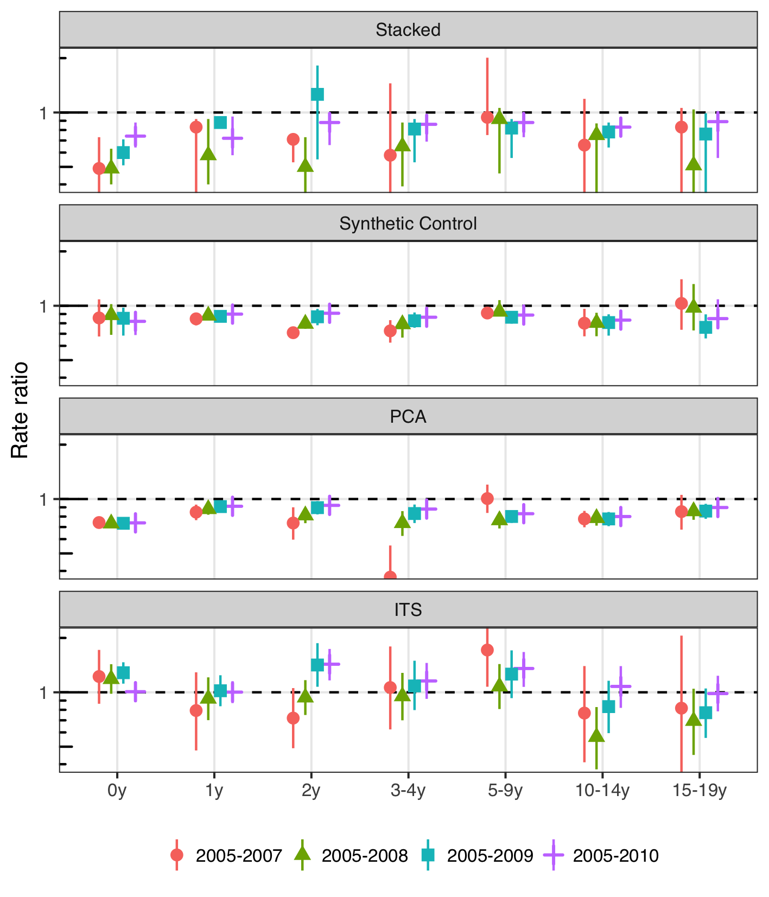

Figure 13 The figure illustrates the estimated rate ratio between the observed and predicted number of acute otitis media (AOM) visits in the post-vaccine period by model and the number of pre-vaccine years. Each age-group is shown separately on the X-axis. An additional pre-vaccine year is added from left to right, starting with the period 2005-2007 and ending with the full pre-vaccine period 2005-2010 that was used in the main analysis. The top frame shows the estimates for the final stacked model. The results are largely invariant to the number of pre-vaccine years, with a slight trend towards decreasing impact as more years are added.

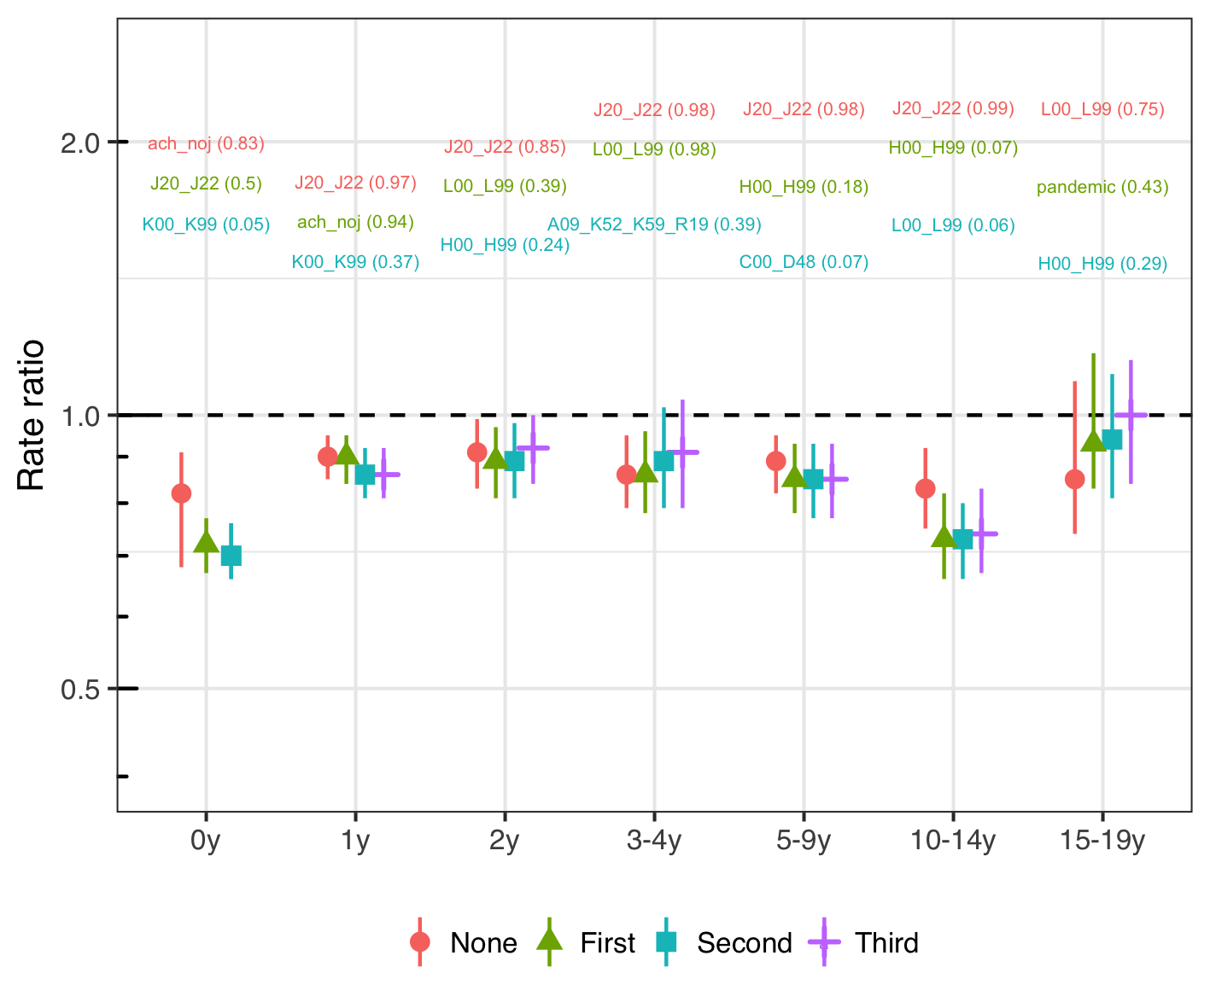

Figure 14 The figure depicts the estimated rate ratio between the observed and predicted number of acute otitis media (AOM) visits in the post-vaccine period for the synthetic control model. The leftmost point and confidence interval represents the full synthetic model used in the analysis, and the same colored label shows the top control and its associated inclusion probability in the Bayesian variable selection process. From left to right, the top control is removed, the model is refitted on the remaining controls and the corresponding rate ratio illustrated with a point and interval. The results are largely invariant to the controls used.

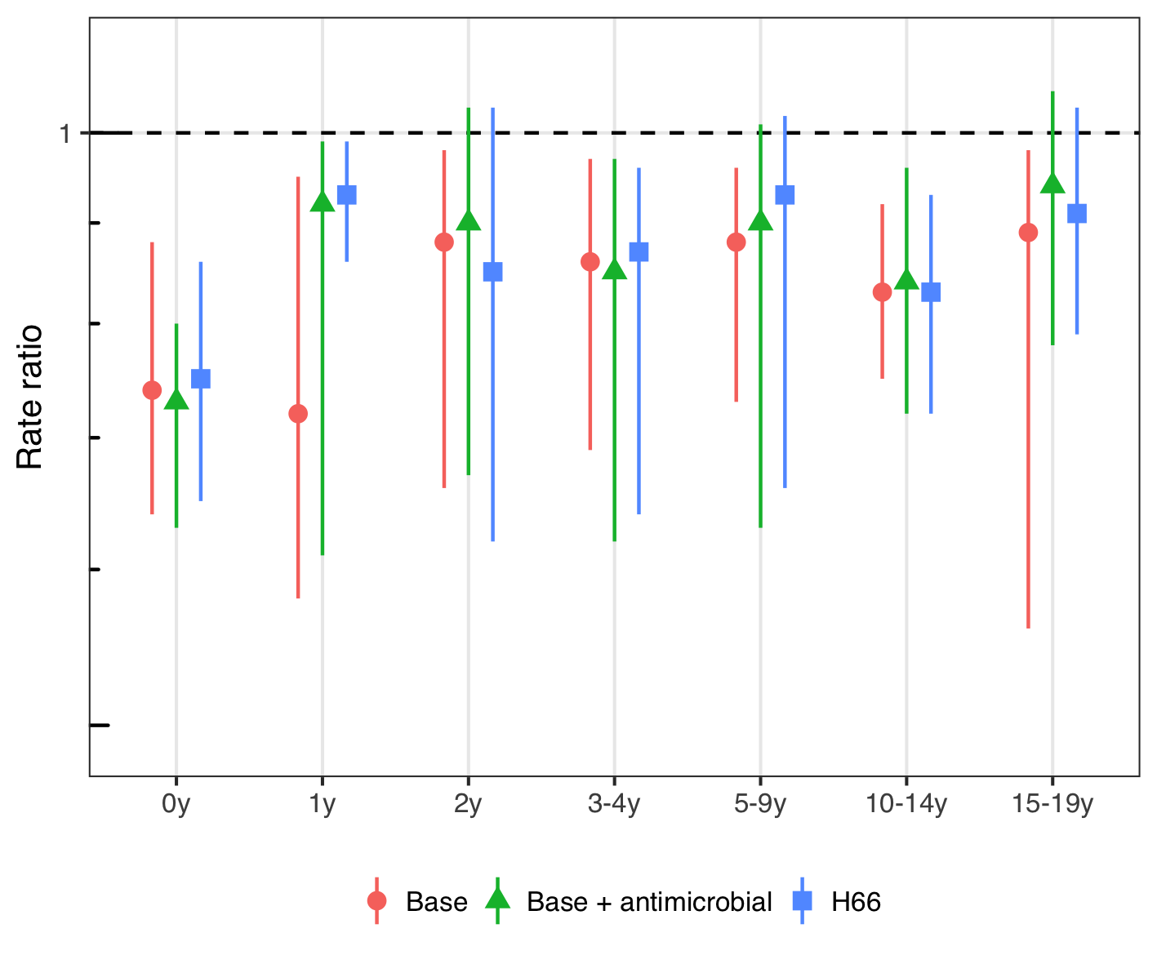

Figure 15 The figure illustrates the estimated rate ratio between the observed and predicted number of acute otitis media (AOM) visits in the post-vaccine period for the final stacked model using different case-definitions. The case-definition used in the main analysis is shown with a red point and intervals. The green point represents the same International Classification of Diseases, 10th revision (ICD-10) codes but only those resulting in an antimicrobial prescription. Finally the blue point represents only H66: Suppurative otitis media only. The results are largely invariant to the case-definition with the exception of one year old children.

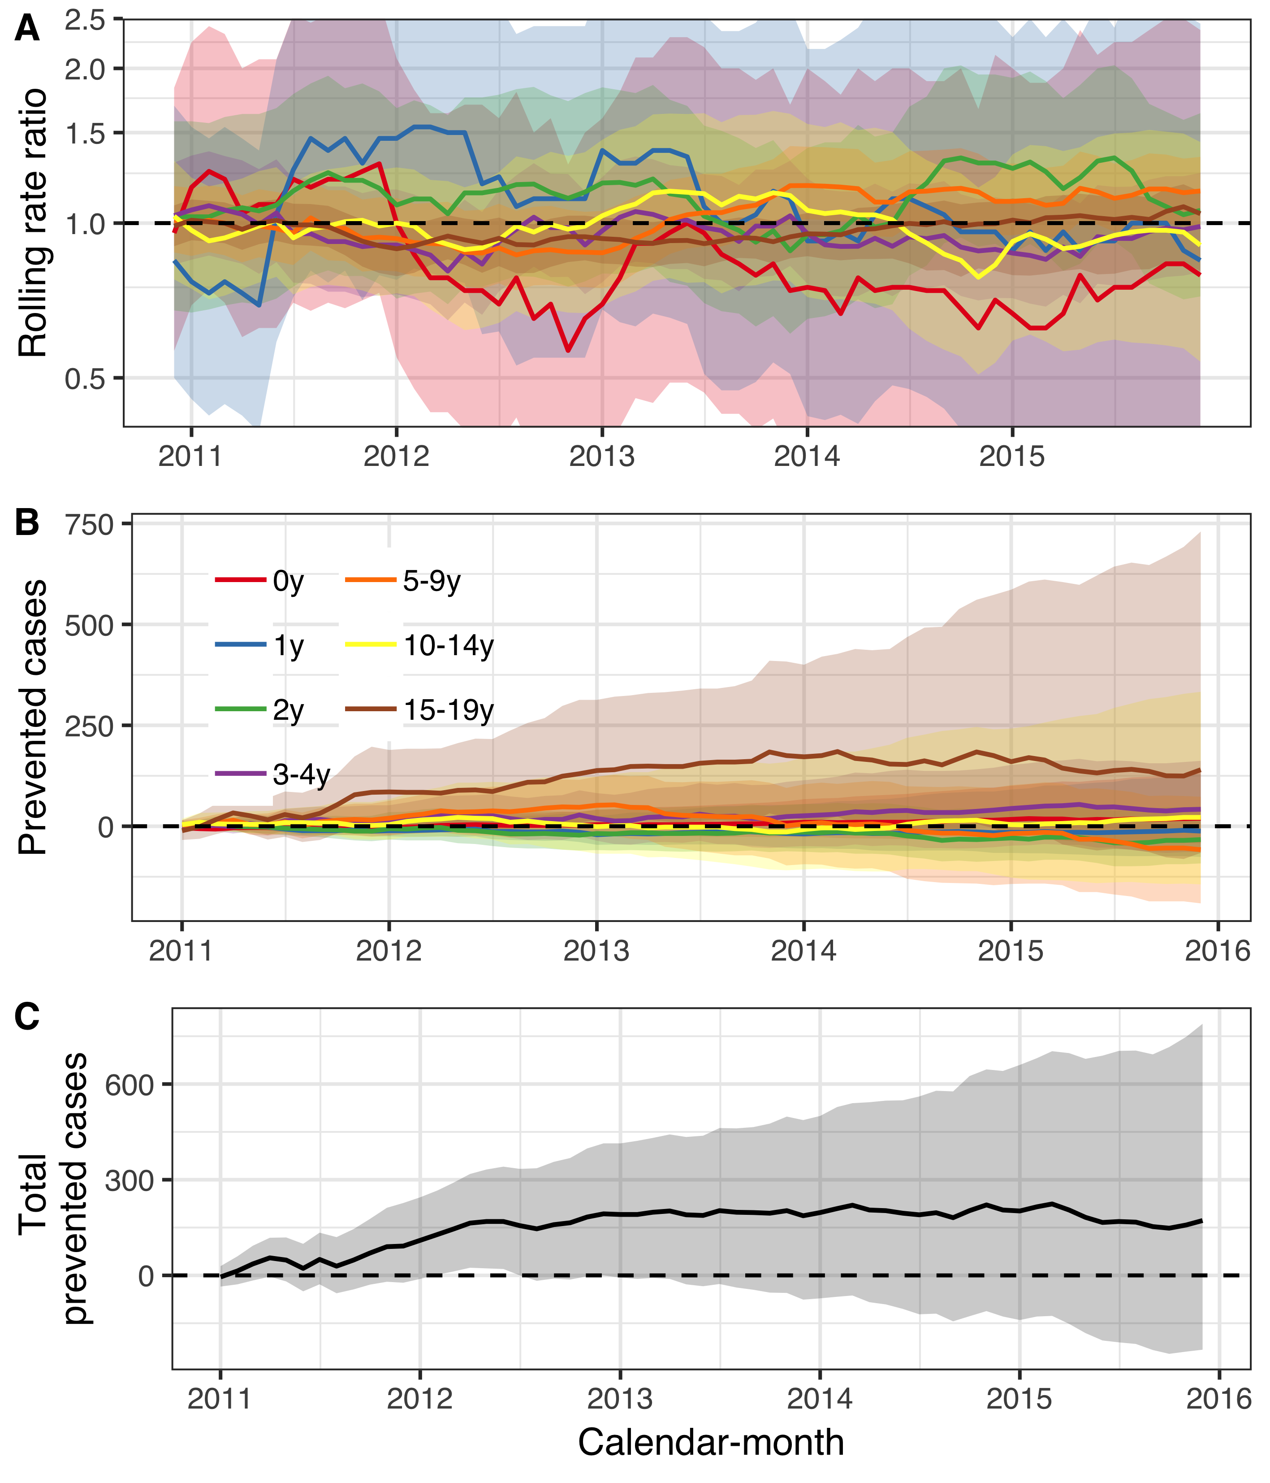

Figure 16 The population impact of the 10-valent *Haemophilus influenzae* protein D pneumococcal conjugate vaccine (PHiD-CV10) on outpatient visits for urinary tract infections (UTI) is summarized. In Panel A, the estimated 12-month rolling rate ratio between the observed and predicted number of UTI visits in the post-vaccine period (2011-2015) is shown per age-group. Panel B depicts the cumulative number of prevented UTI visits during the post-vaccine period (2011-2015) for each age-group along with 95% credible intervals. The total cumulative prevented UTI visits regardless of age-group is shown in Panel C. As expected, there was no discernible impact.

**Pneumonia**

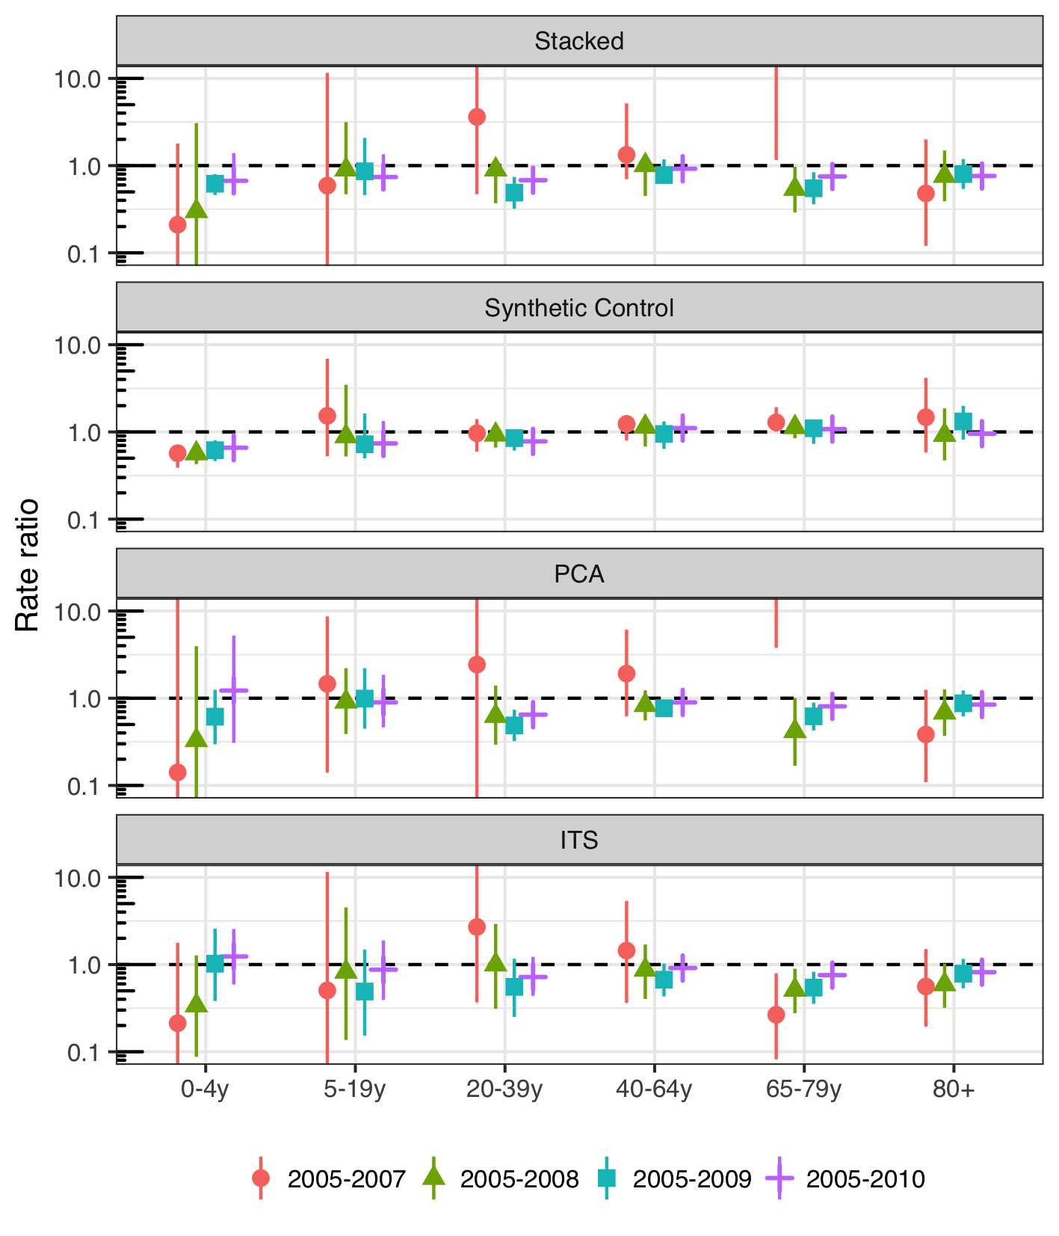

Figure 17 The figure illustrates the estimated rate ratio between the observed and predicted number of pneumonia hospitalizations in the post-vaccine period by model and the number of pre-vaccine years. Each age-group is shown separately on the X-axis. An additional pre-vaccine year is added from left to right, starting with the period 2005-2007 and ending with the full pre-vaccine period 2005-2010 that was used in the main analysis. The top frame shows the estimates for the final stacked model. The results are largely invariant to the number of pre-vaccine years. However, when only 2005-2007 are included, the estimates are severely unstable in the principal component analysis (PCA) model. The PCA model was given undue weight in the model stacking procedure, resulting in the same instability in the final stacked model. Despite this, the figure does not suggest that the inclusion of 2009 has large effects on the results. The 2009 influenza pan-demic does therefore not seem to unduly influence the results.

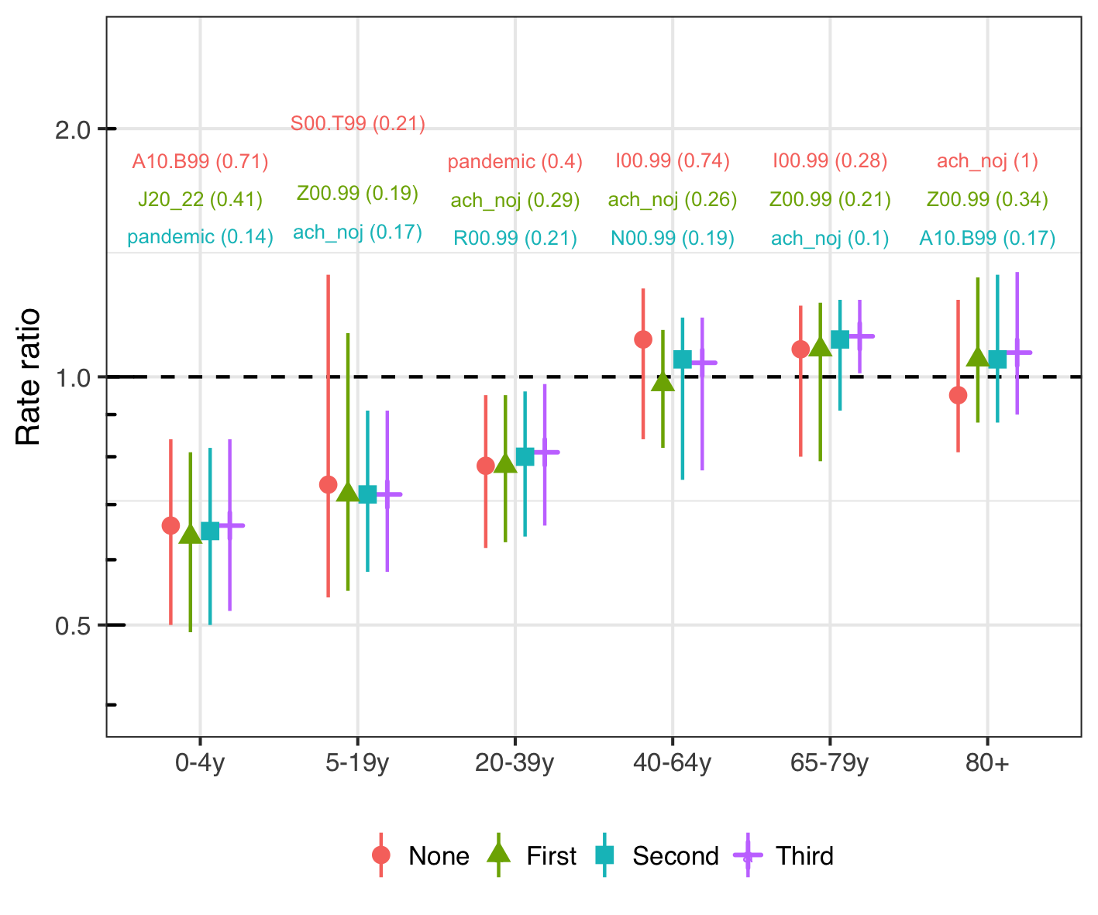

Figure 18 The figure depicts the estimated rate ratio between the observed and predicted number of pneumonia hospitalizations in the post-vaccine period for the synthetic control model. The leftmost point and confidence interval represents the full synthetic model used in the analysis, and the same colored label shows the top control and its associated inclusion probability in the Bayesian variable selection process. From left to right, the top control is removed, the model is refitted on the remaining controls and the corresponding rate ratio illustrated with a point and interval. The results are largely invariant to the controls used.

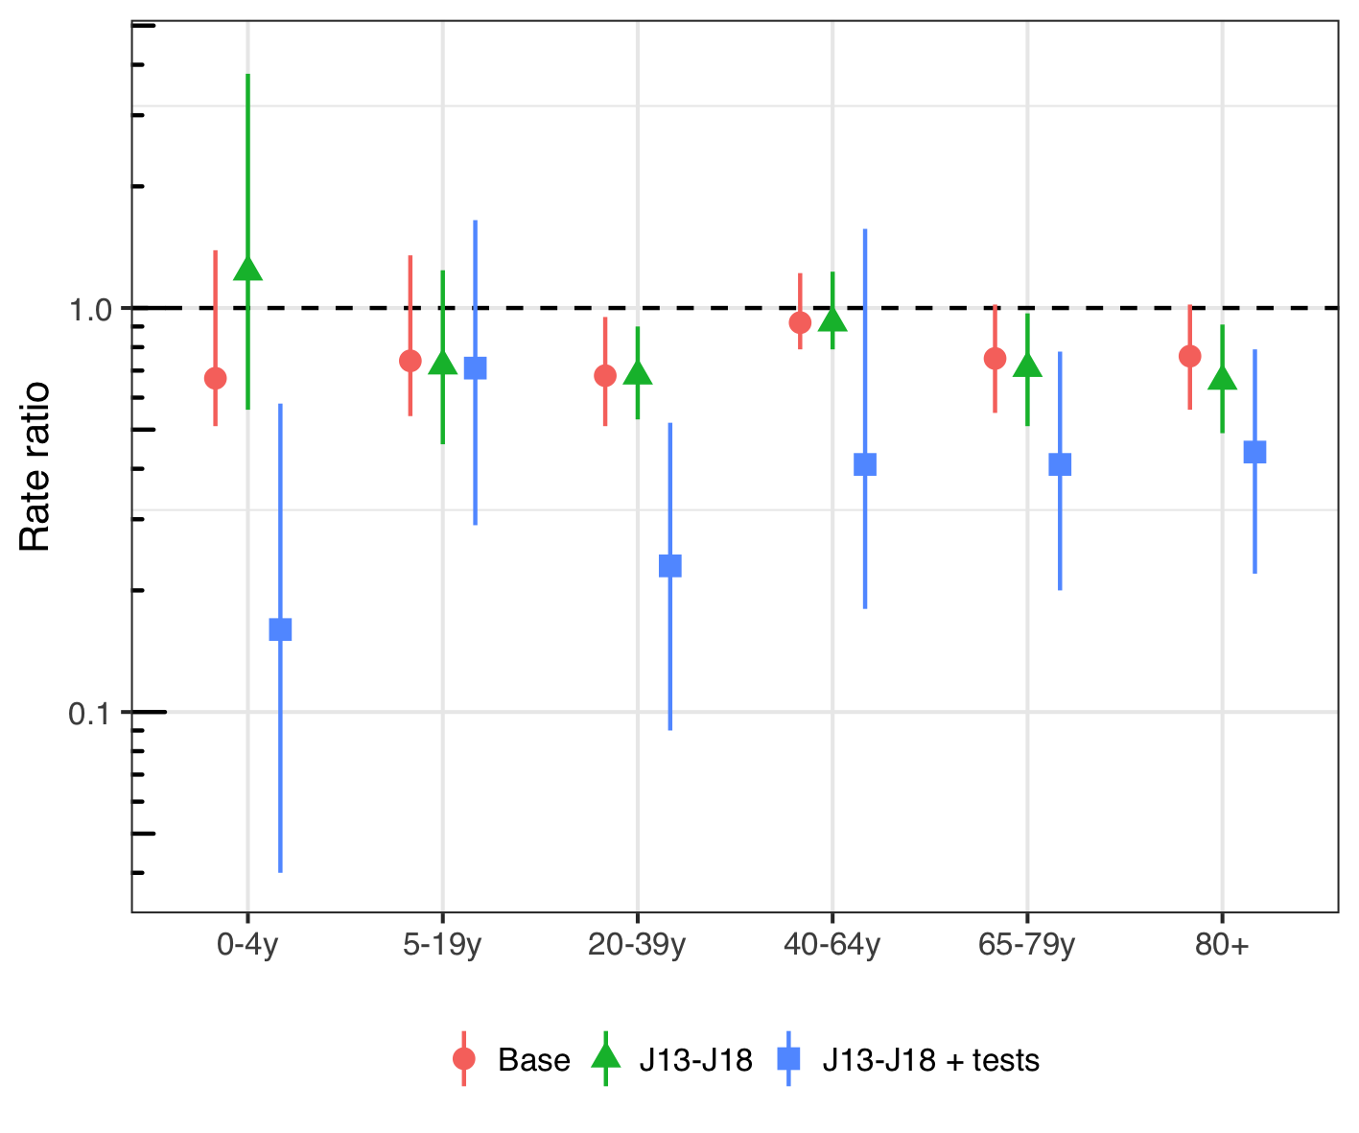

Figure 19 The figure illustrates the estimated rate ratio between the observed and predicted number of pneumonia hospitalizations in the post-vaccine period for the final stacked model using different case-definitions. The case-definition used in the main analysis is shown with a red point and intervals. The green point represents International Classification of Diseases, 10th revision (ICD-10) codes more specific for bacterial pneumonia. Finally the blue point represents the more specific ICD-10 definition of bacterial pneumonia, but only includes those hospitalizations in which radiographical and microbiological testing was performed. Using the most specific definition of pneumonia (blue), the impact of the 10-valent pneumococcal Haemophilus influenzae Protein D conjugate vaccine (PHiD-CV) is significantly larger in all age-groups.

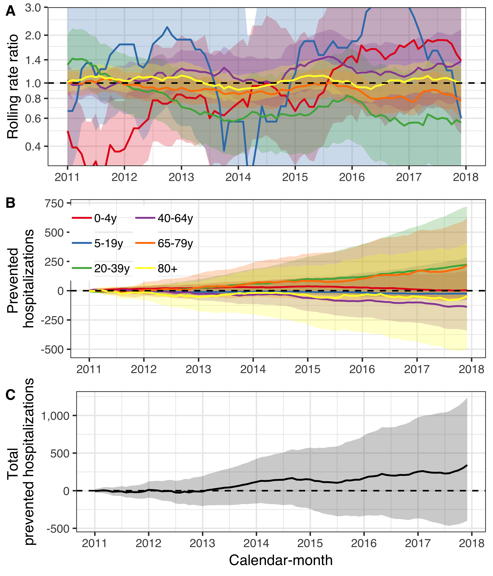

Figure 20 The population impact of the 10-valent *Haemophilus influenzae* protein D pneumococcal conjugate vaccine (PHiD-CV10) on outpatient visits for urinary tract infections (UTI) is summarized. In Panel A, the estimated 12-month rolling rate ratio between the observed and predicted number of UTI visits in the post-vaccine period (2011-2015) is shown per age-group. Panel B depicts the cumulative number of prevented UTI visits during the post-vaccine period (2011-2015) for each age-group along with 95% credible intervals. The total cumulative prevented UTI visits regardless of age-group is shown in Panel C. As expected, there was no discernible impact.

**IPD**

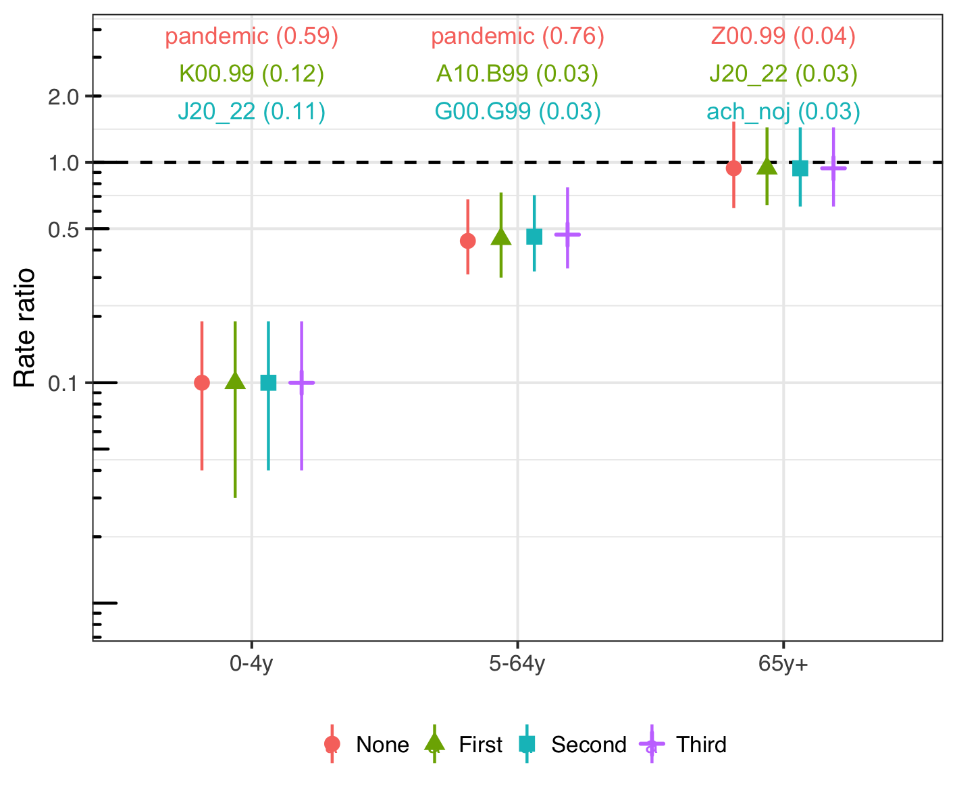

Figure 21 The figure depicts the estimated rate ratio between the observed and predicted number of hospitalizations for invasive pneumococcal disease in the post-vaccine period for the synthetic control model. The leftmost point and confidence interval represents the full synthetic model used in the analysis, and the same colored label shows the top control and its associated inclusion probability in the Bayesian variable selection process. From left to right, the top control is removed, the model is refitted on the remaining controls and the corresponding rate ratio illustrated with a point and interval. The results are largely invariant to the controls used.

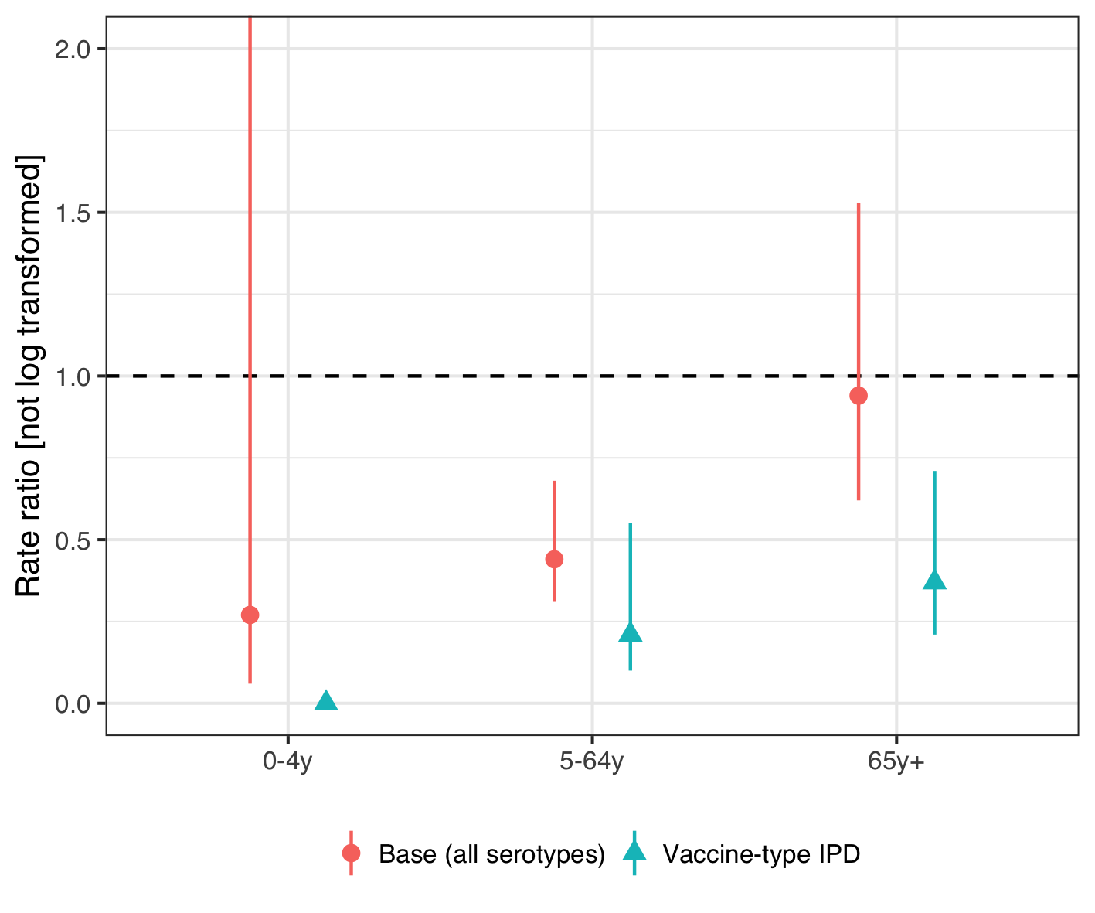

Figure 22 The figure illustrates the estimated rate ratio between the observed and predicted number of hospitalizations for invasive pneumococcal disease (IPD) in the post-vaccine period for the final stacked model using different case-definitions. Culture or PCR confirmed IPD regardless of serotype, the case-definition used in the main analysis, is shown with a red point and intervals. The green point represents vaccine-type IPD. The number of nonvaccine-type IPD in the pre-vaccine period was not large enough to fit any of the time series models. The figure shows that the impact of the 10-valent pneumococcal Haemophilus influenzae Protein D conjugate vaccine (PHiD-CV) on vaccine-type is large in all age-groups.

Alicino, Cristiano, Chiara Paganino, Andrea Orsi, Matteo Astengo, Cecilia Trucchi, Giancarlo Icardi, and Filippo Ansaldi. 2017. “The impact of 10-valent and 13-valent pneumococcal conjugate vaccines on hospitalization for pneumonia in children: A systematic review and meta-analysis.” *Vaccine* 35 (43): 5776–85. <https://doi.org/10.1016/j.vaccine.2017.09.005>.

Andrade, Ana Lucia, Eliane T Afonso, Ruth Minamisava, Ana Luiza Bierrenbach, Elier B Cristo, Otaliba L Morais-Neto, Gabriela M Policena, Carla M. A. S. Domingues, and Cristiana M Toscano. 2017. “Direct and indirect impact of 10-valent pneumococcal conjugate vaccine introduction on pneumonia hospitalizations and economic burden in all age-groups in Brazil: A time-series analysis.” Edited by Philip C Hill. *PLOS ONE* 12 (9): e0184204. <https://doi.org/10.1371/journal.pone.0184204>.

Belgorodski, Natalia, Matthias Greiner, Kristin Tolksdorf, and Katharina Schueller. 2017. *RriskDistributions: Fitting Distributions to Given Data or Known Quantiles*. <https://CRAN.R-project.org/package=rriskDistributions>.

Ben-Shimol, Shalom, Noga Givon-Lavi, Eugene Leibovitz, Simon Raiz, David Greenberg, and Ron Dagan. 2014. “Near-Elimination of Otitis Media Caused by 13-Valent Pneumococcal Conjugate Vaccine (PCV) Serotypes in Southern Israel Shortly After Sequential Introduction of 7-Valent/13-Valent PCV.” *Clinical Infectious Diseases* 59 (12): 1724–32. <https://doi.org/10.1093/cid/ciu683>.

Berglund, Anders, Mats Ekelund, Mark A. Fletcher, and Lars Nyman. 2014. “All-cause pneumonia hospitalizations in children <2 years old in sweden, 1998 to 2012: impact of pneumococcal conjugate vaccine introduction.” Edited by Bernard Beall. *PloS One* 9 (11): e112211. <https://doi.org/10.1371/journal.pone.0112211>.

Black, S, H Shinefield, Bruce Fireman, E Lewis, P Ray, J R Hansen, L Elvin, et al. 2000. “Efficacy, safety and immunogenicity of heptavalent pneumococcal conjugate vaccine in children. Northern California Kaiser Permanente Vaccine Study Center Group.” *The Pediatric Infectious Disease Journal* 19 (3): 187–95. <http://www.ncbi.nlm.nih.gov/pubmed/10749457>.

Blank, Patricia R., and Thomas D. Szucs. 2012. “Cost-effectiveness of 13-valent pneumococcal conjugate vaccine in Switzerland.” *Vaccine* 30 (28): 4267–75. <https://doi.org/10.1016/j.vaccine.2012.04.028>.

Bruhn, Christian A W, Stephen Hetterich, Cynthia Schuck-Paim, Esra Kürüm, Robert J Taylor, Roger Lustig, Eugene D Shapiro, Joshua L Warren, Lone Simonsen, and Daniel M Weinberger. 2017. “Estimating the population-level impact of vaccines using synthetic controls.” *Proceedings of the National Academy of Sciences* 114 (7): 1524–9. <https://doi.org/10.1073/pnas.1612833114>.

By, Åsa, Patrik Sobocki, Arne Forsgren, and Sven-Arne Silfverdal. 2012. “Comparing Health Outcomes and Costs of General Vaccination with Pneumococcal Conjugate Vaccines in Sweden: A Markov Model.” *Clinical Therapeutics* 34 (1): 177–89. <https://doi.org/10.1016/j.clinthera.2011.12.007>.

Castiglia, Paolo, Lorenzo Pradelli, Stefano Castagna, Veronica Freguglia, Giorgio Palù, and Susanna Esposito. 2017. “Overall effectiveness of pneumococcal conjugate vaccines: An economic analysis of PHiD-CV and PCV-13 in the immunization of infants in Italy.” *Human Vaccines & Immunotherapeutics* 13 (10): 2307–15. <https://doi.org/10.1080/21645515.2017.1343773>.

Chuck, Anderson W., Philip Jacobs, Gregory Tyrell, and James D. Kellner. 2010. “Pharmacoeconomic evaluation of 10- and 13-valent pneumococcal conjugate vaccines.” *Vaccine* 28: 5485–90. <https://doi.org/10.1016/j.vaccine.2010.05.058>.

Cutts, Felicity T, S M Zaman, Godwin C Enwere, S Jaffar, O S Levine, J B Okoko, C Oluwalana, et al. 2005. “Efficacy of nine-valent pneumococcal conjugate vaccine against pneumonia and invasive pneumococcal disease in The Gambia: randomised, double-blind, placebo-controlled trial.” *Lancet* 365 (9465): 1139–46. <https://doi.org/10.1016/s0140-6736(05)71876-6>.

Davis, Stephanie M., Maria Deloria-Knoll, Hilina T. Kassa, and Katherine L. O’Brien. 2013. “Impact of pneumococcal conjugate vaccines on nasopharyngeal carriage and invasive disease among unvaccinated people: Review of evidence on indirect effects.” *Vaccine* 32 (1): 133–45. <https://doi.org/10.1016/j.vaccine.2013.05.005>.

Delgleize, Emmanuelle, Oscar Leeuwenkamp, Eleni Theodorou, and Nicolas Van de Velde. 2016. “Cost-effectiveness analysis of routine pneumococcal vaccination in the UK: a comparison of the PHiD-CV vaccine and the PCV-13 vaccine using a Markov model.” *BMJ Open* 6 (11): e010776. <https://doi.org/10.1136/bmjopen-2015-010776>.

Díez-Domingo, Javier, Manuel Ridao-López, M Victoria Gutiérrez-Gimeno, Joan Puig-Barberá, Jose a Lluch-Rodrigo, and Eliseo Pastor-Villalba. 2011. “Pharmacoeconomic assessment of implementing a universal PCV-13 vaccination programme in the Valencian public health system (Spain).” *Vaccine* 29 (52): 9640–8. <https://doi.org/10.1016/j.vaccine.2011.10.038>.

Dvorzak, Michaela, and Helga Wagner. 2019. *Pogit: Bayesian Variable Selection for a Poisson-Logistic Model*. <https://CRAN.R-project.org/package=pogit>.

Earnshaw, Stephanie R, Cheryl L McDade, Giovanni Zanotti, Raymond A Farkouh, and David Strutton. 2012. “Cost-effectiveness of 2 + 1 dosing of 13-valent and 10-valent pneumococcal conjugate vaccines in Canada.” *BMC Infectious Diseases* 12 (1): 101. <https://doi.org/10.1186/1471-2334-12-101>.

Eythorsson, Elias, Birgir Hrafnkelsson, Helga Erlendsdóttir, Sigmar Atli Gudmundsson, Karl G Kristinsson, and Ásgeir Haraldsson. 2017. “Decreased AOM with Treatment Failure Following Introduction of the Ten-Valent Pneumococcal Haemophilus influenzae Protein D Conjugate Vaccine.” *The Pediatric Infectious Disease Journal*, December, 1. <https://doi.org/10.1097/INF.0000000000001870>.

Gouveia, Miguel, Francesca Fiorentino, Gonçalo Jesus, João Costa, and Margarida Borges. 2017. “Cost-effectiveness of the 13-valent Pneumococcal Conjugate Vaccine in Children in Portugal.” *The Pediatric Infectious Disease Journal* 36 (8): 782–87. <https://doi.org/10.1097/INF.0000000000001587>.

Gray, Alastair M, Philip M Clarke, Jane L Wolstenholme, and Sarah Wordsworth. 2011. *Applied Methods of Cost-effectiveness Analysis in Health Care*. New York: Oxford University Press.

Griffin, Marie R., Yuwei Zhu, Matthew R. Moore, Cynthia G. Whitney, and Carlos G. Grijalva. 2013. “U.S. hospitalizations for pneumonia after a decade of pneumococcal vaccination.” *The New England Journal of Medicine* 369 (2): 155–63. <https://doi.org/10.1056/NEJMoa1209165>.

Grijalva, Carlos G., J. Pekka Nuorti, Patrick G. Arbogast, Stacey W. Martin, Kathryn M. Edwards, and Marie R. Griffin. 2007. “Decline in pneumonia admissions after routine childhood immunisation with pneumococcal conjugate vaccine in the USA: a time-series analysis.” *Lancet* 369 (9568): 1179–86. <https://doi.org/10.1016/S0140-6736(07)60564-9>.

Grijalva, C. G., K. A. Poehling, J. P. Nuorti, Y. Zhu, S. W. Martin, K. M. Edwards, and M. R. Griffin. 2006. “National Impact of Universal Childhood Immunization With Pneumococcal Conjugate Vaccine on Outpatient Medical Care Visits in the United States.” *PEDIATRICS* 118 (3): 865–73. <https://doi.org/10.1542/peds.2006-0492>.

Herdman, Michael, Amanda Cole, Christopher K Hoyle, Victoria Coles, Stuart Carroll, and Nancy Devlin. 2016. “Sources and Characteristics of Utility Weights for Economic Evaluation of Pediatric Vaccines: A Systematic Review.” *Value in Health : The Journal of the International Society for Pharmacoeconomics and Outcomes Research* 19 (2): 255–66. <https://doi.org/10.1016/j.jval.2015.11.003>.

Hoek, Albert Jan van, Yoon Hong Choi, Caroline Trotter, Elizabeth Miller, and Mark Jit. 2012. “The cost-effectiveness of a 13-valent pneumococcal conjugate vaccination for infants in England.” *Vaccine* 30 (50): 7205–13. <https://doi.org/10.1016/j.vaccine.2012.10.017>.

Holubar, Marisa, Maria Christina Stavroulakis, Yvonne Maldonado, John P A Ioannidis, and Despina Contopoulos-Ioannidis. 2017. “Impact of vaccine herd-protection effects in cost-effectiveness analyses of childhood vaccinations. A quantitative comparative analysis.” *PLoS ONE* 12 (3): 1–22. <https://doi.org/10.1371/journal.pone.0172414>.

Jardine, Andrew, Robert I. Menzies, and Peter B. McIntyre. 2010. “Reduction in Hospitalizations for Pneumonia Associated With the Introduction of a Pneumococcal Conjugate Vaccination Schedule Without a Booster Dose in Australia.” *The Pediatric Infectious Disease Journal* 29 (7): 607–12. <https://doi.org/10.1097/INF.0b013e3181d7d09c>.

Klok, Rogier M, Rose-Marie Lindkvist, Mats Ekelund, Raymond a Farkouh, and David R Strutton. 2013. “Cost-Effectiveness of a 10- Versus 13-Valent Pneumococcal Conjugate Vaccine in Denmark and Sweden.” *Clinical Therapeutics* 35 (2): 119–34. <https://doi.org/10.1016/j.clinthera.2012.12.006>.

Knerer, Gerhart, Afisi Ismaila, and David Pearce. 2012. “Health and economic impact of PHiD-CV in Canada and the UK: a Markov modelling exercise.” *Journal of Medical Economics* 15 (1): 61–76. <https://doi.org/10.3111/13696998.2011.622323>.

Kuhlmann, Alexander, and J-Matthias Graf von der Schulenburg. 2017. “Modeling the cost-effectiveness of infant vaccination with pneumococcal conjugate vaccines in Germany.” *The European Journal of Health Economics* 18 (3): 273–92. <https://doi.org/10.1007/s10198-016-0770-9>.

Lau, Wallis C Y, Macey Murray, Aisha El-Turki, Sonia Saxena, Shamez Ladhani, Paul Long, Mike Sharland, Ian C K Wong, and Yingfen Hsia. 2015. “Impact of pneumococcal conjugate vaccines on childhood otitis media in the United Kingdom.” *Vaccine* 33 (39): 5072–9. <https://doi.org/10.1016/j.vaccine.2015.08.022>.

Marom, Tal, Alai Tan, Gregg S. Wilkinson, Karen S. Pierson, Jean L. Freeman, and Tasnee Chonmaitree. 2014. “Trends in otitis media-related health care use in the United States, 2001-2011.” *JAMA Pediatrics* 168 (1): 68–75. <https://doi.org/10.1001/jamapediatrics.2013.3924>.

Mauskopf, Josephine, Baudouin Standaert, Mark P. Connolly, Anthony J. Culyer, Louis P. Garrison, Raymond Hutubessy, Mark Jit, Richard Pitman, Paul Revill, and Johan L. Severens. 2018. “Economic Analysis of Vaccination Programs: An ISPOR Good Practices for Outcomes Research Task Force Report.” *Value in Health* 21 (10): 1133–49. <https://doi.org/10.1016/j.jval.2018.08.005>.

McLaughlin, John M, Eric A Utt, Nina M Hill, Verna L Welch, Edward Power, and Gregg C Sylvester. 2016. “A current and historical perspective on disparities in US childhood pneumococcal conjugate vaccine adherence and in rates of invasive pneumococcal disease: Considerations for the routinely-recommended, pediatric PCV dosing schedule in the United States.” *Human Vaccines & Immunotherapeutics* 12 (1): 206–12. <https://doi.org/10.1080/21645515.2015.1069452>.

Nair, Harish, Arun Thor Watts, Linda J. Williams, Saad B. Omer, Colin R. Simpson, Lorna J. Willocks, J. Claire Cameron, and Harry Campbell. 2016. “Pneumonia hospitalisations in Scotland following the introduction of pneumococcal conjugate vaccination in young children.” *BMC Infectious Diseases* 16 (1): 390. <https://doi.org/10.1186/s12879-016-1693-x>.

Newall, Anthony T., Prudence Creighton, David J. Philp, James G. Wood, and C. Raina MacIntyre. 2011. “The potential cost-effectiveness of infant pneumococcal vaccines in Australia.” *Vaccine* 29: 8077–85. <https://doi.org/10.1016/j.vaccine.2011.08.050>.

Newall, A. T., J. F. Reyes, P. McIntyre, R. Menzies, P. Beutels, and J. G. Wood. 2016. “Retrospective economic evaluation of childhood 7-valent pneumococcal conjugate vaccination in Australia: Uncertain herd impact on pneumonia critical.” *Vaccine* 34 (3): 320–27. <https://doi.org/10.1016/j.vaccine.2015.11.053>.

O’Brien, Megan A, Lisa A Prosser, Jack L Paradise, G Thomas Ray, Martin Kulldorff, Marcia Kurs-Lasky, Virginia L Hinrichsen, Jyotsna Mehta, D Kathleen Colborn, and Tracy A Lieu. 2009. “New vaccines against otitis media: projected benefits and cost-effectiveness.” *Pediatrics* 123 (6): 1452–63. <https://doi.org/10.1542/peds.2008-1482>.

*OECD Labour Force Statistics*. 2018. OECD Labour Force Statistics. OECD. <https://doi.org/10.1787/oecd_lfs-2018-en>.

Oliveira, Lucia Helena de, Silas Pierson Trumbo, Cuauhtémoc Ruiz Matus, N. Jennifer Sanwogou, and Cristiana M. Toscano. 2016. “Pneumococcal conjugate vaccine introduction in Latin America and the Caribbean: progress and lessons learned.” *Expert Review of Vaccines* 15 (10): 1295–1304. <https://doi.org/10.1586/14760584.2016.1166961>.

Prymula, Roman, Pascal Peeters, Viktor Chrobok, Pavla Kriz, Elena Novakova, Eva Kaliskova, Igor Kohl, et al. 2006. “Pneumococcal capsular polysaccharides conjugated to protein D for prevention of acute otitis media caused by both Streptococcus pneumoniae and non-typable Haemophilus influenzae: A randomised double-blind efficacy study.” *Lancet* 367 (9512): 740–48. <https://doi.org/10.1016/S0140-6736(06)68304-9>.

Ray, G Thomas, Stephen I Pelton, Keith P Klugman, David R Strutton, and Matthew R Moore. 2009. “Cost-effectiveness of pneumococcal conjugate vaccine: An update after 7 years of use in the United States.” *Vaccine* 27 (47): 6483–94. <https://doi.org/10.1016/j.vaccine.2009.08.045>.

Robberstad, Bjarne, Carl R. Frostad, Per E. Akselsen, Kari J. Kværner, and Aud K H Berstad. 2011. “Economic evaluation of second generation pneumococcal conjugate vaccines in Norway.” *Vaccine* 29: 8564–74. <https://doi.org/10.1016/j.vaccine.2011.09.025>.

Rozenbaum, Mark H, Elisabeth a M Sanders, Albert Jan van Hoek, Angelique G S C Jansen, Arie van der Ende, Germie van den Dobbelsteen, Gerwin D Rodenburg, Eelko Hak, and Maarten J Postma. 2010. “Cost effectiveness of pneumococcal vaccination among Dutch infants: economic analysis of the seven valent pneumococcal conjugated vaccine and forecast for the 10 valent and 13 valent vaccines.” *BMJ* 340 (jun02 1): c2509–c2509. <https://doi.org/10.1136/bmj.c2509>.

Rubin, Jaime L., Lisa J. McGarry, David R. Strutton, Keith P. Klugman, Stephen I. Pelton, Kristen E. Gilmore, and Milton C. Weinstein. 2010. “Public health and economic impact of the 13-valent pneumococcal conjugate vaccine (PCV13) in the United States.” *Vaccine* 28 (48): 7634–43. <https://doi.org/10.1016/j.vaccine.2010.09.049>.

Saokaew, Surasak, Ajaree Rayanakorn, David Bin-Chia Wu, and Nathorn Chaiyakunapruk. 2016. “Cost Effectiveness of Pneumococcal Vaccination in Children in Low- and Middle-Income Countries: A Systematic Review.” *PharmacoEconomics* 34 (12): 1211–25. <https://doi.org/10.1007/s40273-016-0439-3>.

Saxena, Sonia, Christina Atchison, Elizabeth Cecil, Mike Sharland, Elizabeth Koshy, and Alex Bottle. 2015. “Additive impact of pneumococcal conjugate vaccines on pneumonia and empyema hospital admissions in England.” *Journal of Infection* 71 (4): 428–36. <https://doi.org/10.1016/j.jinf.2015.06.011>.

Sgambatti, Sabrina, Ruth Minamisava, Ana Luiza Bierrenbach, Cristiana Maria Toscano, Maria Aparecida Vieira, Gabriela Policena, and Ana Lucia Andrade. 2016. “Early impact of 10-valent pneumococcal conjugate vaccine in childhood pneumonia hospitalizations using primary data from an active population-based surveillance.” *Vaccine* 34 (5): 663–70. <https://doi.org/10.1016/j.vaccine.2015.12.007>.

Shioda, Kayoko, Cynthia Schuck-Paim, Robert J. Taylor, Roger Lustig, Lone Simonsen, Joshua L Warren, and Daniel M Weinberger. 2018. “Challenges in estimating the impact of vaccination with sparse data.” *Epidemiology (Cambridge, Mass.)* 4 (5): 1. <https://doi.org/10.1097/EDE.0000000000000938>.

Shiri, Tinevimbo, Samik Datta, Jason Madan, Alexander Tsertsvadze, Pamela Royle, Matt J. Keeling, Noel D. McCarthy, and Stavros Petrou. 2017. “Indirect effects of childhood pneumococcal conjugate vaccination on invasive pneumococcal disease: a systematic review and meta-analysis.” *The Lancet Global Health* 5 (1): e51–e59. <https://doi.org/10.1016/S2214-109X(16)30306-0>.

Sigurdsson, Samuel, Elias Eythorsson, Birgir Hrafnkelsson, Helga Erlendsdóttir, Karl G Kristinsson, and Ásgeir Haraldsson. 2018. “Reduction in All-Cause Acute Otitis Media in Children <3 Years of Age in Primary Care Following Vaccination With 10-Valent Pneumococcal Haemophilus influenzae Protein-D Conjugate Vaccine: A Whole-Population Study.” *Clinical Infectious Diseases* 67 (8): 1213–9. <https://doi.org/10.1093/cid/ciy233>.

Simonsen, Lone, Robert J Taylor, Cynthia Schuck-Paim, Roger Lustig, Michael Haber, and Keith P Klugman. 2014. “Effect of 13-valent pneumococcal conjugate vaccine on admissions to hospital 2 years after its introduction in the USA: a time series analysis.” *The Lancet Respiratory Medicine* 2 (5): 387–94. <https://doi.org/10.1016/S2213-2600(14)70032-3>.

Simonsen, Lone, Robert J Taylor, Yinong Young-Xu, Michael Haber, Larissa May, and Keith P Klugman. 2011. “Impact of Pneumococcal Conjugate Vaccination of Infants on Pneumonia and Influenza Hospitalization and Mortality in All Age Groups in the United States.” *mBio* 2 (1): e00309–10. <https://doi.org/10.1128/mBio.00309-10>.

Strutton, David R, Raymond a Farkouh, Stephanie R Earnshaw, Sharon Hwang, Ulrike Theidel, Stathis Kontodimas, Rogier Klok, and Sotiria Papanicolaou. 2012. “Cost-effectiveness of 13-valent pneumococcal conjugate vaccine: Germany, Greece, and The Netherlands.” *Journal of Infection* 64 (1): 54–67. <https://doi.org/10.1016/j.jinf.2011.10.015>.

Talbird, Sandra E, Thomas N Taylor, Stefanie Knoll, Carl Richard Frostad, and Sebastián García Martí. 2010. “Outcomes and costs associated with PHiD-CV, a new protein D conjugate pneumococcal vaccine, in four countries.” *Vaccine* 28 Suppl 6 (November): G23–9. <https://doi.org/10.1016/j.vaccine.2010.06.016>.

Taylor, Sylvia, Paola Marchisio, Anne Vergison, Julie Harriague, William P. Hausdorff, and Mark Haggard. 2012. “Impact of pneumococcal conjugate vaccination on otitis media: A systematic review.” *Clinical Infectious Diseases* 54 (12): 1765–73. <https://doi.org/10.1093/cid/cis292>.

Tregnaghi, Miguel W. Marcelo, Xavier Sáez-Llorens, Pio López, Hector Abate, Enrique Smith, Adriana Pósleman, Arlene Calvo, et al. 2014. “Efficacy of pneumococcal nontypable Haemophilus influenzae protein D conjugate vaccine (PHiD-CV) in young Latin American children: A double-blind randomized controlled trial.” Edited by Elizabeth Miller. *PLoS Medicine* 11 (6): e1001657. <https://doi.org/10.1371/journal.pmed.1001657>.

Tsaban, Gal, and Shalom Ben-Shimol. 2017. “Indirect (herd) protection, following pneumococcal conjugated vaccines introduction: A systematic review of the literature.” *Vaccine* 35 (22): 2882–91. <https://doi.org/10.1016/j.vaccine.2017.04.032>.

Vehtari, Aki, Andrew Gelman, Jonah Gabry, and Yuling Yao. 2019. *Loo: Efficient Leave-One-Out Cross-Validation and Waic for Bayesian Models*. <https://CRAN.R-project.org/package=loo>.

Vojtek, Ivo, Marcus Nordgren, and Bernard Hoet. 2017. “Impact of pneumococcal conjugate vaccines on otitis media: A review of measurement and interpretation challenges.” *International Journal of Pediatric Otorhinolaryngology* 100 (September): 174–82. <https://doi.org/10.1016/j.ijporl.2017.07.009>.

Vooren, K van de, S Duranti, A Curto, and L Garattini. 2014. “Cost effectiveness of the new pneumococcal vaccines: a systematic review of European studies.” *Pharmacoeconomics* 32: 29–45. <https://doi.org/10.1007/s40273-013-0113-y>.

Walker, Damian G, Raymond Hutubessy, and Philippe Beutels. 2010. “WHO Guide for standardisation of economic evaluations of immunization programmes.” *Vaccine* 28 (11): 2356–9. <https://doi.org/10.1016/j.vaccine.2009.06.035>.

Wu, David Bin-Chia, Nathorn Chaiyakunapruk, Huey-Yi Chong, and Philippe Beutels. 2015. “Choosing between 7-, 10- and 13-valent pneumococcal conjugate vaccines in childhood: A review of economic evaluations (2006–2014).” *Vaccine* 33 (14): 1633–58. <https://doi.org/10.1016/j.vaccine.2015.01.081>.

Zhou, F., Abigail Shefer, J. Wenger, M. Messonnier, L. Y. Wang, A. Lopez, M. Moore, T. V. Murphy, M. Cortese, and L. Rodewald. 2014. “Economic Evaluation of the Routine Childhood Immunization Program in the United States, 2009.” *PEDIATRICS* 133 (4): 577–85. <https://doi.org/10.1542/peds.2013-0698>.